**Missing persons**

page 1 In the UK, 180,000 people are reported missing

**page 5 -17 Madeleine McCann**

page 18-22 Madeleine McCann June 2020

page 24-26 Madeleine McCann 2023

page 27 Girl fights off kidnapper+ other cases

**page 28-58 Fred and Rosemary West + including 2 films**

page 59-65 Ireland Missing people

In the **UK**, 180,000 **people** are reported **missing** every year. Someone goes **missing** every 90 seconds, according to figures compiled by the charity **Missing People**. One in 200 children will go **missing**, with that **number** standing at one in 500 for adults.7. mar. 2019

[**https://www.missingpeople.org.uk/latest-news/1018-missing-people-publishes-latest-uk-statistics.html**](https://www.missingpeople.org.uk/latest-news/1018-missing-people-publishes-latest-uk-statistics.html)

[](https://www.missingpeople.org.uk/about-us/about-the-issue/research/76-keyinformation2.html)

###### **Someone is reported missing every 90 seconds in the UK**

###### **180,000 people are reported missing every year**

###### **There are 340,000 reported missing incidents every year**

###### **Children are more likely to be reported missing than adults: 1 in 200 children goes missing each year; 1 in every 500 adults goes missing every year**

### How many people go missing each year?

* Missing people: of the 180,000 people reported missing over **95,000 are adults** and over **80,000 are children**
* Missing incidents: of the 340,000 reported incidents over **125,000 incidents are adults** and over **210,000 incidents are children**
* Looked after children are at high risk of being reported missing. **1 in 10** looked after children are reported missing each year compared to **1 in 200** total children. Looked after children who are reported missing will be reported on average **6 times**

The number of missing incidents is higher than the number of individuals who go missing because some people go missing more than once. Most of the people who are reported missing are vulnerable or at risk and many are reported missing multiple times, making them even more vulnerable.

### Under-reporting

Research shows that police data is likely to be a significant underestimate. There are limitations to the NCA data, including differing recording practices and incomplete data, and some people will not be reported missing to the police at all. Research suggests that as many as 7 in 10 children are not reported to the police when they go missing. Little is known about adults who are not reported missing.

### What is 'missing'?

The National Police Chiefs' Council's definition for missing: 'Anyone whose whereabouts cannot be established and where the circumstances are out of character or the context suggests the person may be subject of crime or at risk of harm to themselves or another'.

However, it is difficult to provide a singular definition for missing. This largely stems from the huge variety of potential reasons behind a person going missing, and the different ways an incident may be understood by different parties. Adults, unless they are within the criminal justice system or detained under various sections of the Mental Health Act, have a legal right to go missing. For more information regarding this question please see our [information sheet](https://www.missingpeople.org.uk/files/Information%20sheets/Info_Sheet_What_is_Missing.pdf).

### How long are people missing for?

###### **Children**

* + 80% of children are found within 24 hours
  + 90% of children are found within 2 days
  + Only 2% of children will be missing for longer than a week (estimated 1,600 children)

###### **Adults**

* + 77% of adults are found within 24 hours
  + 87% of adults are found within 2 days
  + 4% of adults will be missing for longer than a week (estimated 3,800 adults)

**Why do children and young people go missing?**

There are a wide range of reasons why adults and children go missing, with varying levels of intentionality, and often more than one cause. The charity is keen to enhance understanding of these factors further, which will require further research.

Among the most common reasons for children to be missing are:

* Conflict, abuse and neglect at home: more than half of missing children have experienced this and **1 in 5 children** felt forced to leave
* Sexual exploitation: **7 in 10 young people** who have been sexually exploited have also been reported missing
* Mental health issues: at least **1 in 10 missing** children

The **most common issues** raised in conversations with the children contacting our helpline are (in order of commonality):

* Problems at home
* Abuse, domestic violence or child sexual exploitation
* Mental health issues including risks of suicide or self-harm
* Living in care

Research about the reasons why people go missing can be found in [Lost from View](http://www.missingpeople.org.uk/downloads/lost-from-view) (pg. 14-26)

**Why do adults go missing?**

There are a wide range of reasons why adults and children go missing, with varying levels of intentionality, and often more than one cause. The charity is keen to enhance understanding of these factors further, which will require further research.

Among the most common reasons for adults to be missing are:

* Diagnosed or undiagnosed mental health issues: up to **8 in every 10** missing adults
* Relationship breakdown: **3 in 10** missing adults
* Dementia: around **1 in 10** adult missing incidents (**4 in every 10 people** with dementia will go missing at some point, often unintentionally)
* Financial problems: **1 in 50** adults have stated this as a principal reason for missing
* Escaping violence: **1 in 50** missing adults

The **most common issues** raised in conversations with adults contacting our helpline (in order of commonality):

* Mental health issues including risks of suicide or self-harm
* Homelessness
* Problems at home including relationship breakdown
* Abuse or domestic violence

Check this link to see latest cases

[Home - Missing People](https://www.missingpeople.org.uk/)

**Madeleine McCann**

https://people.com/crime/madeleine-mccann-abduction-connected-to-sex-trafficking-ring-netflix-docuseries-speculates/

It’s been exactly 13 years since Madeleine McCann, then just 3 years old, vanished from her British family’s vacation villa in the Algarve region of Portugal.

To shine a fresh light on the long-standing, still unsolved case, in March 2019 Netflix debuted an 8-part docuseries about the case, entitled The Disappearance of Madeleine McCann. The following article was originally published on PEOPLE to mark the series’ debut.

The circumstances surrounding Madeleine’s disappearance were any parent’s worst nightmare. And the ensuing years have only compounded the anguish of Madeleine’s physician parents, Gerry and Kate McCann, who faced suspicion and intense media scrutiny after their daughter first went missing on May 3, 2007.

In September of that year, Portuguese authorities even [named the parents as suspects](https://www.telegraph.co.uk/news/uknews/1562417/Kate-and-Gerry-McCann-named-as-suspects.html) in the girl’s disappearance. The couple [later won a libel suit](https://www.usatoday.com/story/money/business/2015/04/28/mcann-libel-suit/26513151/) against a Portuguese detective who wrote a book claiming the McCanns were involved in her vanishing act.

A new 8-part Netflix docuseries, The Disappearance of Madeleine McCann, reexamines the high-profile case with fresh eyes. The documentary is directed by Chris Smith of the recently released [Fyre](https://www.digitalspy.com/tv/a25902068/fyre-festival-netflix-documentary-shocking-revelations/), about the 2017 Fyre Music Festival.

<div class="inner-container"> <img src="https://peopledotcom.files.wordpress.com/2017/04/kate-gerry-mccann-3.jpg" alt="Kate and Gerry McCann" title="Kate and Gerry McCann"> </div>

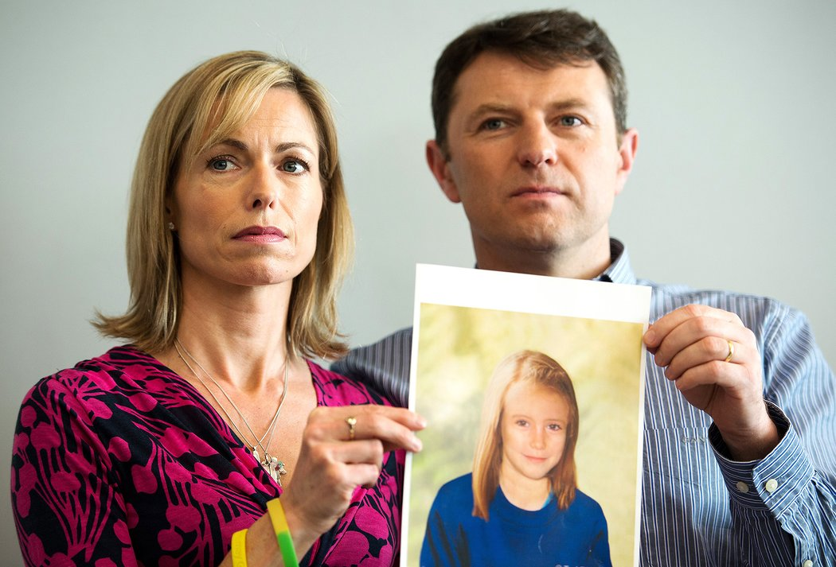

Kate and Gerry McCann

LEON NEAL/AFP/Getty

Was Madeleine Sold Into a Trafficking Ring?

On May 3, 2007, Madeleine; her twin 2-year-old siblings, Sean and Amelie; and her parents were enjoying a family vacation at a Portugese resort called Praia da Luz.

Madeleine’s parents left their three kids asleep in their room so the couple could go to dinner with friends at a nearby tapas restaurant, a mere 80 yards away. They took turns checking on the three children every 20-30 minutes, but when Kate McCann went to check on the kids around 9:30 pm, the film says, she noticed an open window — and that Madeleine was missing from her bed.

<div class="inner-container"> <img src="https://peopledotcom.files.wordpress.com/2017/04/madeleine-mcann.jpg" alt="Madeleine McCann" title="Madeleine McCann"> </div>



Madeleine McCann

Everton FC,HO/AP Photo

Though the girl’s parents were an early target of suspicion, this subsided over the years.

The film advances the theory that Madeleine was abducted and potentially sold into a trafficking ring. Though it’s a disturbing idea, it’s one whose credibility is bolstered by the fact that Madeleine’s body was never found and there is scant evidence pointing elsewhere.

In the film, witnesses recount seeing a man carrying a small blond child in pajamas toward the beach shortly before Kate McCann returned to her room to discover her daughter missing.

Because Portugal provides easy access to numerous countries, it would have been relatively easy for traffickers to transport her. [The Telegraph](https://www.telegraph.co.uk/news/0/happened-madeleine-mccann-six-key-theories/) reports that witnesses reported seeing “suspicious characters” who may have been working as “spotters” at the resort, looking for children to abduct for these shady purposes.

• Want to keep up with the latest crime coverage? Click here to get breaking crime news, ongoing trial coverage and details of intriguing unsolved cases in the True Crime Newsletter.

In the film, a private investigator, [Julian Peribanez](https://twitter.com/jperibanez?lang=en), speculates that if Madeleine were abducted and sold into trafficking, she’d probably still be alive. Why? Because, as a white, young middle-class British girl, Peribanez says, “The value that Madeleine had was really high … If they took her it’s because they were going to get a lot of money.”

Since 2007, there have been more than 8,000 reported sightings of Madeleine across the globe, [the BBC reports](https://www.bbc.com/news/uk-36138504).

<div class="inner-container"> <img src="https://peopledotcom.files.wordpress.com/2019/03/madeleine-mccann-resort.jpg" alt="" title=""> </div>



Jeff J Mitchell/Getty

Family Opposed Series

Madeleine’s parents did not participate in the new Netflix series, instead releasing the following statement [on their website](http://findmadeleine.com/updates/index.html): “We did not see … how this programme will help the search for Madeleine and, particularly given there is an active police investigation, it could potentially hinder it.”

Though the McCanns’ spokesperson has also expressed skepticism about the series, in a recent appearance on This Morning he said the family remains hopeful that Madeleine will return home soon.

“[Kate and Gerry McCann] have always believed that … she could still be alive and that’s what keeps them going to this day,” he said, [per MSN](https://www.msn.com/en-gb/news/newsmanchester/mccanns-spokesman-brands-madeleine-netflix-documentary-nonsense-on-this-morning/ar-BBUOP3u). “There is no evidence that she’s come to any physical harm whatsoever and until somebody absolutely sits them down and says they have the worst possible news for them, and the evidence, then they have to keep going.”

If you have any information about Madeleine McCann’s whereabouts, please send an email to investigation@findmadeleine.com, or call the official investigation line at +44 845 838 4699.

By [Laura Barcella](https://people.com/author/laura-barcella/)

**UNITED**

https://www.thesun.co.uk/news/8653012/madeleine-mccann-parents-kate-gerry-still-together/

**Are Madeleine McCann’s parents Kate and Gerry still married 12 years after she went missing?**

The couple had been wed for nine years when their daughter vanished in May 2007

* **By Dan Hall**

**By Dan Hall**

* Invalid Date,

MADELEINE McCann's parents have never stopped searching for their little girl ever since she went missing 12 years ago in Portugal.

But are Kate and Gerry McCann still together after the ordeal? Here's what we know.

[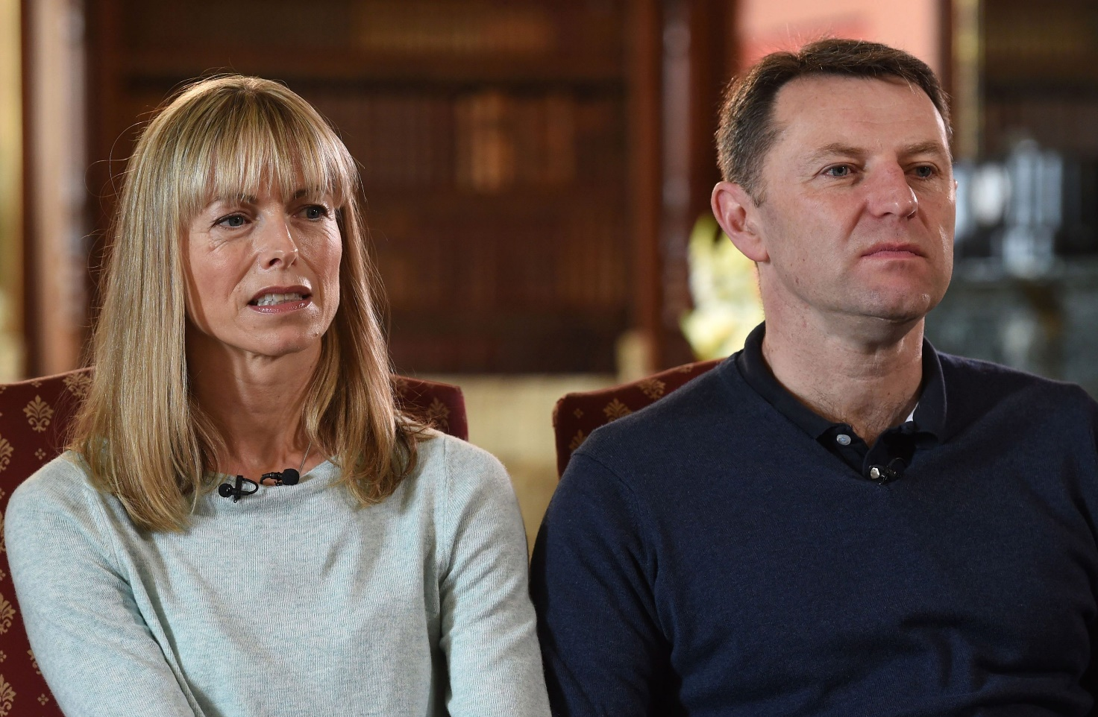](https://www.thesun.co.uk/news/8653012/madeleine-mccann-parents-kate-gerry-still-together/)

Press Association

3

Kate and Gerry McCann being interviewed 10 years after their daughter Madeleine McCann went missing

**Who are Kate and Gerry McCann?**

Madeleine's parents [Kate](https://www.thesun.co.uk/who/kate-mccann/) and [Gerry](https://www.thesun.co.uk/who/gerry-mccann/) are both practising Catholics who met in Glasgow in 1993.

Kate became a GP after studying medicine at the University of Dundee while Gerry has been a consultant cardiologist since 2005.

The couple got married in 1998 before having their first child, Madeleine, in 2003.

They also have twin children, a boy and a girl, who were born in 2005 and live in Rothley, Leicestershire.

Kate and Gerry had been married for nine years when Madeleine disappeared on the night of May 3, 2007.

[](https://www.thesun.co.uk/news/8653012/madeleine-mccann-parents-kate-gerry-still-together/)

Press Association

3

Madeleine McCann disappeared on May 3, 2007, and her whereabouts still remains unknown

**Are they still together?**

Shortly after [Madeleine](https://www.thesun.co.uk/who/madeleine-mccann/) vanished, Kate said their marriage nearly broke down as she withdrew into herself.

She stopped reading, playing music or even having sex with her husband Gerry.

And the couple were gripped by the fear that a paedophile may have taken their daughter.

Writing about that period in her autobiography, Kate said: "Tortured as I was by these images, it's not surprising that even the thought of sex repulsed me.

"I worried about Gerry and me. I worried that if I didn't get our sex life on track our whole relationship would break down."

Kate went on to credit Gerry's understanding and the couple's resilience for the endurance of their marriage.

[They remain together to this day](https://www.thesun.co.uk/news/3428293/who-madeleine-mccann-parents-gerry-kate-brothers-sisters/), despite the stresses of intense media scrutiny on their lives.

[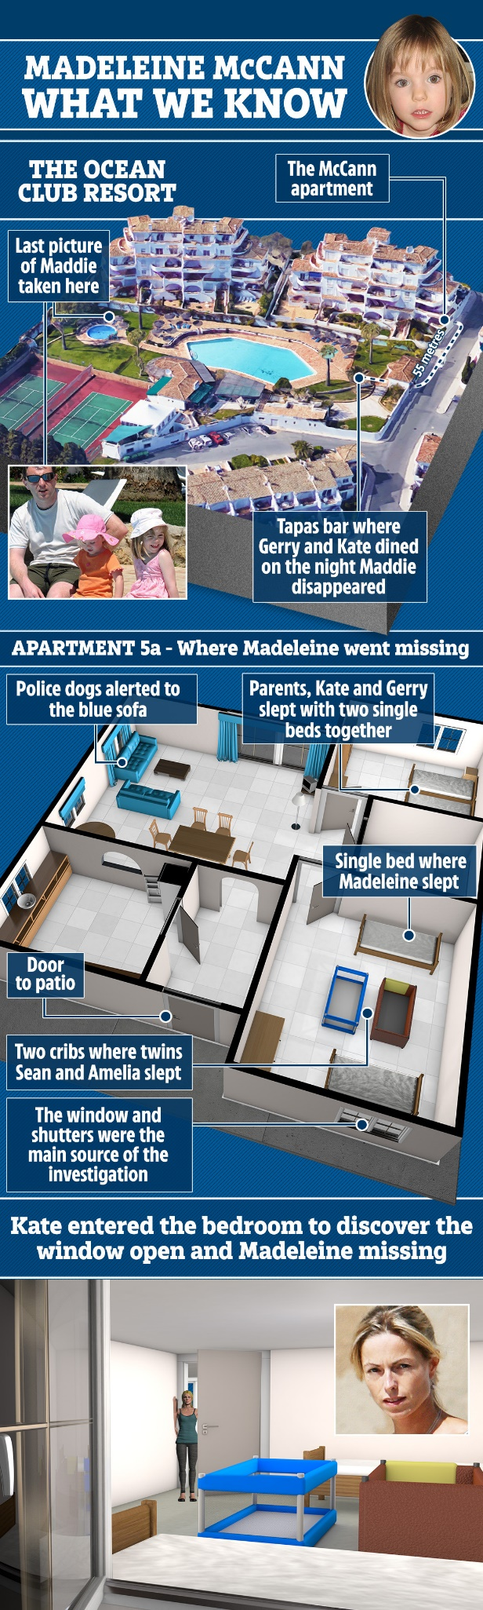](https://www.thesun.co.uk/news/8653012/madeleine-mccann-parents-kate-gerry-still-together/)

3

**Why did they become the centre of scrutiny?**

When three-year-old [Maddie](https://www.thesun.co.uk/news/2238940/madeleine-mccann-investigation-latest-theories/) vanished from the family's [Pria da Luz](https://www.thesun.co.uk/news/8640677/where-praia-da-luz-holiday-madeleine-mccann/) holiday apartment on the Algarve, [Gerry and Kate](https://www.thesun.co.uk/news/3428293/who-madeleine-mccann-parents-gerry-kate-brothers-sisters/) were dining with friends in a nearby restaurant.

Within 24 hours of their [child's disappearance](https://www.thesun.co.uk/news/8650740/url-madeleine-mccann-netflix-documentary-blood-praia-da-luz/), they held a press conference to make the first in a string of public appeals [to help find Madeleine](https://www.thesun.co.uk/news/3435619/what-madeleine-mccann-cuddle-cat-important-portugal-investigation/).

In the intervening years, the couple have constantly kept [the search alive for their daughter](https://www.thesun.co.uk/news/3419009/madeleine-mccann-sightings-around-world-missing-children/).

Over the course of the investigation, they have both been considered "persons of interest".

[A Netflix documentary](https://www.thesun.co.uk/tvandshowbiz/8555309/madeleine-mccann-netflix-documentary-release-parents/) released in March 2019 called The Disappearance of Madeleine McCann is drawing the couple back into public attention, despite their refusal to be involved in or with [the film](https://www.thesun.co.uk/news/8635511/madeleine-mccann-netflix-documentary-trailer-first-look/).

**What is the latest?**

Operation Grange -the Scotland Yard investigation into Madeleine's disappearance - is still continuing.

It began in 2011 and so far it has cost nearly £12million with the continued funding coming from Special Grant funding, which is available to forces that face exceptional costs.

Operation Grange is run from a Met Police branch station in Putney, South West London and is staffed by five officers.

Metropolitan Police chief Cressida Dick confirmed on May 3, 2019, that [the force had applied for more money](https://www.thesun.co.uk/news/8989738/madeleine-mccann-cash-request/) from the Home Office to continue its Operation Grange [search for Maddie](https://www.thesun.co.uk/who/madeleine-mccann/).

Dick said: "We have [active lines of inquiries](https://www.thesun.co.uk/news/8968146/madeleine-mccann-cops-new-clue-suspect/) and I think the public would expect us to see those through.

"A very small team continues to work on this case with Portuguese colleagues and we have put in an application to the Home Office for further funding."

Gerry and Kate [thanked supporters](https://www.thesun.co.uk/news/8930368/madeleine-mccann-gerry-kate-thank-supporters-anniversary/) for "continuing to have hope" ahead of the 12th anniversary of their daughter’s disappearance on May 3.

However, Kate and Gerry have said that the latest images to emerge of [Maddie's age progression are bogus.](https://www.thesun.co.uk/news/8968032/madeleine-mccann-age-progression-instagram-pictures-kate-gerry/)

A revamped Facebook page, run on behalf of Kate and Gerry, has posted a new message stating: "Thank you for continuing to have hope and helping us in the search for Madeleine."

The couple will remember Maddie, who vanished as a three-year-old during a family holiday in Portugal in May 2007, during a poignant outdoor prayer service in their home village .

On May 3, 2019, it emerged that Portuguese police were [hunting a sex fiend who speaks English](https://www.thesun.co.uk/news/8996784/madeleine-mccann-suspect-paedophile-portugal-mask-daddy-holiday-home/) and wears a surgical mask in relation to Maddie's suspected kidnapping.

In one of his previous cases, he broke into a British family's home and loomed over a seven-year-old girl who woke up and asked "Is that you Daddy?" and he replied "Yes" in a foreign accent, author Anthony Summers said in the Netflix doc.

**Madeleine McCann June 2020**

<https://www.bbc.com/news/uk-52914016>

**Madeleine McCann: German prisoner identified as suspect**

* [**Madeleine McCann disappearance**](https://www.bbc.com/news/topics/c8255n4mp88t/madeleine-mccann-disappearance)

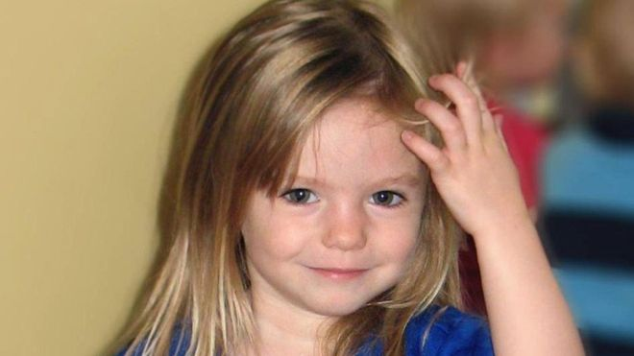Image copyrightPA MEDIAImage captionPolice have been searching for Madeleine McCann for over 13 years

**A 43-year-old German prisoner who travelled around Portugal in a camper van is now the focus of Scotland Yard's investigation into the disappearance of Madeleine McCann 13 years ago.**

Police believe he was in the area where the little girl, then aged three, was last seen in May 2007.

They are appealing for information about the van and the suspect's other vehicle, a Jaguar.

The man transferred it to someone else's name the day after she vanished.

"Someone out there knows a lot more than they're letting on," said DCI Mark Cranwell, who is leading the Met inquiry.

Madeleine went missing from an apartment on a Portuguese holiday resort on the evening of 3 May 2007, while her parents were with friends at a nearby tapas bar. The most recent Met Police investigation, which began in 2011, has cost more than £11m.

The force said it remained a "missing persons" investigation because it doesn't have "definitive evidence" as to whether Madeleine is alive or not.

* [**More funds pledged for Madeleine McCann search**](https://www.bbc.com/news/uk-48533619)
* [**McCanns mark 10 years without Madeleine**](https://www.bbc.com/news/uk-39757287)

Scotland Yard said the German authorities had taken the lead on this aspect of the case because the German suspect was in custody in their country.

Detectives said the suspect, who is not being named, was in jail for an "unrelated matter" and had "previous convictions", but they declined to supply more details.

**'Critical' information**

An appeal on German television was broadcast this evening at 19:15 BST.

DCI Cranwell said the prisoner, then aged 30, frequented the Algarve between 1995 and 2007, staying for "days upon end" in his camper van and living a "transient lifestyle".

He was in the Praia de Luz area where the McCann family was staying when she disappeared and received a phone call at 7.32pm, which ended at 8.02pm.

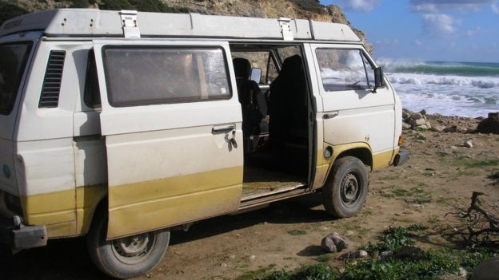Image copyrightMET POLICE HANDOUTImage captionA camper van belonging to the suspect was seen around Praia da Luz in Portugal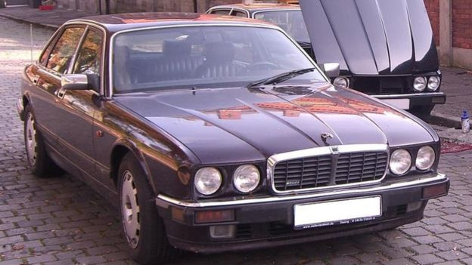Image copyrightMET POLICE HANDOUTImage captionThe suspect transferred the registration of this 1993 Jaguar XJR6 to someone else the day after Madeleine disappeared

Police have released details of the suspect's phone number and the number he dialled saying any information about them could be "critical" to the inquiry.

They also want the person who called the suspect to come forward.

"They're a key witness and we urge them to get in touch," said DCI Cranwell.

"Some people will know the man we're describing today... you may be aware of some of the things he's done," he said.

"He may have confided in you about the disappearance of Madeleine.

"More than 13 years have passed and your loyalties may have changed," he added.

"Now is the time to come forward."

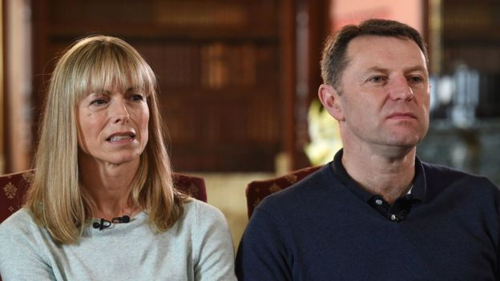Image copyrightPA MEDIAImage captionKate and Gerry McCann, pictured in 2017, said they would never give up hope

Police said the suspect was one of 600 people that detectives on the inquiry, known as Operation Grange, originally looked at, though he had not been a suspect.

After an appeal in 2017, "significant" fresh information about him was provided.

Since then, Met detectives have carried out "extensive inquiries" in Portugal and Germany in order to gather more details about him.

Scotland Yard said they were trying to "prove or disprove" his involvement in the case and retained an "open mind".

**3 links from 2020-21**

[Madeleine McCann prime suspect sexually abused five-year-old girl: report (nypost.com)](https://nypost.com/2020/08/16/madeleine-mccann-prime-suspect-sexually-abused-five-year-old-girl-report/)

[Madeleine McCann: Witness claims she is alive and speaking German | Metro News](https://metro.co.uk/2020/07/25/witness-claims-madeleine-mccann-alive-living-german-family-13036403/)

From 2021

[Madeleine McCann - Latest news updates, pictures, video, reaction - The Mirror](https://www.mirror.co.uk/all-about/madeleine-mccann)



Media captionDet Chief Inspector Mark Cranwell: "He could have looked somewhere between 25 and 32"Presentational grey line

**The Madeleine McCann case: a timeline**

* **3 May 2007:**Alarm is raised after Madeleine is found to be missing
* **September 2007**: Kate and Gerry McCann are made "arguidos" - formal suspects - in their daughter's disappearance
* **July 2008**: Portuguese police halt their investigation and lift the "arguido" status of the McCanns and another man, Robert Murat
* **May 2011:** Prime Minister David Cameron asks the Metropolitan Police [**to help investigate**](https://www.bbc.co.uk/news/uk-13395885). A two-year review follows
* **March 2012:** Portuguese police [**launch a review**](https://www.bbc.co.uk/news/uk-england-leicestershire-17414919) of the original investigation
* **July 2013**: Scotland Yard says it has "new evidence and new witnesses" in the case and [**opens a formal investigation**](https://www.bbc.co.uk/news/uk-23179230) into Madeleine's disappearance
* **October 2013**: Detectives in Portugal reopen the investigation, citing "new lines of inquiry"
* **January 2014**: British detectives fly to Portugal amid claims they are planning to make arrests
* **December 2014**: Detectives question 11 people who it was thought may have information on the case
* **September 2015**: The British government discloses that the investigation has cost more than £10m
* **February 2017**: Portugal's Supreme Court [**dismisses a long-running libel case**](https://www.bbc.co.uk/news/uk-38836473) against Goncalo Amaral, former head of the local police investigation, ruling that his book, which alleged the McCanns disposed of Madeleine's body, is protected by freedom of expression laws
* **April 2017**: The only four official suspects investigated by police are ruled out of the investigation but senior officers say they are pursuing a "[**significant line of inquiry**](https://www.bbc.co.uk/news/uk-39706194)"
* **November 2018**: An extra £150,000 [**is granted to continue**](https://www.bbc.co.uk/news/uk-46196238) the investigation. It is the latest in a series of six-month extensions which take the cost of Operation Grange to an estimated £11.75m
* **March 2019**: Netflix screens an eight-part documentary about Madeleine's disappearance. Her parents, who did not participate in the film, feel it could [**"potentially hinder" the police investigation**](https://www.bbc.co.uk/news/uk-england-leicestershire-47481747)
* **June 2019**: The UK government says it will [**fund the Met Police inquiry**](https://www.bbc.co.uk/news/uk-48533619), which began in 2011, until March 2020
* **June 2020**: Police reveal that a 43-year-old German prisoner has been identified as a suspect in Madeleine's disappearance

[Madeleine McCann: German police say objects analysed after Portugal search - BBC News](https://www.bbc.com/news/uk-65774844)

[**Madeleine McCann: German police say objects analysed after Portugal search - BBC News**](https://www.bbc.com/news/uk-65774844)

5 June 2023

# **Madeleine McCann: German police say objects analysed after Portugal search**

**Related Topics**

* [**Madeleine McCann disappearance**](https://www.bbc.com/news/topics/c8255n4mp88t)

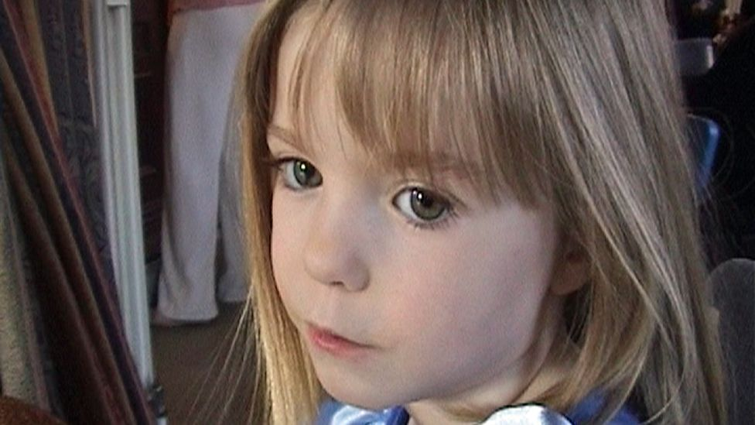

Madeleine McCann was three when she went missing in 2007

**By Rachel Russell**

BBC News

**Several objects were found during a search of a Portuguese reservoir in connection with the disappearance of Madeleine McCann, German officials say.**

It was too early to confirm whether the items, which are being analysed, are connected to the missing Briton, Braunschweig prosecutors added.

Portuguese police helped by their German counterparts, searched the Arade reservoir in Portugal last week.

Madeleine disappeared from a holiday complex in the Algarve in May 2007.

Police say their investigation into 46-year-old German national Christian Brueckner, who has been named as an "arguido" or official suspect, is expected to continue for some time.

Media caption,

Watch: The BBC's Daniel Sandford was at the reservoir in Portugal after the police search ended

Christian Wolters, prosecutor for the city of Braunschweig, said the items found in Portugal would be examined over the coming weeks.

"We thank all officers who participated in the search. The co-operation between the Portuguese police, the British officers and the German federal police was outstanding and very constructive," he added.

Heavy machinery, sniffer dogs and pickaxes were used during the three-day search - which came at the request of German investigators who believe convicted sex offender Brueckner is the prime suspect in her disappearance.

He is currently serving a prison sentence in Germany for the 2005 rape of a woman on the Algarve. Brueckner lived in the region between 1995 and 2007, say police.

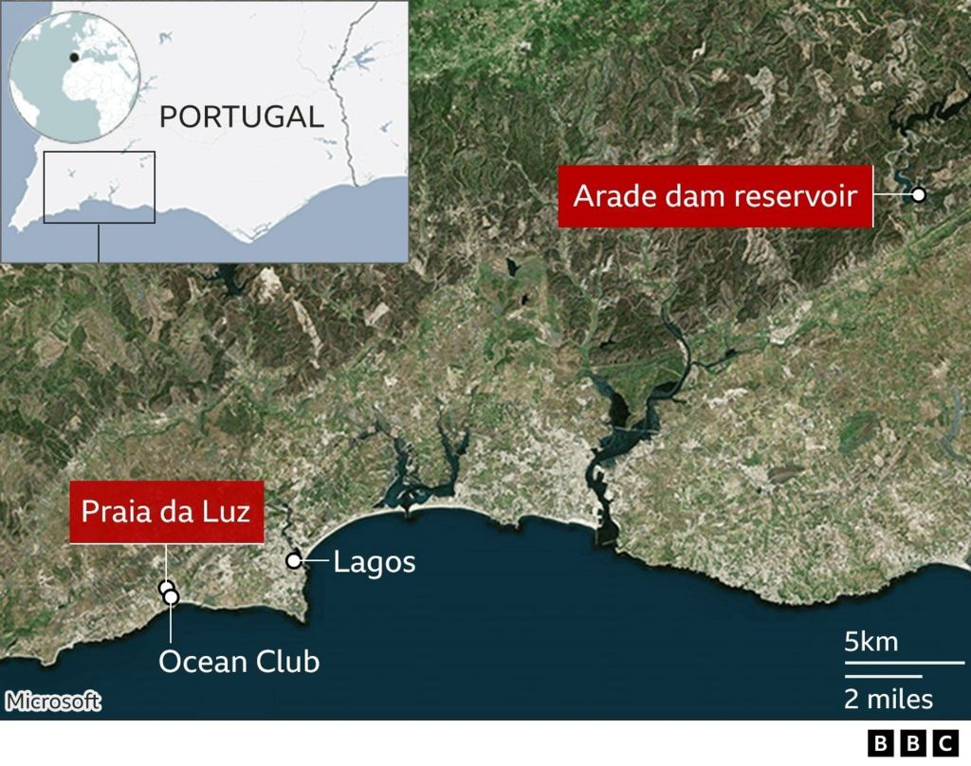

The Arade lake is 31 miles (50km) from where Madeleine went missing while on holiday with her family in Praia da Luz.

Brueckner is thought to have often travelled in his Volkswagen T3 camper van to the reservoir - which is known to have been used as an unofficial camping spot.

The German denies any involvement in Madeleine's disappearance, saying he was "miles away" at the time.

Madeleine was three-years-old when she vanished from the holiday complex where she had been on holiday with her parents Kate and Gerry McCann on 3 May 2007.

They left her and her younger twin siblings asleep in their apartment while they went out to dinner with friends.

Last month, the McCann family marked the 16th anniversary of Madeleine's disappearance, saying she is "still very much missed" and they "await a breakthrough".

**Florida girl, 11, fights off knife-wielding kidnapper**

[Florida girl, 11, fights off knife-wielding kidnapper - BBC News](https://www.bbc.com/news/av/world-us-canada-57178775) = link

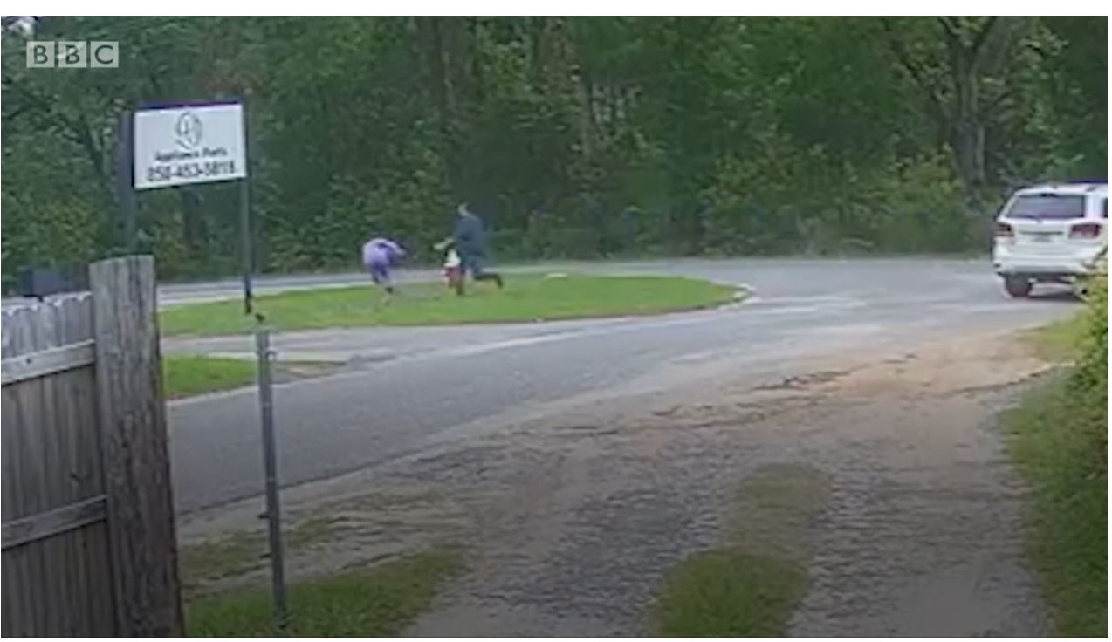

* 20 May 2021
* Florida girl, 11, fights off knife-wielding kidnapperClose
* Surveillance footage captured the attack in West Pensacola, Florida. The girl was waiting for her school bus when a man approached with a knife and attempted to drag her into his vehicle.

**Woman fights off kidnapper**

[Moment New York mum saves five-year-old from kidnap - BBC News](https://www.bbc.com/news/av/world-us-canada-57877269)

* [Moment New York mum saves five-year-old from kidnap - BBC News](https://www.bbc.com/news/av/world-us-canada-57877269)

**Missing girl meets her rescuer**

[Missing girl meets her rescuer again decades later - BBC News](https://www.bbc.com/news/av/world-australia-60129089) 2022

**Missing people FBI**

[Kidnappings & Missing Persons — FBI](https://www.fbi.gov/wanted/kidnap/)

Fred and Rose West documentary watch these after having read the next 29 pages (the gruesome details of…+ a horror story)

<https://www.youtube.com/watch?v=GzoVURPvdkk> (1½ minutes)

<https://www.youtube.com/watch?v=Wt2xI7W7lN4> (45 minutes)???

this link works:

[What Made Fred West a Notorious Serial Killer? (Crime Documentary) | Born To Kill | Real Stories - YouTube](https://www.youtube.com/watch?v=bY0PqtRsX_A)

the children’s story

<https://www.youtube.com/watch?v=iEajPZA1eII> (49 Minutes)

the details of their crimes

<https://en.wikipedia.org/wiki/Fred_West#:~:text=At%20least%20eight%20of%20these,the%20%22House%20of%20Horrors%22.>

Frederick and Rosemary West

<https://criminalminds.fandom.com/wiki/Fred_and_Rosemary_West>

<https://www.devonlive.com/news/celebs-tv/gruesome-details-fred-rose-west-2491388>rror Story

# **The gruesome details of Fred and Rose West murders in House of Horrors revealed**

At the time police uncovered a number of mutilated female bodies in the garden and cellar of their home, including two of their own children

Nederst på formularen

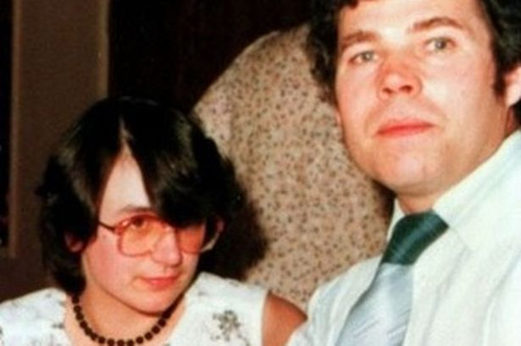**Rose and Fred West look like a normal middle aged couple to friends and neighbours.**

Øverst på formularen

Nederst på formularen

New details of Fred and Rose West and the House of Horrors will come to light in a new documentary which will air on TV tonight.

The ITV programme will see shocking allegations made by the couple's youngest son, Barry, who claims that his mother was 'actively involved' in Fred's murders.

It will also include the first television interview with the sisters of victim Juanita Mott, who vanished at the age of 18, in 1975.

Rose was born in Northam, North Devon, in November 1953. After a troubled childhood a 16 year old Rose fell in love with 28 year old Fred West.

The couple moved together to Gloucester at the beginning of the 1970s and so began more than a decade of sexual abuse and murder.

Fred West killed himself in HMP Birmingham while on remand accused of murdering 12 girls and women in 1995, [**reports Gloucestershire Live.**](https://www.gloucestershirelive.co.uk/news/gloucester-news/know-trevor-mcdonalds-documentary-fred-2479066)

Wife Rose, remains locked up at Low Newton prison in County Durham after being convicted of murdering 10 victims.

From 1967 to 1987, nine victims were buried at the House of Horrors on Cromwell Street, Gloucester.

To this day, West still denies her role in the murders but this latest documentary will indicate she shared the same violent tendencies as her husband.

Son Barry alleged when he was just seven-years-old, he heard his mother savagely attack Heather - one of the couple's 12 known victims.

### Here’s what we know so far about the documentary

### Sir Trevor's investigation

In Sir Trevor McDonald's new powerful ITV documentary, new evidence is set to come light about Rose's level of violence and claims that she could have been more violent than her husband.

While Fred confessed to the killings, Rose, now 65, denied them and still does.

Sir Trevor, 79, sets out to prove Rose was “not a bystander” and was "deeply involved" in the crimes.

"In any normal situation you would think that a wife's influence would curb Fred's horrific tendencies but we learn that she was actively involved,” he says in the Daily Star Sunday.

"When they cruised around to pick up people, she was the one who probably convinced the girls to get in the car."

### The family

The Wests' youngest son will tell Sir Trevor McDonald that he heard Rose attacking his murdered sister Heather.

He and several other siblings were all taken into care in 1992 after the Wests were accused of sexual abuse.

He will say when he was seven years old when his mother “stamped” on Heather’s head five times.

According to the Daily Star he adds: “She didn’t move again.”

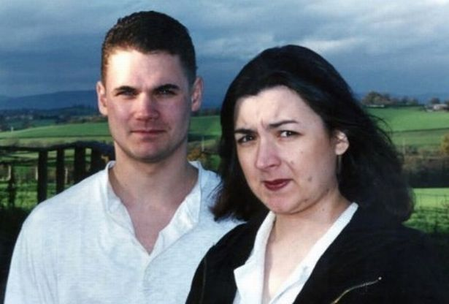

### The victims

The documentary will also include the first television interview with the sisters of victim Juanita Mott, who vanished, aged 18, in 1975.

The daughter of an American serviceman whose parents split up when she was very young, she left both school and home at age 15 and at some point lodged with the Wests.

When she was 18 she accepted a lift from them and her remains were unearthed at 25 Cromwelll Street in 1994.

At the time police uncovered a number of mutilated female bodies in the garden and cellar of their home, including two of their own children.

Most of Fred and Rose West's victims were subjected to rape and other forms of sexual torture before they died.

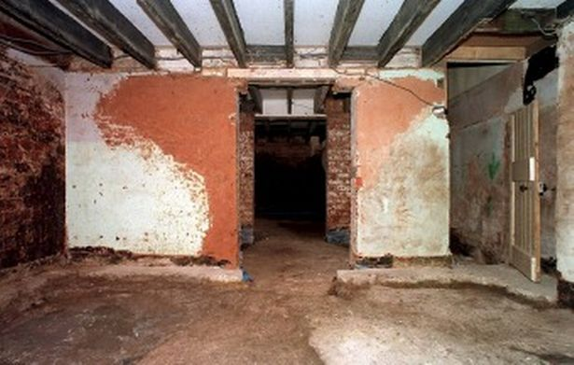The lodger

Former lodger Jayne Hamer told Sir Trevor she feels lucky to be alive after hearing screams from the cellar.

Nanny Caroline Owens, who also escaped after being kidnapped and tortured, has since died.

### The social worker

John Fitzgerald, the senior social worker investigating childcare issues in the case, will tell viewers how the Wests got away with it for so long.

### The lawyer

Sasha Wass QC will give her first media interview since she helped defend Rose in court.

### Who are Fred and Rose West?

Rose became a sex abuser at 13, a murderer at 17 and a fully fledged serial killer while still in her teens.

According to research by criminologist Jane Carter Woodrow it was her insatiable sexual sadism that spurred on the murder spree, with Fred actually following Rose’s lead.

Rose, now 65, is locked up for life for the murders of 10 women, including her own daughter Heather, 16, and step-daughter Charmaine, eight.

Husband Fred, who had also killed his ex-wife Rena and mistress Anna McFall, hanged himself in his prison cell in 1995, aged 53, before he could stand trial.

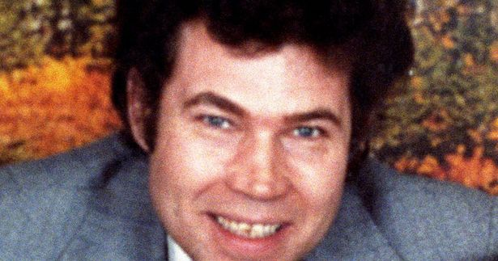

In her book, Rose West, The Making of a Monster, Jane reveals: “This case remains the stuff of our worst nightmares – revealing the depths of depravity and suffering that humankind is capable of inflicting on one another.

“Pictures showed a friendly, middle-aged couple. But Rose and Fred West are the smiling assassins whose names were to become forever linked with evil.

“Based on the fact that men are almost always the dominant partner in serial-killer relationships, many people believed Rose would surely have been, at worse, complicit under coercion, possibly covering for her husband who carried out the murders. But this wasn’t the case.

“Rose was not simply an unsuspecting wife and victim of Fred as she maintained at her trial, but a primary player.”

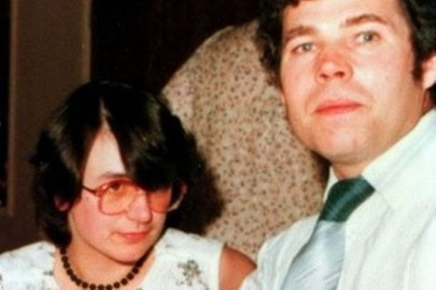

Jane discovered that Rose’s mentally ill mother, Daisy, suffered a severe breakdown in 1953, and underwent gruelling electric shock treatment – while pregnant with Rose.

She writes: “Daisy was given a course of electroconvulsive therapy. A surge of electricity into the brain makes the patient black out and have convulsions.

“Despite her pregnancy, the psychiatrist continued her treatment. This meant as Rose lay in her mother’s womb Daisy had more shocks blasted to her brain, sending convulsions through her body, the last one just days before Rose was born. There has been little research on the use of ECT with pregnant patients, and expert opinion is divided, but given the damage ECT can do to the patient it seems unlikely the foetus would remain unaffected.

“When Rose came home everyone commented on how beautiful the new baby was but noticed her strange ­behaviour. She rocked her head for hours on end and the older children complained as she rhythmically bashed her head against the cot at night.

“As she got older she continued to swing her head for long periods of time, inducing a trance-like state. At other times her eyes were said to look vacant and lost in her own world.

“The kind of behaviour Rose exhibited can be indicative of learning difficulties. They might even be linked to the ECT treatment, but no one knows for sure. But Rose and her siblings had two mentally ill parents whose behaviour shaped their childhood and development.”

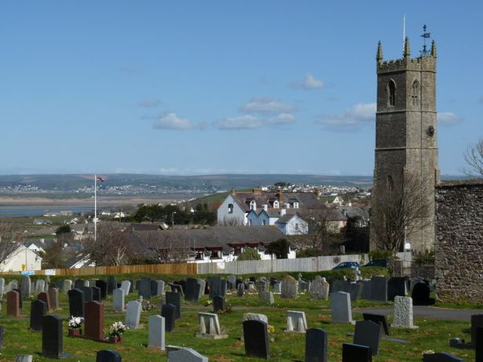

(Image: A Smith

Rose’s father, Bill Letts, was a paranoid schizophrenic who became a cruel and sadistic bully who beat and tortured his family. He began sexually grooming Rose but, because this meant she escaped his beatings, she saw it as a warped form of love. By the age of 13, Rose was sexually abusing her two younger brothers too.

In the book Jane writes: “Rose in her formative years would have grown up believing her father’s behaviour was normal but she was being coached by Bill to share secrets with him that no child should. When she became bored with her sexual explorations of her brothers, and possibly even Bill, she began testing her powers further afield.

“Clearly, this was not the behaviour of a normal 13-year-old girl – this was a girl who had been highly sexualised.

“With this background it isn’t surprising that two years later when Rose met Fred West at a bus stop in Cheltenham there was an instant attraction. They believed they were made for one another.

“Her warped and brutal childhood experiences meant that once she met ‘Weird Freddie’, 12 years her senior, she would find his behaviour neither abhorrent nor strange. She felt comfortable and even excited by him.

“Both Rose and Fred shared depraved backgrounds and that explains why they felt drawn together. Fred wasn’t very good at sex and preferred the role of voyeur.

“He wanted to observe his young girlfriend with other men and introduced Rose to sado-masochism. They began to develop sex games which would later become their modus operandi inflicted on their victims. Despite her father’s furious objection, Rose, 15, moved in with her lover and acted as housewife and carer to his two young girls, Charmaine, then six, and Anne-Marie, five.

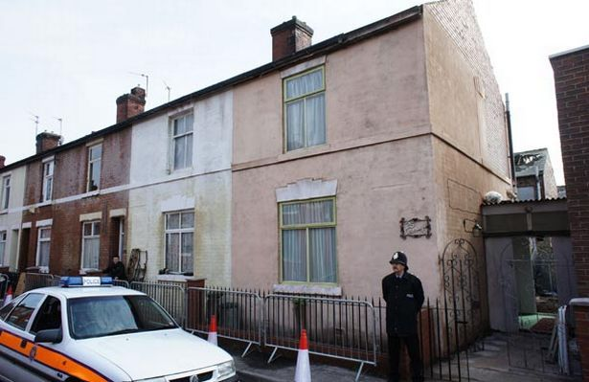

“Fred was abusing the older of the girls and both were exhibiting symptoms of disturbed behaviour that made it even harder for Rose (disturbed herself) to care for them. She would strip the girls and tie them to their beds where they were not allowed to speak or make a sound.

“If she heard them talking in bed at night she would beat them across the legs with a leather strap. She also began to gag them with ripped-up sheets or strips of sticky tape so they wouldn’t be heard by the neighbours should they cry out.”

**TIME LINE**

## Rose West- From Devon schoolgirl to serial killer

### November 1952 - Rosemary Pauline Letts born

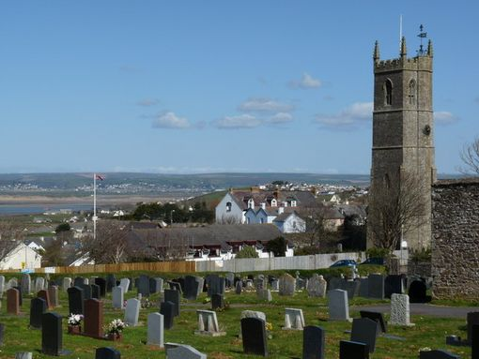

Rosemary Pauline Letts was born on November 29, 1952, in Northam, North Devon.

### 1969 - 15 year old Rose begins dating Fred West

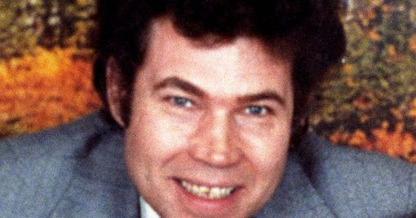

A teenage Rose begins to date 28 year old Fred West after moving to Bishop's Cleeve, near Cheltenham.

76659595577

### 1970 - Rose becomes pregnant by Fred West



In 1970 after Rose fell pregnant the pair moved from Bishop's Cleeve to Midland Road in Gloucester.

### 1972 - Fred and Rose get married.



Fred and Rose married in 1972.

### Early 1970s - Rose works as a prostitute



Fred West would often watch Rose as she slept with customers and it is believed this is when Rose and Fred started to sexually abuse Fred's eight year old stepdaughter Anne Marie.

### June 1971 - Rose murders Fred's daughter

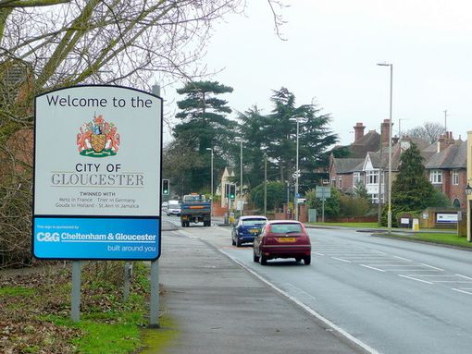

It is believed Rose West murdered her stepdaughter Charmain West at their home in Gloucester in June 1971 while Fred languished in jail for stealing car tyres. When Fred was released later in June he buried his daughter's body.

### January 1973 - Fred and Rose convicted of sexual assault



The pair were fined for indecently assaulting Caroline Roberts, who escaped the couple's home after being attacked and reported them to the police.

### June 1987 - Rose and Fred murder their daughter

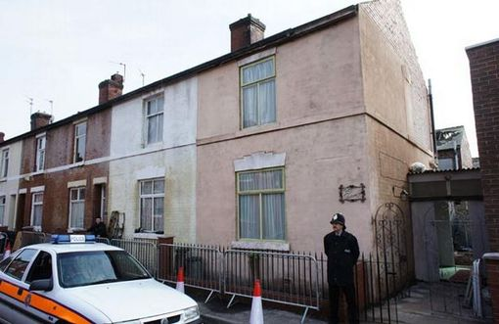

Heather West, 16, was murdered at the family home in Gloucester in June 1987 after being abused by her family all her life.

### August 1992 - Fred and Rose arrested



Fred was arrested for raping his 13 year old daughter three times and Rose was arrested for child cruelty but the case against them collapsed in June 1993. However the failed conviction sparked a much larger investigation.

### Spring 1994 - Fred kills himself and Rose faces 10 murder charges



In the spring of 1994 both Fred and Rose were arrested. While on remand Fred hung himself at Winson Green Prison in Birmingham. Rose went on trial at Winchester Crown Court in October.

### November 1995 - Rose found guilty of 10 murders

On November 22, 1995, Rose West was found guilty of 10 murders. Judge Justice Mantell sentenced her to life in prison, telling her "If attention is paid to what I think, you will never be released".

### March 1996 - Appeal refused

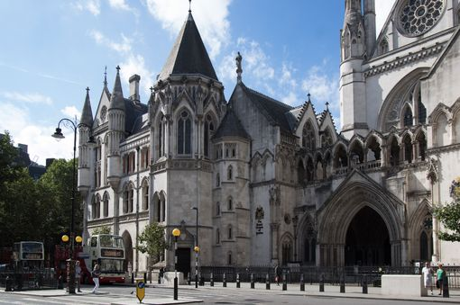

Rose immediately lodged an appeal after her conviction alleging her husband had committed all the murders on his own. On March 18, 1996, the Court of Appeal refused to consider her application for an appeal.

### July 1997 - 25 year "life sentence" becomes "whole life" sentence

In July 1997 Home Secretary Jack Straw changed Rose West's 25 year life sentence to a whole life sentence. This was the second time such a sentence had been imposed. The first time was for serial killer Myra Hindley.

### November 2017 - Reports Rose West is seriously ill

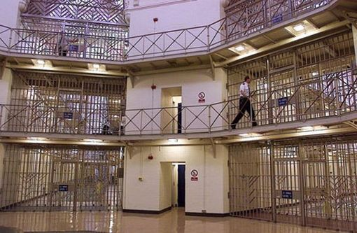

This week there have been reports West is undergoing medical treatment at HMP Low Newton in Durham.

In 1971 Fred West was jailed for nine months for theft and Rose was left alone with his two daughters and their own baby daughter, Heather.

Before his release Rose killed Charmaine, her first victim, after flying into one of her uncontrollable rages, and hid her body. In the book, which contains graphic descriptions of torture and murder, Jane asks: “Having killed Fred’s little girl why didn’t she run away? The most plausible reason for her waiting for Fred to come home and deal with it was because she already knew he had killed too.

“He’d either confided in Rose his most grisly secrets or she herself had found out that four years earlier Fred had killed his mistress, Anna McFall, 18, who was pregnant with his child.

“West did not want his then-wife Rena Costello to find out about his affair and killed Anna as soon as she became a nuisance and buried the remains in a field.

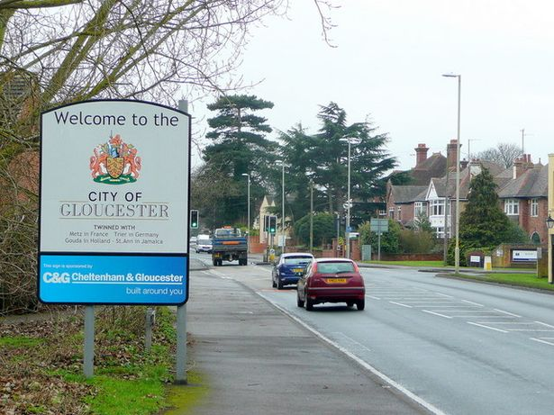

“This was only the start of a depraved reign of murder and sexual terror that was to last almost 20 years as he and Rose helped one another fulfil their perverted fantasies.

“Rose and Fred were narcissistic, psychopathic and had antisocial personality traits. They were also pathological liars. The fact that two such people should meet in a lifetime was highly unlikely but, if they did, it was always going to be a recipe for disaster.

“Having been introduced to sexual sadism, Rose took to it willingly because she saw a way of getting her own back over young women and began exceeding even Fred in cruelty.

“Had she not met Fred it is unlikely Rose would have become a serial killer but as Det Supt John Bennett, who led the investigation, said recently, ‘The whole case was about Rosemary being sexually insatiable. There were huge quantities of pornographic material and sex objects in the house. I firmly believe Rose murdered the girls and Fred disposed of the bodies.’”



In February 1994 police began excavating the garden and patio of Rose and Fred’s home at 25 Cromwell Street, Gloucester. Ten of their victims were found, revealing macabre and horrific evidence of what had happened to the women before their deaths.

All the bodies had been dissected and trophies kept of fingers, toes, kneecaps and other body parts, which to this day have never been found.

Soon after, the remains of Rena Costello and Anna McFall were found nearby.

In October 1995 Rose was found guilty of 10 murders: Lynda Gough, 19; Carol Ann Cooper, 15; Lucy Partington, 21; Therese Siegenthaler, 21; Shirley Hubbard, 15; Juanita Mott, 18; Alison Chambers, 16; Shirley Robinson, 18, step-daughter Charmaine West, eight and daughter Heather West, 16.

Three of the women had been lodgers and the rest were abducted.

**Fred and Rose West: The Real Story with Sir Trevor McDonald airs on Thursday, January 31 at 9pm on ITV.**

**A horror story**

<https://www.city-journal.org/html/horror-story-12312.html>

**A Horror Story**

FROM THE MAGAZINE

## A Horror Story

[Theodore Dalrymple](https://www.city-journal.org/contributor/theodore-dalrymple_44)

[Spring 1996](https://www.city-journal.org/magazine?issue=32)

Public safety

**I**n the psychotherapeutic worldview to which all good liberals subscribe, there is no evil, only victimhood. The robber and the robbed, the murderer and the murdered, are alike the victims of circumstance, united by the events that overtook them. Future generations (I hope) will find it curious how, in the century of Stalin and Hitler, we have been so eager to deny man’s capacity for evil. Every now and again, however, a case arises that stirs a faint memory of this capacity—forgotten soon afterward.

The case of Frederick and Rosemary West is an example of this phenomenon. It began with public levity, passed through a brief stage of appalled disgust, and is now principally a commercial opportunity for publishers and tour operators. But rightly considered, it reminds us of what men are capable, once all restraints are removed; and because the Wests’ crimes were so much worse than can be explained by their personal circumstances, the case reminds us also of what should be obvious, but alas is not, that no conceivable perfection of society will ever render redundant all external restraints upon human conduct.

As soon as the police had dug up the first human remains in the backyard of Number 25, Cromwell Street, Gloucester, in February 1994, bookmakers all over the country started to take bets on how many bodies would eventually be found there. There is nothing that lifts English national morale as effectively as a really gruesome murder, and murders do not come any more gruesome than those that took place on Cromwell Street.

In the end, nine sets of human remains were uncovered at that address, including those of the daughter of the proud houseowners, Mr. Frederick and Mrs. Rosemary West (born in 1943 and 1953, respectively). The remains of their stepdaughter were found at their previous address, Number 25, Midland Road, Gloucester, while those of Mr. West’s first wife, Rena, and those of one of his mistresses—pregnant at the time of her demise—were discovered in two fields near Mr. West's birthplace, the picturesquely named village of Much Marcle. As Agatha Christie once so perceptively remarked, there is a deal of wickedness in an English village.

Before he hanged himself on New Year's Day 1994, in Winson Green Prison, Birmingham, Mr. West confessed to a confidante—who has since been offered more than $150,000 to relay the confidences, as yet unpublished, to a newspaper—that he had killed at least 20 others. It is difficult, however, to place much credence in his confession, for Fred was never very good at figures and, according to members of his family, could never remember exactly how many children he had, or their names. I have heard a rumor that the true number of his victims was nearer to 60 than 20. Admittedly, the bearer of the rumor was a man with reason to be nervous: he was a doctor whose office extension had recently been completed by Fred, a small-time builder. Fred had obligingly offered to prepare the foundations for the extension while the doctor was away on vacation: a thoughtfulness that, in retrospect, may have been motivated by more than a mere desire to spare the doctor the noise that building works inevitably entail.

Another acquaintance of mine turned down Fred's offer to build him a conservatory: the builder's manner put him off. Indeed, there was something distinctly odd about the murderer's appearance: he looked like an intermediate stage in the transformation of man into werewolf. Extremely hirsute, he was short and had a limp from an early motorbike accident; he had the traditional bad teeth of the English working class, but his eyes glittered brightly, and there is no doubt that, despite his poor education, bucolic accent, and limited vocabulary, he was able to exert a hypnotic charm over susceptible and inexperienced young women.

Rosemary's appearance was rather more ordinary. She put on weight early and looked matronly before her time. There was nothing in her face or bearing that suggested a voracious sexual appetite or uncontrolled sadism. While she was in prison awaiting trial, she looked every bit the fond grandmother who knitted socks for her grandchildren.

It is unlikely we shall ever know for certain how many lives Fred and Rose cut short: an entire county would have to be dug up, and since the relatively limited excavations so far undertaken by the police, comprising 200 square yards at most, have already cost $2.25 million, a really thorough investigation would bankrupt the nation. Whatever the true number of victims, the Gloucester of the Wests is now as firmly etched onto the national consciousness as the Whitechapel of Jack the Ripper. Rose’s trial monopolized the attention of the public as 0. J. Simpson's trial had done in America, though only through the medium of the press: cameras (quite rightly) not being allowed in British courtrooms, to preserve whatever little remains of the majesty of the law.

Gloucester is a small cathedral city of about 100,000, where the city council has conclusively demonstrated that with the right combination of 1960s urban planning and an undiscriminating welfare policy, the degraded inner city conditions of much larger conurbations may be successfully reproduced in small country towns. The ancient but decayed medieval city center has been replaced almost in its entirety by concrete buildings that would have gladdened the hearts of another famous couple, the Ceausescus. As for Cromwell Street itself, once decent and even elegant nineteenth-century housing has degenerated into near-slum, where a shifting population of drifters rent dismal rooms by the week, and everything looks uncared for: the paint peels off the woodwork, the stucco crumbles, and litter-the packaging of junk food-flutters in the breeze. On the end wall of another terrace of houses nearby, a muralist has depicted the glorious march of the British masses from unemployment during the Depression to single parenthood in the nineties, headed by a Rastafarian with dreadlocks who holds aloft a banner saying “Give Us a Future”: by which is meant, according to the smaller banners held aloft behind him by the single mothers, more generous welfare payments. Next door to the Wests’ house is a mean little Seventh-Day Adventist Church, whose noticeboard offers passersby “peace and sanity in a mad, mad world.”

Number 25, Cromwell Street, does hold out promise of urban renewal, however. Some have suggested that it be turned into a memorial for the Wests’ victims. Others, more commercial-minded, have suggested that it be made into a waxwork museum, which would undoubtedly transform it into one of the principal tourist attractions of these islands, stimulating the economy of Gloucester as a whole. Some idea of Cromwell Street's touristic potential can be gauged from the fact that, even two years after the first uncovering of the bodies there, a steady and never-ending stream of the curious passes the house: this despite the windows' having been filled in by cinder block, and the doors securely fastened against entry, so that there is nothing whatever to see. Local storekeepers are now so accustomed to the prurience of strangers that they direct them to Cromwell Street even before they have opened their mouths to ask the way.

The revelations during the recent trial of Mrs. West (she was found guilty on three counts of murder on November 21, and on a further seven the following day) were deemed so deeply shocking that even the British gutter press, no enemy to sensation or salaciousness, unanimously declined to print the grimmer details. The jurors were offered psychotherapy after the trial, and some of them may have accepted; the crime reporters present rejected a similar offer with contumely. This solicitousness on the part of the authorities for the emotional welfare of witnesses to the trial was in marked contrast to their previous indifference to the evidence that the Wests were murdering their way through a multitude, almost—but not quite—unmolested for a quarter of a century.

The Wests committed their murders both for practical reasons and for sexual gratification. At first, Fred killed alone. The dismembered body of his pregnant mistress, who was last seen alive in July 1967 (when Fred was 24), was discovered buried in a field in June 1994. As far as is known, she was the first person he had killed-apart from a three-year-old child whom he had, accidentally, run over in a van and crushed to death in Glasgow. He killed his mistress because his first wife, a prostitute and petty criminal from Glasgow, with whom he lived only intermittently, was becoming jealous.

He then killed, dismembered, and buried his first wife in 1970. By this time, he was living with Rosemary, who was 15 when they had first met at a bus stop. Her parents had been so alarmed by her liaison with a man ten years older than she (though her father had himself sexually abused her) that they delivered her up to the care of the local social services department, which, however, permitted her to continue to see Fred. Aged 16, she gave birth to their daughter, Heather, whom they were jointly to murder 16 years later.

In 1971, Rosemary West killed Charmaine, the eight-year-old daughter of Fred’s first wife by an Indian bus driver in Glasgow, who lived with the Wests when she was not in the care of the local social services. Fred was then serving a prison sentence for minor property offenses. “Darling, about Char,” Rosemary wrote to him in prison. “I think she likes to be handled rough. But darling, why do I have to be the one to do it. I would keep her for her own sake, if it wasn’t for the rest of the children.” The rest of the children, at that stage, were Fred’s own daughter by his first wife (Charmaine’s mother) and the Wests’ first child.

When Charmaine no longer appeared at her school, the teachers and her friends (one of whom had witnessed Mrs. West beating her severely with a wooden spoon while her wrists were tied behind her back with a leather belt) were told that she had been taken away by her real mother—who by then had been decomposing for two years in a field. No further efforts to trace Charmaine were ever made: a child had simply vanished without trace.

Fred and Rose were married in 1972, Fred describing himself in the marriage register as a bachelor. Soon thereafter, they first sexually assaulted Charmaine’s half-sister, Anna Marie, then eight years old, Fred’s daughter by his first wife. They took her down into the cellar, her hands already tied and her mouth gagged; Mrs. West sat on her face while Fred raped her. They told her that she should be grateful to have such caring parents and that it had all been for her own good. They kept her out of school for a few days and told her that if she informed anyone of what had happened, she would receive a severe beating. Thereafter, she was repeatedly and regularly strapped to a metal frame, erected in the cellar by Fred, so that his wife could indulge in lesbian sexual acts with her. At school, Anna Marie would often refuse to participate in sports, lest the injuries inflicted by her parents on her be revealed; but no one realized that anything was wrong or thought to intervene.

It was in late 1972 that Fred and Rose first abducted a young woman from the streets. The presence of a woman in the cruising car reassured their victims that nothing was amiss with the offered ride. Their first such victim was sexually assaulted in the car by Rose, then punched unconscious by Fred, then tied up in masking tape, then dragged into the cellar of Number 25, Cromwell Street, then further assaulted by Rose, then raped by Fred (while Rose was upstairs making a cup of tea for them all, a peculiarly English touch to the story), and finally released on condition—to which she assented—that she return in the near future for more. Instead, she went to the police.

The police convinced her that it would be better to charge the Wests with indecent assault rather than with kidnap and rape: that way, the Wests would plead guilty, and she would not have to make a traumatic appearance in court. In the event, the Wests were fined $75 each, a leniency of sentencing that even the most ardent of liberals would, I trust, find unfortunate in the light of subsequent events.

It was after their lucky escape that the Wests got down to some serious killing, deciding that if their sexual playmates were going to go to the police, it would be better to dispose of them altogether. They abducted a number of single girls—six at the very least—whom they sexually tortured, binding them up with masking tape (and, in one case, inserting plastic tubes into her nostrils so that she could continue to breathe—a technique they learned, most probably, from a pornographic magazine later found in their possession), finally killing, dismembering, and burying them in the cellar that was later used as their children’s bedroom.

These were by no means the Wests’ only activities. They took in lodgers, to many of whom Mrs. West, with her husband’s active encouragement, made love, and some of whom heard the nocturnal screams of the tortured downstairs; they refrained from intervening, however, because they accepted the Wests’ explanation that the screams arose from their daughter’s nightmares. Occasionally, the police would raid Number 25 and would prosecute some of the lodgers for possession of small quantities of marijuana—an ironic attention to detail, under the circumstances.

The Wests also ran a brothel (patronized by the local police, according to rumor), in which Mrs. West was the sole prostitute. The Wests repeatedly placed advertisements in local magazines seeking W.E.—i.e., Well-Endowed—West Indian Males for Sex with Housewife. (Of Mrs. West’s eventual eight children, only four were by Fred, and four by her clients, three of them being of mixed race.) Initially, Mrs. West entertained men only for pleasure, both her own and her husband’s; but with so many mouths to feed, she soon turned professional. Fred enjoyed watching and listening to his wife at work, and installed an intercom system so that he could hear her wherever he happened to be in the house. He also installed spy holes and videotaped his wife on many occasions, later showing the films to his children on one of the seven video machines in the house (all of them stolen, for Fred was a petty thief as well as a mass murderer, with 11 convictions for theft). He also offered tapes of women being tortured to the local video store, but the store owner declined the offer and went to the police instead, who, anxious in the then-new permissive moral climate to demonstrate that they were as broad-minded as anybody, did nothing.

This was far from the only missed clue that something strange was going on at Cromwell Street. The Wests’ sadistic treatment of their children led to 31 attendances at the emergency department of the local hospital, for conditions as disparate as peculiar puncture marks on the feet to female genital injuries allegedly caused by having to stop suddenly while riding a bicycle. One daughter, age 15, attended the hospital with an ectopic pregnancy (Fred was the father, of course), but although this meant that, legally speaking, a rape *must* have taken place, the age of consent being 16, no one thought to investigate further or even to ask the simple question as to who the father was: for to have done so would have been regarded as implicitly *judgmental*.

Rosemary was so angered by her son one day that she grabbed him round the throat and throttled him nearly to unconsciousness. There were bruises on his neck afterward—clearly finger marks—and the blood vessels had burst in the whites of his eyes; but when he was asked about these signs at school, he said that he came by them while playing in a tree with a rope around his neck, when he accidentally fell. This was regarded as a perfectly adequate and acceptable explanation. He regularly appeared in school covered in bruises.

The Wests switched from male to female lodgers. Mrs. West, being bisexual, found them as much fun to be with as men; and Mr. West (who, incidentally, had often boasted of his ability to perform abortions and may actually have performed a few) regarded them as more reliable payers of rent than casually employed males, especially if the girls were single, pregnant, and in receipt of welfare.

But most of the Wests’ victims were picked up by the wayside. The majority of them—though not quite all—were rebellious and difficult teenagers from broken homes, who had either run away from home or had been in the care of the social services. One, however, was a university student of medieval English, the niece of the novelist Kingsley Amis, while another was the daughter of a well-to-do Swiss businessman, hitchhiking her way to Ireland. Extensive searches by the police failed to find them: there was nothing to connect them to the Wests.

More typical were the cases of Lynda Gough and Juanita Mott. Lynda was a rebellious and headstrong girl from Gloucester who suddenly left home, leaving behind a note for her parents: “Please don’t worry about me. I have got a flat and will come and see you sometime.”

Three Saturdays later, having heard nothing from her daughter, Mrs. Gough managed to trace her via her friends to Cromwell Street. By then, Lynda had been tortured, raped, cut up, and buried. Rosemary West came to the front door wearing Lynda's slippers; moreover, Mrs. Gough recognized her daughter’s clothes hanging on the washing line. Mrs. West told Mrs. Gough that her daughter had departed for the seaside resort of Weston-super-Mare, leaving her belongings behind. After a further lapse of time, Mrs. Gough and her husband searched Weston for Lynda but of course did not find her. They sought the help of several organizations, including the Salvation Army, but never reported her as missing to the police. Thereafter, they made no further efforts to trace their daughter: perhaps they did not really care, or thought that their daughter, who had attended a school for the mentally backward, had the right and duty to make a life for herself, at the age of 19 (the age at which she disappeared), untrammeled by parental guidance.

Juanita Mott was the daughter of an American serviceman whose parents split up when she was very young. She left both school and home at age 15; three years later, having already lodged with the Wests earlier, she accepted a lift from them and was abducted by them, suspended from the beams in their cellar, and then murdered. She, too, was never reported as missing.

As the number of the West children grew, and as they matured, it became more difficult to conduct burials at home. The abuse of the older children, however, escalated, so that their son, then age 13, ran away from home and stayed for a while with friends. When he returned home, he was beaten and told that he would soon be old enough to have intercourse with his mother (the normal thing for a boy, his father told him). Heather, the eldest daughter, then age 16, vehemently rejected the advances of her father, and was told that this meant she was a lesbian. She was then tied up, raped, killed, and buried in the backyard rather than the cellar. The eldest son was asked to help with the digging, under the impression that it was for a fishpond. The Wests explained Heather’s disappearance to the other children as her decision to work away at a holiday camp. She was the last person to be buried at 25 Cromwell Street, and her parents set up the family barbecue precisely over the site of her grave.

Five years later—and probably many murders later—the Wests were arrested for the rape of a 14-year-old girl. The court case collapsed because the girl ultimately refused to testify in public; but during the police investigation, an immense quantity of pornographic material, including 99 homemade videos, was found at Cromwell Street. The police destroyed the videos, apparently without ever having watched them; they may well have contained recordings of the murders.

The detective in charge of the investigation (who was later officially reprimanded when she tried to sell her story to a publisher for $1.5 million) had by now uncovered evidence of terrible abuse and wanted urgently to interview Heather. No one, however, knew her whereabouts, though one of the children had told a social worker that there was a family rumor that she was buried under the patio. The social worker did not think to inform the police; but in any case, the detective was by now highly suspicious. She attempted to convince her superiors that there was a good case for searching—indeed, excavating—the West house, but they procrastinated for more than a year, worried about the expense of it. Meanwhile, Fred had gone from Gloucester Prison, where he had been held on a charge of rape, to a bail hostel in Birmingham (where, he later boasted, he had killed a woman), to complete freedom after acquittal in court. It was not very long, however, before the game was over, this time for good.

After their final arrest, on February 25, 1994, the Wests chose different paths. Fred confessed—though only gradually and teasingly, with many different versions, no doubt to taunt the police—while Rosemary maintained a posture of injured innocence. When she was asked by the police why, if she were innocent, she had not reported her daughter as missing, she replied, “So I have to snitch on my own daughter now, do 1?”—thus revealing that, for her, to resort to the help of the police when a 16-year-old daughter was missing was a form of betrayal, rather than the natural response of a worried mother.

Both the Wests showed a sentimental streak, however, confirming Jung’s aphorism that sentimentality is a superstructure covering brutality. Fred was writing his memoirs at the time he hanged himself, which he entitled “I Was Loved by an Angel”; and he gave his son advice in his letters from prison, letters that incidentally throw a lurid light upon the level of education in England: “Working all day and night like I did ... you cud end up in hear, all ways no What going on in your home pliase son all Ways spend as much time With your Wife and children as you can and love your Wife and children, there the most valuable thing you will ever have in your life so look after it son.” His suicide note included the following suggestion for the epitaph on his tombstone, as if his death had brought to an end a modern version of *Romeo and Juliet*:

*In loving memory  
  
FRED WEST  ROSE WEST  
  
Rest in peace where no shadow falls  
  
 In perfect peace he  
  
 waits for Rose, his wife*

Rose, on the other hand, turned to poetry. From prison she wrote to her daughter, whom she had repeatedly beaten, raped, and abused:

*I love you like the birds and bee’s  
  
I love you like the flower’s sweet,  
  
I love you like the deep blue sea’s,  
  
And memories dear to keep.*

It was as if the pair of them believed that the utterance of a cloying sentiment or two could establish the purity of their hearts, irrespective of their actions.

Of course, speculation began at once in all the British newspapers as to what social and psychological forces might have molded this extraordinarily depraved couple. For example, both of them came from large and poor families in which violence was commonplace. But none of their siblings approached Fred or Rose in their ferocity or cruelty, even if some of Rose's brothers were petty criminals. Fred was brought up in a rural cottage without electricity; at the age of nine, he was required to slaughter animals. His brothers were raised in similar fashion, however, and they did not end up slaughtering humans. And if the so-called cycle of deprivation explained everything, or indeed anything, how are we to account for the strong moral sense their eldest and worst-abused children appear to have developed?

No doubt there have always been deeply perverted people, and it was a mischance that two of them such as the Wests should have found each other. But reflecting on their story, it is difficult not to conclude that their path was smoothed by the increasing uncertainty during the last three decades as to the line between acceptable and unacceptable conduct, or even whether such a line exists at all. Increasing sexual permissiveness was taken by the Wests, whose libidos were a great deal stronger than their powers of reason, to entail a complete absence of limits; they told those whom they raped that what they were doing was only “natural” and therefore unobjectionable. And they operated in an atmosphere in which, increasingly, self-discipline was not accepted as a necessary condition of freedom—in which everyone's merest whim was law. Moreover, the majority of their victims were young people cast adrift without the guidance of adults, of whom they believed themselves to have no need, and of whom they were in any case highly intolerant.

The West case revealed how easily, in the anonymity of the modern urban environment, and in the midst of crowds, people may disappear; and how such disappearances are made all the easier by a collective refusal—in the name of individual liberty—of parents to take responsibility for their children, of neighbors to notice what is happening around them, of anyone to brave the mockery of libertines in the defense of some standard of decency. And the various public agencies—the police, the schools, the social services, the hospitals—proved no substitute for the personal concern that families were once supposed to have provided, but that, in a permissive climate in which tolerance all too often shades into indifference, many provide no longer. The failure of these agencies was not accidental, but inherent in their nature as bureaucracies: the state is not, and never will be, a substitute for an old-fashioned Mum and Dad.

I meet adolescents each day in my hospital whose conduct renders them vulnerable to any Wests who might present themselves. These adolescents think they are streetwise, but if so, they are streetwise, life foolish. Last week, for example, I spoke to the 14-year-old daughter of Indian parents, who had repeatedly run away from home because her parents insisted that she go out not more than one evening a week and return by ten at night.

“I want them to be like an English family,” she said to me.

“And what is an English family like?” I asked.

“They look after you till you're 16,” she replied. “Then you find a flat on your own.”

I sincerely hope she never meets her West: for were she ever to do so, no one would come to her rescue. All that is necessary for evil to triumph, said Burke, is for good men to do nothing; and most good men nowadays can be relied upon to do precisely that. Where a reputation for intolerance is more feared than a reputation for vice itself, all manner of evil may be expected to flourish.

* [BOOKS](https://www.city-journal.org/books)

[Missing people: 'Life is put on hold' for Irish families - BBC News](https://www.bbc.com/news/uk-northern-ireland-65178464) **Missing people: 'Life is put on hold' for Irish families**

18 April 2023

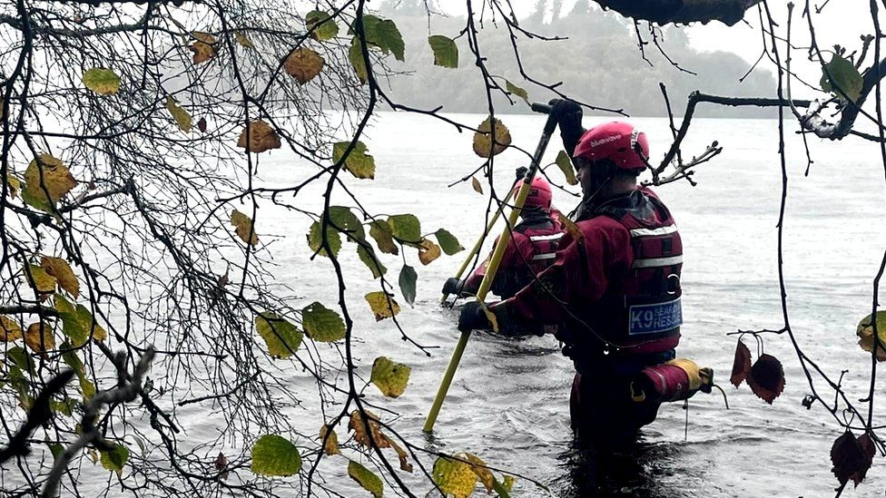

Thousands of people are reported missing in Northern Ireland every year

**By Niall Glynn**

BBC News NI

**The case of missing woman Nicola Bulley dominated headlines in the UK this year.**

For a couple of weeks the relatively forgotten issue of the missing was front and centre of our news feeds.

The number of missing in Northern Ireland is considered low compared with other parts of the British Isles.

However, police figures for the year between 1 April 2021 and 31 March 2022 provide some context for what is considered low.

In that period there were about 9,700 reports concerning almost 5,000 individuals.

Twenty-eight children were missing for more than seven days, as were 83 adults.

There are currently 59 people in Northern Ireland listed as long-term missing, according to the police.

## 'I knew in my gut that something was wrong'

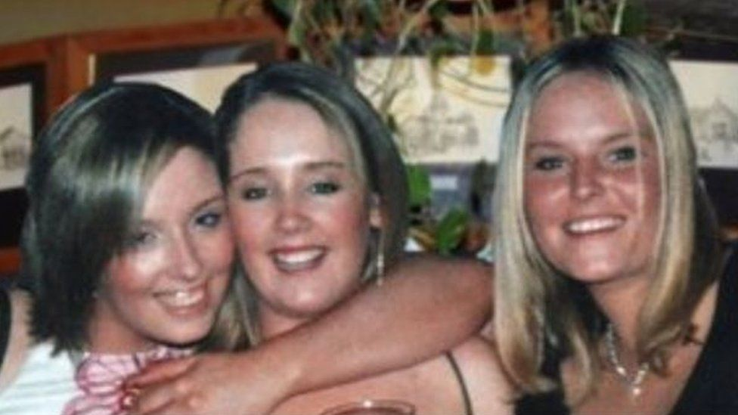IMAGE SOURCE,JOANNE DORRIAN

Lisa Dorrian (right) with her sisters Michelle and Joanne has been missing for 18 years

Perhaps the most high-profile missing person case in Northern Ireland has been that of 25-year-old Lisa Dorrian from Bangor, County Down.

Lisa was last seen at a caravan park in Ballyhalbert, County Down, in the early hours of 28 February 2005.

On 13 March of that year a murder investigation opened. Despite hundreds of searches Lisa's body has never been found.

Lisa's sister Joanne said initially the family thought she was "just out of reach" and they would find her "very quickly".

"But I knew enough instinctively to get on to the police straight away," she added.

"I just knew in my gut that there was something wrong."

* [**Timeline: The disappearance of Lisa Dorrian**](https://www.bbc.co.uk/news/uk-northern-ireland-39116502)
* [**Reward offered for information on 2005 murder**](https://www.bbc.co.uk/news/uk-northern-ireland-63879808)
* [**Views sought on law changes in NI murder cases**](https://www.bbc.co.uk/news/uk-northern-ireland-59375893)

The following 18 years and the acceptance that Lisa was not coming home have affected the family in different ways.

"My mum never got over losing Lisa - all she ever wanted was to find her. Mum died seven years ago and we say she died of a broken heart, she was only 59," Joanne said.

"Me and my sisters have been able to carry on having a life around Lisa.

"We still have a life talking about her every day. We've went on to have our own families, careers, all of that.

"So life didn't stop but life certainly changed the day Lisa went missing for all of us."

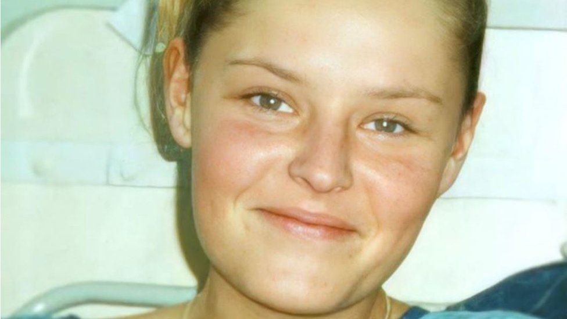IMAGE SOURCE,JOANNE DORRIAN

Lisa, 25, went missing in the early hours of 28 February 2005

Joanne said the fact that the family knows Lisa is gone has, in a way, lessened their torment.

"It's so difficult for people when they live in that limbo - are they still alive or are they dead? I think I feel better having some kind of answer, as brutal as it is, I feel better knowing," she said.

"If I knew Lisa was out there alive how could I sit in the house and drink tea and laugh with my friends?"

She said she believed "justice will come before finding Lisa".

"Lisa's case is still really active. I know it's 18 years old but it's still a live case, it has never gone to cold case or legacy and to be frank I wouldn't allow it."

Joanne now tries to help the families of other missing people.

"I like people to learn from our experience because you don't want to have to look back and say: 'If only the police had done this or if only we had known to ask this'," she said.

"I think any family of the missing would say it changes you as a person, you think about life differently, you think about people differently but it's a very individual journey."

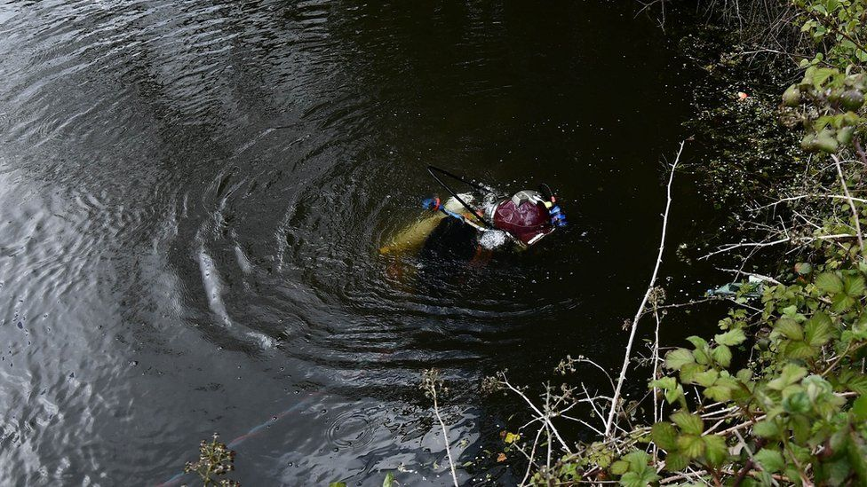IMAGE SOURCE,PACEMAKER

There have been hundreds of searches for Lisa's body, including this one in May 2021 in Ballyhalbert

Last year the Department of Justice carried out a public consultation on Charlotte's Law.

Named after missing murder victim Charlotte Murray, the law would assign an additional tariff to a killer's sentence if they failed to reveal the whereabouts of their victim's body.

"Working closely with affected families, we are continuing to develop the detail of proposed recommendations following the consultation, which will be subject to the views of an incoming justice minister," a department spokesperson said.

## 'Absolutely, completely life is on hold'

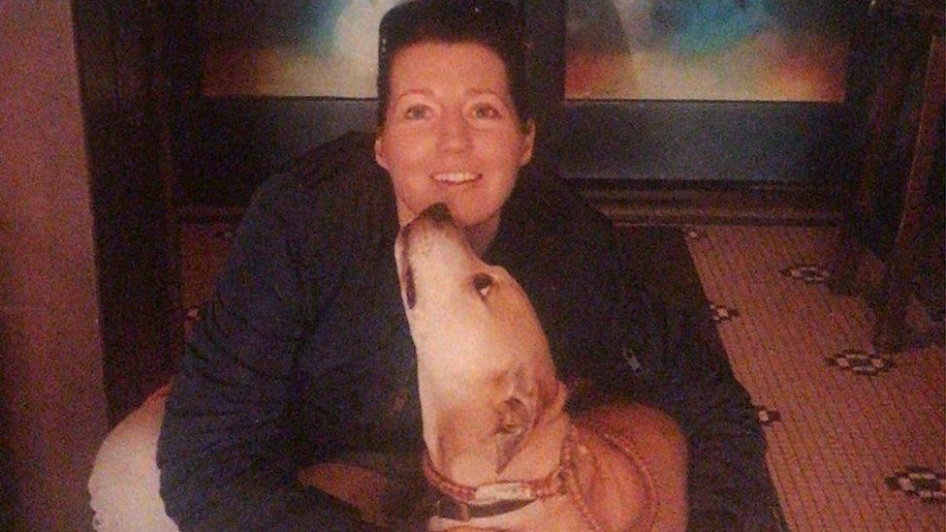IMAGE SOURCE,LEONA TIGHE

Irish woman Jean Tighe was reported missing in Portugal in 2020

A loved one who has gone missing while abroad can further complicate an already torturous experience for families.

County Cavan woman Leona Tighe's sister Jean was reported missing from a hostel in Parede in Portugal in July 2020.

She had been in Parede between February and May before returning to Ireland. She then went back to Portugal on 7 July and was reported missing six days later.

Her sister Leona said Jean, 38, had booked a flight to Dublin for 15 July but never got on it. There have been no known sightings of her since.

Friends became alarmed on 14 July but it was not until 18 July that a formal report was made to police

"A hostel worker said she saw Jean leave the hostel area on Monday 13 July 2020 with a man," Leona said.

"The hostel worker said the man Jean left the hostel with was Brazilian. How did he know he was Brazilian? Who is this hostel worker? How can he be so sure?

"There's just so many questions that are unanswered."

Lorena said police in Portugal did not contact the family during the early stages of the investigation.

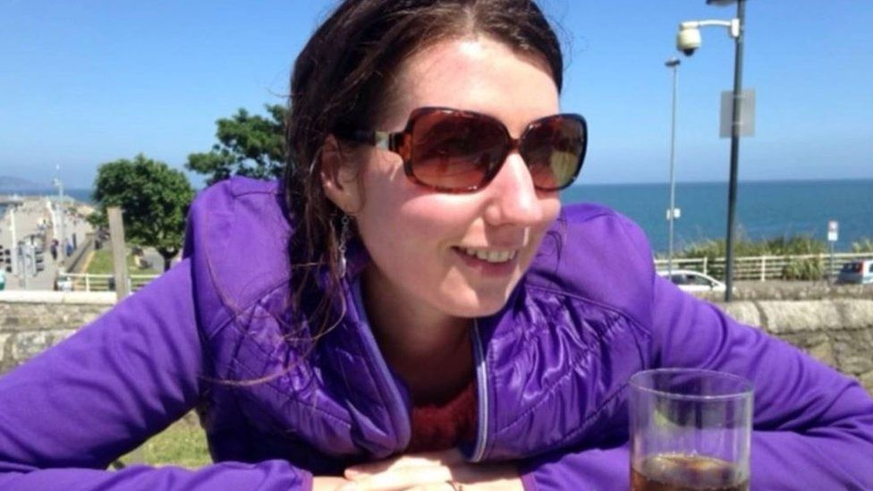IMAGE SOURCE,LEONA TIGHE

Jean's family have had no contact with her since 2020

She added: "Nobody ever contacted us to tell us they were concerned for the welfare of Jean, that she hadn't returned to the hostel.

"We became very worried about Jean when she didn't write home or didn't start to make her way home."

She said Jean's social media remained active with a logged action as recently as January 2023 but no-one has actually spoken to or seen her since she went missing.

She said her life is "absolutely, completely on hold".

"You have to get up obviously and go to work and work is a great thing, it's a great distraction and you have to keep going," she said.

"But you're always thinking: is there any other way to look at this? Are we looking at it in all the right ways?'"

Leona said there were theories that Jean could have started a new life or become involved in a cult but she also feared the worst could have happened.

"Show me the proof, give me the evidence," she said.

## 'People don't realise how many go missing'

Whenever a friend or loved one goes missing, contacting the police is the first thing to do.

They ask questions about the missing person to build a profile of them before beginning a search for the individual.

Voluntary organisations such as the Community Rescue Service (CRS) are often called in by the police to help with searches.

Sean McCarry from the CRS said its volunteers were involved in about 390 searches for missing people in Northern Ireland last year.

"We're very, very busy and it's partly to do with the high suicide rate in Northern Ireland," he said.

Ryan Gray is the founder of K9 Search and Rescue NI and has been involved in searches for missing people.

"In some of the cases you've built up a rapport and become friendly with the family," Ryan said.

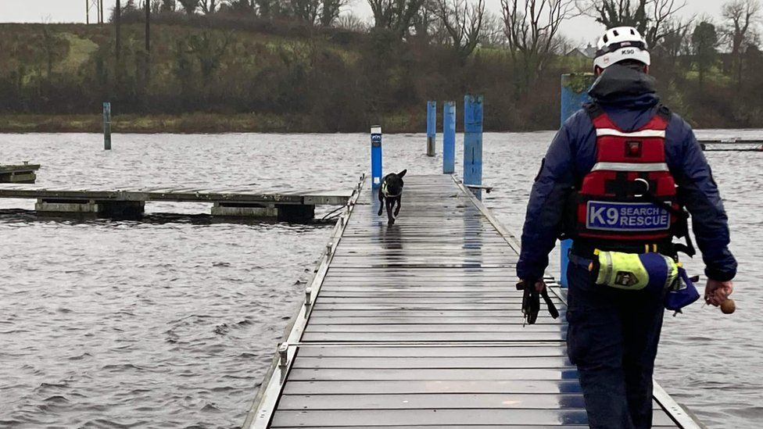IMAGE SOURCE,K9 SEARCH AND RESCUE NI

K9 Search and Rescue NI carries on searches across Ireland

"It's a very sad time for them so we just support them as best we can.

"If we locate someone alive then it's absolutely fantastic and you've got the satisfaction of saving a life and getting someone home or getting them into the system of mental health help."

He added that while it was incredibly sad when a body is found, being able to return them to loved ones can "allow them to start the grieving process".

Ryan said it can be hard to keep emotion out of the job.

"I don't think the general public realise how many people go missing each year.

"I'd imagine they don't really think about it until it comes to their doorstep."

*If you have been affected by any of the issues in this article you can find information about organisations that can help on*[**the BBC Action Line website**](https://www.bbc.co.uk/actionline/)*.*

Peter Sutcliffe

**30 years since the Yorkshire Ripper was sentenced to life behind bars**

By [Toby Neal](https://www.shropshirestar.com/news/authors/toby-neal/) | [Features](https://www.shropshirestar.com/news/features/) | Published: May 22, 2020

He was, the prosecution accepted, insane.

Nederst på formularen

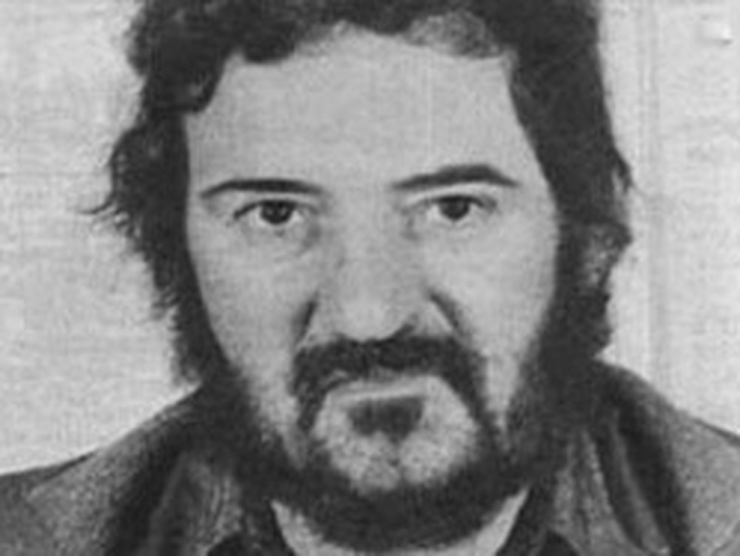Serial killer in captivity

Thirteen women brutally murdered, others savagely attacked, but no jail term lined up for the infamous Yorkshire Ripper despite his reign of terror in northern England.

Peter Sutcliffe was diagnosed by four psychiatrists as being a paranoid schizophrenic, acting under the delusion that God had instructed him to kill prostitutes.

So when he was brought before the Old Bailey, the prosecution was minded to accept the serial killer's plea of not guilty to murder, but guilty to manslaughter through diminished responsibility.

That would have seen him go straight into a secure hospital without the need for a trial.

But the judge would not have it. He directed that Sutcliffe would have to stand trial for murder and that his sanity – and therefore criminal culpability – was a matter for a jury.

The jury found him guilty of 13 murders. In effect, the jurors were saying he was not mad, but bad.

And on this day in 1981, May 22, Sutcliffe, who had also pleaded guilty to seven attempted murders, was sentenced to life imprisonment with a minimum term of 30 years.

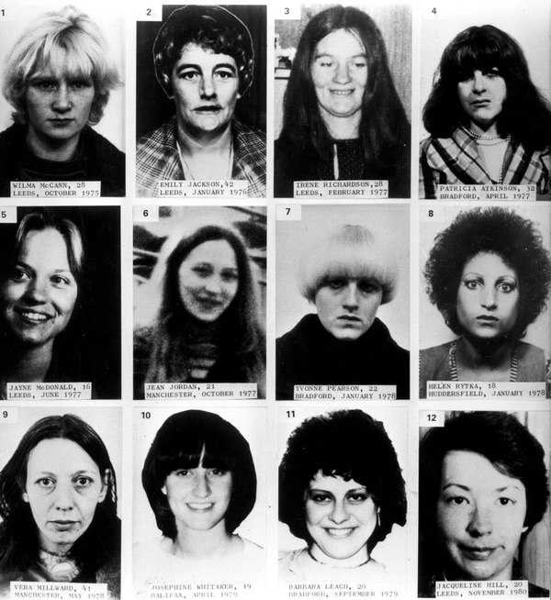Never forget the victims

That would take us to 2011. So why is he not out? It's because in 2010 a whole life tariff was imposed. Sutcliffe will die in prison.

In the wake of his trial, there was a twist. At first Sutcliffe was sent to an ordinary prison.

But those psychiatrists were proven right as he turned out to be mad after all. After three years in Parkhurst prison on the Isle of Wight he was diagnosed with paranoid schizophrenia and sent to Broadmoor, the secure psychiatric hospital.

And in a further twist in the "mad" or "bad" conundrum, after three decades at Broadmoor, a health tribunal found Sutcliffe no longer needed treatment for any mental disorder and in 2016 he was moved to HMP Frankland in Durham.

Today he is aged 73 and calls himself Peter Coonan – his mother's maiden name. A number of attacks during his time locked up have left him blind in one eye and having to have 30 stitches in facial cuts.

Nobody knows how many women Sutcliffe attacked. The first officially recognised Ripper assault was in 1975 and the killings in the Yorkshire and Greater Manchester areas continued until the time of his arrest.

But he is suspected of being behind a number of unsolved crimes.

As a Bradford lorry driver, he travelled widely, and is known to have made a number of deliveries to the then Eaton Yale factory in Halesfield, Telford, and would have stayed in the area overnight.

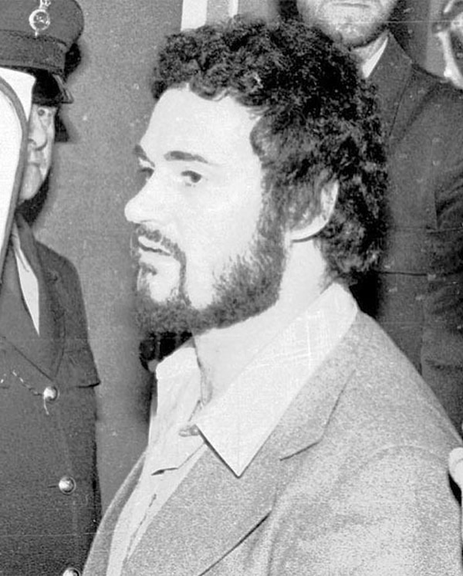Peter Sutcliffe

Typically he would attack his victims from behind with a hammer, before stabbing them with a screwdriver or knife. While his self-styled divine mission was to kill prostitutes, not all his victims were.

It was the savage 1977 murder in Leeds of Jayne MacDonald, a 16-year-old shop assistant, which propelled into national headlines the wave of killings. The feared serial killer was now dubbed the Yorkshire Ripper by the press.

The body of one of his victims was discovered by actor Bruce Jones, who played taxi driver Les Battersby in Coronation Street.

The police investigation was so overwhelmed by the mass of information it received that nobody was able to join the dots.

An infamous hoax in the form of a series of taunting letters and a tape recording purporting to be from the killer fooled police and led to them misdirecting their efforts.

“I'm Jack,” he declared mockingly – a reference to Jack the Ripper. “I see you're still having no luck catching me…”

Police were convinced it was genuine and were led on a wild goose chase hunting for a culprit in the Sunderland area, whose accent led to him being dubbed Wearside Jack.

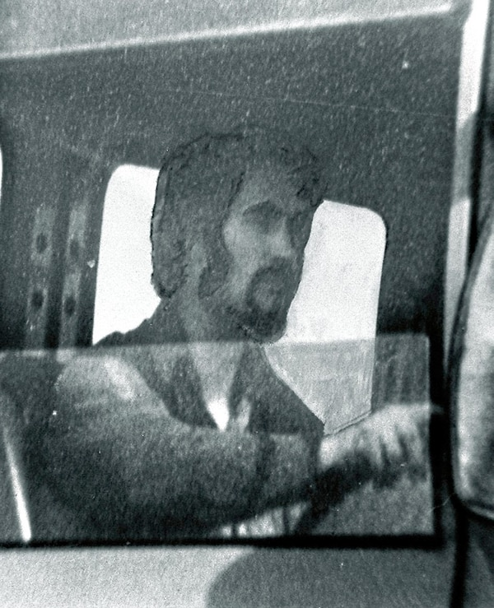Peter Sutcliffe

The tape created a safe space for Yorkshireman Sutcliffe who had been interviewed by police several times, but whose Bradford accent now seemed to rule him out. With the inquiry derailed, he went on to kill three more women.

The reckoning came in a cold case review in 2005 when police matched DNA in saliva on one of the envelopes to hoaxer John Humble. He was jailed in 2006 for eight years for perverting the course of justice.

Alcoholic Humble drank himself to death last July.

In the end Sutcliffe was caught by routine police work, when two Sheffield officers checked on a man and a prostitute in a car in a red light area on January 2, 1981. The car had false plates.

He was questioned at the police station. One of the arresting officers remembered that before being taken to the police station Sutcliffe had asked to answer a call of nature. He returned to search the scene and discovered a ball pein hammer and knife dumped behind a small oil storage tank.

Sutcliffe had also hidden a knife in the cistern of the police station's toilet.

Confronted, he confessed to being the Yorkshire Ripper, and made a long and detailed statement.

Police had got their man.

At last, a great shadow had been lifted.

And

Harold Frederick Shipman…the doctor who killed approx. 250 people