**US global influence**

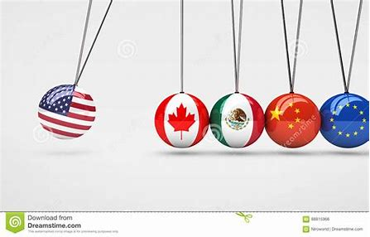

**Page 2 Americanisation (Wikipedia)**

**Page 4 Why the US Dollar Is the Global Currency**

Page 8 Chat gpt!! The US Dollar

Page 9 A simpler version of the same text: (Chat gpt!! The US Dollar)

Page 10 Chat gpt!! What are the best examples of USA's global influence?

**Page 11 Military Power**

**Page 12 BBC The role of the US as a world power**

**Page 16 Coca Cola**

Page 20 Blackrock

Page 21 McDonalds

Page 22 The Biggest Companies in the World

[Americanization - Wikipedia](https://en.wikipedia.org/wiki/Americanization)

Americanization

From Wikipedia, the free encyclopedia

*This article is about the influence the United States of America has on the culture of other countries. For the process of acculturation by immigrants or native populations to American customs and values, see*[*Americanization (immigration)*](https://en.wikipedia.org/wiki/Americanization_(immigration))*. For other uses, see*[*Americanization (disambiguation)*](https://en.wikipedia.org/wiki/Americanization_(disambiguation))*.*

](https://en.wikipedia.org/wiki/File:Lijiang_McDonalds_-_panoramio.jpg)

A [McDonald's](https://en.wikipedia.org/wiki/McDonald%27s) in [China](https://en.wikipedia.org/wiki/China). McDonald's is widely seen as a symbol of Americanization in many countries.[[1]](https://en.wikipedia.org/wiki/Americanization#cite_note-1)[[2]](https://en.wikipedia.org/wiki/Americanization#cite_note-2)[[3]](https://en.wikipedia.org/wiki/Americanization#cite_note-3)

](https://en.wikipedia.org/wiki/File:CCCP_1991_(4377719733).jpg)

The first Russian McDonald's on [Moscow's](https://en.wikipedia.org/wiki/Moscow) [Pushkin Square](https://en.wikipedia.org/wiki/Pushkinskaya_Square), pictured in 1991.

**Americanization** or **Americanisation** (see [spelling differences](https://en.wikipedia.org/wiki/American_and_British_English_spelling_differences#-ise,_-ize_(-isation,_-ization))) is the influence of [American culture](https://en.wikipedia.org/wiki/Culture_of_the_United_States) and business on other countries outside the [United States of America](https://en.wikipedia.org/wiki/United_States), including their media, cuisine, business practices, [popular culture](https://en.wikipedia.org/wiki/Popular_culture), technology or political techniques. Some observers have described Americanization as synonymous with progress and innovation.[[4]](https://en.wikipedia.org/wiki/Americanization#cite_note-stead1901-4)[[5]](https://en.wikipedia.org/wiki/Americanization#cite_note-:0-5)[[6]](https://en.wikipedia.org/wiki/Americanization#cite_note-6)

[Hollywood](https://en.wikipedia.org/wiki/Hollywood,_Los_Angeles), the American [film](https://en.wikipedia.org/wiki/Cinema_of_the_United_States) and [television industry](https://en.wikipedia.org/wiki/Television_in_the_United_States), has since the 1910s dominated most of the world's media markets. It is the chief medium by which people across the globe see American fashions, customs, scenery, and way of life.[[7]](https://en.wikipedia.org/wiki/Americanization#cite_note-Hoynes2011-7)[[8]](https://en.wikipedia.org/wiki/Americanization#cite_note-Pokorny2004-8)

The top 50 [highest-grossing films of all time](https://en.wikipedia.org/wiki/List_of_highest-grossing_films) were all either made entirely or partially in the United States or were financed by US production companies, even with limited or no artistic involvement (criteria for determining a movie's country of origin are mutable and subjective but are, in practice, based on fiscal contribution and head office locations, which creates a significant advantage for a country with the money and industrial support structure - i.e. Hollywood - to fund large-scale motion pictures). Top 50 constituents set and filmed entirely in the UK, like some of the [Harry Potter](https://en.wikipedia.org/wiki/Harry_Potter) franchise, or with deliberately and quintessentially British source material, like the [Lord of the Rings](https://en.wikipedia.org/wiki/Lord_of_the_Rings) series, count as American productions for solely financial reasons. This coopting of the works of other nations and cultures into "American" works (and the hegemonic ability to do as such) forms part of many critical definitions of Americanization.[[9]](https://en.wikipedia.org/wiki/Americanization#cite_note-9)

[Coca-Cola](https://en.wikipedia.org/wiki/Coca-Cola), previously the top global company by revenue, is often viewed as a symbol of Americanization,[[10]](https://en.wikipedia.org/wiki/Americanization#cite_note-Coca-Cola-10) giving rise to the term "Coca-Cola diplomacy" for anything emblematic of U.S. [soft power](https://en.wikipedia.org/wiki/Soft_power). [Fast food](https://en.wikipedia.org/wiki/Fast_food) is also often viewed as being a symbol of U.S. marketing dominance. Companies such as [McDonald's](https://en.wikipedia.org/wiki/McDonald%27s),[[11]](https://en.wikipedia.org/wiki/Americanization#cite_note-DeBres2005-11) [Burger King](https://en.wikipedia.org/wiki/Burger_King), [Pizza Hut](https://en.wikipedia.org/wiki/Pizza_Hut), [Kentucky Fried Chicken](https://en.wikipedia.org/wiki/Kentucky_Fried_Chicken) and [Domino's Pizza](https://en.wikipedia.org/wiki/Domino%27s_Pizza) among others, have numerous outlets around the world. Of the top ten global brands (2017) by revenue, seven are based in the United States:[[12]](https://en.wikipedia.org/wiki/Americanization#cite_note-Fortune-2022-12) [Apple Inc.](https://en.wikipedia.org/wiki/Apple_Inc.), [Google](https://en.wikipedia.org/wiki/Google), [Microsoft](https://en.wikipedia.org/wiki/Microsoft), Coca-Cola, [Amazon](https://en.wikipedia.org/wiki/Amazon_(company)), [Facebook](https://en.wikipedia.org/wiki/Facebook), and [IBM](https://en.wikipedia.org/wiki/IBM).

During the [Cold War](https://en.wikipedia.org/wiki/Cold_War), Americanization was the primary soft power method chosen to counter the polar process of [Sovietization](https://en.wikipedia.org/wiki/Sovietization) around the world. Education, schools, and particularly universities became the main target for Americanization. Resistance to Americanization within the university community restrained its effectiveness,[[13]](https://en.wikipedia.org/wiki/Americanization#cite_note-Tsvetkova2013-13) though it was still much more successful than Sovietization.[[14]](https://en.wikipedia.org/wiki/Americanization#cite_note-:1-14): 6 Americanization has become more prevalent since the [collapse of the Soviet Union](https://en.wikipedia.org/wiki/Dissolution_of_the_Soviet_Union) in 1991, which left America, briefly, as the world's sole undisputed superpower (the full soft power of China as a potential competing influence has yet to manifest within Occidental pop culture). Americanization found yet another gear with the advent of widespread [high-speed Internet](https://en.wikipedia.org/wiki/Internet_access) use in the mid-2000s (notably [heavily censored in China](https://en.wikipedia.org/wiki/Internet_censorship_in_China)).

Criticism of Americanization has included opposition to U.S. investments in Europe during the 1960s,[[15]](https://en.wikipedia.org/wiki/Americanization#cite_note-Grosse1967-15) which subsided by the 1970s.[[16]](https://en.wikipedia.org/wiki/Americanization#cite_note-Lundestad2005-16) A new dimension of [anti-Americanism](https://en.wikipedia.org/wiki/Anti-Americanism) is fear of the pervasiveness of American Internet technology.[[17]](https://en.wikipedia.org/wiki/Americanization#cite_note-Kroes2003-17)

[Why the US Dollar Is the World Currency (thebalancemoney.com)](https://www.thebalancemoney.com/world-currency-3305931)

**Why the US Dollar Is the Global Currency**

By [**Kimberly Amadeo**](https://www.thebalancemoney.com/kimberly-amadeo-3305455)

Updated on March 16, 2022

 Reviewed by

[**Michael J Boyle**](https://www.thebalancemoney.com/michael-boyle-4800825)

**In This Article**

* [Strongest World Currency](https://www.thebalancemoney.com/world-currency-3305931#toc-the-us-dollar-is-the-strongest-world-currency)
* [Why the Dollar Is the Global Currency](https://www.thebalancemoney.com/world-currency-3305931#toc-why-the-dollar-is-the-global-currency)

THE BALANCE / BAILEY MARINER

A global currency is one that is accepted for trade throughout the world. Some of the world's currencies are accepted for most international transactions. The most popular are the U.S. dollar, the euro, and the yen. Another name for a global currency is the reserve currency.

According to the International Monetary Fund, the U.S. dollar is the most popular. As of the fourth quarter of 2019, it makes up over 60% of all known central bank [foreign exchange reserves](https://www.thebalancemoney.com/foreign-exchange-reserves-3306258). That makes it the de facto global [currency](https://www.thebalancemoney.com/what-is-a-currency-symbol-5221431), even though it doesn't hold an official title.

The next closest reserve currency is the euro. It makes up 20% of known central bank foreign currency reserves.1 The chance of the euro becoming a world currency was damaged by the eurozone crisis. It revealed the difficulties of a monetary union that's guided by separate political entities.

**The US Dollar Is the Strongest World Currency**

The relative strength of the U.S. economy supports the value of the dollar. It's the reason the [dollar is the most powerful currency](https://www.thebalancemoney.com/power-of-the-u-s-dollar-3306267). As of the end of 2020, the U.S. had $2.04 trillion in circulation. As much as half that value is estimated to be in circulation abroad.2 Many of these bills are in the former Soviet Union countries and in Latin America. They are often used as hard currency in day-to-day transactions.

In the foreign exchange market, the dollar rules. Around 90% of [forex trading](https://www.thebalancemoney.com/what-is-forex-trading-3306253) involves the U.S. dollar. The dollar is just one of the world's 185 currencies according to the International Standards Organization List, but most of these currencies are only used inside their own countries.3

**Note**

Theoretically, any nation's currency could replace the dollar as the world's currency, but they won't because they aren't as widely traded

Almost 40% of the world's debt is issued in dollars.4 As a result, foreign banks need a lot of dollars to conduct business. This became evident during the 2008 financial crisis. Non-American banks had $27 trillion in international liabilities denominated in foreign currencies. Of that, $18 trillion was in U.S. dollars.5 As a result, the U.S. Federal Reserve had to increase its [dollar swap line](https://www.thebalancemoney.com/swap-line-definition-purpose-examples-3305966). That was the only way to keep the world's banks from running out of dollars.

The financial crisis made the dollar even more widely used. In 2018, the banks of Germany, France, and Great Britain held more liabilities denominated in dollars than in their own currencies.6 Additionally, bank regulations enacted to prevent another crisis can make dollars scarce. that can also happen when the Federal Reserve increases the [fed funds rate](https://www.thebalancemoney.com/fed-funds-rate-definition-impact-and-how-it-works-3306122). That decreases the money supply by making dollars more expensive to borrow.

The dollar's strength is the reason governments are willing to hold the dollar in their foreign exchange reserves. Governments acquire currencies from their international transactions. They also receive them from domestic businesses and travelers who redeem them for local currencies.

Some governments invest their reserves in foreign currencies. China and Japan deliberately buy the currencies of their main export partners. The United States is the largest export partner to both China and Japan.78 They try to keep their currencies cheaper in comparison so their exports are competitively priced.

**Why the Dollar Is the Global Currency**

The 1944 Bretton Woods agreement kickstarted the dollar into its current position. Before then, most countries were on the gold standard. Their governments promised to redeem their currencies for their value in gold upon demand. The world's developed countries met at Bretton Woods, New Hampshire, to peg the exchange rate for all currencies to the U.S. dollar. At that time, the United States held the largest gold reserves. This agreement allowed other countries to back their currencies with dollars rather than gold.9

By the early 1970s, countries began demanding gold for the dollars they held. They needed to combat inflation. Rather than allow Fort Knox to be depleted of all its reserves, President Nixon separated the dollar from gold.10

**Note**

By that time, the dollar had already become the world's dominant reserve currency. But, unpegging the dollar from its value in gold created stagflation. That's a combination of inflation and stagnant growth.

**Calls for a One World Currency**

In March 2009, China and Russia called for a new global currency.11 They wanted the world to create a reserve currency “that is disconnected from individual nations and is able to remain stable in the long run, thus removing the inherent deficiencies caused by using credit-based national currencies."

China was concerned that the trillions it holds in dollars would be worthless if dollar [inflation](https://www.thebalancemoney.com/what-is-inflation-how-it-s-measured-and-managed-3306170) set in. This could happen as a result of increased U.S. deficit spending and printing of U.S. Treasurys to support U.S. debt. China called for the International Monetary Fund (IMF) to develop a currency to replace the dollar.

In the fourth quarter of 2016, the Chinese renminbi became another one of the world's reserve currencies. As of the first quarter of 2020, the world's central banks held $221 billion worth, according to the IMF. That's a fraction of the $6.8 trillion held in U.S. dollars but it will continue to grow in the future.12

China wants its currency to be fully traded on the global foreign exchange markets. It would like the yuan to replace the dollar as the global currency. To do so, China is reforming its economy.

**The Bottom Line**

Despite trillions of dollars in foreign debt and continuous large deficit spending, the United States still holds global trust and confidence in its ability to pay its obligations. For this reason, the U.S. dollar remains the strongest world currency. It may continue to be the top global currency in the years to come.

The dollar’s current number one status is under contention though. Countries such as China and Russia feel a new one-world currency, one not backed by any one nation, is overdue in this increasingly integrated global economy.

**Chat gpt**

The US dollar holds the status of a world currency due to several key factors that have contributed to its widespread acceptance and use in international transactions. These factors include economic strength, stability, global trade dominance, and historical circumstances.

Firstly, the United States has long been one of the world's largest economies, possessing substantial industrial and technological capabilities. Its economic strength, along with a stable political system, has fostered investor confidence, making the US dollar a reliable store of value and medium of exchange.

Secondly, the US dollar benefits from stability. The Federal Reserve, the central bank of the United States, has a strong reputation for maintaining price stability and controlling inflation. The stability of the US dollar makes it an attractive currency for international trade, investment, and as a reserve currency held by central banks worldwide.

Thirdly, the dominance of the US dollar in global trade further solidifies its status as a world currency. The United States is one of the largest players in international trade, and many commodities, such as oil and gold, are priced and traded in US dollars. As a result, countries often need to hold US dollars to facilitate international transactions, increasing the demand for the currency.

Additionally, historical circumstances have played a significant role in the dollar's global prominence. After World War II, the Bretton Woods agreement established the US dollar as the world's reserve currency, backed by gold. Although the gold standard was abandoned in 1971, the US dollar retained its status due to its wide acceptance and the absence of a viable alternative.

Furthermore, the United States has a robust financial system, with Wall Street serving as a global financial hub. The depth and liquidity of US financial markets, along with the widespread use of the US dollar in international banking and capital flows, further reinforce its status as a world currency.

In conclusion, the US dollar's status as a world currency can be attributed to its economic strength, stability, dominance in global trade, historical circumstances, and the strength of the US financial system. These factors have created a network effect, where the widespread use and acceptance of the US dollar in international transactions have further entrenched its position as a key global currency. However, it's important to note that the dynamics of global currencies can evolve over time, and alternative currencies or arrangements could emerge in the future.

**A simpler version of the same text:**

The US dollar is considered a world currency for a few main reasons. First, the United States has a strong economy and is known for its stability, which makes people trust the US dollar as a reliable form of money. Second, the US dollar is widely used in global trade because the United States is a major player in international business. Many countries use the US dollar to buy and sell goods, so there is a high demand for it.

Another reason is that the US dollar has a long history of being accepted worldwide. After World War II, an agreement called the Bretton Woods agreement made the US dollar the main currency for international trade. Even though that agreement is no longer in effect, the US dollar has remained popular because people are used to using it and there is no strong alternative.

Additionally, the United States has a strong financial system, and its markets are seen as reliable and easy to trade in. Many global financial transactions are done in US dollars, which adds to its popularity.

In simple terms, the US dollar is a world currency because the United States is economically strong and stable, it is widely used in global trade, and it has a long history of being accepted internationally. Its popularity is also supported by the strong US financial system. However, it's important to remember that things can change over time, and new currencies or arrangements could become more important in the future.

**What are the best examples of USA's global influence?**

ChatGPT

The United States has had a significant global influence in various aspects. Here are some of the best examples of the USA's global influence:

1. Economic Power: The United States has the world's largest economy and is a leading force in global trade and finance. The U.S. dollar is the world's dominant reserve currency, and many international transactions are conducted in dollars. American multinational corporations have a significant global presence, shaping industries and markets worldwide.
2. Military Power: The United States has the world's most powerful military, with a vast network of military bases around the globe. The U.S. military plays a crucial role in maintaining security and stability in various regions, and the country has been involved in numerous conflicts and peacekeeping operations worldwide.
3. Technological Innovation: The USA has been at the forefront of technological advancements, particularly in the fields of information technology, aerospace, and biotechnology. American companies and institutions have developed groundbreaking technologies, including the internet, smartphones, and advancements in medical research.
4. Cultural Influence: American popular culture, including music, movies, television shows, and fashion, has a significant global impact. Hollywood movies dominate international box offices, American music artists enjoy widespread popularity, and American TV shows are watched by audiences around the world. The English language, largely influenced by American English, has become a global lingua franca.
5. Diplomacy and Alliances: The United States has a wide network of diplomatic relations and alliances across the globe. Through diplomatic efforts and treaties, the U.S. has influenced international agreements on issues such as trade, climate change, and nuclear disarmament. Organizations such as the United Nations, NATO, and the World Bank have also been shaped by American influence.
6. Soft Power: The USA promotes its values, ideas, and democratic principles through cultural exchanges, educational programs, and humanitarian initiatives. American universities attract students from around the world, and organizations such as the Peace Corps provide assistance and development programs in various countries, enhancing America's soft power and influence.
7. Global Financial Institutions: The United States plays a significant role in global financial institutions such as the International Monetary Fund (IMF) and the World Bank. These institutions provide financial assistance, loans, and policy recommendations to countries worldwide, with the United States being a key decision-making player.
8. Scientific Research and Innovation: American universities, research institutions, and laboratories have produced groundbreaking scientific discoveries and technological innovations. The United States remains a hub for scientific research, attracting international talent and contributing to advancements in various fields.

It is important to note that while the USA has a substantial global influence, it is not the sole influential actor, and there are other countries and factors that also shape the dynamics of the international system.

**Military Power**

[Scary! United States Armed Forces | How Powerful is United States 2023 | US Military Strength - YouTube](https://www.youtube.com/watch?v=pWXcHpfY3eQ)

9 mins film

[How strong is the United States military? Why is the US military the strongest? - YouTube](https://www.youtube.com/watch?v=7H3BDtBhANg)

12 mins film

[The role of the US as a world power - The USA's international influence - Higher Modern Studies Revision - BBC Bitesize](https://www.bbc.co.uk/bitesize/guides/z6frqp3/revision/2)

**The role of the US as a world power**

*All statistics via the CIA World Factbook*.

**Economic influence**

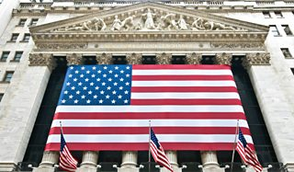

New York Stock Exchange, Wall Street

The United States of America is the world's foremost economic and military power. It has the **third largest population** in the world (335 million). Income in 2017 was **$62,530 per capita**, one of the highest in the developed world.

The US is home to many entrepreneurs and has created many iconic products which are highly sought after around the world, for example Apple and Facebook.

The US also provides the greatest amount of international aid.

* $11 billion to the United Nations – one fifth of their entire budget
* $58.5 billion is given to USAID – the US Agency for International Development for missions in more than 80 countries

**Military influence**

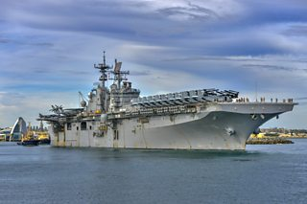

US Navy aircraft carrier USS Bonhomme Richard

Militarily, the US remains the world's only superpower. Although the US does not spend the most in the world on defence as a proportion of GDP (3.7%), in absolute terms it spends vastly more than any other country. In 2020, they spent**$778 billion**. Over one third (39%) of the total world’s defence spending is by the US alone.

The US has the largest naval fleet in the world. The US carrier fleet dwarfs every other country in the world, particularly in terms of in size and technological hardware. The scale of the US navy allows it to have a military presence anywhere in the world.

**Cultural influence**

The USA's cultural influence extends across the world, for example over two billion people speak some English in the world today with the majority speaking an Americanised version of the language. US TV programmes, films, video games and music have a large domestic market of more than 300 million customers, in addition to their influence on the rest of the world. The USA also has a social and cultural impact on immediate neighbours such as Mexico and Canada and on North/Central America as a whole.

**The USA's international influence**

With the world's most powerful military, a huge economy, and a leading role in international institutions such as the UN and NATO, the USA is a superpower. The rise in power and importance of China and re-emergence of Russia will continue to challenge the global dominance of the USA.

Part of

[**Modern Studies**](https://www.bbc.co.uk/bitesize/subjects/ztsvr82)

[**World power: USA**](https://www.bbc.co.uk/bitesize/topics/zsbg87h)

Add to My Bitesize

**Involvement in international organisations**

The USA is a leading member of a number of important international organisations.

**G7 and G20 Group**

These groups contain most of the countries in the world with the largest economies. Summits or meetings of the leaders of the G7 countries offer the opportunity for the US and other group members to develop closer economic ties to expand trade. In addition, it allows the US another forum to discuss issues of global concern such as climate change, terrorism or conflict and poverty. In 2014, Russian membership of the G8 was suspended because of its involvement in the crisis in Ukraine.

The G20 has similar aims to the G7 but includes an additional 12 members to reflect the growing economic importance of countries such as Brazil, India and Indonesia.

**The United Nations**

The USA is a founding member of the United Nations (UN):

* it is one of the five permanent members (P5) on the UN Security Council, alongside the UK, China, Russia and France
* it is the biggest single contributor to the UN budget, providing one fifth of its total
* its headquarters is in New York

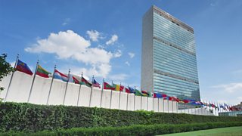

United Nations building, New York

Although the US is an important member of the UN, the relationship between the two has been strained. The US hosts the UN headquarters in New York and contributes the most of any single country to UN programs but in most years the US has failed to pay its contribution in full.

As a permanent member of the UN Security Council, the US has the opportunity to veto any Security Council proposal put forward. Since the Security Council is the part of the UN responsible for peace making and peacekeeping as well as international sanctions, this gives the US a very influential role.

The US has at times found decision making within the UN Security Council frustrating or time consuming. Russia and China are also permanent members and often use their veto to block US proposals.

On occasion the US has ignored the UN and its decision-making procedures. For example, the US did not seek UN approval when it decided to invade Iraq in 2003. The US has also consistently backed Israeli actions financially and militarily despite widespread UN and international condemnation.

Like many other countries, the US will do what it believes is in its best interests regardless of what the UN or the rest of the world think. However, on most occasions, the US does work within the decision-making processes of the UN Security Council, e.g. leading a response to the crisis in Libya in 2011. More recently, the USA's diplomatic efforts have led to resolving issues in Syria.

**The North Atlantic Treaty Organisation**

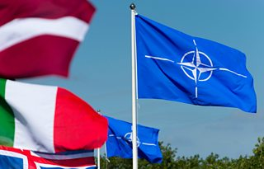

The USA has been a prominent member of the North Atlantic Treaty Organisation (NATO) since it was established in 1949. NATO is the largest and most powerful military alliance in the world. As of 2022 it has 30 member states.

In theory, the organisation is made up of members of equal standing, where each country has one vote in decision-making.

In reality, the USA is the dominant player within NATO. It contributes far more troops, resources, and finances than any other single member of the alliance. As a result, it is the country most able to set the NATO agenda.

For example, it is claimed the USA has kept the pressure up on European countries to look to expand NATO eastwards.

In recent years, the USA has also tried to encourage the other members of NATO to take a greater responsibility for their own defence and to make a larger contribution to NATO's finances. It has been argued that the US has been focusing its attention more on Asia and the Far East as opposed to Europe.

However, after Russian annexation of the Crimea in 2014, NATO and American support for the Atlantic Alliance moved closer to the top of the US international agenda.

US leadership within NATO remains very important:

* American military support was crucial in NATO’s involvement in Libya that led to the downfall of President Gaddafi
* The USA played a lead role in NATO’s mission to Afghanistan

However, the US also needs NATO as it allows the US to confront difficult and diverse threats to its security alongside other countries which support democratic values. As part of NATO the US is stronger.

**Ukraine**

The 2022, the Russian invasion of Ukraine has become the biggest international issue for the USA.

Ukraine is not a member of Nato, so the alliance is not obliged to come to its defence. However, it is a "partner" country - there is an understanding it will join at some point in the future.

Some Nato nations have been sending weapons to Ukraine to help its defend itself against Russia. As of the end of February 2022, the US has sent $200m of weapons to Ukraine, and says it will send an extra $350m in weapons.

The US and many other nations have also worked to impose sanctions on President Putin, his associates and Russia.

The US and other NATO members face difficult decisions over how much to support Ukraine while not wishing for their armed forces to come into direct conflict with Russia.

**Biden and NATO**

When visiting Europe in June for the G7, Joe Biden reaffirmed the US support for NATO. This is in contrast to Donald Trump who criticised NATO members and wanted all members to increase military spending to 4% of GDP.

Donald Trump had threatened to remove US forces from Germany over accusations that Germany were ‘not paying their bills’, but these plans changed when Biden took office.

**Coca Cola**

[How Coca-Cola became a million dollar idea - BBC News](https://www.bbc.com/news/av/business-42445549) (1½ min film)

**How Coca-Cola became a million dollar idea**

Coca-Cola is the most famous soft drink ever made. But its inventor thought he should sell it as a medicine. Coke's marketing has been so powerful, it is now one of the most valuable brand names in the world.

It has even managed to define what Santa Claus should look like. Aaron Heslehurst tells the story of Coca-Cola's humble beginnings and its incredible rise.

[Business](https://www.bbc.com/news/business)

22 December 2017

[Who, What, Why: In which countries is Coca-Cola not sold? - BBC News](https://www.bbc.com/news/magazine-19550067)

Who, What, Why: In which countries is Coca-Cola not sold?

* Published

11 September 2012

Share

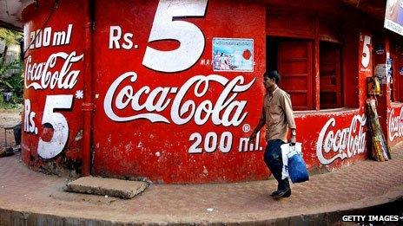

**After almost 60 years, Coca-Cola is on sale again in Burma. It's one of the world's most recognised brands, so are there any countries where the drinks giant still remains unsold?**

Coca-Cola says it sells 1.8 billion servings of the drink every day. But for the last six decades, none has been in Burma.

That's because of US trade sanctions on the military junta which ruled the country from 1962 to 2011.

Those sanctions were suspended a few months ago, as the country began to move towards democratic reforms.

But the company said on Monday its first delivery had arrived and local production would begin soon.

Coca-Cola's entry into any country is a powerful symbol, says Tom Standage, author of A History of the World in Six Glasses.

"The moment Coca-Cola starts shipping is the moment you can say there might be real change going on here," he says. "Coca-Cola is the nearest thing to capitalism in a bottle."

Coca-Cola's rival PepsiCo has also [**announced plans to resume sales in Burma**](http://www.pepsico.com/PressRelease/PepsiCo-Announces-Myanmar-Distribution-Agreement-with-Diamond-Star08092012.html).

There are now just two countries in the world where Coca-Cola cannot be bought or sold - at least, not officially. They are Cuba and North Korea, which are both under long-term US trade embargoes (Cuba since 1962 and North Korea since 1950).

Cuba was actually one of the first three countries outside the US to bottle Coke, in 1906.

But the company moved out as Fidel Castro's government began seizing private assets in the 1960s, and has never returned.

In North Korea - the other Coca-Cola-free zone - [**recent media reports suggested it was being sold in a restaurant**](http://www.telegraph.co.uk/news/worldnews/asia/northkorea/9511235/Coca-Cola-denies-cracking-North-Korea.html) in Pyongyang. But Coca-Cola says if any drinks are being sold in either North Korea or Cuba, they are being smuggled in on the black market, not via official channels.

The dark fizzy soda was created in 1886 in Atlanta, Georgia. From the early days the Coca-Cola company looked to expand worldwide, and by the early 1900s it was bottling the drink in Asia and Europe.

But the big boost came as a result of World War II when Coca-Cola was provided to US troops overseas.

There were more than 60 military bottling plants for Coca-Cola around the world during the war, and locals got a taste for the drink too.

It became powerfully associated with American patriotism, says Standage, and was seen as so crucial to the war effort that it was exempted from sugar rationing.

Dwight Eisenhower, at the time the supreme commander of Allied forces in Europe, was said to be a particular fan and he ensured its availability in North Africa.

He also introduced the drink to top Soviet general, Georgy Zhukov, who asked if a special, colourless version - one that looked like vodka - could be made, and Coca-Cola duly obliged for a while, says Standage.

These days Coca-Cola is [**regularly ranked as one of the top, if not the top, global brands**](http://www.interbrand.com/en/best-global-brands/BGB-Interactive-Charts.aspx).

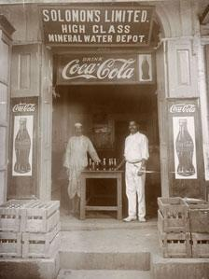

Image caption,

Coca-Cola in Burma, pre-embargo

"It has always been about the American dream," says Bruce Webster, an independent branding consultant who has done work for the Coca-Cola company in the past.

But not all countries have embraced the American-ness that seems to be embodied by Coca-Cola.

It was the French who first coined the pejorative term "coca-colonisation" in the 1950s. Trucks were overturned and bottles smashed, says Standage, as protesters saw the drink as a threat to French society.

During the Cold War, Coca-Cola became a symbol of capitalism and a faultline between capitalism and communism, says Webster.

It was not marketed in the former Soviet Union due to the fear that profits would go straight into communist government coffers, says Standage.

Pepsi filled the gap and was widely sold.

When the Berlin Wall fell in 1989, many East Germans bought Coca-Cola by the crate-load, says Standage. "Drinking Coca-Cola became a symbol of freedom."

Other than the former Soviet Union, the main region that Coca-Cola has struggled in historically is the Middle East, largely due to a boycott implemented by the Arab League from 1968-1991, as a punishment for it selling in Israel

Pepsi picked up a lot of the sales in the Middle East - and many local versions. of the drink thrived.

Coca-Cola is not trying to get involved in politics, says Webster, but as a huge brand so closely associated with the US, it sometimes finds itself tangled up in politics, or singled out for criticism.

"The whole strength of the brand is plugging into a way of life that so many people wanted. As an ideology, it polarises. And sometimes those associations become unattractive," he says.

"America itself as a brand is more tarnished now. People are more ambiguous towards it."

In 2003, protesters in Thailand poured Coca-Cola onto the streets as a demonstration against the US-led invasion of Iraq, and sales were temporarily suspended, says Standage.

Iran's president Mahmoud Ahmadinejad has [**threatened to ban Coca-Cola**](http://www.csmonitor.com/USA/Foreign-Policy/2010/0701/Iran-sanctions-kick-in-and-Ahmadinejad-says-he-ll-ban-Coca-Cola) and Venezuela's Hugo Chavez [**recently urged people to drink locally-made fruit juice**](http://www.guardian.co.uk/world/2012/jul/23/hugo-chavez-venezuelans-drink-juice) rather than drink Coca-Cola or Pepsi.

But 126 years after its birth, Coca-Cola is still pushing forward in terms of sales, [**with strong growth**](http://www.bbc.co.uk/news/business-17742632) - especially, it says, in the emerging markets of India, China and Brazil.

*Reporting by Cordelia Hebblethwaite*

[What Makes Coca-Cola a Global Marketing Success? - YouTube](https://www.youtube.com/watch?v=neNWIfWFNj8)

7 min film (very neutral description)

[Coca Globalization - YouTube](https://www.youtube.com/watch?v=NUzql4U5t8E)

More critical mono-culturalisation

['Drink water': Ronaldo removes Coca-Cola bottles in press conference - YouTube](https://www.youtube.com/watch?v=x2ZLS1V3iMw)

**Blackrock**

["They Own Everyt hing" | THE MOST POWERFUL COMPANY IN THE WORLD - YouTube](https://www.youtube.com/watch?v=dsQrDFLe-2M)

10 min film

[Blackrock chief Larry Fink praises Trump tax cuts - BBC News](https://www.bbc.com/news/av/business-42830383)

**Blackrock chief Larry Fink praises Trump tax cuts**Close

Although he disagrees with many things that US President Donald Trump says, Blackrock chief executive Larry Fink feels that the controversial tax cuts are good for America.

"Unquestionably, the tax reform is going to add at least nine tenths of GDP to the US economy," he tells the BBC.

[Business](https://www.bbc.com/news/business)

26 January 2018

McDonald’s - statistics & facts

Worldwide

McDonald’s is a quick service restaurant (QSR) chain based in the United States. It was founded in California in 1940 by brothers Richard and Maurice McDonald. Eventually, it was transformed by a production line system that rolled out burgers in a quick service style. This was the start of the company’s “McDonaldization”, a phrase coined by sociologist George Ritzer, meaning that the company prioritized efficiency, calculability, predictability, standardization, and control. Today, this type of system is not only used in many QSRs but also for a variety of other institutions and organizations. Ultimately, this method of operating has allowed McDonald's golden arches to become a familiar spectacle in towns and cities all over the world. In 2022, there were over 40 thousand [McDonald’s restaurants globally](https://www.statista.com/statistics/219454/mcdonalds-restaurants-worldwide/) a figure that has grown year-over-year for the past decade.

**Where are McDonald's biggest markets?**

The quick service behemoth operated and franchised by far the largest proportion of restaurants in its home country. In 2022, the [number of McDonald’s restaurants in the U.S.](https://www.statista.com/statistics/256040/mcdonalds-restaurants-in-north-america/) was around 13.4 thousand. When looking at the [countries with the most McDonald’s in Europe](https://www.statista.com/statistics/256044/mcdonalds-restaurants-in-europe/), France (including Monaco) took the top spot, accounting for 1.5 thousand units. Meanwhile, China had the most [McDonald's restaurants in the Asia Pacific and Middle East regions](https://www.statista.com/statistics/256049/mcdonalds-restaurants-in-the-emea-region/). The United States was also one of McDonald’s biggest markets in terms of revenue. In [McDonald’s regional revenue breakdown](https://www.statista.com/statistics/219453/revenue-of-the-mcdonalds-corporation-by-geographic-region/), the U.S. accounted for roughly 9.42 billion U.S. dollars in revenue in 2022. Meanwhile, internationally operated markets such as Australia, France, Canada, and the UK made the largest overall contribution to McDonald's total revenue, with a sum of 11.16 billion U.S. dollars. In total, [McDonald's revenue](https://www.statista.com/statistics/208917/revenue-of-the-mcdonalds-corporation-since-2005/) amounted to 23.18 billion U.S. dollars in 2022.

**Is McDonald's the biggest fast food brand?**

Given its global reach, large number of units, and high revenue it is perhaps no surprise that in 2022 McDonald’s placed in the [Forbes top 100 largest global companies](https://www.statista.com/statistics/263264/top-companies-in-the-world-by-market-capitalization/) in terms of market capitalization. Furthermore, when looking at a ranking of the [biggest global QSRs by brand value](https://www.statista.com/statistics/273057/value-of-the-most-valuable-fast-food-brands-worldwide/), McDonald's came out on top as the biggest QSR brand in the world. With a brand value of almost 197 billion U.S. dollars in 2022, McDonald’s surpassed other QSR chains by a large margin. Coffeehouse chain [Starbucks](https://www.statista.com/topics/1246/starbucks/) was its closest competitor with a brand value of 61.7 billion U.S. dollars. Following McDonald’s and Starbucks by another considerable margin was KFC, the third largest fast food brand worldwide.

[Ranked: The Biggest Companies in the World in 2021 (visualcapitalist.com)](https://www.visualcapitalist.com/the-biggest-companies-in-the-world-in-2021/)

**The Biggest Companies in the World in 2021**



Published

 2 years ago

on

 June 10, 2021

By

[**Jenna Ross**](https://www.visualcapitalist.com/author/jenna/)

*View the*[*full-resolution version*](https://www.visualcapitalist.com/wp-content/uploads/2022/08/The-Biggest-Companies-in-the-World-in-2021.html)*of this infographic.*

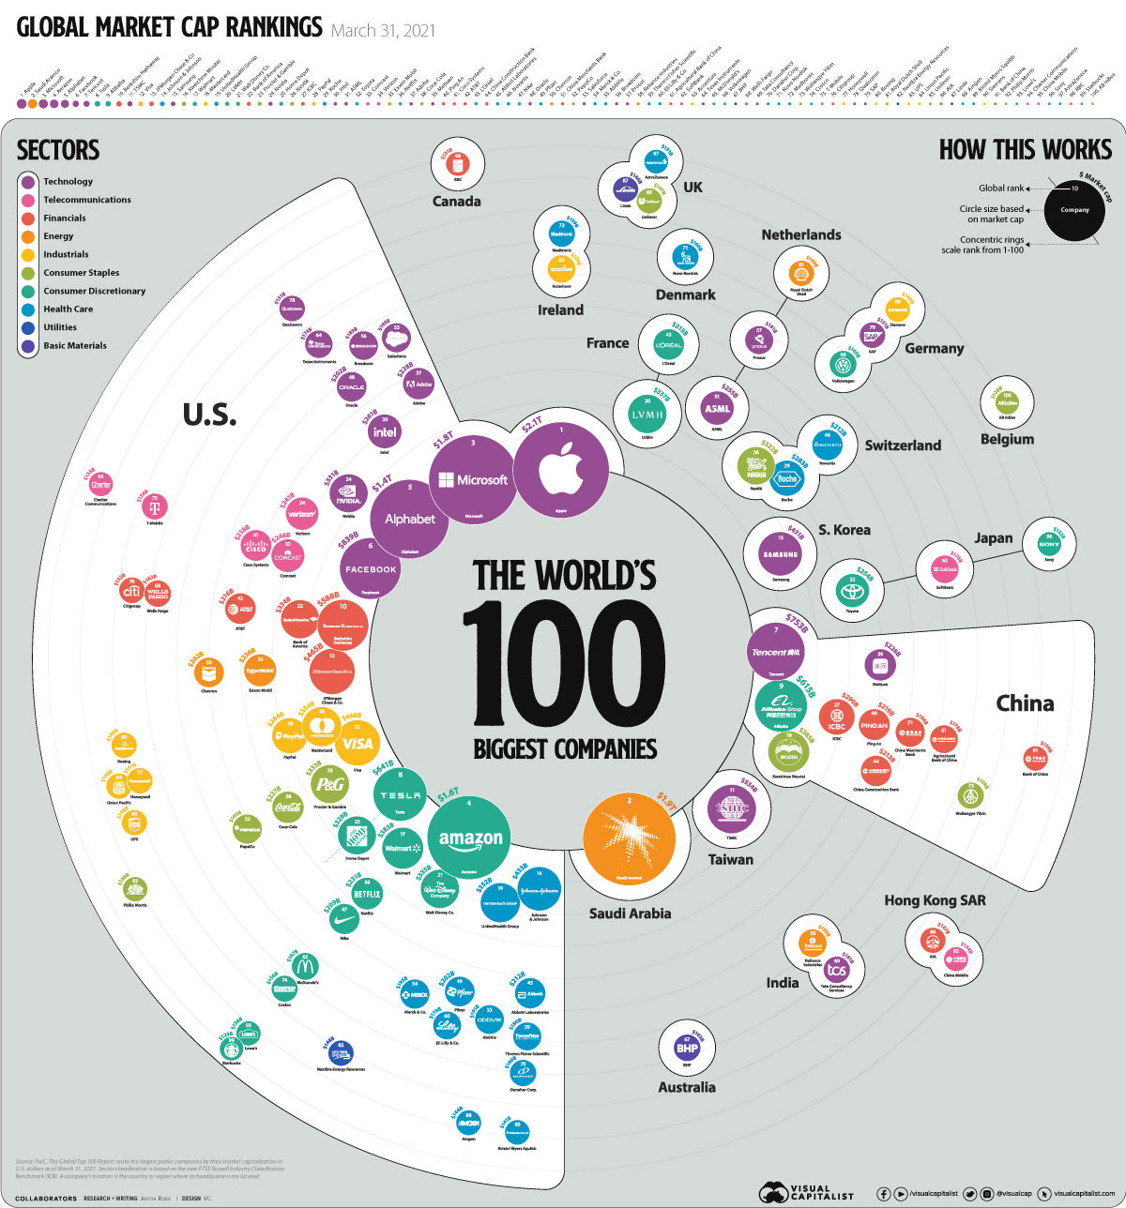

▼ Use This Visualization

**The Biggest Companies in the World**

*View the high-resolution version of the infographic by*[*clicking here*](https://www.visualcapitalist.com/wp-content/uploads/2022/08/The-Biggest-Companies-in-the-World-in-2021.html)*.*

Since the COVID-19 crash, global equity markets have seen a strong recovery. The 100 biggest companies in the world were worth a record-breaking **$31.7 trillion** as of March 31 2021, up 48% year-over-year. As a point of comparison, the combined GDP of the U.S. and China was $35.7 trillion in 2020.

In today’s graphic, we use [PwC data](https://www.pwc.com/gx/en/audit-services/publications/assets/pwc-global-top-100-companies-2021.pdf) to show the world’s biggest businesses by market capitalization, as well as the countries and sectors they are from.

**The Top 100, Ranked**

PwC ranked the largest publicly-traded companies by their market capitalization in U.S. dollars. It’s also worth noting that sector classification is based on the FTSE Russell Industry Classification Benchmark, and a company’s location is based on where its headquarters are located.

Here is the top 100 ranking of the biggest companies in the world, organized from the biggest to the smallest.

Search:

| **Rank** | **Company name** | **Location** | **Sector** | **Market Capitalization** |
| --- | --- | --- | --- | --- |
| 1 | APPLE INC | United States | Technology | $2.1T |
| 2 | SAUDI ARAMCO | Saudi Arabia | Energy | $1.9T |
| 3 | MICROSOFT CORP | United States | Technology | $1.8T |
| 4 | AMAZON.COM INC | United States | Consumer Discretionary | $1.6T |
| 5 | ALPHABET INC | United States | Technology | $1.4T |
| 6 | FACEBOOK INC | United States | Technology | $839B |
| 7 | TENCENT | China | Technology | $753B |
| 8 | TESLA INC | United States | Consumer Discretionary | $641B |
| 9 | ALIBABA GRP | China | Consumer Discretionary | $615B |
| 10 | BERKSHIRE HATHAWAY | United States | Financials | $588B |

Showing 1 to 10 of 100 entries

PreviousNext

*Note: Data as of March 31, 2021.*

Within the ranking, there was a wide disparity in value. Apple was worth over **$2 trillion**, more than 16 times that of Anheuser-Busch (AB InBev), which took the 100th spot at $128 billion.

In total, 59 companies were headquartered in the United States, making up 65% of the top 100’s total market capitalization. China and its regions was the second most common location for company headquarters, with 14 companies on the list.