**Space 2024.1**

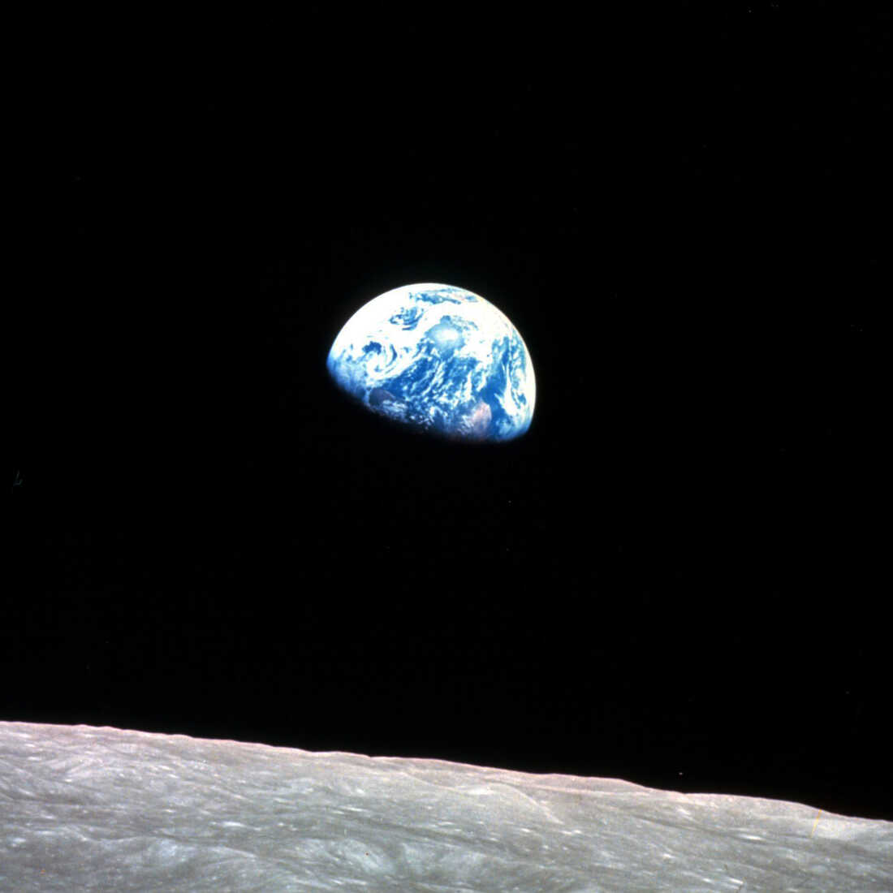

**Big bang theory page 2**

**Earthrise page 2**

**Apollo Mission page 5**

**Exo planets page 11**

**Aliens page 13**

**Telescopes page 23**

**Rockets and Exploration page 24**

**Very good podcasts (possible project topics) page32**

**Big bang theory**

The big band Kurz gesagt [The Beginning of Everything -- The Big Bang - YouTube](https://www.youtube.com/watch?v=wNDGgL73ihY)

**Earthrise (the person who took the photograph died aged 90 on 7 June 2024, when his small plane crashed)**

[The 1968 photo that changed the world (bbc.com)](https://www.bbc.com/future/article/20230511-earthrise-the-photo-that-sparked-an-environmental-movement)

The 1968 photo that changed the world

22 April 2024

**By Isabelle Gerretsen,**Features correspondent,@izzygerretsen

Share

Nasa

The famous Earthrise picture captured by Apollo astronauts has helped to inspire awe by giving us perspective of humanity's place in the Universe (Credit: Nasa)

**More than 50 years after it was shot, Earthrise continues to be seen as one of the most iconic environmental photographs ever taken.**

On Christmas Eve, 1968 the crew of Apollo 8 captured a spectacular sight as they orbited the Moon: the illuminated Earth appearing above the barren lunar horizon.

[The Nasa astronauts were awestruck](https://svs.gsfc.nasa.gov/vis/a000000/a004100/a004129/G2013-102_Earthrise_MASTER_youtube_hqTranscripts.html) by what they saw.

"Oh my God, look at that picture over there! There's the Earth coming up. Wow, is that pretty!" [Bill Anders shouted](https://svs.gsfc.nasa.gov/vis/a000000/a004100/a004129/G2013-102_Earthrise_MASTER_youtube_hqTranscripts.html) at fellow astronaut Jim Lovell. "You got a colour film, Jim? Hand me a roll of colour, quick, would you?"

"That's a beautiful shot," said Lovell as Anders clicked the shutter and captured what has become one of the world's most famous photographs.

The image was coined "Earthrise". It was the first colour photograph of Earth taken from space and quickly circulated around the world. The photo is widely credited with propelling [the global environmental movement](https://www.space.com/earthrise-image-apollo-8-earth-day-50th-anniversary.html) and leading to the [creation of Earth Day, an annual event promoting environmental activism and awareness, in 1970](https://www.earthday.org/coronavirus-drives-digital-striking-movement/).

*You might also like:*

* [**How the largest environmental movement in history was born**](https://www.bbc.com/future/article/20200420-earth-day-2020-how-an-environmental-movement-was-born)
* [**The surprising science of climate protests**](https://www.bbc.com/future/article/20230421-earth-day-the-science-of-climate-change-protest)
* [**What 1.5C living actually looks like**](https://www.bbc.com/future/article/20230504-the-people-living-ultra-low-carbon-lifestyles)

More than 50 years after it was shot, Earthrise continues to be seen as one of the most iconic environmental photographs ever taken.

"It's just the perfect image," says Michael Pritchard, programmes director at the Royal Photographic Society in the UK. "It was a colour and good high-resolution image that could be reproduced really well and it provided a perspective of the Earth that had never been seen before."

"It clearly showed the Earth from space but also put it into a context that we hadn't seen before," he says. "It showed that Earth was this very vulnerable sphere in space."

In the late 1960s, environmental perspectives and activism were rapidly sweeping across the United States and Europe. The environmental groups Friends of the Earth and Greenpeace were founded in 1969 and 1971, respectively. The US government established the Environmental Protection Agency in 1970.

3:38

How Apollo 8 Astronauts took the famous 'Earthrise' photograph

Eighteen months after the Apollo 8 astronauts shot Earthrise, 20 million people took to the streets across the US to protest environmental destruction in the first ever Earth Day.

Carbon Count

*The emissions from travel it took to report this story were 0kg CO2. The digital emissions from this story are an estimated 1.2g to 3.6g CO2 per page view.*[***Find out more about how we calculated this figure here.***](https://www.bbc.com/future/article/20200131-why-and-how-does-future-planet-count-carbon)

Kathleen Rogers, president of the Earth Day Network, says the Earthrise photo played a pivotal role in encouraging people to take part in environmental activism.

"It gave rise to Earth Day, which now has a billion people participating, and created an environmental movement worldwide," says Rogers. The posters for Earth Day in 1970 all featured the Earthrise photo, she says. **(*Read more about how***[***the first Earth Day helped to create an environmental movement***](https://www.bbc.com/future/article/20200420-earth-day-2020-how-an-environmental-movement-was-born)**).**

Before Earth Day, people talked about how space exploration had made it far clearer how unique we are, adds Rogers. "Once the photo was published, members of Congress and global leaders all started talking about how fragile the Earth was. Earthrise highlighted the uniqueness of Earth in that big black universe and it drove home to millions of people how dirty our planet was."

*It showed that Earth was this very vulnerable sphere in space – Michael Pritchard*

Pritchard adds that images such as the Earthrise photo can say far more "than pages and pages of reports" from environmental organisations.

"[It highlighted] that the Earth is not something that we can continually take from, that we have to preserve it," he says. "That's where Earthrise's real strength and importance lies…it was able to sum up so much in just a single image in a way that transcended documents and papers."

Because of its history and powerful message, the Earthrise photo continues to ignite environmental awareness.

"It shows the Earth that we all live on, a little blue sphere set within this black expanse," says Pritchard. "It suggests everything from fragility to our uniqueness."

*\* This article was originally published on 12 May 2023.*

**Apollo Mission**

[1969 Moon Landing - Date, Facts, Video | HISTORY](https://www.history.com/topics/1960s/moon-landing-1969)

Use this link to play the videos

**1969 Moon Landing**

BY: [HISTORY.COM EDITORS](https://www.history.com/author/history)

UPDATED: JULY 17, 2023 | ORIGINAL: AUGUST 23, 2018

copy page linkPRINT PAGE

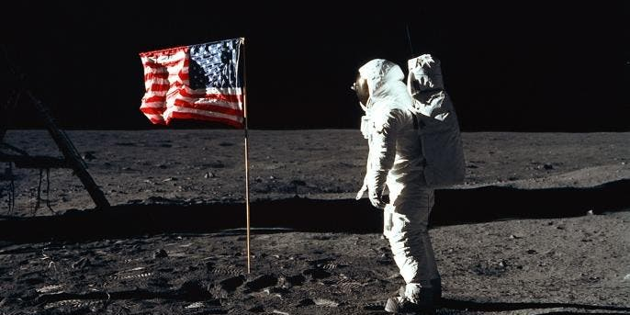NASA/NEWSMAKERS/GETTY IMAGES

**Table of Contents**

1. [JFK's Pledge Leads to Start of Apollo Program](https://www.history.com/topics/1960s/moon-landing-1969#jfk-s-pledge-leads-to-start-of-apollo-program)
2. [Timeline of the 1969 Moon Landing](https://www.history.com/topics/1960s/moon-landing-1969#timeline-of-the-1969-moon-landing)
3. [How Many Times Did the US Land on the Moon?](https://www.history.com/topics/1960s/moon-landing-1969#how-many-times-did-the-us-land-on-the-moon)

On July 20, 1969, American astronauts [Neil Armstrong](https://www.history.com/topics/space-exploration/neil-armstrong) (1930-2012) and [Edwin "Buzz" Aldrin](https://www.history.com/topics/space-exploration/buzz-aldrin) (1930-) became the first humans ever to land on the moon. About six-and-a-half hours later, Armstrong became the first person to walk on the moon. As he took his first step, Armstrong famously said, "That's one small step for man, one giant leap for mankind." The Apollo 11 mission occurred eight years after [President John F. Kennedy](https://www.history.com/topics/us-presidents/john-f-kennedy) (1917-1963) announced a national goal of landing a man on the moon by the end of the 1960s. Apollo 17, the final manned moon mission, took place in 1972.

**JFK's Pledge Leads to Start of Apollo Program**

Did the US Go to the Moon to Beat the Soviets?

Loaded: 0%

Progress: 0%

Play**Play**Unmute**Unmute**

Current Time0:07

/

Duration Time4:51

SUBTITLES**Subtitles**SETTINGS**Settings**Fullscreen

The American effort to send astronauts to the moon had its origins in an appeal President Kennedy made to a special joint session of Congress on May 25, 1961: "I believe this nation should commit itself to achieving the goal, before this decade is out, of landing a man on the moon and returning him safely to Earth."

At the time, the United States was still trailing the [Soviet Union](https://www.history.com/topics/russia/history-of-the-soviet-union) in space developments, and [Cold War](https://www.history.com/topics/cold-war/cold-war-history)-era America welcomed Kennedy's bold proposal. In 1966, after five years of work by an international team of scientists and engineers, the National Aeronautics and Space Administration (NASA) conducted the first unmanned [Apollo mission](https://www.history.com/news/10-things-you-may-not-know-about-the-apollo-program), testing the structural integrity of the proposed launch vehicle and spacecraft combination.

Then, on January 27, 1967, tragedy struck at Kennedy Space Center in Cape Canaveral, Florida, when a fire broke out during a manned launch-pad test of the Apollo spacecraft and Saturn rocket. Three astronauts were killed in the fire.

President Richard Nixon spoke with Armstrong and Aldrin via a telephone radio transmission shortly after they planted the American flag on the lunar surface. Nixon considered it the "most historic phone call ever made from the White House."

Loaded: 0%

Progress: 0%

Play**Play**Mute

Current Time0:40

/

Duration Time1:01

SUBTITLES**Subtitles**SETTINGS**HDSettings**Fullscreen

Apollo 11: JFK’s Secret Space Tapes

Despite the setback, NASA and its thousands of employees forged ahead, and in October 1968, Apollo 7, the first manned Apollo mission, orbited Earth and successfully tested many of the sophisticated systems needed to conduct a moon journey and landing.

In December of the same year, Apollo 8 took three astronauts to the far side of the moon and back, and in March 1969 Apollo 9 tested the lunar module for the first time while in Earth orbit. That May, the three astronauts of Apollo 10 took the first complete Apollo spacecraft around the moon in a dry run for the scheduled July landing mission.

**Timeline of the 1969 Moon Landing**

At 9:32 a.m. EDT on July 16, with the world watching, Apollo 11 took off from Kennedy Space Center with astronauts Neil Armstrong, Buzz Aldrin and Michael Collins (1930-) aboard. Armstrong, a 38-year-old civilian research pilot, was the commander of the mission.

After traveling 240,000 miles in 76 hours, Apollo 11 entered into a lunar orbit on July 19. The next day, at 1:46 p.m., the lunar module Eagle, manned by Armstrong and Aldrin, separated from the command module, where Collins remained. Two hours later, the Eagle began its descent to the lunar surface, and at 4:17 p.m. the craft touched down on the southwestern edge of the Sea of Tranquility. Armstrong immediately radioed to Mission Control in Houston, Texas, a now-famous message: "The Eagle has landed."

At 10:39 p.m., five hours ahead of the original schedule, Armstrong opened the hatch of the lunar module. As he made his way down the module's ladder, a television camera attached to the craft recorded his progress and beamed the signal back to Earth, where hundreds of millions watched in great anticipation.

[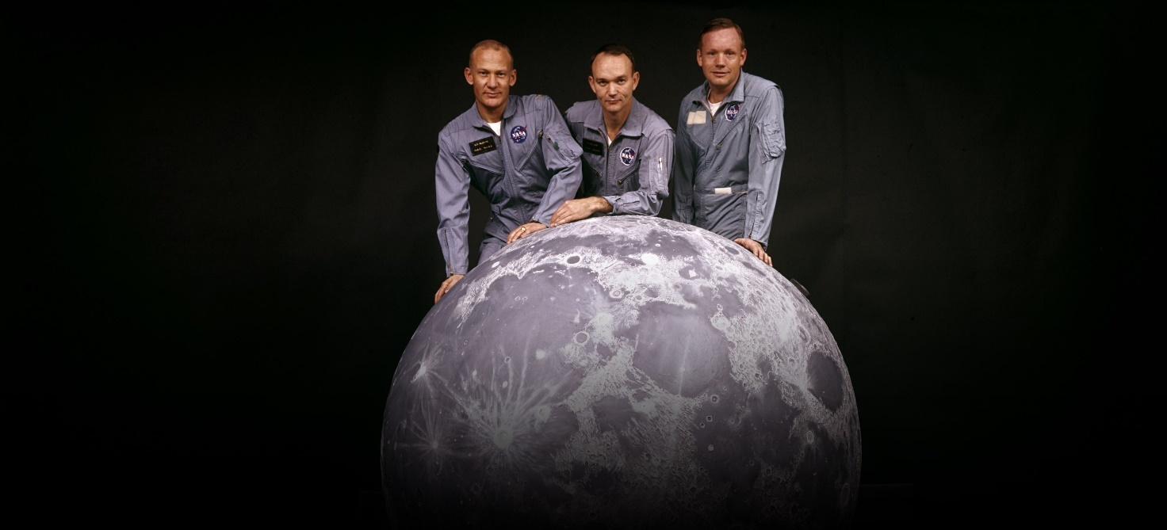](https://www.history.com/news/apollo-11-moon-landing-timeline)

FEATURED

[**Apollo 11 Moon Landing Timeline: From Liftoff to Splashdown**](https://www.history.com/news/apollo-11-moon-landing-timeline)

Neil Armstrong’s celebrated “one small step” was far from the most dangerous maneuver in the effort to send three men to the moon and return them home a week later. See a timeline of the entire mission.

[Read moreRead more about Apollo 11 Moon Landing Timeline: From Liftoff to Splashdown](https://www.history.com/news/apollo-11-moon-landing-timeline)

At 10:56 p.m., as Armstrong stepped off the ladder and planted his foot on the moon’s powdery surface, he spoke his famous quote, which he later contended was slightly garbled by his microphone and meant to be "that's one small step for a man, one giant leap for mankind."

Aldrin joined him on the moon's surface 19 minutes later, and together they took photographs of the terrain, planted a U.S. flag, ran a few simple scientific tests and spoke with President Richard Nixon (1913-94) via Houston.

By 1:11 a.m. on July 21, both astronauts were back in the lunar module and the hatch was closed. The two men slept that night on the surface of the moon, and at 1:54 p.m. the Eagle began its ascent back to the command module. Among the items left on the surface of the moon was a plaque that read: "Here men from the planet Earth first set foot on the moon—July 1969 A.D.—We came in peace for all mankind."

At 5:35 p.m., Armstrong and Aldrin successfully docked and rejoined Collins, and at 12:56 a.m. on July 22 Apollo 11 began its journey home, safely splashing down in the Pacific Ocean at 12:50 p.m. on July 24.

Play Video

Loaded: 0%

Progress: 0%

Replay**Replay**Mute**Mute**

Current Time1:00

/

Duration Time1:00

SUBTITLES**Subtitles**SETTINGS**HDSettings**Fullscreen

Apollo 11: Handmade Parts

**How Many Times Did the US Land on the Moon?**

There would be five more successful lunar landing missions, and one unplanned lunar swing-by. [Apollo 13](https://www.history.com/topics/space-exploration/apollo-13) had to abort its lunar landing due to technical difficulties. The last men to walk on the moon, astronauts Eugene Cernan (1934-2017) and Harrison Schmitt (1935-) of the Apollo 17 mission, left the lunar surface on December 14, 1972.

The Apollo program was a costly and labor-intensive endeavor, involving an estimated 400,000 engineers, technicians and scientists, and costing $24 billion (close to $100 billion in today's dollars). The expense was justified by Kennedy's 1961 mandate to beat the Soviets to the moon, and after the feat was accomplished, ongoing missions lost their viability.

**Apollo 11 Photos**

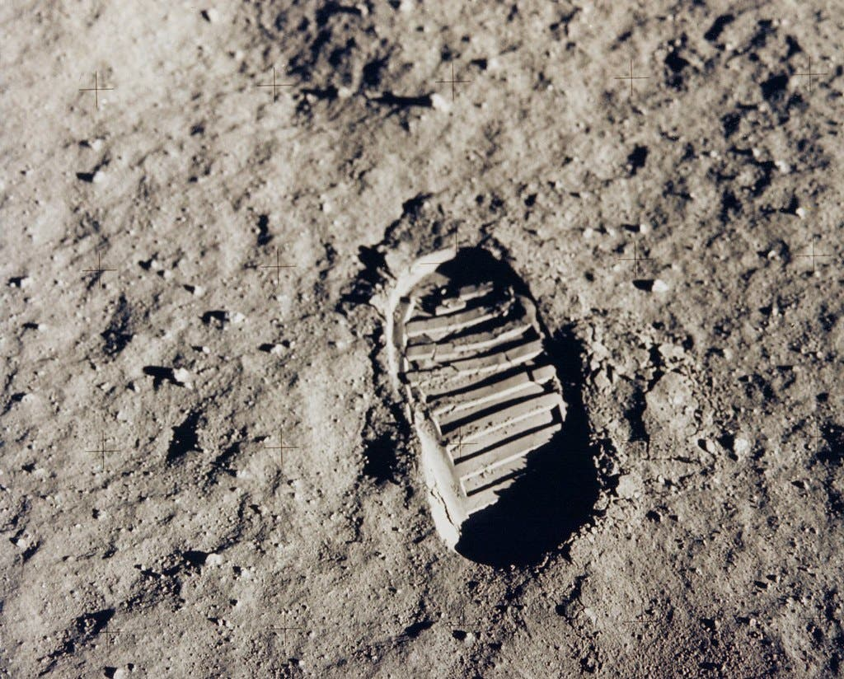

This is an image of Buzz Aldrin's bootprint from the Apollo 11 mission in 1969, one of the first steps taken on the Moon.

Apollo 12

Apollo 12 astronaut Charles "Pete" Conrad stands beside the United States flag after is was unfurled on the lunar surface during the first extravehicular activity (EVA-1), on November 19, 1969. Several footprints made by the crew can be seen in the photograph.

Apollo 14

A front view of the Apollo 14 Lunar Module "Antares", which reflects a circular flare caused by the brilliant sun. The unusual ball of light was said by the astronauts to have a jewel-like appearance.

Apollo 15

Astronaut James B. Irwin, Lunar Module pilot, works at the Lunar Roving Vehicle during the first Apollo 15 lunar surface extravehicular activity (EVA-1) at the Hadley-Apennine landing site. This view is looking northeast, with Mount Hadley in the background.

Apollo 16

Astronaut Charles M. Duke Jr., Lunar Module pilot of the Apollo 16 mission, is photographed collecting lunar samples at Station no. 1 during the first Apollo 16 extravehicular activity at the Descartes landing site. Duke is standing at the rim of Plum crater, which is 40 meters in diameter and 10 meters deep.

Apollo 17

Astronaut Eugene A. Cernan, Apollo 17 mission commander, makes a short checkout of the Lunar Roving Vehicle during the early part of the first Apollo 17 extravehicular activity (EVA-1) at the Taurus-Littrow landing site. This view of the "stripped down" Rover is prior to loadup. The mountain in the right background is the East end of South Massif.

**1 / 6:**NASA

**Exo planets**

[Researchers discover Earth-sized planet Gliese 12 b (bbc.com)](https://www.bbc.com/news/articles/c511xnyw3pyo)

Earth-sized planet discovered by researchers

5 days ago 23 May 2024

**Caroline Gall,**BBC News, West Midlands

Share

University of Warwick

The planet's distance of 40 light years away means it is too far to be reached by humans, the university said

Scientists at the University of Warwick say they have been part of an international team to discover a new habitable Earth-sized planet.

Working with Nasa and the European Space Agency (ESA), they say Gliese 12 b has the same temperature as the 2022 UK heatwave and is one of the few known rocky planets where humans could theoretically survive.

But the planet's distance of 40 lights years away means it is too far away to experience more closely, the university said.

Warwick astrophysicist Dr Thomas Wilson said: "This is a really exciting discovery and will help our research into planets similar to Earth across our galaxy."

The planet has an estimated surface temperature of about 42C, but the scientists said they were still unsure of what, if any, its atmosphere was like.

It orbits its version of the sun every 12.8 days and is a similar size to Earth.

The planet’s equivalent of the Sun, called Gliese 12, is a cool, red dwarf located in the constellation Pisces and the planet receives 1.6 times more energy from its star as Earth does from the sun, the university said.

The team used data from Nasa and ESA’s satellites to confirm the planet’s existence and characteristics like its size, temperature and distance away from Earth.

"Thrillingly, this planet is the closest Earth-sized and temperature planet we know," Dr Wilson added.

"The light we are seeing now is from 1984 [40 years ago] – that’s how long it has taken to reach us here on Earth.

"Planets like Gliese 12 b are very few and far between, so for us to be able to examine one this closely and learn about its atmosphere and temperature is very rare."

Larissa Palethorpe, co-lead of the study and doctoral student at the University of Edinburgh and University College London, said it was a "unique candidate" for further atmospheric study to help unlock some aspects of our own solar system’s evolution.

"Earth remains habitable, but Venus does not due to its complete loss of water. Gliese 12 b’s atmosphere could teach us a lot about the habitability pathways planets take as they develop," she added.

[Where we might find aliens in the next decade (bbc.com)](https://www.bbc.com/future/article/20240308-how-the-hunt-for-alien-life-is-hotting-up)

Where we might find aliens in the next decade

12 March 2024

**By Jonathan O'Callaghan,**Features correspondent

Share

Nasa/JPL

Nasa's Perseverance rover is currently trundling around Jezero Crater on Mars to collect samples that can be sent back to Earth (Credit: Nasa/JPL)

**Forget UFOs and alien abductions, here's how scientists are really looking for life on other worlds.**

It is easy to wax lyrical about aliens. The prospect of life on other planets has [shaped much of our culture](https://www.bbc.com/future/article/20231019-the-weird-aliens-of-early-science-fiction) and continues to inspire books, TV shows, movies – and the [odd conspiracy theory](https://www.bbc.com/future/article/20230726-the-weird-incidents-piquing-nasas-interest) of course. But amongst all the fantastical visions of little green men there is a real, actual hunt for alien life taking place right now, and it is not some fringe science or controversial idea. It is a systematic process that scientists are undertaking, with results expected in as little as a decade.

To be more exact, there are multiple hunts for alien life currently underway. On Mars, a rover is [collecting samples](https://www.scientificamerican.com/article/nasas-perseverance-rover-may-already-have-evidence-of-ancient-martian-life/) that may determine if life ever existed on the red planet. Probes are visiting some of our solar system's [icy moons](https://www.scientificamerican.com/article/at-jupiter-juice-and-clipper-will-work-together-in-hunt-for-life/) to search for signs of habitability. Astronomers are also beginning to scour the atmospheres of planets beyond our own solar system for telltale elemental cocktails that hint at alien life. And, yes, we are even keeping a beady eye out for signals from any intelligent civilisation that might purposefully – or accidentally – make contact.

"I think in 10 years we'll have some evidence about whether there's anything organic on some nearby planets," says Lord Martin Rees, the UK astronomer royal. "I think we are really [on the cusp]."

Alien life, if it exists, has not made itself easily known. Early attempts to [search for extraterrestrial intelligence](https://www.bbc.com/future/article/20231025-if-alien-life-is-artificially-intelligent-it-may-be-stranger-than-we-can-imagine), called Seti, [began in the mid-20th Century](https://www.seti.org/origin-of-the-institute), with astronomers looking in vain for radio signals on other planets. Mars, which was believed in the late 19th Century to have life-harbouring [canals and rivers](https://www.space.com/13197-mars-canals-water-history-lowell.html), was discovered to be a mostly dry, barren wasteland. Planets around other stars, meanwhile, were so small that finding them was difficult, let alone learning much about them.

To hunt for alien life we have had to fine-tune how we search for it, and prepare for the possibility that any initial detection is likely to be perhaps somewhat small – evidence of microbes or chemical markers in a distant atmosphere. Compared to the Hollywood vision of first contacts with extra-terrestrial life, it might seem anticlimactic, but hard evidence that life exists beyond the boundaries of our own planet will still fundamentally [alter our view of our place in the Universe](https://www.bbc.com/future/article/20161215-if-we-made-contact-with-aliens-how-would-religions-react).

Nasa

Two spacecraft are due to visit the icy moon Europa to study the extent of the ocean that exists beneath its fractured surface (Credit: Nasa)

In our solar system, Mars is arguably the most popular destination to hunt for life, at present. We know the planet [was likely wet](https://mars.nasa.gov/mer/mission/science) and potentially habitable billions of years ago, with seas and lakes on its surface. More recently scientists have even found tantalizing clues that there may be liquid water on Mars still, [hidden beneath the planet's southern ice cap](https://www.science.org/doi/10.1126/science.aar7268).

Currently, Nasa's Perseverance rover is scooping up samples from the now-dry bed of what was thought to be once a lake in a region called Jezero Crater, just to the north of the Martian equator. The goal is to collect dozens of samples and return these to Earth in the early 2030s – a mission known as Mars Sample Return – where they can be investigated in detail for signs of life. The mission is currently facing difficulties, with the return aspect [struggling for funding](https://aerospaceamerica.aiaa.org/features/nasa-faces-its-mars-conundrum/). But if they can pull it off, there are scientific riches in store.

Susanne Schwenzer, a planetary scientist at The Open University in the UK and a member of the Mars Sample Return science team, says the presence of past life on Mars could leave a fingerprint in the interaction of its rocks and water. "If you have life, things look very different," she says. "If we have the samples from Mars, we can go into miniature detail to study these processes."

It's possible some of the samples could even contain fossilised microbes inside the rocks. "I as a scientist wouldn't have spent my life on this if I weren't hopeful that we have a good chance of finding something," says Schwenzer. "I hope we will find something, but I can't predict it."

*If we were to find life on the icy moons, we would be sure this is a different genesis of life from Earth – Susanne Schwenzer*

But even if signs of life on Mars were to be detected, it would not be unequivocal proof of widespread alien life elsewhere in the universe. Mars and Earth are known to have [shared material early in their history](https://adsabs.harvard.edu/full/1993Metic..28Q.398M), meaning they might also have shared the genesis of life. For evidence of a true second genesis, proof that life arose for a second time independently on another world, scientists are looking to the solar system's icy moons such as Jupiter's [Europa](https://europa.nasa.gov/why-europa/evidence-for-an-ocean/) and Saturn's [Enceladus](https://science.nasa.gov/saturn/moons/enceladus/), thought to contain vast oceans beneath their frozen surfaces. "If we were to find life on the icy moons, we would be sure this is a different genesis of life from Earth," says Schwenzer. (*Read more about*[*what life in alien oceans might be like*](https://www.bbc.com/future/article/20190926-what-life-might-be-like-in-the-alien-oceans).)

A Nasa spacecraft called Europa Clipper is due to launch to Europa in October, [following a European spacecraft](https://www.bbc.co.uk/news/live/science-environment-65258309/page/2), Juice, which launched in April 2023. Set to arrive in 2030 and 2031, the two spacecraft are not likely to detect life on Europa. But they will study the extent of its ocean, and set the stage for a future mission that might try to burrow beneath the ice sheet – such as an ongoing Nasa proposal called [Europa Lander](https://www.jpl.nasa.gov/missions/europa-lander) that remains on the drawing board – or fly through plumes that might be ejected from the moons' oceans into space, to look for life.

Actually getting a machine into the ocean of one of these worlds is a "100-year-problem", says Britney Schmidt, an astronomer at Cornell University in New York, because of the difficulties of getting through the multi-kilometeres-thick ice. But "getting into the ice shell and interacting with liquids is something we could do" more near-term, she says. "That's the kind of mission I would like to see happen. Our group is working on instruments and technologies so we know when we get there what to do."

Getty Images

Recent research using radar from orbiting satellites has suggested there may be liquid water beneath the Martian southern ice cap (Credit: Getty Images)

If you aren't quite ready to wait 100 years, then you might want to cast your gaze to other solar systems. We now know of more than [5,500 planets around other stars](https://exoplanets.nasa.gov/discovery/exoplanet-catalog/), known as exoplanets, and more continue to trickle in every day. With the immense power of new telescopes, most notably [the James Webb Space Telescope](https://webb.nasa.gov/) (JWST), astronomers are now beginning to probe some of these planets in exquisite detail.

In particular, they are using JWST to see if they can work out what gases are present on some rocky exoplanets similar to Earth. JWST was not initially designed to study exoplanets when it was first drawn up [at the turn of the century](https://webbtelescope.org/news/milestones/mission-timeline), but it has since been [re-tasked with studying these worlds](https://www.nasa.gov/missions/webb/nasas-webb-confirms-its-first-exoplanet/), being the largest space telescope in history and thus our best machine to do so.

It cannot study Earth-like worlds around stars like our Sun. These planets are simply too dim against such bright stars for even JWST to study, and will require a more advanced telescope such as Nasa's [Habitable Worlds Observatory](https://science.nasa.gov/astrophysics/programs/habitable-worlds-observatory/), set to launch in the 2040s to investigate them. But JWST can study planets around small stars called red dwarfs, and right now it is flexing its capabilities with a fascinating system called TRAPPIST-1, which contains [seven Earth-sized worlds](https://www.bbc.co.uk/news/science-environment-39034050). At least three of the planets orbit in the star's habitable zone, where liquid water – and life – could exist.

The first step is for astronomers to confirm if these planets have atmospheres. Research with JWST to make this determination is currently underway, with results expected later this year or in 2025. Initial results have shown that the innermost planet likely [lacks an atmosphere](https://iopscience.iop.org/article/10.3847/2041-8213/acf7c4) required for life, but if atmospheres can be found on the other TRAPPIST-1 planets it would be a monumental discovery says Jessie Christiansen, an astrophysicist at Nasa's Exoplanet Science Institute at the California Institute of Technology in the US. "The next 20 years of exoplanet search will depend on that result," she says. "If red dwarf planets have atmospheres, we will point every telescope on Earth at these planets to try and see something."

If we can find those atmospheres, JWST [will be used](https://www.scientificamerican.com/article/jwst-will-finally-hunt-for-alien-moons-and-much-more/) to look for signs of biosignatures in atmospheres that might hint at life. "We'll be looking for disequilibrium chemistry," says Christiansen. "You can make carbon dioxide, methane, and water on [any] planet. But having them in ratios where they can't be maintained naturally, that's where you start to say biology is involved."

8:16

Watch: Why are some people obsessed with UFOs?

Future telescopes, like the Habitable Worlds Observatory and a [European proposal called Life](https://life-space-mission.com/), will then try to perform this same analysis for true Earth-analogue planets around stars like our Sun. "The driving planetary class will be rocky planets in the habitable zone," says Sascha Quanz, an astrophysicist at ETH Zürich in Switzerland who leads the Life program.

And then there's the hunt for intelligent life. Jason Wright, an astronomer at The Pennsylvania State University in the US, says much of the low-hanging fruit has been picked. Radio observations have shown that, within about 100 light-years of Earth, powerful beacons pointed in our direction "don't seem to exist", says Wright. Now, programs like [Breakthrough Listen](https://breakthroughinitiatives.org/initiative/1) in the US are casting their gaze further afield. They are looking for directed radio signals coming from more distant planets in our galaxy, and are even starting to look for accidental communications leakage from planets like that which is emitted from Earth.

*You might also like:*

* [What alien langauges might sound like](https://www.bbc.com/future/article/20231027-alien-language-if-we-met-extraterrestrials-could-we-talk-to-them)
* [Why alien life might be plant life](https://www.bbc.com/future/article/20231026-the-scientists-looking-for-alien-vegetation)
* [Could we detect alien pollution](https://www.bbc.com/future/article/20231023-could-we-find-alien-life-via-their-pollution)

Upcoming telescopes, most notably a vast new radio telescope set to come online in 2028 called the [Square Kilometer Array](https://www.skao.int/en), a group of thousands of radio antennas [spread across two continents](https://www.space.com/square-kilometre-array-observatory-skao), should significantly expand this search. "That's really exciting," says Wright. But even with modern radio telescopes a detection could come "at any moment", says Wright.

Nasa

There are at least three planets orbiting around the red dwarf TRAPPIST-1 that exist in the stars "habitable zone" where liquid water could exist (Credit: Nasa)

If we do find evidence of alien life, whether that's in our solar system, on an exoplanet, or from an intelligent civilisation, that evidence is unlikely to be a slam-dunk. It will more likely be a [gradual process](https://www.scientificamerican.com/article/how-scientists-could-tell-the-world-if-they-find-alien-life/) to the point where life seems like the most likely explanation. "The more information you have, the more you're in a position to rule out false positives," says Quanz.

Thus, the discovery of alien life might not be a single defining moment. How the public reacts to that possibility is an interesting question, says Rees. "If it's tentative, that should be made clear by the scientists," he says. "One hopes it would be reflected in any newspaper reports." Recent examples include the detection of [phosphine on Venus](https://www.bbc.co.uk/news/science-environment-57641247) and [dimethyl sulfide on an exoplanet](https://www.theguardian.com/science/2023/sep/11/nasa-planet-ocean-life-james-webb-telescope), both hotly debated hints of biology that remain extremely uncertain.

There remains the other possibility, too, that all of these searches will turn up empty. That in itself will be an interesting scientific result, telling us that alien life – if it exists at all – is not common in the Universe.  "A null result tells you something fundamentally important" about life, says Quanz. "Maybe it's really rare."

--

[If alien life is artificially intelligent, it may be stranger than we can imagine (bbc.com)](https://www.bbc.com/future/article/20231025-if-alien-life-is-artificially-intelligent-it-may-be-stranger-than-we-can-imagine)

If alien life is artificially intelligent, it may be stranger than we can imagine

26 October 2023

**By Martin Rees,**Features correspondent

Share

Getty Images

Alien AI may be stranger than we can imagine (Credit: Getty Images)

**We've long assumed that aliens will be like us, but there's every reason to think they are instead a form of unfathomable AI, says the UK astronomer royal Lord Martin Rees.**

It's taken more than four billion years for intelligent life to emerge by natural selection on Earth, but there are billions more years ahead in our planet's lifetime. Over that time, intelligence could develop in entirely new directions.

Comment & Analysis

*Lord Martin Rees is the UK's Astronomer Royal, and is based at the University of Cambridge. His most recent books are*[*If Science is to Save Us*](https://www.wiley.com/en-gb/If+Science+is+to+Save+Us-p-9781509554201)*, and*[*The End of Astronauts*](https://www.hup.harvard.edu/catalog.php?isbn=9780674257726)*, co-authored with Donald Goldsmith.*

We human beings may be near the end of Darwinian evolution – no longer required to become the fittest to survive – but technological evolution of artificially intelligent minds is only just beginning. It may be only one or two more centuries before humans are overtaken or transcended by inorganic intelligence. If this happens, our species would have been just a brief interlude in Earth's history before the machines take over.

That raises a profound question about the wider cosmos: are aliens more likely to be flesh and blood like us, or something more artificial? And if they are more like machines, what would they be like and how might we detect them?

**Not like us**

Many assume that human beings are the peak of intelligence, but it's possible that our species may represent a stage on the path towards minds that are more artificial. This could explain why the cosmos seems so empty of life like us. If an evolutionary transition to non-organic intelligence is inevitable across the Universe, our telescopes would be most unlikely to catch human-like intelligence in the sliver of time when it was still embodied in that form. It is perhaps more likely that the aliens would be the remote electronic progeny of other organic creatures that existed long ago.

Getty Images

In the classic movie The Day The Earth Stood Still, one of the aliens is a robot - but still humanoid (Credit: Getty Images)

The prospect of inorganic alien intelligence raises some striking possibilities. If these beings are out there, they would act and think totally differently to us. They may not want to be detected. Indeed, their intentions may be impossible to fathom. To quote Charles Darwin, "A dog might as well speculate on the mind of [Isaac] Newton." However, we might deduce a few things.

For one, non-organic intelligence may have no use for an atmosphere, or the planet on which they originated. Interstellar voyages – or even intergalactic voyages – would hold no terrors for near-immortals.

Indeed, they may prefer to live in zero-gravity, because there you can make very large, very lightweight objects. If you wanted to build a huge, elaborate gossamer-thin structure to harvest energy, for example, it's easier in space than on a planet.

*If they have silicon-based brains, they might realise they could expend less energy in colder regions away from planetary systems*

It's also not obvious that they would need to live in orbit around a star. Perhaps they'd have new ways of getting energy that we just can't envisage yet. If they have silicon-based brains, they might realise that the energy needed for processing "bits" is less at low temperatures, so they would expend less energy in colder regions away from planetary systems. They might even choose to hibernate for billions of years until the [cosmic microwave background](https://www.esa.int/Science_Exploration/Space_Science/Herschel/Cosmic_Microwave_Background_CMB_radiation) – the leftover radiation from the Big Bang – is further cooled by the continuing expansion of the Universe.

STScI/Nasa

We look to the galaxies for life, but could AI aliens live in the cold inbetween? (Credit: STScI/Nasa)

They may not have the same base desires as us. We have evolved through Darwinian pressures to be an expansionist species. Selection has favoured intelligence but also aggression. But if Darwinian pressures do not apply to these artificial entities, there's no reason why they should be aggressive. They may just want to think deep thoughts.

The fact we haven't seen any, and haven't been invaded by them, doesn't mean there's nothing out there. They may simply be more contemplative. We can't assess whether the "great silence" of the cosmos signifies their absence, or simply their preference.

*We can't assess whether the "great silence" of the cosmos signifies their absence, or simply their preference*

We also can't assume that they'd even be a "civilisation". On Earth, this term connotes a society of individuals: in contrast, ET might be a single integrated intelligence.

Pessimistically, they could be what philosophers call "zombies". It's unknown whether consciousness is special to the wet, organic brains of humans, apes and dogs. Might it be that electronic intelligences, even if their intellects seem superhuman, lack self-awareness or inner life? If so, they would be alive, but unable to contemplate themselves, or the beauty, wonder and mystery of the Universe. A rather bleak prospect.

Alternatively, their more advanced intelligence could well allow them to understand crucial aspects of reality that we cannot, just as a monkey can't understand quantum theory. There could be complexities to the Universe that neither our intellect nor our senses can grasp, but electronic brains may have a quite different perception.

**Implications for searching**

If alien intelligence is more likely to be non-organic, what would this mean for the [Search for Extraterrestrial Intelligence](https://www.seti.org/seti-research) (Seti)?

In a decade or two, there's a realistic prospect that we'll have the capability to detect biosignatures on other planets – atmospheric chemistry or vegetation, for example. But to detect artificial life, we would need to look for "technosignatures", such as electromagnetic transmissions. (*Read more about*[*how astronomers are looking for life on other worlds*](https://www.bbc.com/future/article/20231024-how-aliens-might-detect-our-existence-on-earth).)

Getty Images

The Green Bank telescope in West Virginia has monitored a bizarre cigar-shaped object called Oumuamua (Credit: Getty Images)

The focus of Seti has been on the radio part of the spectrum. But of course, in our state of ignorance about what might be out there, we should explore all wavebands: the optical and X-ray band. Even if messages were being transmitted, we may not recognise them as artificial because we may not know how to decode them. Consider the difficulty a veteran radio engineer familiar only with the amplitude-modulation of the 20th Century might have decoding modern wireless communication.

Finding non-organic intelligence also means being alert to evidence of non-natural phenomena or activity – even within our own Solar System. It was right that the Green Bank telescope stayed pointed at [Oumuamua](https://www.bbc.com/future/article/20210506-the-interstellar-voyagers-that-visited-our-sun), the anomalous object that passed through our neighbourhood recently and is believed to have originated from outside our Solar System. It’s also worth keeping an eye open for especially shiny or oddly-shaped objects lurking among the asteroids. We may also need to seek evidence for [non-natural construction projects](https://www.bbc.com/future/article/20210113-the-megascale-structures-that-humans-could-one-day-build), such as a "Dyson Sphere", a giant, hypothetical energy-harvesting structure built around a star.

In sum, astronomers like me should expect surprises. We ought to be open-minded and make sure that we wouldn't miss anything odd.

**You may also like:**

* [Could we find alien life via its pollution?](https://www.bbc.com/future/article/20231023-could-we-find-alien-life-via-their-pollution)
* [The weird aliens of early science fiction](https://www.bbc.com/future/article/20231019-the-weird-aliens-of-early-science-fiction)
* [Seven things science has revealed about aliens so far](https://www.bbc.com/future/article/20231020-seven-surprising-things-we-now-know-about-aliens)

Scientists still don't know whether the origin of life is rare, and only happened here on Earth. But if that's not the case, and if life gets started elsewhere, then intelligence could evolve in all sorts of ways. There are planetary systems out there that are [at least a billion years older than our own](https://iopscience.iop.org/article/10.1088/0004-637X/799/2/170), so it's possible that intelligence has already developed into something nonorganic.

Perhaps whatever is out there doesn't evolve by Darwinian selection: it would be what I call "secular intelligent design" that's a bit like machines designing better machines. And while it may not be broadcasting its existence to us, it could be found throughout the Universe.

*\*This article is as told to Richard Fisher. Lord Martin Rees is the UK's Astronomer Royal, and is based at the University of Cambridge. His most recent books are*[*If Science is to Save Us*](https://www.wiley.com/en-gb/If+Science+is+to+Save+Us-p-9781509554201)*, and*[*The End of Astronauts*](https://www.hup.harvard.edu/catalog.php?isbn=9780674257726)*, co-authored with Donald Goldsmith.*

--

Stars and stardust

Telescopes.

What is the James Webb telescope

[James Webb Space Telescope: How will it work? - BBC News (youtube.com)](https://www.youtube.com/watch?v=Gx4uq83GSrE)

And in more detail

([The James Webb Space Telescope Explained In 9 Minutes (youtube.com)](https://www.youtube.com/watch?v=tnbSIbsF4t4))

What it has discovered?

[James Webb Space Telescope's discoveries 2 years since launch (youtube.com)](https://www.youtube.com/watch?v=SnqTLCt9yvQ)

([Incredible Discoveries Of The James Webb Telescope | Universe Explorers | BBC Earth Science (youtube.com)](https://www.youtube.com/watch?v=AvioLeO8Weo))

Galileo

**Great Minds of Astronomy: Cecilia Payne-Gaposchkin** [Bing Videos](https://www.bing.com/videos/riverview/relatedvideo?q=Cecilia+Payne-Gaposchkin&mid=0D37D1254B3C27FB156C0D37D1254B3C27FB156C&FORM=VIRE)

Dark matter

Starlight is history

Satellites

[US says Russia likely launched space weapon (bbc.com)](https://www.bbc.com/news/articles/cq55ww5j7e2o)

**Rockets and Exploration**

Starliner

[Starliner: The US space industry's next big thing? (bbc.com)](https://www.bbc.com/future/article/20240502-starliner-the-us-space-industrys-next-big-thing)

Starliner: The US space industry's next big thing?

3 May 2024

**By Richard Hollingham**

Share

Nasa

Starliner (Credit: Nasa)

**Astronauts are preparing for launch in Boeing's new Starliner. What does the spacecraft mean for the future of the US space programme?**

When the Space Shuttle Atlantis rolled to a stand on the runway at Kennedy Space Centre in 2011, ending 30 years of the manned shuttle programme, it left Nasa with a problem. Without enough government funding to build a replacement while the shuttle was still flying, the US had no means of launching its astronauts into orbit.

The only way to fly a crew to its own orbiting laboratory on the International Space Station (ISS) was to pay some $80m (£64m) for a seat in a cramped [Russian Soyuz capsule](https://www.esa.int/Enabling_Support/Space_Transportation/Launch_vehicles/The_Russian_Soyuz_spacecraft).

It seemed extraordinary to many that the nation that had landed men on the Moon, built and serviced – in orbit, no less – the [Hubble Space Telescope](https://science.nasa.gov/mission/hubble/) and assembled a giant space station was now relying on a 45-year-old spacecraft built by its Cold War rival.

As relations deteriorated following Russia's [invasion of Crimea in 2014](https://www.bbc.co.uk/news/world-europe-26644082), the embarrassment was further compounded by tweets from Russia's Deputy Prime Minister Dmitry Rogozin.

Responding to the introduction of restrictions on US technology exports he wrote: "After analysing the sanctions against our space industry I suggest the US delivers its astronauts to the ISS with a trampoline." In case that message was too subtle, he also posted a picture of a trampoline with a Nasa badge.

Nasa

Starliner made its maiden launch in December 2019 but the programme was affected by the Covid pandemic (Credit: Nasa)

But Nasa had a long-term plan – the Commercial Crew Program (CCP) – and, after 13 years, the first crewed launch of Boeing's Starliner spacecraft means it is finally being fully realised. The viability of the CCP model, not to mention Boeing's already [fragile reputation](https://www.bbc.co.uk/news/business-68573686) depend on a successful test flight.

**"**It's been a long road to get here," says Makena Young, a fellow with the Aerospace Security Project at the Center for Strategic and International Studies in Washington DC. "I think it's a reminder that although we have a good record, space is still really difficult and it's hard to be successful."

The idea behind the CCP is that instead of Nasa designing, building and owning its spacecraft, it buys seats from commercial operators. You could liken it to purchasing a seat on an aeroplane, albeit a seat that costs more than $55m (£44m) for a return trip and involves billions of dollars of taxpayer investment to construct the vehicle in the first place.

*Boeing's Starliner website reads like a car brochure*

After funding the initial development of five potential commercial spacecraft, Nasa narrowed the field down to two in 2014 (you can see the [timeline and all the costings here](https://www.nasa.gov/humans-in-space/commercial-space/commercial-crew-program/commercial-crew-program-essentials/)): aerospace behemoth Boeing's Starliner, and space upstart SpaceX with its Crew Dragon.

By the end of 2019, the race to launch between the two space rivals appeared to be neck and neck. Then, following a near-disastrous test flight of the first [uncrewed Starliner in December that year](https://www.bbc.co.uk/news/science-environment-50855395), and a series of subsequent hardware failures to the Boeing craft during further testing, SpaceX took the lead. In May 2020, the first [Crew Dragon](https://www.bbc.co.uk/news/science-environment-52840482) lofted Nasa astronauts Doug Hurley and Bob Behnken into orbit.

Meanwhile, Starliner's pioneer astronauts, Barry "Butch" Wilmore and Suni Williams, have been patiently waiting a further four years for their chance to fly a week-long mission to the ISS in what Boeing promises will be a "next generation space capsule".

Boeing

Starliner will be able to take up to seven people into space (Credit: Boeing)

Boeing's [Starliner website](https://www.boeing.com/space/starliner) reads like a car brochure, reflecting its commercial proposition. The reusable spacecraft promises customers precision software, advanced "cruise control" and a spacious interior. In fact, the capsule (and it is more of a capsule than anything resembling an ocean liner) can carry up to seven crew, although typically under contract to Nasa it will ferry four people to the ISS.

Boeing has also designed new blue-coloured spacesuits, overtly distinctive to Dragon's monochrome designs. Offered in a range of sizes, the suits promise astronauts greater comfort and flexibility.

"They've spent a lot of time, a lot of Nasa money as well as their own money to get this across the finish line," says Young. "Being able to successfully and safely deliver this crew to the ISS will be a really big accomplishment and show that all that time, money and effort has been worth it."

*Nasa very much wants to establish a market for low-Earth orbit – Jason Davis*

For Boeing and SpaceX's primary customer, Nasa, the benefit of having two commercial providers flying two different spacecraft almost guarantees sovereign access to space. Even if one spacecraft is grounded for some reason, the other is likely to be available.

"Nasa always wanted two providers, but it was very big unknown at the time [CCP was conceived] whether or not these companies could actually deliver," says Jason Davis, senior editor for the [Planetary Society](https://www.planetary.org/). "It's a big deal for Nasa because this validates a strategy that they've put in place almost two decades ago."

The competition should also drive down prices for both the agency but also other potential clients, opening up human spaceflight to a growing number of commercial operators.

Getty Images

SpaceX's Starship is another US spacecraft which the US space industry could one day use (Credit: Getty Images)

"Nasa very much wants to establish a market for low-Earth orbit," says Davis. "So that crew and cargo transportation becomes independent from them."

Now, for the first time in history, if a company wants to buy a seat on a spacecraft – or even hire a whole capsule – they have a choice of providers. Texas-based [Axiom Space](https://www.axiomspace.com/) has already chartered three private flights in Crew Dragon spacecraft to the ISS and is planning several more including a possible UK mission flown by an [all-British crew](https://www.bbc.co.uk/news/science-environment-67207375). In future, it is hoped that Dragon and Starliner could also ferry astronauts to and from privately operated space stations.

**"**The [ISS will be retired sometime around the end of this decade](https://www.bbc.com/future/article/20230502-a-fiery-end-how-the-iss-will-end-its-life-in-orbit), and it will be replaced by [a number of [private] space stations](https://www.bbc.com/future/article/20230512-what-will-replace-the-international-space-station)," says Libby Jackson, head of space exploration at the [UK Space Agency](https://www.gov.uk/government/organisations/uk-space-agency). "These stations will still have anchor customers in the form of Nasa or the European Space Agency (Esa), but there are opportunities to develop new materials, new drugs that you could only manufacture in space – I'm really excited to see what opportunities that free market thinking will bring."

*China is increasingly being seen as the world's second space superpower*

But although access to space is increasingly about competition between companies, when it comes to human spaceflight, geopolitics and national pride are still important. Despite the war in Ukraine, the [US is still co-operating with Russia on the ISS](https://www.bbc.com/news/world-europe-62308069) and US astronauts are still flying in Soyuz capsules and Russians in Crew Dragon. When that agreement comes to an end, and unless there are some major political changes in Moscow, the US and Russia will once again become rivals.

Soyuz, however, will be more than 60 years old by that time, so it is not Russia that the US will be worrying about. With its own space station, new spacecraft and plans for crewed missions to the Moon, China is increasingly being seen as the world's second space superpower.

**More like this:**

• [The other nations with the Moon in their sights](https://www.bbc.com/future/article/20240216-moon-race-20-why-so-many-nations-are-aiming-for-lunar-landings)

• [Reviving the reusable spaceplane](https://www.bbc.com/future/article/20210121-spaceplanes-the-return-of-the-reuseable-spacecraft" \t "_self)

• [Artemis: the mission that will set new space records](https://www.bbc.com/future/article/20220927-artemis-i-a-giant-rocket-to-set-new-space-records)

**"**China has really emerged as a powerful nation in space," says Young. "We regard them as the number two behind the US in our annual strategic assessments."

**"**Being able to have these resilient, robust, reliable, ways to get into low-Earth orbit for the US is incredibly important in maintaining that strategic advantage and being able to show the world that we have more than one way to get to space," she says.

After the successful [unmanned flight of its Orion capsule](https://www.bbc.com/news/science-environment-63866949) ahead of its planned [Artemis lunar missions](https://www.bbc.com/future/article/20220927-artemis-i-a-giant-rocket-to-set-new-space-records) the US has gone from having no spacecraft in 2011 to three in 2024.

No need for that trampoline now.

SpaceX launch

[SpaceX launch: Starship rocket launches on third test flight (bbc.com)](https://www.bbc.com/news/science-environment-68565986)

SpaceX launch: Starship rocket launches on third test flight

Elon Musk's SpaceX company has conducted a third test flight of the most powerful rocket ever built.

The Starship vehicle lifted off successfully from its base in south-east Texas at around 08:25 local time (13:25 GMT) and went "faster and further" than before, the SpaceX team said in its live stream.

It is hoped that the 120m-tall (393ft) Starship will usher in a revolution in space transportation, radically lowering the cost of putting people and objects into orbit.

Thursday's test flight followed missions in April and November of last year, neither of which made it many minutes beyond the point of lift-off.

Read more: [Elon Musk's Starship goes 'farther than ever'](https://www.bbc.co.uk/news/science-environment-68547482)

14 March 2024

[Elon Musk's Starship goes 'farther than ever' (bbc.com)](https://www.bbc.com/news/science-environment-68547482)

Elon Musk's Starship goes 'farther than ever'

14 March 2024

**By Jonathan Amos,**Science correspondent

Share

1:11

SpaceX launches Starship for the third time

**US company SpaceX's Starship rocket made major progress in its third test flight on Thursday, completing many of its objectives.**

The two-stage vehicle produced a clean getaway from its Texas launch site, to send its upper portion around the globe to a re-entry over the Indian Ocean.

Radio contact was lost towards the end but the firm said it was "incredible to see how far we got this time around".

SpaceX boss Elon Musk was delighted with the outcome of the flight, too.

He posted on X, formerly Twitter, that "Starship will take humanity to Mars".

* [Who is Elon Musk?](https://www.bbc.co.uk/news/business-61234231)
* [Europe to develop commercial space capsule](https://www.bbc.co.uk/news/science-environment-67339057)
* [Plan to send all-UK astronaut mission into orbit](https://www.bbc.co.uk/news/science-environment-67207375)

Reuters

Huge crowds had gathered on nearby beaches to watch the launch

When the 120m-tall (395ft) vehicle launched in April and November last year, it blew apart not long into the missions.

Mr Musk was looking for significant improvement from his SpaceX team this time - and he got it.

The rocket left its launch mount with a huge rumble from its 33 engines, and the vehicle then proceeded to step perfectly through all of the anticipated phases in the climb to space.

Separation of the bottom half, the booster, from the top half, the Ship, occurred right on cue, two minutes and 44 seconds into the flight.

The ship then powered on, crossing the Atlantic and southern Africa.

Video cameras sent back spectacular views of Earth from more than 100 miles up.

SpaceX

The Ship was aiming for a splashdown in the Indian Ocean

Then came the task of re-entry, when the ship needed to descend to a splashdown in the ocean.

Video imagery once again captured incredible scenes as hot gases enveloped the vehicle, just before radio contact was interrupted.

Controllers reported shortly after that the Ship had been "lost", presumably because it had broken up.

SPACEX

The hot gases (plasma) of re-entry surrounded the ship as it came down

Not every milestone was ticked off. It was hoped the booster after separation might have been able to power its way back to a controlled drop into the sea just off the Texas coast. It got close but it looked as though the vehicle came in way too fast and was lost before hitting the water.

The Ship, too, was expected to re-ignite an engine to initiate the re-entry, but this was skipped for a reason not immediately apparent.

These are issues that can be re-visited once all the data is in hand. The upsum, however, is that engineers now know the development of the world's most powerful rocket is firmly on track. And Elon Musk is promising perhaps six more test flights this year.

Reuters

Starship is unlike any rocket system we've seen to date.

The 33 engines at the base of the booster produce 74 meganewtons of thrust. This dwarfs all previous vehicles, including those that sent men to the Moon in the 1960s/70s.

If engineers can perfect Starship, it will be revolutionary.

The rocket is intended to be fully and rapidly reusable, to operate much like an aeroplane that can be refuelled and put back in the air in quick order.

This capability, along with the heft to carry more than a hundred tonnes to orbit in one go, would radically lower the cost of space activity.

For Elon Musk, Starship is key to his Starlink project which is establishing a global network of broadband internet satellites. The current count in orbit is more than 5,500. The new rocket will be able to put up many more spacecraft for the network.

To that end, this test flight demonstrated the opening and closing of a payload bay door, through which future Starlink satellites could be dispensed.

And Starship will also help Mr Musk realise that long-held ambition of taking people and supplies to Red Planet to build a human settlement.

Among the keenest observers on Thursday will have been the US space agency.

Starship is central to Nasa's Artemis programme to put astronauts back on the Moon this decade.

A version of Starship would act as the landing craft, taking the crew from lunar orbit down to the surface - and then lifting them back off again.

SpaceX will have to show it can produce a safe and reliable vehicle before astronauts are permitted to climb aboard. Nasa has scheduled late 2026 for when it would like to see this happen.

Bill Nelson, the Nasa Administrator, issued a statement on X: "Congrats to @SpaceX on a successful test flight! Starship has soared into the heavens. Together, we are making great strides through Artemis to return humanity to the Moon — then look onward to Mars."

The Federal Aviation Administration, which licenses commercial spaceflight in the US, immediately announced there would be a mishap investigation following the mission, given the way the booster and Ship ended their flights. This is standard practice, and SpaceX will lead the inquiry into what it got right and what it got wrong. This, too, is standard practice.

Very good podcasts and possible project topics

[BBC Sounds - Space - Available Episodes](https://www.bbc.co.uk/sounds/series/p03bv899)