Guns and USA

Page 2 Statistics

Page 3 Coronavirus cause spike in gun sales

Page 7 13-year-old buys gun,

Page 8 Iowa boy, 12, 'tries to shoot teacher in face'

Page 9 Six-year-old shoots teacher

Page 12 I accidentally shot my little sister

Page 13 Florida school shooting

Page 22 Parkland 2 years on 2020 election + Emma González 2020

Page 23 How many US mass shootings have there been in 2023?

Page 30 What type of Guns kill Americans

Page 35 Random pictures

Page 37 Uvalde school shooting (19 small kids and 2 teachers)

Page 38 Matthew McConaughey brings dead girl's shoes to White House

Page 33 Republican party response to shootings etc.

Page 40 Joe

Page 45 Parkland gunman's brain irretrievably broken, jury hears

Page 49 Parkland school shooter sentenced

Page 58 Ethan Crumbley: Parents of Michigan school gunman sentenced to at least 10 years

Page 62 Kyle Rittenhouse and Ahmaud Arbery

Page 63 Four films (inclusive Kip Kinkel)

Page 64 Emma G surplus texts

[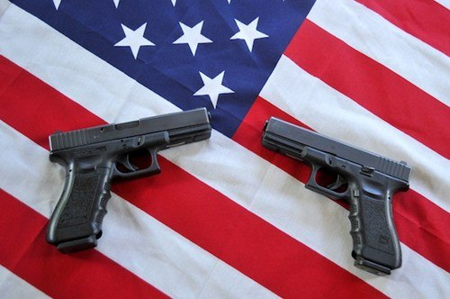](https://www.google.dk/url?sa=i&rct=j&q=&esrc=s&source=images&cd=&cad=rja&uact=8&ved=2ahUKEwizs_-1nfLbAhXLyaQKHfXFCCUQjRx6BAgBEAU&url=https%3A%2F%2Fwww.wonderslist.com%2F10-facts-about-guns-in-the-usa%2F&psig=AOvVaw2zjxU22wzJdzYIc-7NTsmq&ust=1530133440194861)[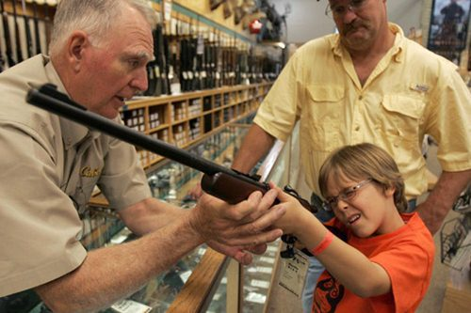](https://www.google.dk/url?sa=i&rct=j&q=&esrc=s&source=images&cd=&cad=rja&uact=8&ved=2ahUKEwiI-8LEnfLbAhWF6qQKHRnyDywQjRx6BAgBEAU&url=http%3A%2F%2Fwww.opinionnigeria.com%2Fguns-in-the-usa-by-minabere-ibelema%2F&psig=AOvVaw2zjxU22wzJdzYIc-7NTsmq&ust=1530133440194861)

[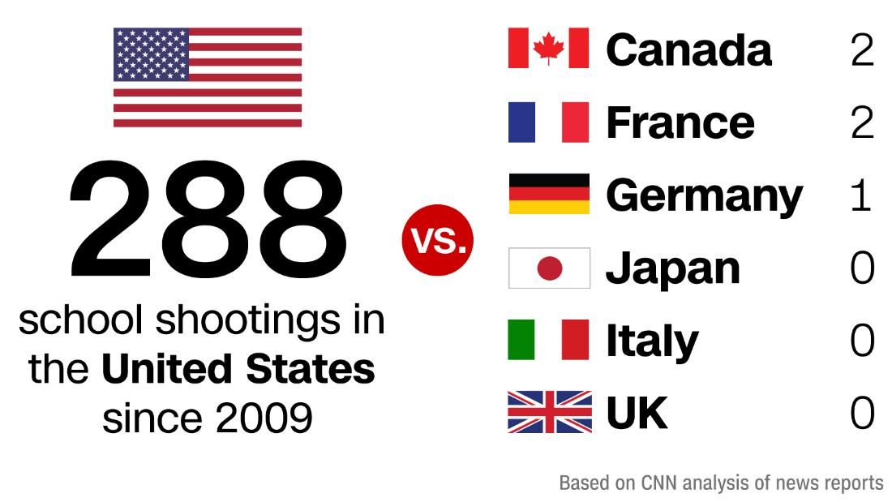](https://www.google.dk/url?sa=i&rct=j&q=&esrc=s&source=images&cd=&cad=rja&uact=8&ved=2ahUKEwiOtu7NnvLbAhURDuwKHVqIAE4QjRx6BAgBEAU&url=https%3A%2F%2Fwww.cnn.com%2F2018%2F05%2F21%2Fus%2Fschool-shooting-us-versus-world-trnd%2Findex.html&psig=AOvVaw0Ur1zSAFY4OeSFF8Y5xE0u&ust=1530133690714733)

School shootings dynamic graph

[There have been 404 school shootings since Columbine - Washington Post](https://www.washingtonpost.com/education/interactive/school-shootings-database/)

Mass shootings USA 2024

[List of mass shootings in the United States in 2024 - Wikipedia](https://en.wikipedia.org/wiki/List_of_mass_shootings_in_the_United_States_in_2024)

<https://www.bbc.com/news/world-us-canada-52189349>

# How the coronavirus led to the highest-ever spike in US gun sales

By Max MatzaBBC News, Washington

* 6 April 2020[**Coronavirus pandemic**](https://www.bbc.com/news/topics/cyz0z8w0ydwt/coronavirus-pandemic)

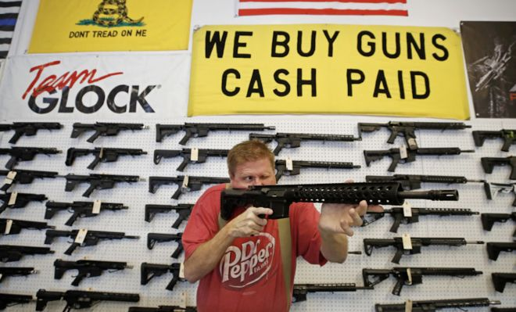

**Americans grappling with the rapidly-spreading coronavirus purchased more guns last month than at any other point since the FBI began collecting data over 20 years ago. Why?**

With the death toll climbing every day and most of the country under some form of lockdown, many Americans seem to be turning to guns as part of their response.

And it's not just about fears over social disorder, say experts.

## What do the figures show?

The FBI conducted 3.7m background checks in March 2020, the highest total since the instant background check programme began in 1998.

The figure represents an increase of 1.1m over March 2019.

On 21 March alone, 210,000 checks were done, the largest one-day record ever.

According to US media, the FBI data indicates that over two million guns were purchased in March alone.

Illinois led with nearly a half million sales, followed by Texas, Kentucky, Florida, and California.

Gun shops across the country report that they are unable to re-stock shelves quickly enough to cope with the rush.

The latest figure also tops the previous high of 3.3 million, which was set in December 2015 after the Obama administration raised the possibility of restricting assault rifles in the wake of a mass shooting in San Bernardino, California.

## Why are sales skyrocketing?

According to Georgia State University law school professor Timothy Lytton, an expert on the US gun industry, most new gun sales are being motivated by two factors that have been spurred on by the coronavirus crisis.

The first is the concern that civil society - fire, police and health services - could be severely "eroded" someday, leading to a breakdown in law and order. In such a case, a gun can be viewed as a "self-help" survival tool, he says.

[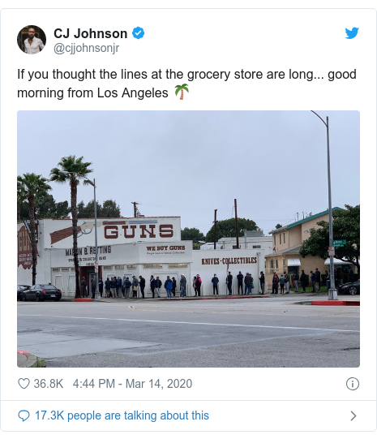Image Copyright @cjjohnsonjr@CJJOHNSONJR](https://twitter.com/cjjohnsonjr/status/1238868541689880576)

[Report](https://www.bbc.co.uk/news/contact-us/editorial)

The second reason is concerns over so-called big government infringing on American freedoms such as gun ownership, which is enshrined in the US constitution.

"Many of the public health measures, such as shelter-in-place, restricting peoples' movements, restricting what people can buy," Mr Lytton says, "raises fears among many groups of the potential for government takeover and tyranny."

In some ways these two reasons are in opposition to each other, he tells BBC News.

"Some people are worried about the fact that government's falling apart and won't protect them, and other people are worried that the government is getting too strong and is going to limit their freedom."

* [**LA gun stores reopen, deemed 'essential' business**](https://www.bbc.com/news/world-us-canada-52108162)

## Why I bought my first guns

One new gun owner told BBC News that he made the decision to buy his first two firearms on 12 March, one day after the NBA announced that they were suspending all games.

The man, who asked that his name not be used, says he views his decision as an extension of the guidance he had seen from emergency officials, who have told Americans to consider having a few days supply of food and water in case of any disruptions to the supply chain.

"I think it's hard to discount the very minor chance of there being temporary civil unrest where I can't rely on the police department.

"And a gun is cheap insurance against that," says the man, who grew up in Berkeley, California and now lives in Chicago.

It's all well and good to have a stockpile of food and supplies, but there is no use having all that without a means of defending it, he argues.

## What's the reaction been?

Some states have allowed gun stores to continue to operate as "essential" businesses despite mandatory lockdown orders affecting around 90% of the US.

New York, Massachusetts, and New Mexico have forced shops to close but have allowed them to continue selling online. Washington state ordered shops to close, but several continued to operate despite the ban.

* [**America's gun culture in charts**](https://www.bbc.com/news/world-us-canada-41488081)
* [**The lengths Americans will go to protect gun rights**](https://www.bbc.com/news/world-us-canada-51483541)

Gun control advocacy groups have praised the closures.

"There is no constitutional right to immediately buy or sell guns. And there certainly is no right to spread coronavirus while buying or selling guns," Kris Brown, president of the anti-gun violence Brady Campaign, told NBC News.

Shannon Watts, from the group Moms Demand Action, said her concern was for the families of new gun owners, who she says are adding danger to an already volatile situation.

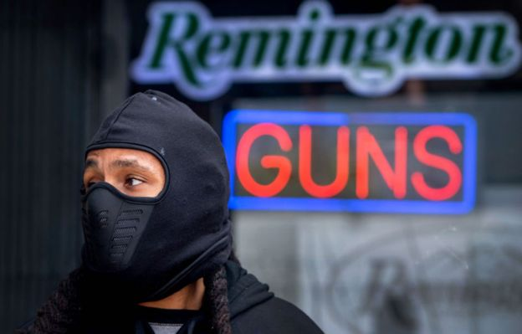Image copyrightGETTY IMAGES

Amy Hunter, a spokeswoman for the National Rifle Association (NRA), said in a statement to BBC News that "headlines about prisoner furloughs and law enforcement selectively responding to calls have made many realise ​the gravity of self-defense during these unprecedented times.

"In addition, efforts by some anti-gun politicians to shutter gun stores have deeply concerned law-abiding Americans. That is why the NRA makes no apology for our efforts to ensure gun stores stay open so law-abiding people can exercise their right to defend themselves and their families."

* [**What the Covid-19 crisis reveals about US - and its president**](https://www.bbc.com/news/world-us-canada-52012049)

## What else can influence gun sales?

US domestic politics often influence gun sales, as Democratic candidates are viewed as more likely to crack down on gun rights than Republicans such as President Trump.

Gun sales spiked after President Obama's two election victories, and rose in 2016 as Hillary Clinton rose in the presidential polls and was widely expected to defeat Mr Trump. Sales then dropped off after Mr Trump's victory.

Mass shootings, which also trigger concerns among gun advocates of a crackdown on private ownership, also cause sales of guns and ammo to go up.

"It tends to go up and down depending on what people's anxiety levels are," says Mr Lytton.

Normally the concern is over access to weapons, he adds.

"Or in this case it's anxiety about the deterioration of government - or the growth of government."

**13 year buys gun**

<https://www.youtube.com/watch?v=fB7MwvqCtlk>

**Sister is shot dead by her own brother in tragic accident**

[Sister is shot dead by her own brother in tragic accident - YouTube](https://www.youtube.com/watch?v=_Gy9JxaIH4M) (23 seconds video)

# Iowa boy, 12, 'tries to shoot teacher in face'

<https://www.bbc.com/news/world-us-canada-45481527>

* 11 September 2018[Share this with Facebook](https://www.bbc.com/news/world-us-canada-45481527)

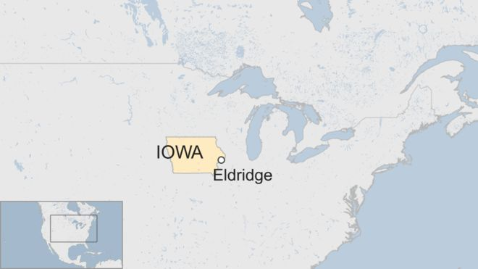

**A 12-year-old US boy accused of walking into a classroom with a handgun, pointing it at his teacher and pulling the trigger is in custody on a charge of attempted murder.**

The gun did not go off as the safety catch was on. The teacher then managed to talk him down and disarm him, court papers say.

The incident happened at a junior high school in Iowa on 31 August.

The school was put on lockdown and police seized the gun.

* [**America's gun culture in 10 charts**](https://www.bbc.com/news/world-us-canada-41488081)
* [**Six radical ways to tackle US school shootings**](https://www.bbc.com/news/world-us-canada-43118865)

The boy is alleged to have walked into the classroom at North Scott junior high school in Eldridge with a handgun and ordered everyone to the floor.

He pointed the gun, which had one round in the chamber, at the teacher's face and pulled the trigger, according to the documents.

No-one was harmed during the incident, and the boy's teacher and another staff member were able to take the gun from the boy.

He faces charges of attempted murder, carrying a weapon on school grounds, and assault while displaying a dangerous weapon.

He has been ordered to remain in state custody at a juvenile detention centre for the time being.

Six year old shoots teacher

[Abby Zwerner: Six-year-old who shot his teacher used mother's gun - BBC News](https://www.bbc.com/news/world-us-canada-64210387)

# Abby Zwerner: Six-year-old who shot his teacher used mother's gun

* Published

10 January 2023

Share

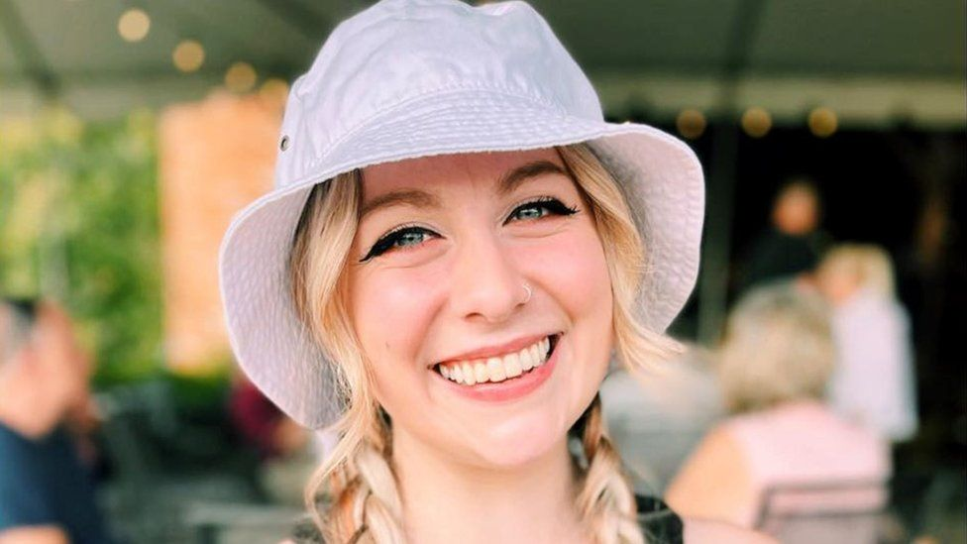IMAGE SOURCE,ABBY ZWERNER/FACEBOOK

Image caption,

Abby Zwerner was shot after an "altercation" with a six-year-old pupil

**A six-year-old child used his mother's legally purchased handgun to shoot his teacher at a US school, police said.**

In a news conference on Monday, police in Virginia said the child brought the pistol to school in his backpack.

The child intentionally shot his teacher, Abigail 'Abby' Zwerner, during class on Friday. Police said she managed to escort her students to safety before calling for help for herself.

Ms Zwerner, 25, remains in hospital in a stable condition.

Police in Newport News, a city of 180,000 people north-west of Virginia Beach, said they spoke with the teacher earlier on Monday.

"She is a trooper, she is a hero," said police chief Steve Drew, adding that Ms Zwerner has asked him repeatedly about the well-being of her students who were in the classroom at the time of the shooting.

Media caption,

Watch: Police chief says teacher Abby Zwerner saved lives

Police received a call of a teacher being shot around 14:00 local time (19:00 GMT) on Friday at Richneck Elementary School. When they entered the classroom, they found a six-year-old student restrained by a school employee.

Chief Drew said the child fired one round at his teacher. He added that the "shooting was not accidental, it was intentional", and that it took place while Ms Zwerner was giving a lesson.

Ms Zwerner was struck through her hand and into her upper chest, Chief Drew said. She then made sure her students were safely outside the classroom, before making her way down to the school's administration office to call for help, he said.

"She turned around to make sure that every one of those students was safe," Chief Drew said.

As the building was placed under lockdown, a woman who was picking up her grandchildren saw Ms Zwerner appear in the doorway of the school's front office.

Lowanda Sample-Rusk [**told the New York Times**](https://www.nytimes.com/2023/01/09/us/newport-news-teacher-shooting.html): "She said, 'Call 911, I've been shot.' And then she fainted."

Chief Drew said the shooting happened without warning, and with no fight or physical struggle.

Police said they found a 9mm Taurus pistol in the class near the student's desk, along with his backpack, a mobile phone and one spent shell casing.

Chief Drew said police determined through an interview with the child's mother that the gun was bought legally and stored in their home.

The child, who has not been identified, was taken into custody and is undergoing evaluation in hospital, police said, adding that they will seek a temporary detention order.

Police are continuing to investigate the incident, Chief Drew said, including conducting more interviews with witnesses and local child services.

Officials said that while the school - which has about 550 pupils - had metal detectors, pupils were checked at random and not every child was inspected.

A pupil at the school - Novah Jones, who is in fifth grade and was in a different classroom - described the moment her class was locked down.

"I was scare," she told CNN. "It was like my first lockdown and I didn't know what to do, so I just hid under my desk like everybody was."

One parent, Steve Gonzalez, whose child was in the classroom at the time, said Ms Zwerner's actions were selfless.

After being struck by the bullet, "she screamed at her kids to run away", he told Fox News.

Shortly after the shooting, students were evacuated to the school's gym before they were reunited with their families. Chief Drew described tearful parents waiting to see their children.

One unnamed British mother picking up her child told local media that guns were "biggest problem in this country".

"Why is it so bad?" she continued.

The school will remain closed all week to give students and families "time to heal," the chief said.

## Related Topics

[US six-year-old who shot teacher won't be charged - prosecutor - BBC News](https://www.bbc.com/news/world-us-canada-64897423)

# US six-year-old who shot teacher won't be charged - prosecutor

* Published

8 March 2023

Share

Abby Zwerner was shot after an "altercation" with a six-year-old pupil

**By Nadine Yousif**

BBC News

**A six-year-old boy who shot his teacher in a primary school in the US state of Virginia is unlikely to be charged, a prosecutor has said.**

But authorities in the city of Newport News have yet to decide if any adult will face criminal charges in the case.

Police have said the child brought the gun in his backpack to Richneck Elementary School on 6 January.

Abigail Zwerner, a 25-year-old teacher, was shot in the hand and chest, but survived.

On Wednesday, Newport News Commonwealth's Attorney Howard Gwynn said that his office would not seek charges against the boy.

He said the "prospect that a six-year-old can stand trial is problematic" because the child is too young to understand the legal system, [**he told NBC News**](https://www.nbcnews.com/news/us-news/6-year-old-shot-teacher-newport-news-wont-face-criminal-charges-prosec-rcna70794).

"Our objective is not just to do something as quickly as possible," Mr Gwynn added.

"Once we analyse all the facts, we will charge any person or persons that we believe we can prove beyond a reasonable doubt committed a crime."

In a separate interview with a local ABC News outlet, Mr Gwynn said that the general consensus among US legal experts is that a six-year-old "cannot form the requisite criminal intent to be guilty of an aggravated assault".

* [**Three warnings before boy, 6, shot teacher - lawyer**](https://www.bbc.co.uk/news/world-us-canada-64406295)

Ms Zwerner is suing the school district after she was shot through her hand and upper chest following what police described as an "altercation" with the first-grader.

The firearm was legally purchased and belonged to the child's mother, police have said.

[Family of 6-year-old who shot teacher speaks out l GMA (youtube.com)](https://www.youtube.com/watch?v=ySCcicGzgT8)

The answer!!!!!!!!!!!!!!

['I accidentally shot dead my little sister' - BBC News](https://www.bbc.com/news/av/world-us-canada-48139558)

**'I accidentally shot dead my little sister'**Close

Sean was 10 years old when he found a gun in the house and thought it was a toy. The weapon accidentally went off and a stray bullet pierced the heart of his younger sister, Erin.

Thirty years on, Sean and his mother reflect on how those few tragic seconds changed the course of their lives.

*Video by Hannah Long-Higgins and Angélica M Casas*

* Published

2 May 2019

<http://www.bbc.com/news/world-us-canada-43081361>

# Florida school shooting: Nikolas Cruz confesses to police

* 16 February 2018[**Florida school shooting**](https://www.bbc.com/news/topics/cwy56y59kg6t/florida-school-shooting)

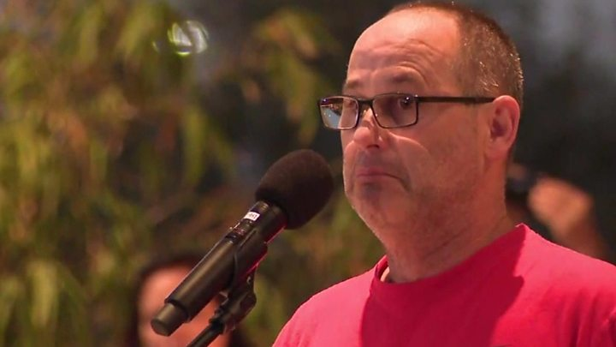

Media captionFred Guttenberg said he couldn't remember if he had told his daughter Jaime that he loved her

**The teenager accused of killing 17 people at a Florida high school on Wednesday has confessed to the shooting, police say.**

Nikolas Cruz, 19, said he arrived on campus and began shooting students before abandoning his weapon and escaping, according to a court document.

He has appeared in court charged with 17 counts of premeditated murder.

The FBI has admitted it received a tip-off about him last year.

The attack, at Marjory Stoneman Douglas High School in Parkland, Florida, is the deadliest US school shooting since 2012.

* [**Who are the victims?**](http://www.bbc.co.uk/news/world-us-canada-43070359)
* [**How the school attack happened**](https://www.bbc.com/news/world-us-canada-43071281)
* [**English teen hid from gunman in cupboard**](https://www.bbc.com/news/uk-england-coventry-warwickshire-43084653)
* [**Analysis: One shooting, two Americas**](http://www.bbc.co.uk/news/world-us-canada-43079170)

"[**Cruz stated that he was the gunman**](https://www.nytimes.com/interactive/2018/02/15/us/document-cruz-arrest.html) who entered the school campus armed with a AR-15 and began shooting students that he saw in the hallways and on the school grounds," according to the court document.

He said he was carrying extra ammunition in a black duffel bag and backpack, it said.

Mr Cruz then discarded his weapon in an attempt to blend in and escape, the documents showed.

He was reportedly able to flee the scene undetected before entering a Walmart and then a McDonald's, and was eventually spotted by police and arrested one hour after the attack.

## What do we know about the suspect?

Mr Cruz had been expelled from the school he has confessed to attacking and some students said they had joked "he's the one to shoot up the school".

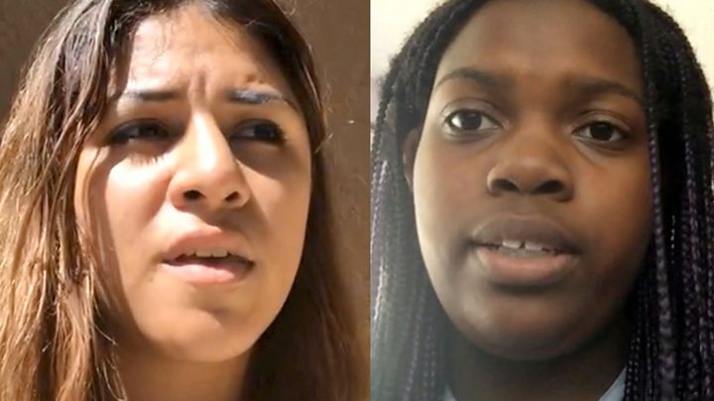

Media captionInside the classroom: 'We watched gunman shoot our friends'

One former schoolmate, Chad Williams, told Reuters Mr Cruz was an "outcast" who was "crazy about guns".

* [**Depressed loner 'crazy about guns'**](http://www.bbc.co.uk/news/world-us-canada-43067530)

His interest in weapons was apparent on his social media profiles, which Broward County Sheriff Scott Israel said were "very, very disturbing".

Two separate Instagram accounts, now deleted, purport to show Mr Cruz posing with guns and knives.

## What were the warnings?

After seeing a comment on a YouTube post last year by Mr Cruz, user Ben Bennight contacted the FBI and spoke to representatives for about 20 minutes.

Mr Bennight said the FBI contacted him again following the school shooting in Parkland.

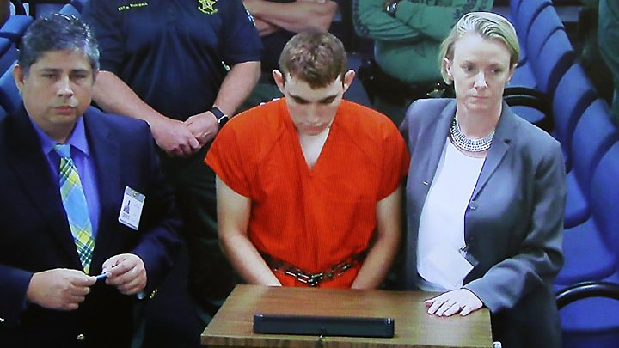

Media captionFlorida shooting suspect appears in court

The FBI confirmed on Thursday that they were made aware of the comment, adding that they had conducted "checks" but were unable to identify the person behind it.

Meanwhile, maths teacher Jim Gard told the Miami Herald that school authorities had emailed teachers about Mr Cruz's behavioural problems.

"There were problems with him last year threatening students, and I guess he was asked to leave campus," he said.

* [**Is it time to arm teachers?**](http://www.bbc.co.uk/news/world-us-canada-42804741)
* [**Florida shooting: A survivor's story**](https://www.bbc.com/news/world-us-canada-43069670)

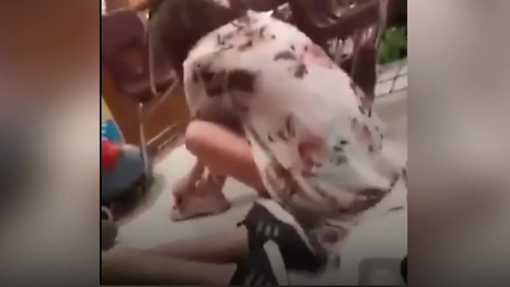

Media captionFootage posted on social media captures the moment Nikolas Cruz opened fire

## Who were the victims?

Three staff members and 14 students died in the attack.

The school's assistant football coach, **Aaron Feis,** was shot after jumping in front of students to shield them from bullets. His team tweeted that he had "died a hero".

[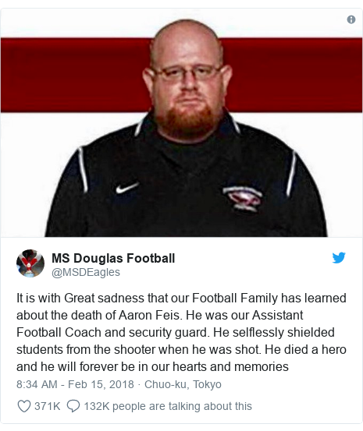Image Copyright @MSDEagles@MSDEAGLES](https://twitter.com/MSDEagles/status/964055383970123776)

[Report](https://www.bbc.co.uk/news/contact-us/editorial)

White line 2 pixels

**Chris Hixon**, who was the athletic director at the school, was also confirmed dead by local media. In 2007 Mr Hixon, 49, served as a US Naval Reservist in Iraq.

Teacher **Scott Beigel**[**died while trying to lock the door**](https://twitter.com/GMA/status/964136409597530117), a student told Good Morning America.

The students who died were:

* **Alyssa Alhadeff**, 14
* **Martin Duque**, 14
* **Alaina Petty**, 14
* **Alex Schachter,** 14
* **Jaime Guttenberg**, 14
* **Cara Loughran**, 14
* **Gina Montalto**, 14
* **Luke Hoyer**, 15
* **Peter Wang**, 15
* **Carmen Schentrup**, 16
* **Nicholas Dworet**, 17
* **Joaquin Oliver**, 17
* **Helena Ramsey**, 17
* **Meadow Pollack**, 18

On Thursday, thousands of people attended a candlelit vigil to honour the victims. There were chants of "no more guns" as speakers demanded tougher gun laws.

* [**What the survivors saw**](https://www.bbc.com/news/world-us-canada-43070350)

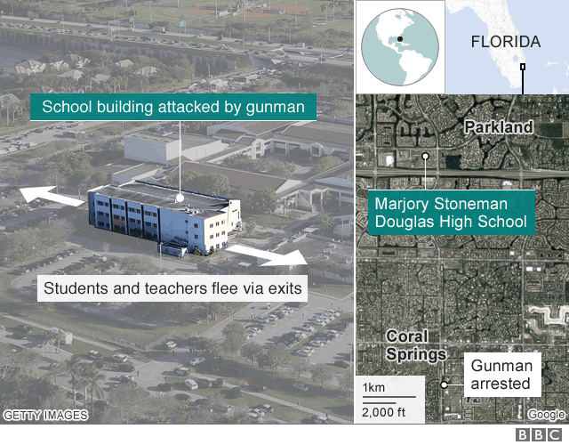

## What's the reaction been?

In the wake of the shooting, politicians across the ideological spectrum were quick to offer their condolences. But the conversation soon turned to gun control.

Democrats, many of whom expressed frustration at the levels of gun violence in the US, proposed increased regulation of firearms.

Florida's Democratic Senator Bill Nelson asked what it would take "for enough to be enough".

[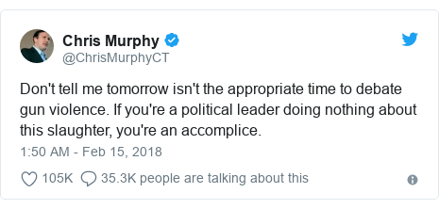Image Copyright @ChrisMurphyCT@CHRISMURPHYCT](https://twitter.com/ChrisMurphyCT/status/963953708437573632)

In an emotional interview on CNN, the mother of one of the victims called on President Trump to respond with policy.

"Do something. Action, we need it now. These kids need safety now," she said.

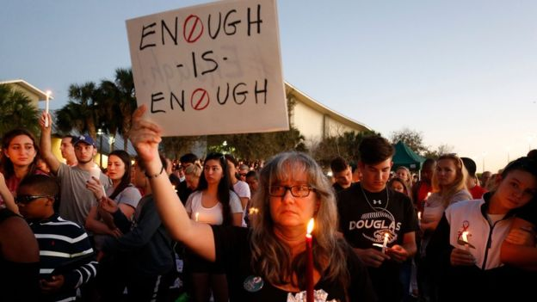Image copyrightAFPImage captionThousands of people attended a candlelit vigil to honour the victims

But many Republicans refused to be drawn into the debate.

In his address to the nation on Thursday, Donald Trump didn't mention the word "gun" or "firearm" once.

Florida Senator Marco Rubio said that it was too soon to debate whether tighter gun laws could have stopped it.

* [**Call for policy change: 'Prayers not enough'**](https://www.bbc.com/news/newsbeat-43069230)
* [**Senators singled out over gun lobby funds**](http://www.bbc.co.uk/news/blogs-trending-43070480)
* [**What is the NRA and why is it so powerful?**](http://www.bbc.co.uk/news/world-us-canada-35261394)

Texas Senator Ted Cruz accused Democrats of politicising the shooting.

"They immediately start calling that we've got to take away the Second Amendment rights of law-abiding citizens. That's not the right answer," he told Fox News.

<https://dailycaller.com/2020/07/01/2020-gun-sales-june-record-fbi/>

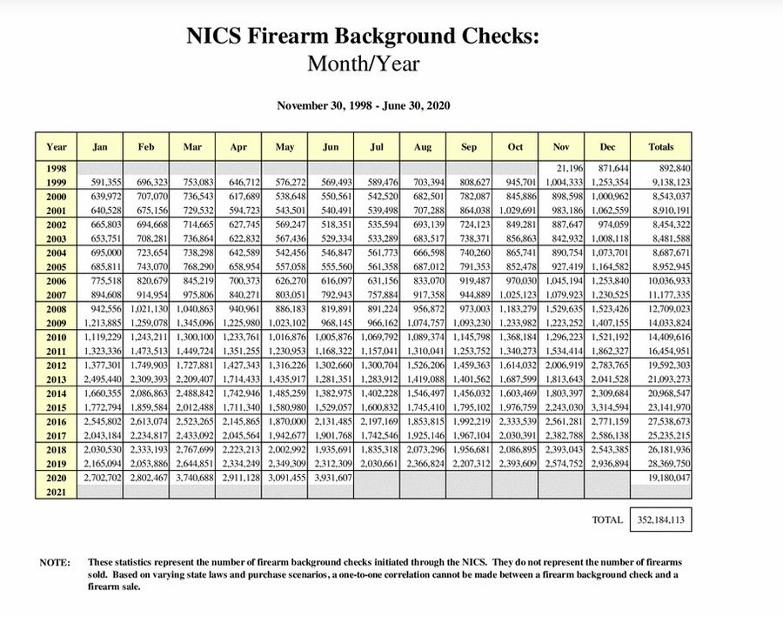

the victims

<https://www.youtube.com/watch?v=pifUrlyo7HU>

he pleads guilty

<https://www.youtube.com/watch?v=wdFK4tqn4Co>

Emma Gonzalez speech 1

<https://www.youtube.com/watch?v=Zoby1ODY14w>

Gunman confesses + live film from shooting

<https://www.youtube.com/watch?v=VIVF65-HTlc>

Emma Gonzalez speech 2 (March inn Washington)

<https://www.youtube.com/watch?v=hDEc4ImIVHk>

Parkland 2 years on 2020 election

<https://www.bbc.com/news/av/election-us-2020-54699553>

# US election: 'Our kids died in the Parkland shooting, but we disagree on guns'

Emma gonzález 2020

**Florida school shootings**

[**https://www.youtube.com/watch?v=xgIJosk0pnA**](https://www.youtube.com/watch?v=xgIJosk0pnA)

**How many US mass shootings have there been in 2023?**

[How many US mass shootings have there been in 2023? - BBC News](https://www.bbc.com/news/world-us-canada-41488081)

* Published

26 May 2023

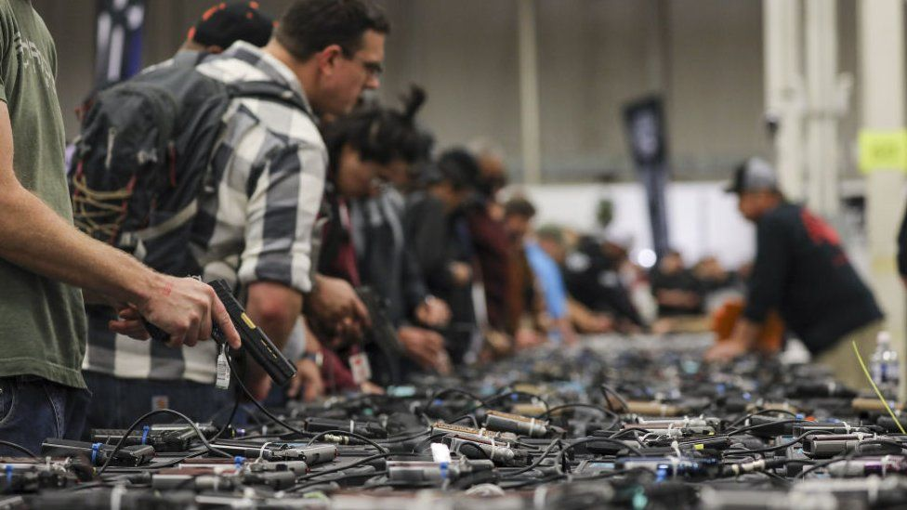IMAGE SOURCE,GETTY IMAGES

Data shows gun ownership in the US has grown over the last several years

**Gun violence is a fixture in American life - but the issue is a highly political one, pitting gun control advocates against people who are fiercely protective of their right to bear arms.**

We've looked into some of the numbers behind firearms in the US.

## Mass shootings on the rise

There have been more than 200 mass shootings across the US so far this year, [**according to the Gun Violence Archive**](https://www.gunviolencearchive.org/), which defines a mass shooting as an incident in which four or more people are injured or killed. Their figures include shootings that happen in homes and in public places.

There have been two in Texas in the last week - five killed at a home in Cleveland, north of Houston, and eight dead at a shopping mall in Allen, near Dallas.

In each of the last three years, there have been more than 600 mass shootings, almost two a day on average.

* [**He counts US shootings. He no longer remembers names**](https://www.bbc.co.uk/news/world-us-canada-65305145)

The deadliest such attack, in Las Vegas in 2017, killed more than 50 people and left 500 wounded. The vast majority of mass shootings, however, leave fewer than 10 people dead.

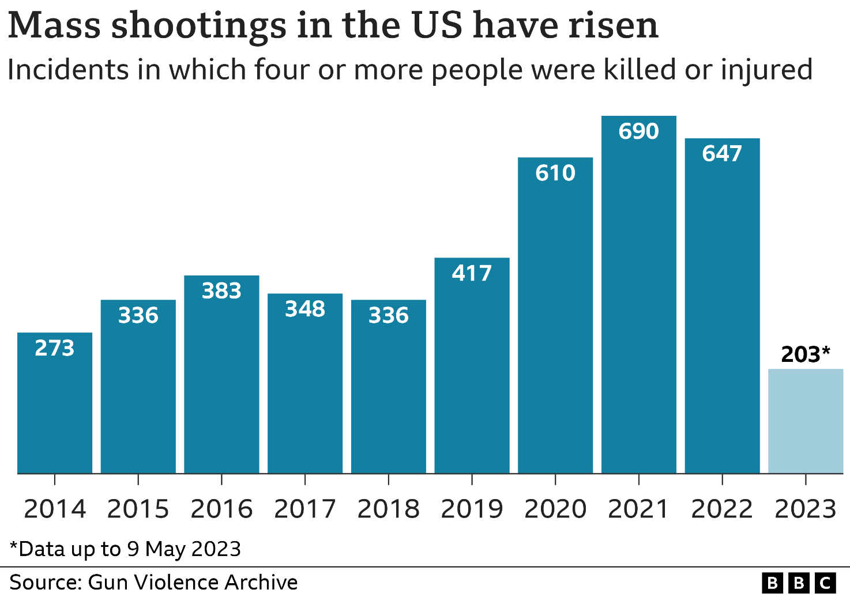

1px transparent line

## How do US gun deaths break down?

48,830 people died from gun-related injuries in the US during 2021, according to the latest data from [**the US Centers for Disease Control and Prevention (CDC)**](https://wonder.cdc.gov/controller/datarequest/D157;jsessionid=A42E9669378EDE78DB1D14EE5397).

That's nearly an 8% increase from 2020, which was a record-breaking year for firearm deaths.

While mass shootings and gun murders (homicides) generally garner much media attention, more than half of the total in 2021 were suicides.

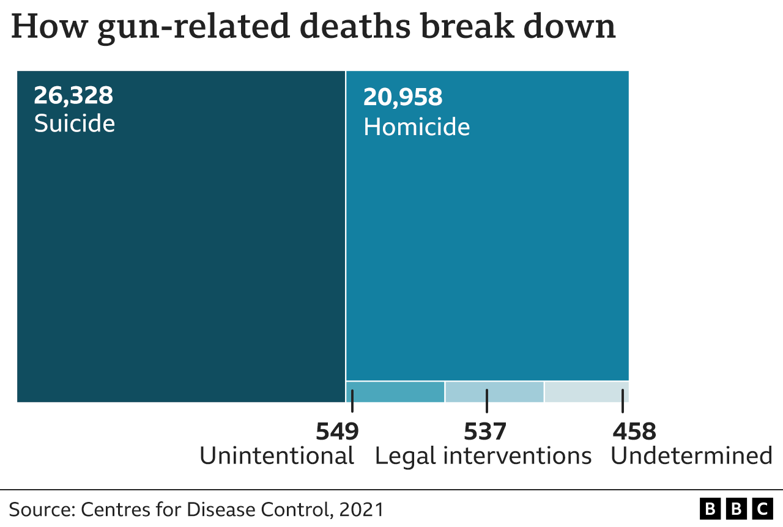

1px transparent line

That year, more than 20,000 of the deaths were homicides, [**according to the CDC**](https://wisqars.cdc.gov/data/explore-data/explore/selected-years?ex=).

Data shows more than 50 people are killed each day by a firearm in the US.

That's a significantly larger proportion of homicides than is the case in Canada, Australia, England and Wales, and many other countries.

1px transparent line

## How many guns are there in the US?

While calculating the number of guns in private hands around the world is difficult, the latest figures from the Small Arms Survey - a Swiss-based research project - estimated that there were 390 million guns in circulation in the US in 2018.

The US ratio of 120.5 firearms per 100 residents, up from 88 per 100 in 2011, far surpasses that of other countries around the world.

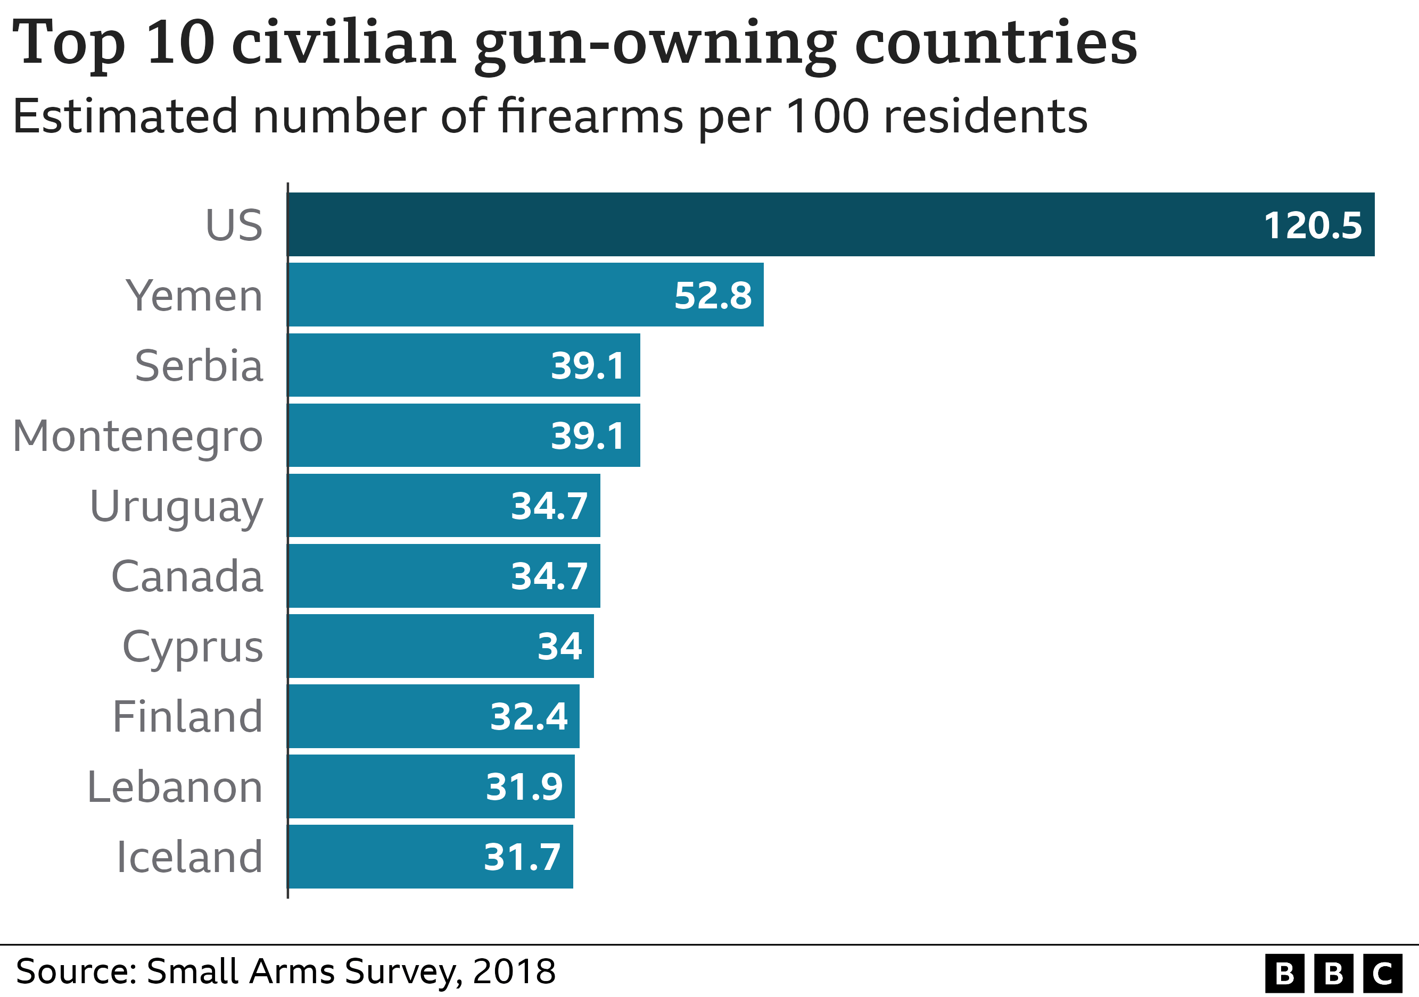

1px transparent line

More recent data out of the US suggests that gun ownership grew significantly over the last few years. A study, published by [**the Annals of Internal Medicine in February**](https://www.acpjournals.org/doi/full/10.7326/M21-3423?journalCode=aim), found that 7.5 million US adults became new gun owners between January 2019 and April 2021.

This, in turn, exposed 11 million people to firearms in their homes, including 5 million children. About half of new gun owners in that time period were women, while 40% were either black or Hispanic.

## Who supports gun control?

A majority of Americans are in favour of gun control.

57% of Americans surveyed said they wanted stricter gun laws - although this fell last year - [**according to polling by Gallup**](https://news.gallup.com/poll/1645/guns.aspx).

32% said the laws should remain the same, while 10% of people surveyed said they should be "made less strict".

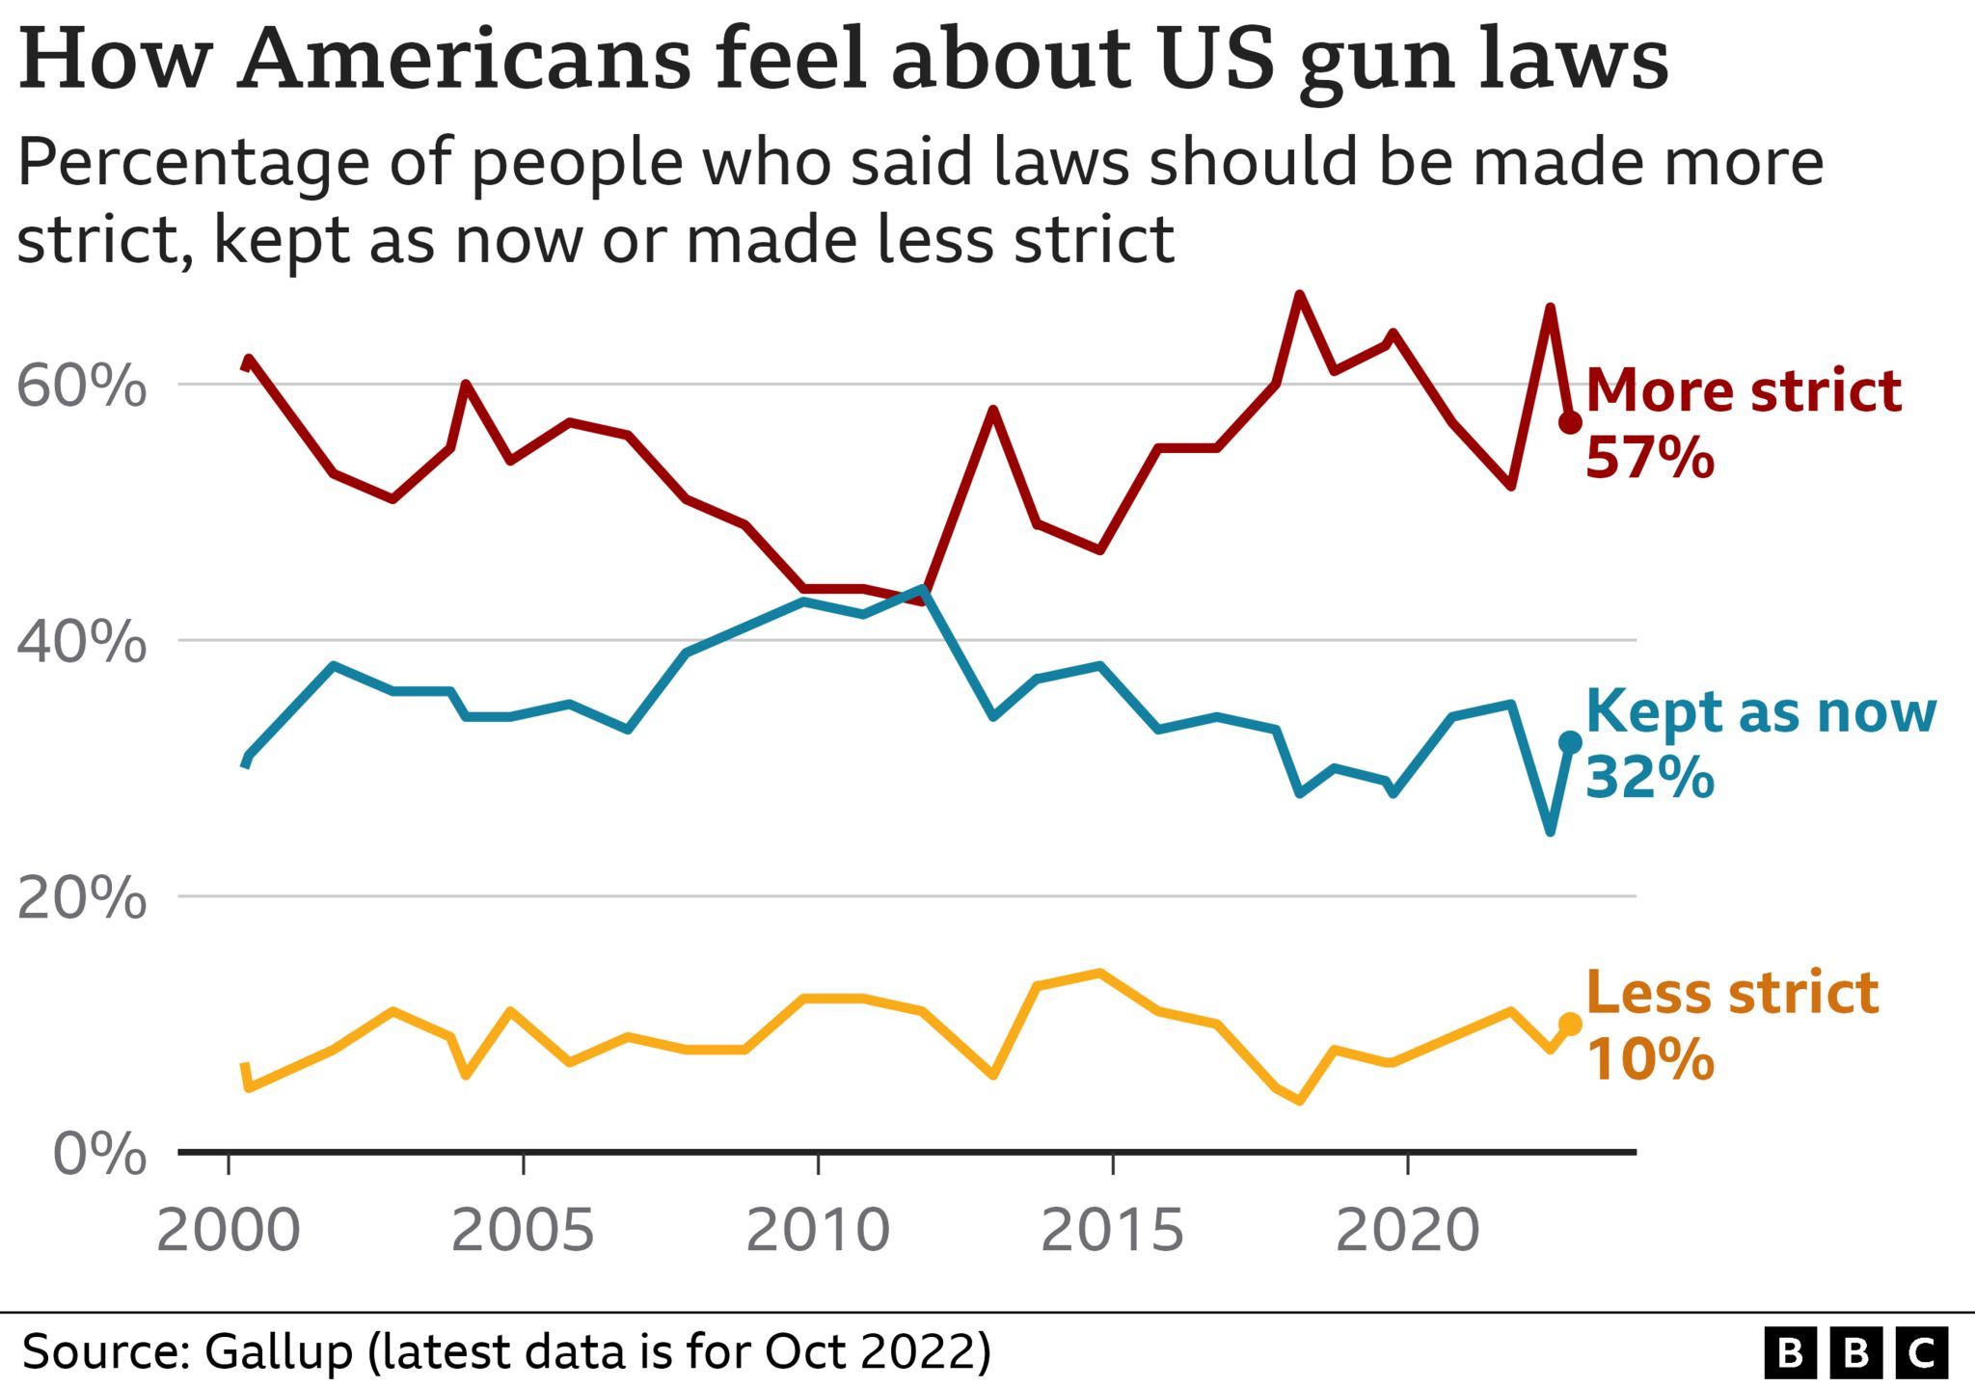

1px transparent line

The issue is extremely divisive, falling largely along party lines.

"Democrats are nearly unanimous in their support for stricter gun laws," [**another Gallup study noted**](https://news.gallup.com/poll/357317/stricter-gun-laws-less-popular.aspx), with nearly 91% in favour of stricter gun laws.

Only 24% Republicans, on the other hand, agreed with the same statement, along with 45% of Independent voters.

Some states have taken steps to ban or strictly regulate ownership of assault weapons. Laws vary by state but California, for example, has banned ownership of assault weapons with limited exceptions.

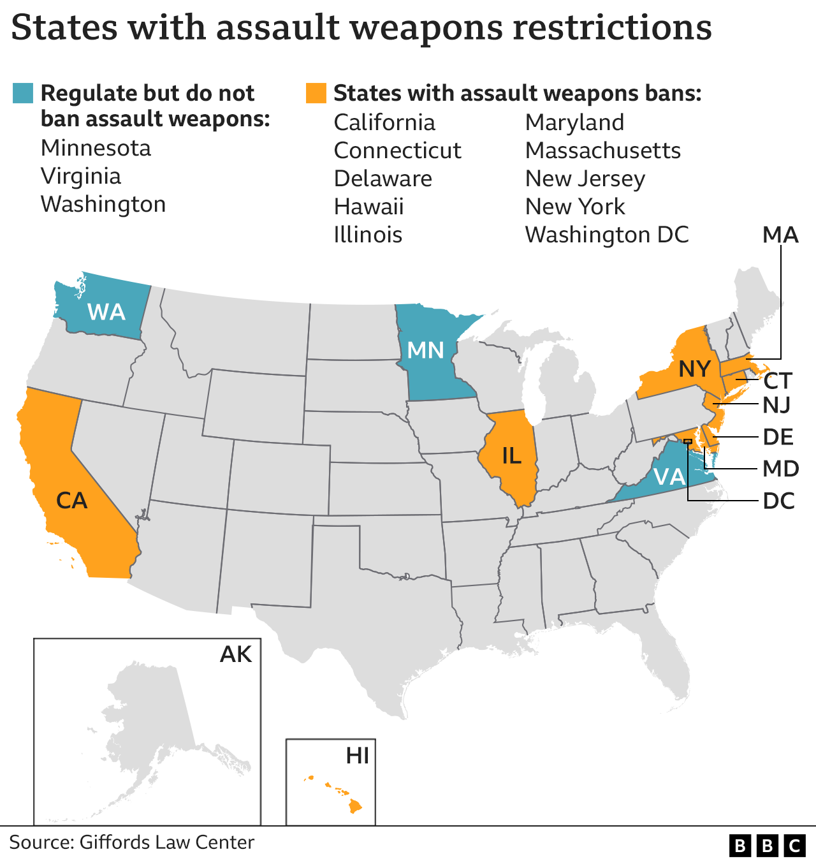

1px transparent line

Some controls are widely supported by people across the political divide - such as restrictions governing the sale of guns to people who are mentally ill or on "watch" lists.

## Who opposes gun control?

Despite years of financial woes and internal strife, the National Rifle Association (NRA) remains the most powerful gun lobby in the United States, with a substantial budget to influence members of Congress on gun policy.

Over the last several election cycles, it, and other organisations, have consistently spent more on pro-gun rights messaging than their rivals in the gun control lobby.

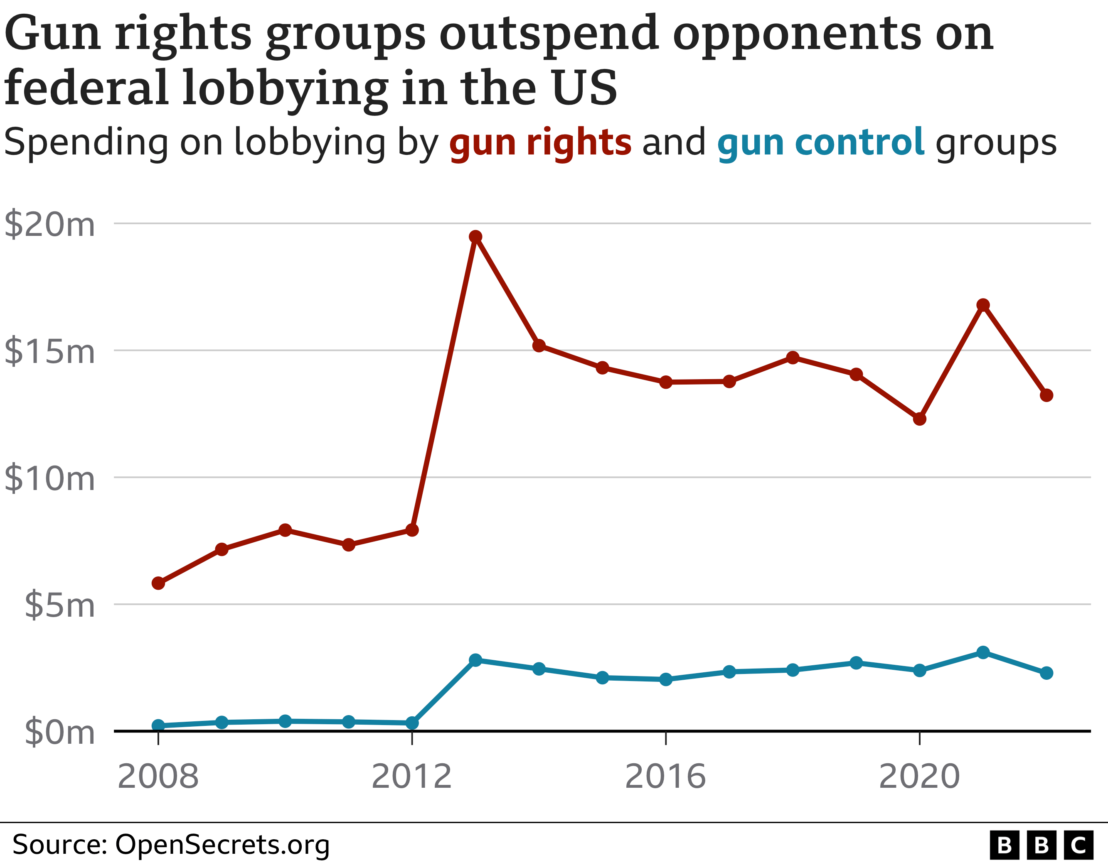

1px transparent line

A number of states have also gone as far as to largely eliminate restrictions on who can carry a gun. In June 2021, for example, Texas Governor Greg Abbott signed into law a "permitless carry bill" that allows the state's residents to carry handguns without a licence or training.

Similarly, in April last year Georgia became the 25th in the nation to eliminate the need for a permit to conceal or openly carry a firearm. The law means any citizen of that state has the right to carry a firearm without a licence or a permit.

The law was backed by the NRA, and leaders within the organisation called the move "a monumental moment for the Second Amendment".

## What types of guns kill Americans?

Military-style assault-style weapons have been blamed for some of the major mass shootings such as the attack in an Orlando nightclub and at the Sandy Hook School in Connecticut.

Dozens of rifles were recovered from the scene of the Las Vegas shooting, Police reported.

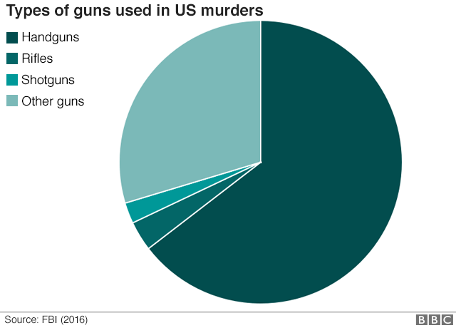

A few US states have banned assault-style weapons, which were totally restricted for a decade until 2004.

However most murders caused by guns involve handguns, according to FBI data.

## How much do guns cost to buy?

For those from countries where guns are not widely owned, it can be a surprise to discover that they are relatively cheap to purchase in the US.

Among the arsenal of weapons recovered from the hotel room of Las Vegas shooter Stephen Paddock were handguns, which can cost from as little $200 (£151) - comparable to a Chromebook laptop.

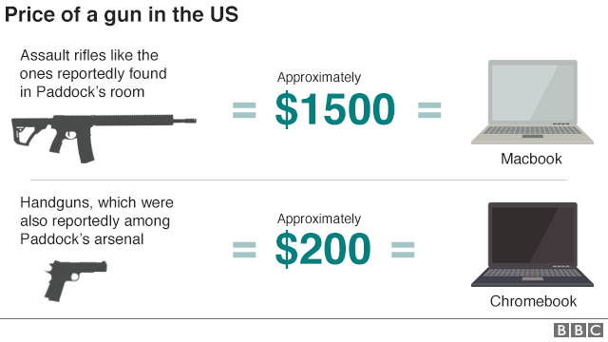

Assault-style rifles, also recovered from Paddock's room, can cost from around $1,500 (£1,132).

In addition to the 23 weapons at the hotel, a further 19 were recovered from Paddock's home. It is estimated that he may have spent more than $70,000 (£52,800) on firearms and accessories such as tripods, scopes, ammunition and cartridges.

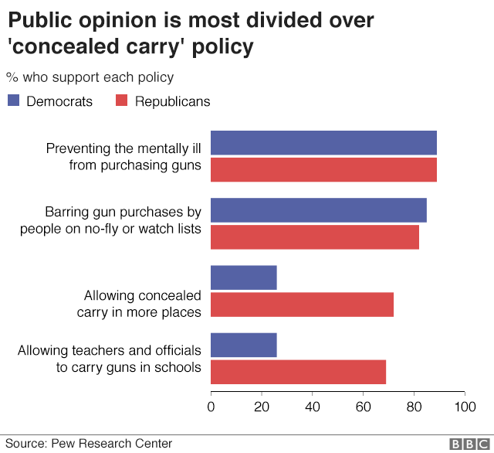

But Republicans and Democrats are much more divided over other policy proposals, such as whether to allow ordinary citizens increased rights to carry concealed weapons - according to a survey from [**Pew Research Center.**](http://www.pewresearch.org/fact-tank/2017/06/23/bipartisan-support-for-some-gun-proposals-stark-partisan-divisions-on-many-others/)

In his latest comment on the shootings, President Donald Trump said he would be "talking about gun laws as times goes by". The White House said now is not the time to be debating gun control.

His predecessor, Barack Obama, struggled to get any new gun control laws onto the statute books, because of Republican opposition.

## Who opposes gun control?

The [**National Rifle Association (NRA)**](http://www.bbc.co.uk/news/world-us-canada-35261394) campaigns against all forms of gun control in the US and argues that more guns make the country safer.

It is among the most powerful special interest lobby groups in the US, with a substantial budget to influence members of Congress on gun policy.

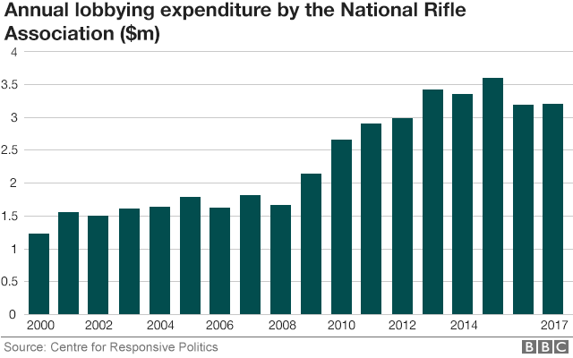

In total about one in five US gun owners say they are members of the NRA - and it has especially widespread support from Republican-leaning gun owners, [**according to Pew Research**](http://www.pewresearch.org/fact-tank/2017/06/22/key-takeaways-on-americans-views-of-guns-and-gun-ownership/).

In terms of lobbying, the NRA officially spends about $3m per year to influence gun policy.

The chart shows only the recorded contributions to lawmakers published by the Senate Office of Public Records.

The NRA spends millions more elsewhere, such as on supporting the election campaigns of political candidates who oppose gun controls.

**Random pictures of life in the US**

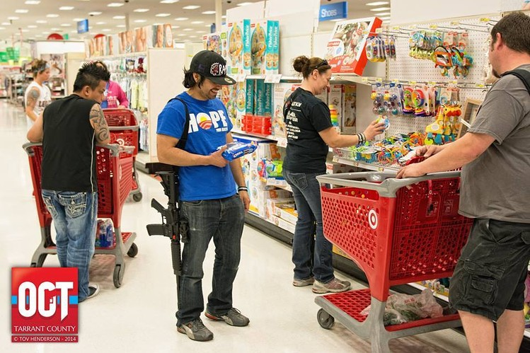

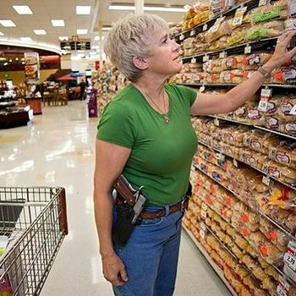

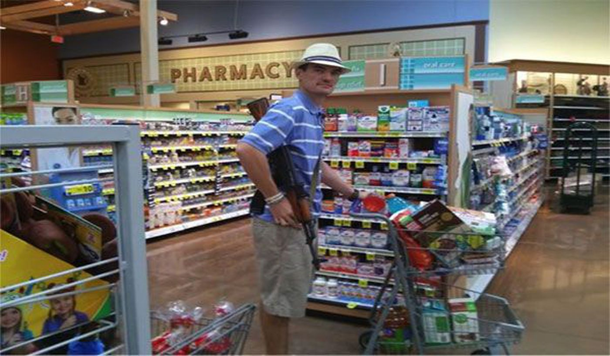

**Uvalde school shooting 19 small kids and two teachers**

[BBC - Search results for Uvalde shooting](https://www.bbc.co.uk/search?q=Uvalde+shooting&page=1)

Uvalde shooting in Texas

[Uvalde shooting: Robb Elementary School to be demolished - mayor - BBC News](https://www.bbc.com/news/world-us-canada-61890558)

Uvalde shooting: Robb Elementary School to be demolished - mayor

Published

6 hours ago

Share

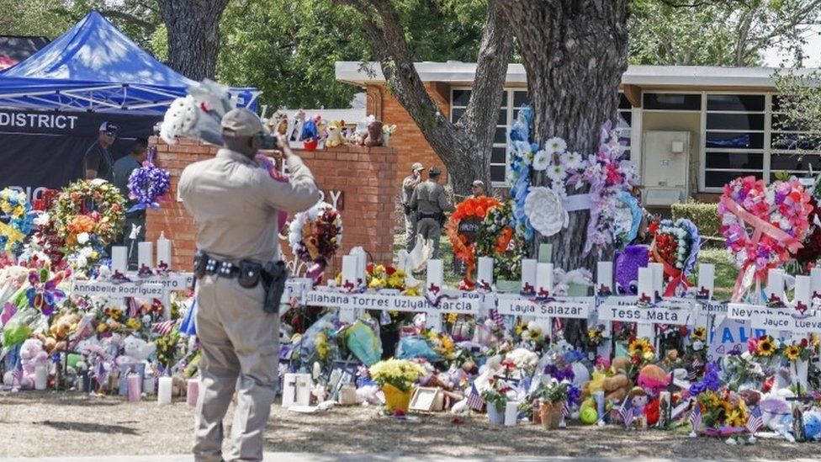IMAGE SOURCE,EPA

Image caption,

A timeline has not been provided for the demolition

**Robb Elementary School in Uvalde, Texas - where a gunman killed 19 students and two teachers - will be demolished, the city's mayor has said.**

Don McLaughlin made the claim on Tuesday at a tense and emotional council meeting with residents demanding answers over the shooting.

He did not say when the school would be demolished.

Public anger has risen since the May rampage, with police accused of waiting over an hour to confront the assailant.

"My understanding - and I had this discussion with the superintendent - is that school will be demolished. You can never ask a child to go back or teacher to go back in that school ever," Mr McLaughlin said.

Robb Elementary has nearly 600 students in the second, third and fourth grades.

* [**The teachers who died trying to save their pupils**](https://www.bbc.co.uk/news/world-us-canada-61593071)
* [**US to review response to Texas school shooting**](https://www.bbc.co.uk/news/world-us-canada-61622797)

US President Joe Biden had suggested knocking down the school, State Senator Roland Gutierrez told local media last month.

Robb Elementary will not be the first school to be demolished after a mass shooting.

Sandy Hook Elementary School in Newtown, Connecticut, was razed after 20 students aged six and seven years old and six staff members were shot in 2012. A new school was built on the same land.

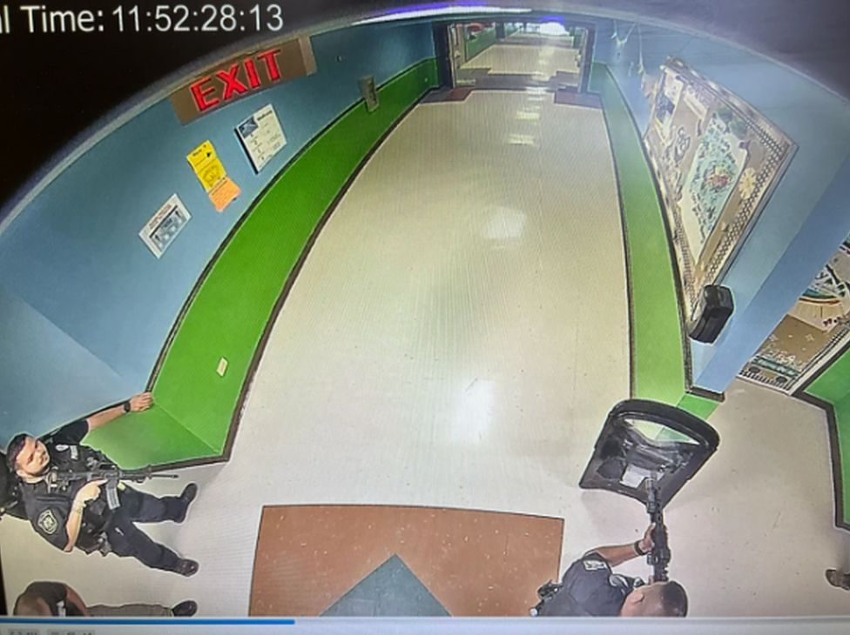IMAGE SOURCE,AUSTIN AMERICAN-STATESMAN / KVUE-TV

Image caption,

Images have emerged showing police officers arriving at the attack earlier than previously reported

Texas's public safety chief [**said on Tuesday**](https://www.bbc.co.uk/news/world-us-canada-61877914) there were enough police on the scene in Uvalde to have stopped the gunman three minutes after he entered the building. But police waited for more than an hour outside classrooms before a team made entry.

Steven McCraw told a state Senate hearing the police response was an "abject failure" and accused the on-scene commander of putting officers' lives above the children's.

The attack by an 18-year-old - identified as Salvador Ramos - has led to renewed national debate about gun regulations.

US Senators on Tuesday advanced new legislation to address mass shootings in what has been called the most significant new gun controls in a generation.

[Matthew McConaughey brings dead girl's shoes to White House - BBC News](https://www.bbc.com/news/av/world-us-canada-61726841)

# Matthew McConaughey brings dead girl's shoes to White House

**Matthew McConaughey brings dead girl's shoes to White House**Close

The actor spoke at the White House to advocate for "responsible gun ownership".

He was born in Uvalde, Texas, where 21 people died in a school shooting last month.

Joe..….

Heidi.

**Fra:** W,Jo   
**Sendt:** 22. marts 2018 20:49  
**Til:** H’  
**Emne:** RE: Happy birthday

H’,

As always – your faithful friendship brings a smile to my face!  Thank you for your birthday note.

I’m delighted to hear of Molly’s successes – with her education, job, boyfriend, and the resulting stability all these have produced.  That is an answer to many prayers… I’m certain!

Sally’s adventures also point to “divine intervention” – it really sounds like she has grabbed life by the tail and is hanging on for the ride!  I hope she never loses that fire, determination, and positive outlook.  If life hands you lemons – make the best lemonade possible!

It also warms my heart that you and Frank are enjoying each other as well as visiting wonderful vacation locations.

I have some harder news to share.  On 02 July 2017, my oldest son (Joseph W. Walker, III) committed suicide in his home in Virginia.  He was 34½ and had just returned from a 42-day assignment for his relatively new job at the US Embassy in Kabul, Afghanistan.  Joe suffered from mild/moderate Bipolar Disorder since he was a teenager.  Unfortunately, back then it wasn’t correctly diagnosed in many mild cases.  The symptoms were obvious – but not the root cause. Treating the symptoms was not effective (most of the time) and extremely frustrating (all of the time).

After Joe returned from the War in Iraq (2004/5 time frame) he exhibited all the signs of severe PTSD, but he refused to seek treatment for years and years.  When he finally sought treatment for PTSD, he was correctly and officially diagnosed with both Bipolar Disorder and PTSD.  As I’ve since learned, nearly 100% of all bipolar people have addiction disorders too.  Joe spent the last 20 years of his life trading one addition for another: drugs, excess risk taking, stealing, sex, alcohol (his long-term favorite), etc.  When Joe was taking his bipolar medication – he was VERY stable, and everyone around him loved him.  The problem for Joe (as with the majority of bipolars) – he hated taking the medicine.  While the medication leveled out the “lows” – they also reduced the “highs” that bipolars crave.  After a few months, he would decide that he was “cured” and stop taking his meds – then before long the mood swings, anxiety, depression, anger, etc. would resurface.  He went through this cycle multiple times – always with terrible pain and suffering for him, and everyone around him.

Joe married a much older woman with 2 adult children on 01 July 2016; 1 year + 1 day before his death.  She is a raging alcoholic; between the two of them, they spent more money on booze in a month than most do for a year (or more).

The afternoon Joe returned from his trip to Afghanistan, he and his wife drank an insane amount of alcohol to celebrate their 1-year anniversary and his safe return.  At some point – they got into an argument which quickly escalated.  She told him to leave the bed; that she was kicking him out.  He said “I don’t think so” – picked up a pistol and shot himself.  All this happened within about 4 hours of his return home from the trip.  I got the phone call from the Police Chaplain about an hour later.  I flew out to Washington DC the following day, then returned to AZ a week later with Joe’s remains.  I arranged a full military memorial service and funeral for him here at Fort Huachuca, where he was born.

It was a rough few months at first; July is a total blur.  I have little recollection of the 500 things that I had to coordinate, arrange, and manage.  His wife was in a drug & alcohol daze the entire time and could do nothing.  Joe’s youngest brother (Jim) took the suicide really hard… I was very worried about him and spent a lot of time trying to keep him stable.  There have been lots of other ramifications – but I truly believe the worst is past and healing, at least for me, has progressed fairly well.  Joe’s 35th birthday was in January… that was a hard day for me.

I’m sorry to pour all this out… but I know you care, and I’ve learned that holding all this inside is unhealthy.

Again – thank you for your enduring friendship and birthday wishes.

Wishing you and family ALL the BEST,

Jo

**Republican party response to shootings**

# Guardian Newspaper

# <https://www.theguardian.com/us-news/2018/may/21/school-shootings-republicans-nra-blame-gun-violence>

# Doors, backpacks and Ritalin: what Republicans have blamed school shootings on

A list of what’s really behind America’s epidemic of gun violence, according to NRA-funded Republicans

[Arwa Mahdawi](https://www.theguardian.com/profile/arwa-mahdawi)

Mon 21 May 2018 18.40 BST Last modified on Mon 21 May 2018 22.38 BST

This year, there has been, on average, one school shooting a week where someone was hurt or killed in America. According to a [Washington Post analysis](https://www.washingtonpost.com/news/politics/wp/2018/05/18/2018-has-been-deadlier-for-schoolchildren-than-service-members/?noredirect=on&utm_term=.8d20b487b2e8), the number of people killed in American schools in 2018 is “nearly double” the number of people who have been killed while serving in the military. There is nowhere else in the world, barring war zones, where kids have to worry about dying in their classrooms.

And yet, instead of taking steps to implement commonsense gun control, many politicians are taking to the media to explain, yet again, that guns aren’t actually the cause of gun violence. No, the real cause of mass shootings, the Texas lieutenant governor, Dan Patrick, [explained on Saturday](https://www.cnn.com/2018/05/19/us/texas-school-shooting-exits-trnd/index.html), is doors. “There are too many entrances and too many exits to our over 8,000 campuses in Texas,” Patrick said. “There aren’t enough people to put a guard in every entrance and exit.” Patrick’s call for “door control” was quickly mocked. Indeed, former government ethics director Walter Shaub [pointed ou](https://twitter.com/waltshaub/status/997592292935553024)t that “Texas has stricter regulations for doors than it does for guns”.

And it’s not just doors that are the problem, according to some lawmakers. Over the years, American politicians have blamed gun violence on just about anything that isn’t a gun …

## **Abortions**

This is another Patrick special. Speaking to ABC’S This Week on Sunday, Patrick cited abortion as one reason disenfranchised kids were shooting up schools. Patrick said: “We have 50 million abortions. We have families that are broken apart, no fathers at home … And we stand here and we wonder why this happens to certain students.”

## Backpacks

After the Parkland shooting, Marjory Stoneman Douglas high school put in place a [transparent backpack policy](http://www.bbc.com/news/world-us-canada-43626893): students weren’t allowed to use rucksacks unless they were clear.

## **Decline in family values**

In 2013, PoliceOne, a news site aimed at law enforcement officers, [conducted a survey](https://www.policeone.com/police-products/firearms/articles/6188462-PoliceOnes-2013-Gun-Policy-Law-Enforcement-Survey-Results-Executive-Summary/) about gun control among about 15,000 verified law enforcement professionals. Thirty-eight per cent of respondents believed that a “decline in parenting and family values” was the biggest cause of gun violence in the US. Only 4.4% thought that guns being too prevalent and easy to obtain was the real problem.

## Marilyn Manson

Forget guns, it’s Marilyn Manson that’s the problem. Photograph: Christian Palma/AP

In 1999, controversial singer Marilyn Manson was partly blamed for the Columbine high school shooting which left 15 people dead. It was thought that the shooters were fans of Manson’s and were inspired by his lyrics.

## **Mental health**

The argument that mass shootings are caused by mental illness is wheeled out after every attack perpetrated by a white person. (If a brown person is involved then mental illness obviously has nothing to do with it, it’s terrorism.) While mental health probably plays a role in many shootings, it should be said that there is clear evidence that most mentally ill people do not go around shooting other people. According to a [2015 research paper](https://www.ncbi.nlm.nih.gov/pmc/articles/PMC4211925/) on mental illness and gun violence, “the large majority of people with serious mental illnesses are never violent”. Further, mental health issues are not unique to America; the epidemic of gun violence is, however.

## **People**

As we all know, guns don’t kill people, people kill people.

How about we ban idiots and guns? Just a thought. Photograph: Julie Dermansky for the Guardian

## **Ritalin**

On Sunday, [Oliver North, the incoming NRA president](https://www.theguardian.com/us-news/2018/may/07/oliver-north-nra-president-iran-contra), blamed the Santa Fe shooting on “young boys [who] have been on Ritalin since they were in kindergarten”. America’s prescription pill habit is a real problem that warrants discussion. However, you can’t shoot people with Ritalin last time I checked.

## **Schools**

On Friday, Jonathan Stickland, a Texas state representative [tweeted](https://twitter.com/RepStickland/status/997876699655221248) that he’s been “hearing from many parents they’re scared to send their kids to school. We need to give them as many different choices as possible.”

## **Video games**

Video games are a favourite scapegoat for shootings. And unlike guns, politicians seem very keen to do something about videogame control. Following February’s Parkland shooting, Trump invited video game executives to the White House to discuss how exposure to violent video games desensitized children. And after the Sandy Hook attack, [Barack Obama said](https://www.usatoday.com/story/tech/gaming/2013/01/16/obama-gun-violence-video-games/1839879/): “Congress should fund research into the effects that violent video games have on young minds.”

## **Women**

“Texas school shooter killed girl who turned down his advances and embarrassed him in class, her mother says,” reported the LA Times [over the weekend](http://www.latimes.com/nation/la-na-texas-shooter-20180519-story.html), in response to the Santa Fe school shooting. The LA Times wasn’t alone in insinuating that, if only women were just a little bit nicer to guys who are harassing them, then nobody would get killed. Jordan Peterson recently told the New York Times that there is a very easy way to stop so-called incels from violently murdering people. “He was angry at God because women were rejecting him,” Peterson said in reference to the Toronto man who [killed 10 people with a van](https://www.theguardian.com/world/2018/may/10/canada-toronto-van-attack-alek-minassian-attempted-murder) in April. “The cure for that is enforced monogamy.” Now, the Toronto killer used a van, not a gun, but give it time and we’ll see Republicans explain how [“the redistribution of sex”](https://www.nytimes.com/2018/05/02/opinion/incels-sex-robots-redistribution.html) is a better way to solve gun violence than doing something about the distribution of guns.

[Parkland gunman's brain irretrievably broken, jury hears - BBC News](https://www.bbc.com/news/world-us-canada-62640447)

# Parkland gunman's brain irretrievably broken, jury hears

* Published

23 August 2022

Share

**Related Topics**

* [**Florida school shooting**](https://www.bbc.com/news/topics/cwy56y59kg6t)

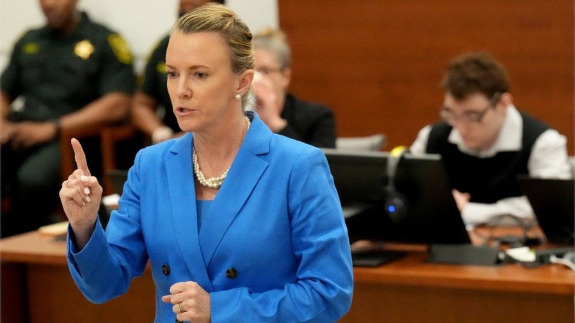IMAGE SOURCE,REUTERS

Image caption,

Cruz's lawyer Melisa McNeil argued that events before he was even born contributed to the attack

**By Max Matza**

BBC News

**Lawyers for a Florida school gunman have asked a jury to spare him the death penalty, arguing that his "brain was irretrievably broken" owing to a difficult childhood.**

Nikolas Cruz, 23, pleaded guilty last year to killing 17 people at Marjory Stoneman Douglas High School in Parkland, Florida, on 14 February 2018.

The trial will determine whether he is put to death or jailed for life.

The case is the deadliest mass shooting to reach a jury trial in the US.

On Monday Melisa McNeil, Cruz's lead lawyer, said her client had been exposed to drugs and alcohol while in his mother's womb, citing this as a contributing factor to the massacre.

"Because of that, his brain was irretrievably broken, through no fault of his own," she said, calling him a "damaged person", and describing his run-ins with school officials and police throughout his childhood in an adopted home.

"We must understand the person behind the crime," Ms McNeil told the jury of seven men, five women and 10 alternate jurors.

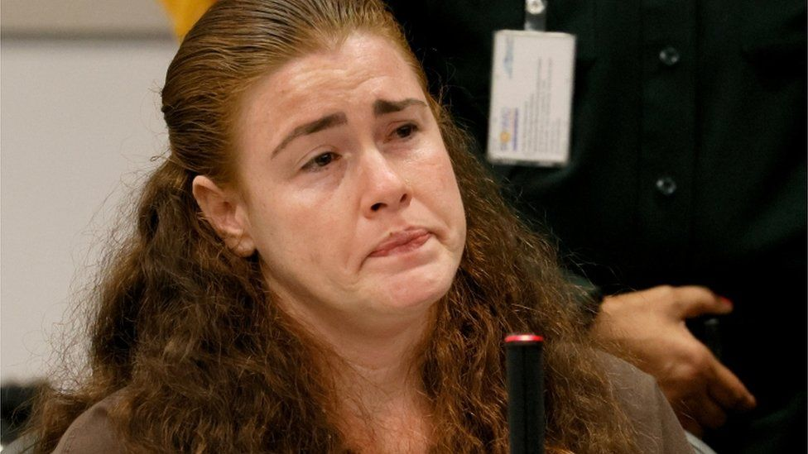IMAGE SOURCE,REUTERS

Image caption,

Danielle Woodard, Cruz's half-sister, described their mother as "horrible"

Cruz's half-sister, Danielle Woodard, also testified that her mother had abused drugs while the future school shooter was developing in "her polluted womb". She said her mother had told her that she was raped, [**reports the Miami Herald**](https://www.miamiherald.com/news/local/crime/article264768514.html).

Ms Woodard, who is herself awaiting trial on a carjacking charge, described their mother as "horrible". As she prepared to give evidence on Monday, her half-brother nodded at her across the court.

When the trial began on 18 July, prosecutors argued that the defendant deserved to die for the "goal-directed, planned, systematic murder - mass murder - of 14 students, an athletic director, a teacher and a coach".

Jurors were shown gruesome video evidence from the crime scene, as well as video of the attacker calmly ordering a drink from a nearby shop minutes after the massacre, and later of him attacking a guard in jail.

They were also taken to the fenced-off school building where they toured the preserved crime scene. Balloons and cards for Valentine's Day were still scattered around the freshman building where Cruz fired around 150 shots from a semi-automatic rifle.

* [**Will the Parkland gunman get the death penalty?**](https://www.bbc.co.uk/news/world-us-canada-62058386)
* [**America's gun culture - in seven charts**](https://www.bbc.co.uk/news/world-us-canada-41488081)

In her defence arguments, Ms McNeil argued that the seeds of the seven-minute massacre were sown years earlier, when her client's biological mother was working as a drug-addicted prostitute.

The first defence witness on Monday was a recovering addict who said she worked as a prostitute with Cruz's late birth mother, Brenda Woodard, in the 1990s when she became pregnant with the boy.

Carolyn Deakins said Woodard had abused cocaine, marijuana and alcohol throughout her pregnancy, and that "she didn't care" because she planned to put the baby up for adoption.

Cruz's adoptive father died shortly after he came into the home, and his adopted mother, Lynda Cruz, had ignored troubles he was having at school, his lawyer said.

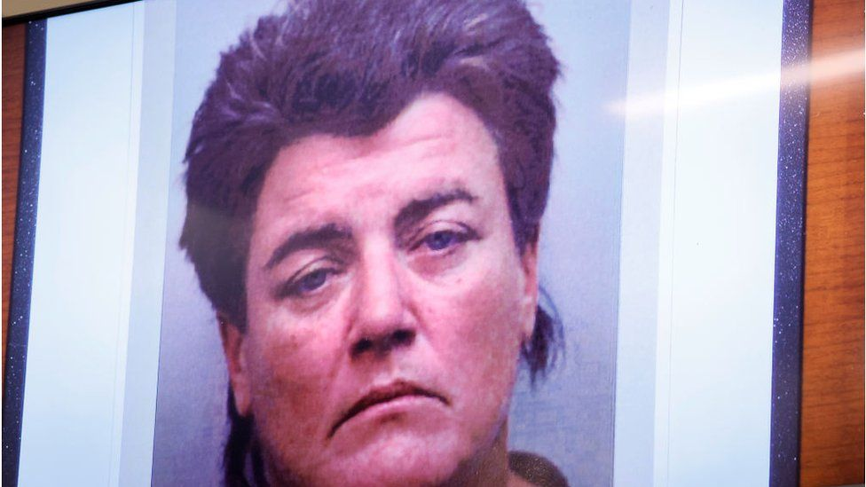IMAGE SOURCE,REUTERS

Image caption,

A photo of Cruz's drug-addicted birth mother was shown to the court

She removed him from psychiatric programmes that could have helped him curtail the violent episodes he was having as a young child in pre-school, Ms McNeil said.

Deeply in debt after her husband's death, Lynda Cruz had refused to have the troubled youth committed to a mental hospital because she did not want to stop receiving his Social Security benefits cheque each month, according to Ms McNeil.

The adoptive mother, who died several months before the attack, bought him a BB gun and airgun before getting him a rifle for his 18th birthday.

At the time of his guilty plea last October, Cruz said he was "very sorry" for the shooting.

All 12 jurors must vote unanimously in order for him to be put to death.

**Video: Parkland victim alone in hallway with Nikolas Cruz targeting him: Hear his survival story**

[Parkland victim alone in hallway with Nikolas Cruz targeting him: Hear his survival story | LiveNOW - YouTube](https://www.youtube.com/watch?v=pqwDWKyju5E)

[Parkland shooter Nikolas Cruz sentenced to life in prison without parole for 2018 massacre | CNN](https://edition.cnn.com/2022/11/02/us/parkland-shooter-nikolas-cruz-sentencing-wednesday/index.html)

**Parkland school shooter sentenced to life in prison without parole for 2018 massacre**

[[](https://www.cnn.com/profiles/dakin-andone)](https://www.cnn.com/profiles/dakin-andone)[](https://www.cnn.com/profiles/alta-spells)

By [Dakin Andone](https://www.cnn.com/profiles/dakin-andone), Denise Royal and [Alta Spells](https://www.cnn.com/profiles/alta-spells), CNN

Updated 6:28 PM EDT, Wed November 2, 2022

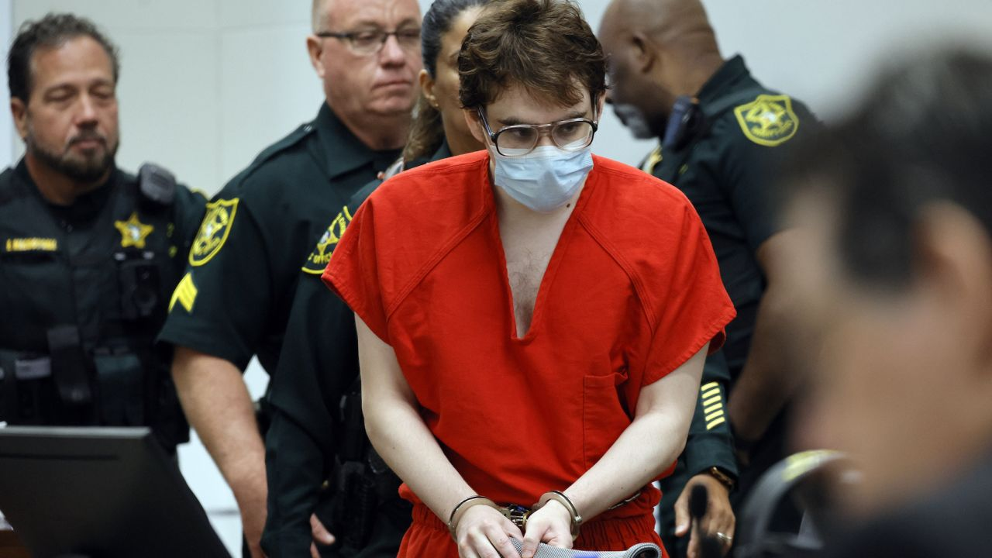

Marjory Stoneman Douglas High School shooter Nikolas Cruz enters the courtroom Tuesday for his first of two expected sentencing hearings in Fort Lauderdale, Florida.

Amy Beth Bennett/Pool/South Florida Sun Sentinel/AP

**CNN —**

The gunman who carried out the Parkland school shooting has been formally sentenced to life in prison without the possibility of parole after[a jury last month failed to unanimously recommend the death penalty](https://www.cnn.com/2022/10/13/us/nikolas-cruz-jury-deliberation-thursday/index.html), disappointing and angering many of the families of the [17 people he killed.](https://www.cnn.com/2018/02/15/us/florida-shooting-victims-school/index.html)

Broward Circuit Judge Elizabeth Scherer imposed the statutorily mandated sentence Wednesday, ordering Nikolas Cruz, 24, to serve a life sentence with no possibility of parole for each of the 17 counts of murder to which he had pleaded guilty, with the sentences to run consecutively.

Additionally, Scherer imposed a sentence of life in prison with a minimum of 20 years to serve on 14 of the 17 counts of attempted murder, and life without the possibility of parole for the remaining three counts of attempted murder. All counts are to run consecutively, the judge ruled.

Under Florida law, Cruz will not be able to financially benefit in any way from the crimes he committed, according to the judge. Scherer also garnished his commissary funds until all costs and restitution are paid.

Cruz was then [ordered to be transferred](https://www.cnn.com/2022/10/16/us/nikolas-cruz-jury-life-recommendation-whats-next) to the custody of the Florida Department of Corrections.

[[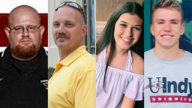](https://edition.cnn.com/2018/02/15/us/florida-shooting-victims-school/index.html)](https://edition.cnn.com/2018/02/15/us/florida-shooting-victims-school/index.html)

[These are the victims of the Florida school shooting](https://edition.cnn.com/2018/02/15/us/florida-shooting-victims-school/index.html)

Before handing down the sentence, the judge addressed the victims’ families, thanking them for “the privilege of learning about each and every one of your loved ones.”

“I can tell you that they will not be forgotten and I feel that I know each and every one of them by the personal stories that you have given,” Scherer said. “You all have been so strong and patient and graceful throughout this process and I can’t help but think how I would behave or respond if I were in your shoes.”

“If I could take your pain away or carry your pain for you just for five minutes so that you could breathe, I would,” the judge added. “Because I can’t even imagine what you go through each day.”

The end of the monthslong trial to decide Cruz’s fate came after two days of victim impact testimony in which families of those killed and survivors of the February 2018 shooting at Marjory Stoneman Douglas High School in South Florida confronted the gunman, spelling out for the court what he took from them and expressing their anger he will not be put to death.

[LIVE UPDATES: Parkland shooter Nikolas Cruz formally sentenced](https://www.cnn.com/us/live-news/parkland-shooter-nikolas-cruz-sentencing-11-02-2022/index.html)

“It is heartbreaking how any person who heard and saw all this did not give this killer the worst punishment possible,”[Annika Dworet](https://www.cnn.com/2022/08/02/us/nikolas-cruz-trial-victim-impact-statements-tuesday/index.html), the mother of 17-year-old victim Nicholas Dworet, said Wednesday. “As we all know the worst punishment in the state of Florida is the death penalty. How much worse would the crime have to be to warrant the death penalty?”

“You robbed Alyssa (of) a lifetime of memories,” Lori Alhadeff, the mother of 14-year-old victim Alyssa Alhadeff, said to the gunman. “Alyssa will never graduate from high school. Alyssa will never go to college, and Alyssa will never play soccer. She will never get married and she will never have a baby.”

“My hope for you is that you are miserable for the rest of your pathetic life,” Lori Alhadeff added. “My hope for you is that the pain of what you did to my family burns and traumatizes you every day.”

Cruz pleaded guilty last year to the 17 counts of murder and 17 counts of attempted murder in connection to the shooting, which, despite [the continued American gun violence epidemic](https://www.cnn.com/2022/10/25/us/st-louis-school-shooting-victims/index.html), remains [the deadliest mass shooting at a US high school](https://www.cnn.com/2019/08/19/us/mass-shootings-fast-facts/index.html;).

[[](https://edition.cnn.com/2022/08/04/us/parkland-shooting-sentencing-massacre-scene/index.html)](https://edition.cnn.com/2022/08/04/us/parkland-shooting-sentencing-massacre-scene/index.html)

[Frozen in horror: Notes from inside the Parkland school massacre site](https://edition.cnn.com/2022/08/04/us/parkland-shooting-sentencing-massacre-scene/index.html)

The state sought the death penalty, and so Cruz’s trial moved to the sentencing phase, in which a jury was tasked with hearing prosecutors and defense attorneys argue reasons they felt he should or should not be put to death.

The prosecution argued, in part, the shooting was especially heinous, atrocious or cruel and was premeditated and calculated. [The defense, pushing for a life sentence](http://www.cnn.com/2022/10/14/us/nikolas-cruz-defense-life-prison/index.html), pointed to the shooter’s mental or intellectual deficits they said stemmed from prenatal alcohol exposure.

[Three jurors were persuaded to vote for life](http://www.cnn.com/2022/10/16/us/nikolas-cruz-jury-life-recommendation-whats-next/index.html), sparing Cruz a death sentence, which in Florida a jury must unanimously recommend. Scherer must follow the jury’s recommendation of life without parole, per state law.

Throughout the testimony this week, the gunman remained emotionless, wearing a red prison jumpsuit and eyeglasses. He also wore a medical mask, though he removed it Wednesday after Jennifer Guttenberg, the mother of 14-year-old victim Jaime, told him it was disrespectful.

“You shouldn’t be sitting there with a mask on your face. It’s disrespectful to be hiding your expressions under your mask when we as the families are sitting here talking to you,” she said during her testimony. “Lowered down in your seat. Hunched over trying to make yourself look innocent, when you’re not, because you admitted to what you did. And everybody knows what you did.”

The gunman then took off the mask, but his facial expression did not change.

**Parkland students confront gunman in court**

Of those killed, 14 were students, and three were staff members who perished running toward danger or trying to help students to safety.

The slain students were: Alyssa Alhadeff, 14; Martin Duque Anguiano, 14; Nicholas Dworet, 17; Jaime Guttenberg, 14; Luke Hoyer, 15; Cara Loughran, 14; Gina Montalto, 14; Joaquin Oliver, 17; Alaina Petty, 14; Meadow Pollack, 18; Helena Ramsay, 17; Alex Schachter, 14; Carmen Schentrup, 16; and Peter Wang, 15.

Geography teacher Scott Beigel, 35; wrestling coach Chris Hixon, 49; and assistant football coach Aaron Feis, 37, also were killed.

The life sentence fell short of what many of those Cruz wounded and the families of those he killed wanted. Some said in testimony this week it indicated the jury gave more weight to his life than to the lives of the 17 dead.

“It’s really, really sad. I miss my little boy,” Max Schachter, Alex Schachter’s father, told CNN Wednesday before the sentencing. “It’s not right that the worst high school shooter in US history basically gets what he wants,” he said, referring to Cruz’s life sentence.

[[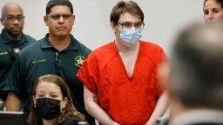](https://edition.cnn.com/2022/11/01/us/nikolas-cruz-parkland-victim-testimony-sentencing/index.html)](https://edition.cnn.com/2022/11/01/us/nikolas-cruz-parkland-victim-testimony-sentencing/index.html)

['You don't know me, but you tried to kill me.' Parkland victims and loved ones get last word before shooter sentenced to life in prison](https://edition.cnn.com/2022/11/01/us/nikolas-cruz-parkland-victim-testimony-sentencing/index.html)

[Samantha Fuentes](https://www.cnn.com/2018/02/28/us/parkland-survivor-samantha-fuentes/index.html), one of the shooting survivors, faced Cruz Wednesday, admitting she was “angry” about his sentence. But unlike him, she said, “I’ll never take my anger, pain and suffering out on others because I am stronger than you. This entire community that stands behind me is stronger than you.”

Fuentes reminded Cruz they walked the same hallways and were even in JROTC together.

“We were still children back then,” she said. “I was still a child when I saw you standing in the window, peering into my Holocaust studies class, holding your AR-15 that had swastikas, ironically, scratched into it. I was still a child after I watched you kill two of my friends. I was still a child when you shot me with your gun.”

Another student, Victoria Gonzalez, Joaquin Oliver’s girlfriend, similarly reminded the gunman that they, too, had shared a class together, recalling how the teacher would go around the room each day asking students for an answer from their homework to make sure each student had done it. Each day, she said, she hoped that Cruz had his – for his sake.

“I was rooting for you silently in my desk. You had no idea who I was and I was rooting for you,” Gonzalez said. “Because I felt like you needed someone or you needed something. And I could feel that.”

But Joaquin’s murder has made it hard for Gonzalez to make friends, to get close to others, she said, and to allow others to love her in the way he did.

“I wish that you met Joaquin,” she said. “Because he would have been your friend. He would have extended a hand to you.”

Michael Schulman, the father of Scott Beigel, told the court about the geography teacher’s altruistic nature and the impact he left on his students and cross-country athletes. The gunman stole not only a son, but a teacher, as well, he said.

“You are spineless and soulless monster. My son Scott was a human being – he still is – something you will never be and never were,” Schulman said.

Beigel’s mother, Linda Beigel Schulman, also addressed the court and the shooter, telling him, “I have never uttered your name, and I never will.”

She ended her statement by holding up a picture of the deceased victims. “These are the names and faces I want you to remember,” she said, including her son Scott, “who I will honor, cherish and love for every day of the rest of my life.”

See the moment judge dismisses member of Parkland shooter's defense team

02:17 - Source: [CNN](https://www.cnn.com/)

Some of the victim impact testimony this week was directed not only at Cruz but at the public defenders who represented him.

That led the defense to object, including Broward County Public Defender Gordon Weekes, who asked Scherer Tuesday to direct the state to encourage witnesses not to make statements to or about the lawyers. They were just doing their jobs as the law provides all criminal defendants a right to legal representation, he said.

That further angered some of the Parkland family members, including Fred Guttenberg, Jaime’s father, who called Wednesday for Weekes to resign.

“I understand that you have a job to do, defending the indefensible, defending a mass murderer of 17 people. I understand that was hard,” he said to the defense attorneys. “And you were doing your job as you were required to do. But I’m not sure anywhere along the way there was a requirement that you give up your humanity and your decency. That was a choice you made.”

**What’s next for the gunman**

A lot is still unclear about [what Cruz’s future will look like](https://www.cnn.com/2022/10/16/us/nikolas-cruz-jury-life-recommendation-whats-next). He’ll likely be held in Broward County custody before being handed over to the Florida Department of Corrections and taken to one of several reception centers across the state.

There, Cruz will spend weeks undergoing physical and mental examinations, Florida criminal defense attorney Janet Johnson has told CNN. “They’ll look at his record, they’ll look at the level of crime that he’s convicted of, which is obviously the highest, and they’ll recommend a facility somewhere in the state,” she said.

Which facility is determined by factors including the seriousness of the offense, the length of sentence and the inmate’s prior criminal record, per the Florida State Department of Corrections website. Typically, those convicted of the most serious offenses or with the longest sentences are placed in the most secure facilities, the website says.

Because Cruz is a high-risk offender, he will likely be placed in a prison with other high-profile or “very dangerous criminals,” Johnson said.

“But he wouldn’t be isolated, which of course, is a real threat for him because there may be people who want to do ‘prison justice,’ who didn’t feel that the sentence he got in court was enough,” Johnson added.

[[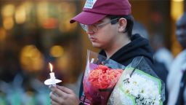](https://edition.cnn.com/2022/10/10/us/robert-schentrup-parkland-shooting-death-penalty/index.html)](https://edition.cnn.com/2022/10/10/us/robert-schentrup-parkland-shooting-death-penalty/index.html)

[Why the brother of Parkland school shooting victim Carmen Schentrup is against the death penalty for her killer](https://edition.cnn.com/2022/10/10/us/robert-schentrup-parkland-shooting-death-penalty/index.html)

The corrections department did not answer CNN’s question about what kind of mental health treatment Cruz may receive while in prison. During the trial, the Broward County Sheriff’s Office released more than 30 pages of writings and drawings by Cruz which revealed disturbing thoughts he has had while in custody, focusing on guns, blood and death.

On one page, Cruz wrote that he wanted to go to death row, while on another he told his family he was sad and hoped to die of a heart attack by taking painkillers and through extreme eating.

As for the victims and their families, the end of the gunman’s trial marks simply the close of one chapter in a lifelong journey with grief.

“I want to put this behind me,” Max Schachter told CNN on Wednesday. “I’m going to court later today. He will be sentenced to life, and I will never think about this murderer again.”CNN’s Christina Maxouris contributed to this report.

[Ethan Crumbley: Parents of Michigan school gunman sentenced to at least 10 years (bbc.com)](https://www.bbc.com/news/world-us-canada-68773119)

Ethan Crumbley: Parents of Michigan school gunman sentenced to at least 10 years

9 April 2024

By Brandon Drenon, BBC News

1:46

Watch: Emotional moments in courtroom as gunman's parents sentenced to prison

**The parents of a Michigan teenager who shot dead four students have each been sentenced to 10 to 15 years in prison.**

A seven-year sentence was recommended, but prosecutors asked for more.

James and Jennifer Crumbley, the first parents of a US school shooter to be convicted, appeared together for the first time in months at Tuesday's sentencing hearing.

Both expressed regret about their son's attack, as their lawyers pushed to minimise their prison sentence.

In a landmark case, jurors in separate trials found each parent of shooter Ethan Crumbley guilty of involuntary manslaughter earlier this year.

Judge Cheryl Matthews said that the expanded sentence of 10 to 15 years was "to act as a deterrent" and reflected the parents' failure to stop the attack.

"They [parents] are not expected to be psychic. But these convictions are not about poor parenting. They concern acts that could have halted a runaway train," she told the court.

"Opportunity knocked over and over again, louder and louder, and it was ignored."

The Crumbleys are eligible for parole after they serve 10 years in prison, but they cannot be held for more than 15 years if parole is denied.

Prosecutors had alleged that the pair had dismissed clear signs that their son's mental health had deteriorated, and noted that the parents had bought Ethan Crumbley the gun he used in the 2021 attack.

Their son was 15 when he killed four students with a semi-automatic handgun at Oxford High School. Seven others were wounded in the shooting.

He is now serving life in prison without parole.

On Tuesday, parents of the dead students, who were all under the age of 17, delivered emotionally charged victim impact statements in court.

Nicole Beausoleil, mother of 17-year-old victim Madisyn Baldwin, addressed Ethan Crumbley's parents directly.

"When you were purchasing a gun for your son and leaving it unlocked, I was helping her finish her college essay," a teary-eyed Ms Beausoleil said.

"You decided parenting wasn't a priority," she added. "And because of that I've lost my daughter."

Jill Soave - the mother of another 17-year-old victim, Justin Shilling - was the second parent to speak. She noted that her "horror and trauma is hard to put into words".

But she looked directly at James and Jennifer Crumbley as she slammed the parents for their "failure to act" and stop a "completely preventable" tragedy.

"If only they had done something, anything, to shift the course of events," she said.

In a separate trial for each parent, prosecutors accused the Crumbleys of ignoring warning signs about their son's growing mental health crisis. They accused them of being negligent by buying him a gun and not storing it properly.

Prosecutor's sentencing recommendations were based on four separate counts of involuntary manslaughter, one for each of the four students that were killed.

During Tuesday's sentencing, the prosecution said James Crumbley showed a "total lack of remorse" after they read from a profanity-laden transcript of a call he made from jail. They alleged that James Crumbley had made death threats against the lead prosecutor in the case during the call.

James Crumbley's lawyers disagreed, and said that their client only "vented" and used language that was "angry" and "not respectful".

The shooter's father emphasised his regret in a statement before the hearing and told the court later that he wished he had acted differently.

"I cannot express how much I wish that I had known what was going on with him or what was going to happen, because I absolutely would have done a lot of things differently."

Jennifer Crumbley also shared her own regret to the families affected.

"I stand today not to ask for your forgiveness, as I know it may be beyond reach, but to express my sincerest apologies for the pain that has been caused," she said in court

James Crumbley's lawyer, Mariell Lehman, said that there was no evidence that Ethan Crumbley's father was aware of his son's plans.

Defence attorneys also argued that there was no legal precedent for this case, and it was inappropriate to hold the parents responsible for each person that their son killed.

Prosecutors disagreed, as did the judge.

On the day of the shooting at Oxford High School in Oxford, Michigan, the Crumbleys cut short a school meeting about a disturbing drawing their son had made, instead opting to go to work and not take him home.

School staff later sent him back to class without checking his backpack, which contained the gun his parents had purchased.

An independent investigation published last year alleged multiple failures from the school system, including the decision to allow Ethan to return to class.

In response, the school district has pledged to review and improve its practices and policies.

**Kyle Rittenhous and Ahmaud Arbery**

Den første er sagen om Kyle Rittenhouse. – den 17-årige unge mand, hvis mor kørte ham sammen med hans semiautomatiske gevær til en Black Lives Matter-demonstration, så han kunne beskytte byen mod demonstranter. Den anden er sagen om 17-årige Ahmaud Arbery, der blev skudt og dræbt af tre hvide mænd, da han var ude at løbetræne.

Jeg fremlagde kort sagen om Kyle Rittenhouse og bad klassen om at diskutere, hvad de syntes om den. Eleverne syntes, at det var en spændende sag. At han er kun 17 år gammel og har et ekstremt farligt våben, at hans mor vil køre ham til en demonstration med våbnet, og at han dræber to mennesker, fik diskussionen til at køre i grupperne.

Så viste jeg videoen om Kyle Rittenhouse (link: [Kyle Rittenhouse](https://www.facebook.com/skynews/videos/2966144190318257/)), og eleverne fik lejlighed til at snakke igen.

Kyle blev fundet uskyldig i alle anklagepunkter og er nu en helt for de folk i USA, som bakker op om ”the second amendment” (retten til at bære våben).

Der er ikke noget rigtigt svar her. Vi kan synes, at han er skyldig eller uskyldig, og alle ”synsninger” er rigtige, men sagen fik eleverne til at tænke og bruge engelsk kommunikativt.

Dernæst fortalte jeg om Ahmaud Arbery-sagen. Igen fik eleverne mulighed for at diskutere først og se videoen bagefter ([What Ahmaud Arbery's murder exposes about America - BBC News](https://www.bbc.com/news/av/world-us-canada-59410920)).

Begge sager handler om selvforsvar, men de ender helt forskelligt. Begge sager lægger op til emner som racisme, våbenlov i USA, politik i USA og en diskussion om ”right and wrong”.

Og begge sager får eleverne til at tænke.

**Kids Meet a School Shooting Survivor | Kids Meet | HiHo Kids**

[Kids Meet a School Shooting Survivor | Kids Meet | HiHo Kids - YouTube](https://www.youtube.com/watch?v=BDh46oosdms)

**Evan | Sandy Hook Promise**

[Evan | Sandy Hook Promise - YouTube](https://www.youtube.com/watch?v=A8syQeFtBKc)

**Guns with History**

[guns with history video - Bing video](https://www.bing.com/videos/search?q=guns+with+history+video&qpvt=guns+with+history+video&FORM=VDRE)

Why Are Americans So Obsessed With Guns?

[Why Are Americans So Obsessed With Guns? - YouTube](https://www.youtube.com/watch?v=ILUVKIUdHNo)

Finish here…

With Kip Kinkel

**Extra material**

Emma Gonzales 2020

<https://www.refinery29.com/en-us/2020/03/9584732/where-is-emma-gonzalez-march-for-our-lives-anniversary>

Emma Gonzalez

<https://variety.com/2018/politics/features/emma-gonzalez-parkland-interview-1202972485/>

**Emma Gonzalez 2020 election gun reform**

<https://variety.com/2020/politics/news/march-for-our-lives-emma-gonzalez-2020-election-gun-reform-1203521099/>

# Parkland Survivor Emma González Urges Hollywood to Fight Harder in 2020 Election

By [Claudia Eller](https://variety.com/author/claudia-eller/)

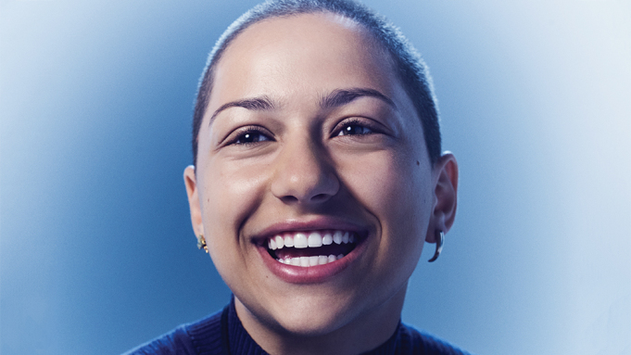

Joe Pugliese for Variety

Parkland shooting survivor Emma González, who co-founded [March for Our Lives](https://variety.com/t/march-for-our-lives/) and is an activist for gun violence prevention, wants entertainment industry influencers to fight harder for important causes in the 2020 election. Here are excerpts of an email exchange with González, who is attending New College of Florida.

**What is your call to action for Hollywood this election season?**

Do better. Your words and actions have weight, and they can inspire change when used correctly. Recognize the power you have to move the needle on issues that matter.

**How important is it for influential people in the entertainment business to be politically active in this election year? Do you think that could have a significant impact on the outcome?**

I think that people in our society tend to deify celebrities and famous people, and stop seeing them as people once their names become recognized on the larger scale. Celebrities and famous people are at the end of the day human beings, and we are all capable of being better people, of asking the difficult questions, and of demanding more from our government. Everyone in this country, no matter who they are, should be politically active. Many people in this country are still being denied the right to vote, so if you still have your voting ability, you should make good use of it.

Emma Gonzalez 2020 anniversary

<https://www.refinery29.com/en-us/2020/03/9584732/where-is-emma-gonzalez-march-for-our-lives-anniversary>

# Two Years After March For Our Lives, Here’s What Emma González Is Up To

[ELLY BELLE](https://www.refinery29.com/en-us/author/elly-belle)

LAST UPDATED [MARCH 24, 2020, 2:45 PM](https://www.refinery29.com/en-us/archives/2020/03/24)

PHOTO: KATIE JONES/VARIETY/SHUTTERSTOCK.

On the two-year anniversary of the first March for Our Lives, started by [students who survived the Parkland shooting](https://www.refinery29.com/en-us/2020/02/9416055/parkland-shooting-school-anniversary-gun-violence-laws-change) in 2018, young activists like Emma González are still doing the difficult work. March for Our Lives and González herself both had [extreme global impact](https://giffords.org/blog/2019/03/7-ways-america-changed-since-the-march-for-our-lives/) on conversations surrounding gun control and mass shootings, disrupting the notion that we’d never make progress in pushing political leaders to take it more seriously.

After a former student showed up at Marjory Stoneman Douglas High School in Parkland, FL, with an assault weapon on February 14, 2018, [killing 17 students and staff and injuring 17 others](https://www.refinery29.com/en-us/2018/02/190915/douglas-high-school-florida-shooting-victims), survivors like González immediately sprung to action. In the wake of the shooting, [González and her friends](https://www.refinery29.com/en-us/2018/02/191135/emma-gonzalez-speech-florida-shooting-gun-activists) Cameron Kasky, David Hogg, Jaclyn Corin and more, helped ignite a conversation about gun violence and, in the following month, launched [the largest youth movement against gun violence](https://www.refinery29.com/en-us/2019/02/206625/march-for-our-lives-parkland-one-year-later) that’s ever existed.

ADVERTISEMENT

In March of 2018, González kicked off [March for Our Lives](https://marchforourlives.com/), a country-wide rally that captured the streets of major cities across the U.S., in a bone-chilling 6 minute and 20 second speech — most of which was complete silence, to make people around the world understand the excruciating feeling she and her friends felt during the time it took for the shooter to terrorize the school. In total, the speech, with silence, was the same length of time it took him to shoot up the school.

**Related Stories**

**[Two Years After Parkland: What's Changed](https://www.refinery29.com/en-us/2020/02/9416055/parkland-shooting-school-anniversary-gun-violence-laws-change)**

**[Gun Violence Through The Eyes Of Young Immigrants](https://www.refinery29.com/en-us/2019/10/8626174/fighting-gun-violence-immigrant-women-of-color-malavika-kannan)**

**[Students Protest Against The Kent State Gun Girl](https://www.refinery29.com/en-us/2020/02/9428857/kaitlin-bennett-kent-state-gun-girl-ohio-university-riot)**

“Six minutes and 20 seconds,” she began her speech. González then named those who were killed that day, in a tone of anguish, and went on to say, “My friend Carmen will never complain to me about piano practice.” She continued saying names until her speech came to an abrupt hault, and she stood in silence for the remainder of the six minutes and 20 seconds, tears streaming down her face. At the end of the speech, she pleaded us all to fight for our lives before it’s “someone else’s job.” Approximately 200,000 people attended the rally in total.

So, what is Emma González doing since she started a revolution? The young activist, whose [organizing work and voice](https://www.refinery29.com/en-us/2018/03/195023/parkland-students-critics-example-emma-gonzalez-david-hogg) has been an [immeasurable service to the world](https://www.vox.com/policy-and-politics/2018/3/26/17160646/march-for-our-lives-crowd-size-count), has an incomparable ability to help the world understand the deep grief and consequences caused by gun violence. Since she graduated high school in 2018, she’s since gone on to become a student at New College of Florida. In 2020, she’s [urging people to turn up at the polls](https://variety.com/2020/politics/news/march-for-our-lives-emma-gonzalez-2020-election-gun-reform-1203521099/) and make a difference in their communities and country at large, using their voice and votes as power.

I VOTED EARLY TODAY !! IT WAS MY FIRST TIME VOTING IN PERSON AND I FINALLY GOT A STICKER !!!!!

[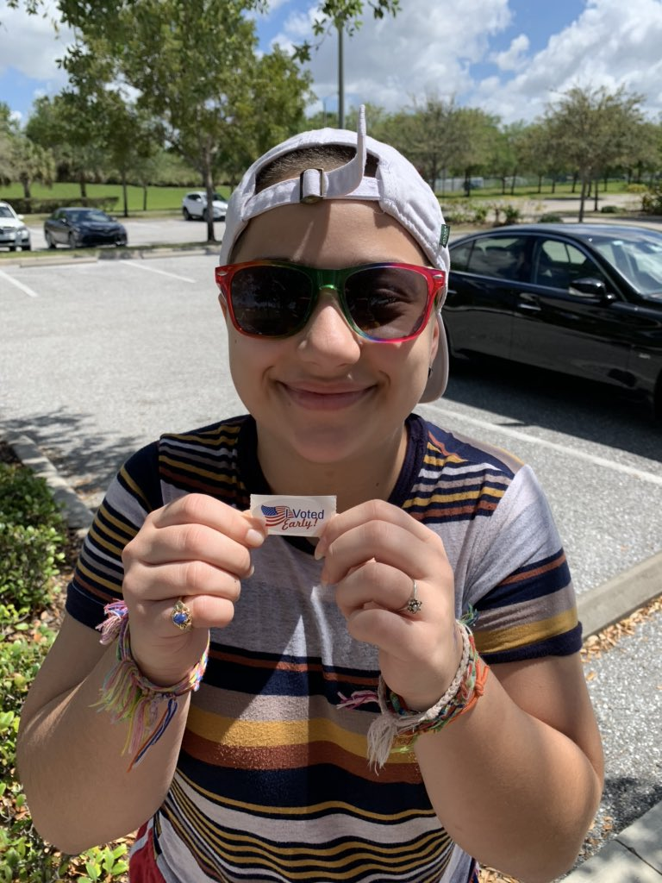](https://twitter.com/Emma4Change/status/1239287416302772226/photo/1)

The Cuban, bisexual powerhouse, who's unapolagetically loud about her identities and standing up for marginalized, at-risk people, continues to frequently organize in her community and uses social media to rally people to use their voices and privilege to make a difference. In recent days, she’s even launched [a March for Our Lives zine, titled “Unquiet,”](https://www.teenvogue.com/story/march-for-our-lives-zine-unquiet) about continuing to use your voice for the greater good.

González continues to act in the greater interest of her community by organizing for causes and instigating change among local leadership. In a [recent testimony to Florida representatives](https://twitter.com/Emma4Change/status/1232375381740654594), she wrote about how meaningful her college acceptance was, why she chose her school, and why she does not want representatives to vote for a merger between her school and a larger college.

Even two years later, González continues to tout the messaging of March for Our Lives and protect the lives of other young people above all else. “If you are in a position of power, you need to aim to make the world a better place for every-one living here, not just yourself and your donors,” [she told *TIME*magazine.](https://time.com/5764543/young-activists-letters-to-elders/) "Stop allowing violence to persist and being shocked when the youth are softer and gentler than you."

**Related Content:**

ADVERTISEMENT

Emma Gonzalez 2020 gun reform election

<https://variety.com/2020/politics/news/march-for-our-lives-emma-gonzalez-2020-election-gun-reform-1203521099/>

# Parkland Survivor Emma González Urges Hollywood to Fight Harder in 2020 Election

By [Claudia Eller](https://variety.com/author/claudia-eller/)



Joe Pugliese for Variety

Parkland shooting survivor Emma González, who co-founded [March for Our Lives](https://variety.com/t/march-for-our-lives/) and is an activist for gun violence prevention, wants entertainment industry influencers to fight harder for important causes in the 2020 election. Here are excerpts of an email exchange with González, who is attending New College of Florida.

**What is your call to action for Hollywood this election season?**

Do better. Your words and actions have weight, and they can inspire change when used correctly. Recognize the power you have to move the needle on issues that matter.

**How important is it for influential people in the entertainment business to be politically active in this election year? Do you think that could have a significant impact on the outcome?**

I think that people in our society tend to deify celebrities and famous people, and stop seeing them as people once their names become recognized on the larger scale. Celebrities and famous people are at the end of the day human beings, and we are all capable of being better people, of asking the difficult questions, and of demanding more from our government. Everyone in this country, no matter who they are, should be politically active. Many people in this country are still being denied the right to vote, so if you still have your voting ability, you should make good use of it.

## Related Stories

[[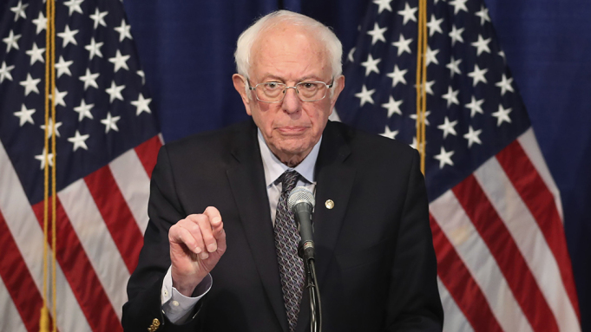](https://variety.com/2020/politics/news/bernie-sanders-fight-on-1203530447/)](https://variety.com/2020/politics/news/bernie-sanders-fight-on-1203530447/)

## [Bernie Sanders Acknowledges He Is Trailing but Vows to Fight On](https://variety.com/2020/politics/news/bernie-sanders-fight-on-1203530447/)

[[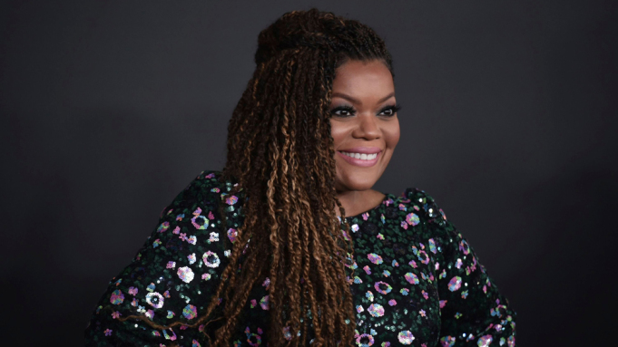](https://variety.com/video/naacp-image-awards-2020-election/)](https://variety.com/video/naacp-image-awards-2020-election/)

## [Stars at NAACP Image Awards Share Biggest Concerns Ahead of 2020 Election](https://variety.com/video/naacp-image-awards-2020-election/)

**You were very instrumental in helping get out the young vote in the midterm elections last November. What are you doing in the run-up to the November election? Are you going to be out there again registering folks to vote?**

March for Our Lives has big plans to ensure young people get involved and registered this year. We worked our asses off before the 2018 midterms to get as many people as possible registered to vote and saw an incredible increase in voter turnout. We are bringing that same drive to this election cycle, and of course since this election will decide the next president, more people are paying attention and are likely to vote, so I personally have high hopes for a high voter turnout, no matter the outcome.

In this current day and age, with all of the world’s technology right at our fingertips and a constant barrage of information being spit at us by the never-ending news cycle, it is very easy to feel disenfranchised, and that our votes don’t matter. We need to be more conscientious about our every movement, individually and as a society, so research who you vote for and stay steadfast in your convictions, even if the current political state of this country makes you want to hide your head in the sand. You’ve been given a voice, so use it.

**Tragically, since Parkland there have been a number of mass shootings at schools and elsewhere. And this president and his administration have done nothing to curb it, is that correct?**

The sad truth is, mass shootings are not the only instances of gun violence that exist in this country. Black and brown people are getting killed every day by gun violence, and their deaths have just as big an impact on their community as mass shootings, so we also need to talk about racism and police brutality and poverty and the school-to-prison pipeline when we talk about gun reform. Second, suicides comprise two-thirds of gun violence in this country, so when we talk about gun reform in this country we need to talk about health care and the stigma around mental illness, in addition to the classism/racism/sexism that exists in those conversations. We also can’t ignore who makes money by selling guns when violence occurs, then scared people buy guns for protection, and the cycle continues.

All of this begs the question, why would a Republican-led government, much less a Republican president, do anything to slow the influx of cash that the gun-manufacturing industry receives? It is up to us, in this election cycle and during midterm election cycles, to push the vital, time-sensitive and interrelated issues of gun reform, mental health, poverty and racism into the election process. These problems aren’t going to solve themselves.

**Do you think our government is still in bed with the NRA and the organization is as powerful as it once was?**

I don’t think we as constituents should ever be fully trusting of our government or our elected leaders; it’s up to us to be informed and hold them accountable. There are many websites you can visit that tell you the public donations that elected officials accept from the NRA and how much. As for the NRA, that’s just one of the many problems in this country, and as much as I let my days go by without thinking about the NRA or Oliver North or Wayne LaPierre and their various financial and imperialist scandals, and Marion Hammer’s possibly irreparable damage done to this country and my home state of Florida, it is vital to keep an eye on the threats to sanity, health and protection of the general and at-risk population in this country. When you stop taking a threat seriously, it becomes all the more threatening.

Emma Gonzales 2020

<https://www.refinery29.com/en-us/2020/03/9584732/where-is-emma-gonzalez-march-for-our-lives-anniversary>

# Emma Gonzalez Opens Up About How Her Life Has Changed Since Parkland Tragedy

By [Claudia Eller](https://variety.com/author/claudia-eller/)

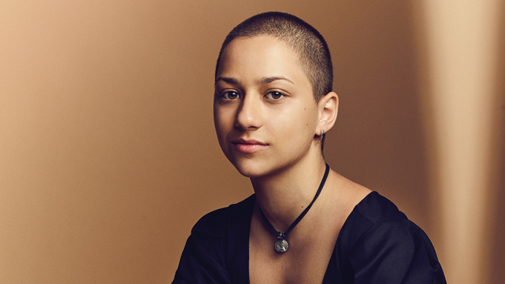

Joe Pugliese for Variety

Emma González is, in many ways, your typical teenager. She’s bright-eyed and jaunty, and wears her passions, emotions and fierce independence on her sleeve. She doesn’t attempt to censor her opinions. She voraciously consumes movies and TV shows like “The Office” on Netflix. She knows all the lyrics to her favorite songs, and her Spotify user name is González spelled backward.

But 18-year-old Emma González is anything but typical.

On her left wrist, she wears an array of rubber bracelets memorializing victims who were gunned down at her high school in Parkland, Fla., earlier this year. The bands are a stark daily reminder of the painful memories that no young person should ever have seared into her consciousness. On her right wrist, González wears friendship bracelets. “I have friends who are still alive on my other bracelets,” she says, perhaps not realizing just how heartbreaking that sounds.

Her life took a shocking turn on the afternoon of Feb. 14, when 17 students and teachers died in a mass shooting at Marjory Stoneman Douglas High School. González was in the auditorium attending a class when the fire alarm went off. Students spilled onto the campus to find SWAT teams swarming and authorities screaming, “Code Red!” González and her classmates were rushed back into the auditorium, where they took cover on the floor between the folding seats. Holding the hands of friends on either side of her, González focused on keeping those around her calm as many began frantically searching the internet for any news that could explain what was unfolding on their campus.

“I didn’t know what was going on,” recalls González. “I didn’t want to go on my phone to check and see if anything was real because I was in a complete state of denial,” she tells me in her first-ever solo magazine interview. It wasn’t until days later that she would learn the full extent of the tragedy, when she read a story in the Miami Herald and saw the names of all the students and faculty members who had died.

Just three days after the massacre, González mustered remarkable resilience and courage when she transformed her anguish and heartbreak into unabashed activism. She delivered an impassioned speech at a gun control rally in Fort Lauderdale, calling “B.S.” on President Trump, other politicians and the NRA for not tightening gun laws that could prevent “the hundreds of senseless tragedies that have occurred.” Her speech was broadcast nationally, and her name began trending on Twitter that afternoon. She created the @Emma4Change handle to promote stricter gun laws, and along with other Parkland survivors she founded March for Our Lives, a nonprofit, nonpartisan organization pushing for stricter gun laws and registering young voters.

Today, González boasts 1.66 million Twitter followers — hundreds of thousands more than the NRA’s 710,000. She and other Parkland activists, including Cameron Kasky, Jaclyn Corin and David Hogg, have been featured in magazines and interviewed on countless news programs. When Variety invited González to be one of our five 2018 [Power of Women](https://variety.com/t/power-of-women/) honorees, which entailed a solo cover and a one-on-one interview, she was initially reluctant. She was used to sharing the spotlight with her compatriots and wasn’t comfortable drawing attention exclusively to herself.

But González arrives at our photo session and interview — which takes place shortly after she graduated from high school — raring to go. If she is nervous, it doesn’t show. She talks excitedly about having watched Sacha Baron Cohen’s mockumentary “Borat” for the first time, which she says made her laugh so hard she fell off her chair. She comes dressed in blue jeans rolled at the cuffs, Vans and a cropped, sleeveless T-shirt printed with the American flag and a QR code that when scanned enables her to register people to vote in less than two minutes.

As the photographer clicks away, González lip synchs and grooves to the tunes on her playlist. After the session, I remark that for someone unaccustomed to the spotlight, she seems incredibly comfortable in her own skin. “I am comfortable in my own skin,” she replies.

How many teenagers can say that?

**What advice would you give to young women who are growing up in an era when female empowerment is so vital on every level?**

To young women who are growing up in an era of female empowerment, it is important to remember that quote from Eleanor Roosevelt: “No one can make you feel inferior without your consent.” Many people in this world are not raised to understand the concept of consent, in all walks of life, and it’s important that abusers of consent not be treated as victims when they are rightfully exposed.

Volume 0%

Women have the power to do anything men can do, just as black people have the power to do anything Hispanic people can do, and gay people have the power do anything that straight people can do, and trans people have the power to do anything that cis people can do. This country’s government was made to work slowly, but if we elect the right people and keep moving as fast as we have been, we will change our world for the better.

Women need to feel powerful enough to share their stories and make their impact, but perpetrators of the system that make women have stories to share in the first place need to be reminded that their behavior is disgusting and disgraceful. I’m looking at you, [Brett] Kavanaugh.

We forget that half the solution is women being comfortable with who they are and who they wish to be, and the other half is taking down the system and people who made them uncomfortable and have low self-worth in the first place. This is an effort to be taken on by all genders.

**Do you consider yourself a feminist?**

Feminism is defined as the advocacy of women’s rights on the basis of the equality of the sexes. I do indeed describe myself as a feminist because I believe equality of the sexes (and all genders) should be the basis our society builds upon.

**How has life changed for you since the shooting? What kind of emotional toll has it taken?**

There are always moments in the day when I get hit with a sadness about the people who have been lost in this tragedy. That has directly affected me. It’s really hard to get through those moments when you’re upset about somebody having passed.

**I imagine that you have encountered some incredible people as a result of your activism.**

Meeting with people is awesome in every sense of the word. It can inspire you with glee. It can inspire you with happiness. It can inspire you with sadness and melancholy, but also hope.

**What is the biggest impact you and the other Parkland survivors have had so far?**

We’ve gotten a lot of people registered to vote. Even if one more person who normally wouldn’t have gone to the midterms goes to the midterms this November, I personally will feel that we’ve done our jobs. And I know it’s going to be a lot more than one person. Four million people turn 18 this year in time for the midterms. So if we could get every one of those kids registered and even half of them to vote, we will have a major impact.

**Is it odd for you to suddenly be recognized everywhere you go?**

It does feel a little strange. It’s not a bad thing though because it’s nice to know how expansive our message has gotten. If people are listening because they like the people who are delivering the message, that’s all the better because it means we’re doing our jobs, which is getting the message to everybody who needs to hear it. I never used to be afraid to have my head uncovered in public spaces. It’s not settling to have people recognize you and come up to you when your head is uncovered versus when it’s covered and nobody comes up to you. It’s a weird feeling. So if I wear a hat and sunglasses, not as many people recognize me.

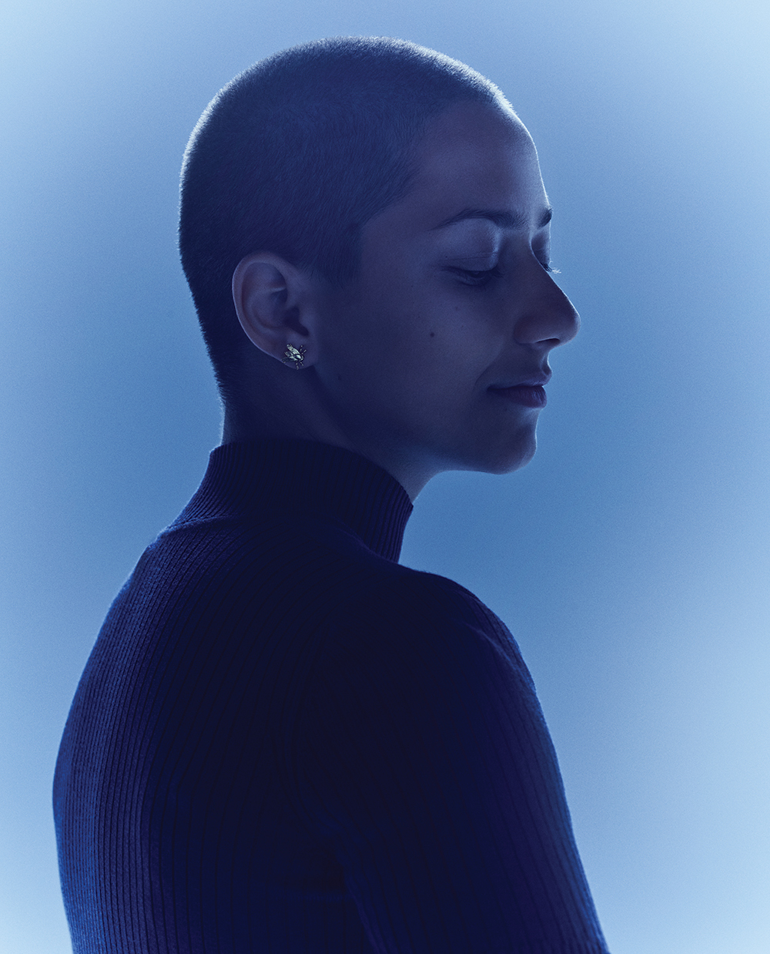

Joe Pugliese for Variety

**Were you an activist before the shooting?**

I was active in terms of class discussions, and I was president of the school’s GSA [Gay-Straight Alliance]. But I didn’t want to be another voice lost in the crowd and have people listen to me at that point in my life. I was still just trying to become the person that I was trying to be, which [is to say] I was waiting for college. I was still formulating myself as a person. I feel like in my senior year of high school, I had my clothes a lot more figured out. I had my hair figured out.

**As you’ve explained in interviews, your buzz cut wasn’t a political statement but a practicality, and you made a PowerPoint presentation to change the minds of your reluctant parents.**

Yes. It was too hot in Florida. My hair was heavy. Any time I had my hair in a ponytail it would give me a headache by the end of the day. I was super self-conscious because I was worried it didn’t always look perfect, and because of that I was thinking about it so much. Insecurities are debilitating a lot of times, and if it was a windy day or a rainy day, which happens in Florida, I didn’t want to worry about the fact that my hair was going to look less than I wanted it to. So if I shaved it off it would always look good and always look the same — which is fantastic!

My parents wouldn’t let me shave it earlier, so I made a PowerPoint presentation to convince them. I strategically put pictures of bald women in there. My dad was laughing so hard the whole time he couldn’t even pay attention.

**Is it true that your parents have been supportive of your individualism and have encouraged you to speak out?**

My parents were very hesitant to tell me to stop talking after everything that had happened, but they were also like, “You haven’t spent any time at home. You’re living at Cameron’s house with everybody else when you’re working [on the campaign]. You need to come home and take a shower. Be a person for four hours. Just be regular,” and I’m like, “I can’t. I have interviews I need to do. I need to call people.” My life was very messy, but my parents managed to get through my awful, awful communication.

**How did your two older brothers deal with the trauma?**

My one brother, Dan, lives in New York. It hit him hard because he couldn’t come home to visit with us. He has a job so he couldn’t take time away. My other brother, considering he was at home, was hit as you expect with news of that sort. All of his friends are out of Douglas by now because he’s three years older than me. But still, it was a rough time for everybody. I was the only one actually at the school, so it hit me hard but differently than it did them.

**On the day of the shooting, how did you process what was going on when everything was happening so quickly?**

I had no idea what was going on. I waited to find out what happened after it happened. I didn’t want to know during because that was only going to most likely incite panic, which is the last thing you needed in a situation like that. I was with my friend Lenore at the time. I was holding her hand and another one of my friends who will remain nameless.

Lenore and I are going to be roommates at college because she and I are the only two people who know what each other was going through, and we had the same experience at the shooting. So it’s going to be really cool to have her with me and have me for her. We already have little movies set up, communicating with pictures instead of words, because sometimes it’s hard to always figure out what words we’re feeling.

**When you hear about other mass shootings, do you relive the horrors of Parkland?**

It’s not that we relive everything, though some people definitely do. But it’s very easy to go back to the mind-set that existed in those days. I remember that everything felt a lot darker. By “darker” I mean that there were actually lights turned off because we did a lot of stuff in the evenings and early mornings. We did a lot indoors. We didn’t go outside a lot. Or we’d be up really early doing interviews. I don’t know how many calls I had in Cameron’s driveway in the evening in the dark, pacing around his driveway. People coming and going and going and coming, and it was such a hectic and unstructured period of time. Very loosey-goosey.

But when I hear about the details of situations, it does bring it back a little bit in terms of “I know how it feels to be in that situation, and I can completely and totally empathize with the emotional process of dealing with it.”

**What do you say to all of the critics, internet trolls and cyberbullies who call you and other survivors “child actors,” anti-gun liberals, communists — and float these ridiculous conspiracy theories?**

I haven’t actually said anything to any of my critics. The reason why I haven’t talked to anyone else about the specific criticisms that you mentioned is because they never come up in person. They only come up online. Nobody’s going to go up to a child and say, “You’re not real. I don’t believe that you exist.” [When I say] “Hi, I’m Emma González. I lost a friend in the shooting” ­— and since I learned about the other people, I lost many friends in the shooting — who is going to come up to me and say, “That’s not true”? … We shouldn’t have negativity attached to our names for reasons that are obviously fake conspiracy theories.

**What’s the biggest public misperception about you?**

A lot of people say “dyke” in terms of negative statements against me. Technically it’s for lesbians. I’m not a lesbian; I’m bisexual. I like guys and girls. There’s confusion with the fact that definition isn’t widely known. But it’s fine, I guess. We’ll get there.

**Has anyone from Hollywood approached you about doing documentaries, movies, TV shows, writing a book?**

[Her publicist cautions her not to give any specifics.] Initially everybody was like, “Let’s do a documentary,” and so many documentary crews appeared, and there were documentaries made, and I was not a fan of how they portrayed everything. … The documentaries were not what they could have been because we were being looked at through the eyes of people who didn’t fully understand, didn’t want to understand, and wanted to change the story because it didn’t fit with their narrative.

**Are you hopeful about the future of America?**

I most definitely feel hopeful because I’ve met so many people who are ready to engage in our political system, and these are exactly the people we need to engage. People who are devoted to the concept of keeping people safe, focusing on the rights of people who need to be kept in mind, who need to be kept alive. People who are looking out for each other, not just themselves. People who are sacrificing a lot because they feel like it’s their job. Because not enough people do that anymore. A lot of people have folded up within themselves, ignoring responsibilities because they don’t want to take on the task of fixing the country that has been broken for so long.

The fact that it is broken feels like a parent who has not done their job properly, and you feel embarrassed and ashamed for the fact that you don’t know how to change the country, how to change the way this parent acts. You don’t know how to have pride in a system, a situation that only causes many people pain and suffering. But we realize now that it’s not that the system exists — it’s that we have a direct hand over the system’s checks and balances. We are the checks and balances.

Americans have bought record 17m guns in year of unrest, analysis finds

**Sales surged in the spring amid coronavirus fears and climbed higher during protests for racial justice**

[**Lois Beckett**](https://www.theguardian.com/profile/lois-beckett)

[**@loisbeckett**](https://twitter.com/loisbeckett)

Fri 30 Oct 2020

[[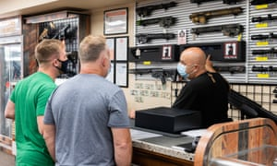](https://www.theguardian.com/us-news/2020/oct/29/coronavirus-pandemic-americans-gun-sales#img-1)](https://www.theguardian.com/us-news/2020/oct/29/coronavirus-pandemic-americans-gun-sales" \l "img-1)

 Gun sales have surged this year during the coronavirus pandemic. Photograph: Mike Pont/Getty Images

Americans have bought nearly 17m guns so far in 2020, more than in any other single year, according to estimates from a firearms analytics company.

Gun sales across the United States first jumped in the spring, driven by fears about the coronavirus pandemic, and spiked even higher in the summer, during massive racial justice protests across the country, prompted by police killings of black Americans.

“By August, we had exceeded last year’s total. By September, we exceeded the highest total ever,” said Jurgen Brauer, the chief economist of [Small Arms Analytics](http://smallarmsanalytics.com/v1/pr/2020-10-03.pdf), which produces widely cited estimates of US gun sales.

The estimated number of guns sold in the US through the end of September 2020 is “not only more than last year, it’s more than any full year in the last 20 years we have records for”, Brauer said.

The previous record for estimated firearms sold in a single year was 16.6m in 2016, when Hillary Clinton ran for president against Donald Trump and endorsed a strong gun-control platform, he said.

The spike in gun sales comes amid rising tensions and intense political polarization. Citing “the current unrest”, Walmart removed guns and ammunition from display in stores this week, as a “precaution” against theft if stores are robbed, the [Wall Street Journal reported](https://www.wsj.com/articles/walmart-pulls-guns-ammo-displays-in-u-s-stores-citing-civil-unrest-11604002136). The retailer did not confirm when firearms and ammunition would be put back on display but said that customers could continue to buy guns and ammunition by request.

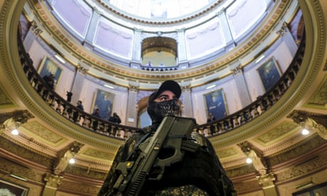

**‘Guns are a way to exercise power’: how the idea of overthrowing the government became mainstream**

Read more

Walmart has already restricted the types of guns and ammunition it sells in the wake of mass shootings and other instances of gun violence. Last year the company announced it would no longer sell ammunition for [military-style rifles](https://www.wsj.com/articles/walmart-to-stop-selling-ammunition-for-assault-style-weapons-11567530289) after a white nationalist terror attack targeting Latino families at a Walmart in El Paso, Texas.

The increase in gun sales appeared to be primarily driven by more purchases of handguns, though Americans were also buying more rifles and other long guns, Brauer, the firearms analyst, said.

While there is no hard data on how many Americans bought a gun for the first time this year, advocates across the political spectrum say they believe that many of the guns sold in 2020 went to new gun owners.

Fears about lawlessness and government instability drove many people to purchase firearms, according to a [recent survey](https://www.theguardian.com/us-news/2020/oct/20/more-than-100000-californians-have-bought-a-gun-in-response-to-covid-19-crisis-report-finds) of California residents conducted by researchers at the University of California, Davis.

Of the people who said they had bought guns this year, “Two-thirds expressed worry about lawlessnes, and close to half worried about prisoners being released. Half also cited worry about the ‘government going too far’,” said Nicole Kravitz-Wirtz, the [lead author of the study](https://www.theguardian.com/us-news/2020/oct/20/more-than-100000-californians-have-bought-a-gun-in-response-to-covid-19-crisis-report-finds).

In the past, demand for guns in the US has typically spiked in reaction to events that are seen as increasing the risk of new gun control laws, including major mass shootings and the chance that a Democrat might win the White House. Barack Obama was known as America’s [greatest gun salesman](https://money.cnn.com/2016/01/06/news/obama-gun-control-sales/), while firearm sales initially [slumped under Trump](https://www.theguardian.com/us-news/2017/sep/08/us-gun-makers-battle-trump-slump-as-sales-fall-by-100m-compared-to-2016), whose election victory was backed by more than $30m from the National Rifle Association.

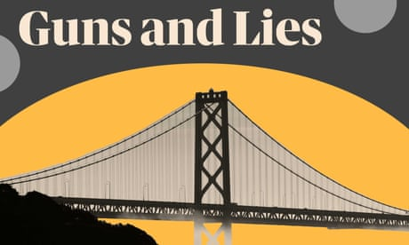

**Guns and lies in America: sign up for email updates**

Read more

This year, months of sustained demand for firearms has resulted in continuing shortages, as well as rising prices, gun owners say.

“I don’t think there’s been anything like it in my 30 years of being involved in firearms,” said Chuck Rossi, one of the founders of Open Source Defense, a gun-rights group created by current and former tech workers.

“There’s no inventory. There are no guns to buy. There is no ammunition to buy. There continue, to this day, to be lines at the gun counters, with empty shelves.”

Gun violence prevention advocates said the sustained surge in gun sales was deeply troubling and could contribute to an increase in domestic violence, suicide and children accidentally shooting themselves or other people with adults’ guns.

An increase in gun purchases in just the first three months of the coronavirus pandemic was associated with a [nearly 8% increase](https://www.theguardian.com/world/live/2020/jul/05/coronavirus-live-news-daily-global-cases-top-200000-as-australias-toughest-lockdown-begins?page=with:block-5f023c648f08ff51fe2ad5e0#block-5f023c648f08ff51fe2ad5e0) in firearm violence in the US, according to [an estimate](https://www.medrxiv.org/content/10.1101/2020.07.02.20145508v1.full.pdf+html) from researchers at the University of California, Davis.

That increase translated into an estimated 776 additional shooting injuries in the US from March through May, the researchers found. States that had lower levels of violent crime pre-Covid saw a stronger connection between additional gun purchases and more gun violence.

“The gun industry thrives in a culture of fear. Their business model is based on a model of leveraging people’s fear in order to buy these products, and they never talk about the risk,” said Robyn Thomas, the executive director of the Giffords Law Center to Prevent Gun Violence.

“The common thread is just uncertainty,” said Kareem Shaya, a gun rights advocate and another founder of Open Source Defense, which has [organized dozens of video training sessions](https://www.theguardian.com/us-news/2020/may/15/gun-sales-us-zoom-classes-activists) for first-time gun owners this year. “A feeling of, hey, if nobody else is going to be able to take care of me, push comes to shove, I want to be able to take care of myself.”