**Death Penalty**

**Is it okay? If somebody has done something terrible…**

(the death penalty is forbidden by EU law)

*Dead Man Walking* (film)…maybe

**Page 2 short videos**

* **Death penalty 1½ min video**
* How does lethal injection work and …if it goes wrong..
* **Two young women on death row (still alive in May 2023)**

**Page 7 wrongly convicted released after 25 years**

Page 9 America Letter: $21m for innocent man after 37 years in prison

Page 12 Central Park Five

**Page 15 After 39 Years of Wrongful Imprisonment, Ricky Jackson Is Finally Free**

Page 18 the waiting list!

Page 27 [Tennessee fires officials after damning death penalty report - BBC News](https://www.bbc.com/news/world-us-canada-64347169)

Page 29 South Carolina court halts executions until firing squad is available

**Page 32 Lee Anderson: New Tory deputy chairman would support return of death penalty**

Page 33 Women who send love letters to PRISONERS reveal what they look for in a jailbird pen pal

Death penalty 1½ min video

<https://www.youtube.com/watch?v=W_mb7tuNJS0>

How does lethal injection work and …if it goes wrong..

<https://www.youtube.com/watch?v=dprfHZ7gYvw>

Two young women on death row (still alive in May 2023)

<https://www.youtube.com/watch?v=dlZs0GMRqT0>

[‘America’s youngest female killers on death row, Emilia Carr and Tiffany Cole’ beg for their lives | news.com.au — Australia’s leading news site](https://www.news.com.au/world/north-america/americas-youngest-female-killers-on-death-row-emilia-carr-and-tiffany-cole-beg-for-their-lives/news-story/66397d55b2477b4b2b9b80f51c754f6f)

**‘America’s youngest female killers on death row, Emilia Carr and Tiffany Cole’ beg for their lives**

AMERICA’S youngest female killers on death row have issued a new plea for their lives, saying they are victims of an unjust system.

**Network Writers**

**2 min read**

February 26, 2015 - 1:02AM

**News Corp Australia**



Supplied Editorial 25022015Killers

AMERICA’S youngest female killers on death row have issued a new plea for their lives, saying they are victims of an unjust system.

Emilia Carr, 30 is the youngest woman in the country on death row. She shares a cell at Florida’s Lowell Correctional Institution with Tiffany Cole, 33, who is the third youngest.

Both women were sexually abused when they were young. Both were convicted of separate murders they say they didn’t do and both are fighting to have their death sentences converted to life sentences.

The pair spoke to US [ABC’s](http://abcnews.go.com/US/call-life-row-youngest-us-women-death-row/story?id=29165934&singlePage=true)Diane Sawyer saying they are only on death row because they didn’t have the money to buy their way out of their situations.

“How many rich people go to prison?” Carr said. “We’re all minorities. We’re all people who are either minorities or didn’t have any, money — any way to say, ‘Hey, let me buy my freedom’, because it’s not free in this country.

“Unfortunately, equality is an illusion,” she said.

The women call it “life row” because they choose to focus on the fact that they aren’t dead yet.

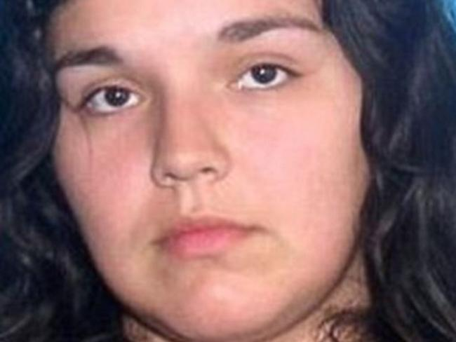

Jealousy ... Prosecutors say Emilia Carr, 30, killed her boyfriend’s wife to be with him. Picture: Supplied

Carr, a mother of four, was sentenced to die by lethal injection for the 2009 murder of Heather Strong — the wife of Carr’s boyfriend, Joshua Fulgham.

Carr is said to have tricked Strong into a storage container where she placed a plastic bag over her head after unsuccessfully trying to break her neck. Strong eventually died of asphyxiation. Carr claims she left before the murder was committed.

“Wouldn’t there have been physical evidence?” she told ABC. “I mean, duct tape is some sticky stuff, yet there’s no finger prints, no DNA, no hair.”

A jury decided 7-5 that she would be sentenced to death, ignoring her defence’s evidence of her abuse as a child from her grandfather and father and the fact that her own father tried to have her killed.

Her co-accused, Fulgham, was sentenced to life in prison for his involvement.

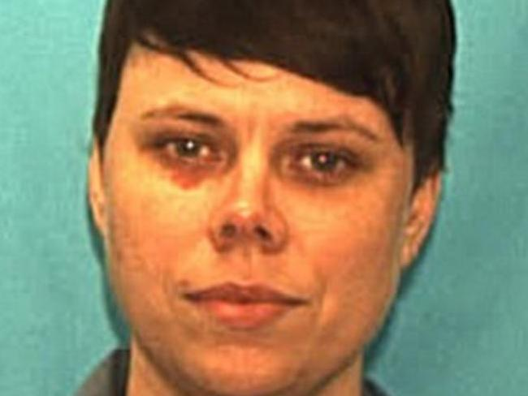

Buried couple alive ... Tiffany Cole is 33. Picture: Supplied

Cole was 26 when she was found guilty of kidnapping and killing her former neighbours Carol and Reggie Sumner.

Cole and three men robbed the couple, tied them up and buried them alive. Photos showed her and the co-defendents celebrating with champagne and handfuls of cash after the crime.

Cole says she helped dig the grave but claims she didn’t know it was for the victims.

“I am not the same person anymore,” Cole said. “I have peace, I have joy. I have a sound mind.”

Both women have lodged appeals — a process that takes an average of 12 years.

Cole’s prosecutor Jay Plotkin told ABC that he does not believe that she should be let off.

“I was a prosecutor for more than 20 years. There was not any case that I prosecuted where the crime was more vile or cruel than the torture and murder of the Sumners,” he said. “This case lingers on in the heart and soul of our community.”

planned executions

[Upcoming Executions | Death Penalty Information Center](https://deathpenaltyinfo.org/executions/upcoming-executions)

Death row inmates released

<https://www.youtube.com/watch?v=otYGdEqhAxY>

after 30 years

<https://www.youtube.com/watch?v=H5xn_YWAGEk>

XXXXXXXXXXXXXXXXXXXXXXXXXXXXXXXXXXXXXXXXXXXXXXXXXXXXXXX

<https://abc7ny.com/wrongfully-convicted-man-freed-after-25-years-in-prison/3761107/>

# Wrongfully convicted man freed after 25 years in prison

Monday, July 16, 2018

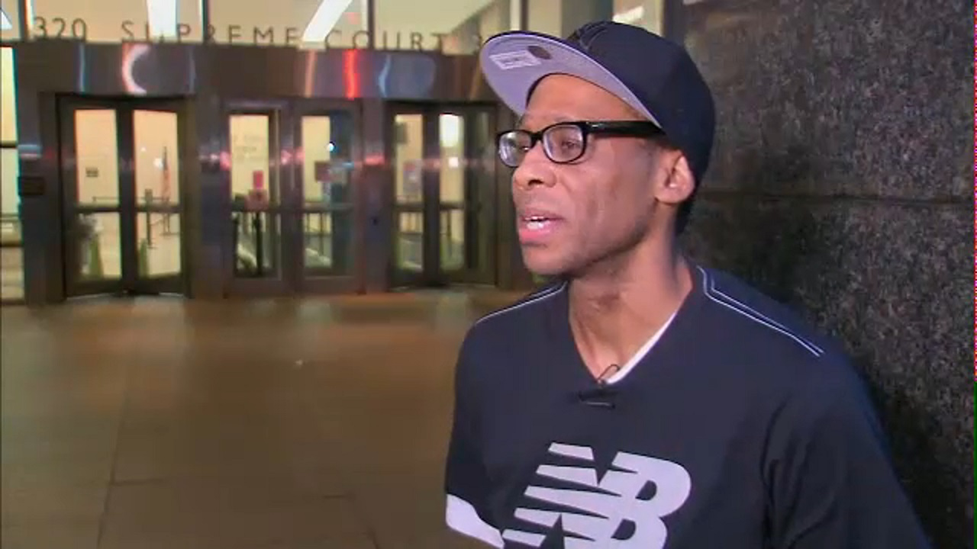

NEW YORK (WABC) -- Stepping out on Friday for Shawn Williams is something he has not been able to do for nearly 25 years. He is now a free man.

"It was like a rush and a big relief," Williams said.

Williams spend more than two decades in prison, wrongly convicted.

"The hardships I endured in prison...but it was a big relief to be reunited with my family," he said.

Making that happen is his attorney, Sam Hershey from Cleary Gottlieb, and the Legal Aid Society, who have worked tirelessly since his case came up for review in 2013.

"We believed from the beginning, based on record, we knew and from what we heard from our client, that he was innocent," said Hershey.

Williams says his good childhood friend was murdered, and he was framed for it.

The Brooklyn DA's conviction review unit suggested Williams' case be looked at again after questionable conduct by former detective Louis Scarcella surfaced including eliciting false statements in other murder cases.

"I certainly hope that other people who have been wrongly convicted get their day in court, and have their convictions vacated as our client was fortunate to have today," added Hershey.

In state Supreme Court, his conviction was vacated, and Williams was set free.

<https://www.irishtimes.com/news/world/us/america-letter-21m-for-innocent-man-after-37-years-in-prison->[1.3811410?fbclid=IwAR1EHcKdGvlkY_FW7znh2am33JmUryCc4oBCJR1natCxxMtQ7_x1az038lU](https://www.irishtimes.com/news/world/us/america-letter-21m-for-innocent-man-after-37-years-in-prison-1.3811410?fbclid=IwAR1EHcKdGvlkY_FW7znh2am33JmUryCc4oBCJR1natCxxMtQ7_x1az038lU)

America Letter: $21m for innocent man after 37 years in prison

DNA evidence proved Craig Coley did not kill his ex-girlfriend and her son in 1978

Sat, Mar 2, 2019, 01:00

[](https://www.irishtimes.com/profile/suzanne-lynch-7.1837435)

[**Suzanne Lynch**](https://www.irishtimes.com/profile/suzanne-lynch-7.1837435) **Washington Correspondent**

[0](https://www.irishtimes.com/news/world/us/america-letter-21m-for-innocent-man-after-37-years-in-prison-1.3811410?fbclid=IwAR1EHcKdGvlkY_FW7znh2am33JmUryCc4oBCJR1natCxxMtQ7_x1az038lU" \l "comments)

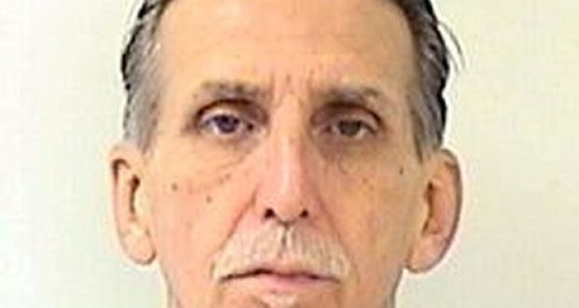

Craig Coley: he was wrongly convicted of the 1978 murders of an ex-girlfriend and her four-year-old son

AddThis Sharing Buttons

Share to LinkedInShare to PinterestShare to ReThis Sharing Buttons

Share to FacebookShare to TwitterShare to Email Ap

This week the city of Simi Valley in California announced it had made a $21 million (€18.4m) settlement with one of its residents, [Craig Coley](https://www.irishtimes.com/topics/topics-7.1213540?article=true&tag_person=Craig+Coley). Now 71, Coley spent 37 years in prison for a crime he did not commit.

The grievous miscarriage of justice dates back to 1978 when Coley’s ex-girlfriend, [Rhonda Wicht](https://www.irishtimes.com/topics/topics-7.1213540?article=true&tag_person=Rhonda+Wicht), who was then 24, and her four-year-old son were found dead in their home. Cowley was arrested and tried for their murder. The case resulted in a hung jury, and the judge declared a mistrial.

However, he was found guilty in a second trial the following year, and the conviction was upheld by the California court of appeal a decade later.

Coley always maintained his innocence, representing himself at the trials and insisting that he had been socialising at a restaurant right up to the time the murders took place.

A diligent Simi Valley police detective began to re-examine the case many years after Coley’s conviction despite resistance from within the police department. DNA evidence emerged that proved Coley was not the killer, and his conviction was overturned. He was released in November 2017, and pardoned by then governor [Jerry Brown](https://www.irishtimes.com/topics/topics-7.1213540?article=true&tag_person=Jerry+Brown).

Announcing the settlement this week, Simi city manager [Eric Levitt](https://www.irishtimes.com/topics/topics-7.1213540?article=true&tag_person=Eric+Levitt) said: “While no amount of money can make up for what happened to Mr Coley, settling this case is the right thing to do for Mr Coley and our community.”

Coley is just one of hundreds of convicted prisoners exonerated each year in the US.

Last month Huwe Burton, who spent 19 years in prison for the murder of his mother, was cleared. He was found to have been pressurised into making a false confession. “I stand here for that 16-year-old boy who didn’t have anyone to protect him, and the adults didn’t protect him at that time,” he said in court.

In Brooklyn, New York, prosecutors are re-examining dozens of cases after several convictions in cases run by one particular detective were overturned.

**Incarceration rate**

The case of Coley and others also shines a spotlight on America’s prison population. The US has the highest incarceration rate in the world. Figures from the Bureau of Justice Statistics show that almost 2.2 million people were held in federal, state and correctional facilities at the end of 2016 – up from 350,000 in 1972.

While there has been a slight drop-off in recent years, the US’s prison population has been expanding exponentially for decades, with many blaming the war on drugs and Bill Clinton’s controversial 1994 crime bill which introduced a mandatory life sentence for repeat offenders and increased funding for federal prisons.

The problem of mass incarceration also has a strong racial component, with African-American men more likely to end up in prison, often for minor misdemeanours or because they cannot afford bail payments. According to writer and lawyer [Michelle Alexander](https://www.irishtimes.com/topics/topics-7.1213540?article=true&tag_person=Michelle+Alexander), one in three African-American men will spend time in prison if current trends continue.

Criminal justice reform has emerged as a policy issue for Democratic candidates in next year’s presidential campaign. Senator [Kamala Harris](https://www.irishtimes.com/topics/topics-7.1213540?article=true&tag_person=Kamala+Harris), for example, has highlighted her background as a prosecutor and state attorney general to make the case for prison reform.

Yet the US’s mass incarceration problem has also prompted a rare example of successful bipartisanship. One of the final achievements of the last [Congress](https://www.irishtimes.com/topics/topics-7.1213540?article=true&tag_organisation=Congress) was the passing of a criminal justice reform bill. Known as the First Step Act, the new legislation is the most significant change to crime policy in a generation.

**Spiralling prison costs**

Spearheaded by President Donald Trump’s son-in-law and adviser [Jared Kushner](https://www.irishtimes.com/topics/topics-7.1213540?article=true&tag_person=Jared+Kushner), whose own father spent time in prison for white-collar crime, it was backed by a majority of both Democrats and Republicans. Though cautious about embracing a policy that could be seen as soft on crime, many conservatives came on board because of concerns about the spiralling cost of the prison system.

The new law introduces changes around sentencing, including a reduction in mandatory minimum sentences for non-violent drug offenders, while also expanding early-release programmes.

Trump has made criminal justice reform one of his surprise policy priorities, meeting with celebrity [Kim Kardashian West](https://www.irishtimes.com/topics/topics-7.1213540?article=true&tag_person=Kim+Kardashian+West) on the issue, and agreeing to her request to pardon [Alice Johnson](https://www.irishtimes.com/topics/topics-7.1213540?article=true&tag_person=Alice+Johnson), a grandmother who was serving a life sentence for drug offences.

For those such as Coley who have been jailed in the wrong, however, it may be too late. Speaking this week, Coley said he forgave those who wrongfully convicted him. But he was clear about one thing: “There is no money that can replace what I lost.”

<https://www.bbc.com/news/world-us-canada-48687356>

**bbc 19 June 2019**

# When They See Us: Trump stands by 1989 Central Park Five comments

* 2 hours ago
* [Share this with Facebook](https://www.bbc.com/news/world-us-canada-48687356)
* [Share this with Messenger](https://www.bbc.com/news/world-us-canada-48687356)
* [Share this with Twitter](https://www.bbc.com/news/world-us-canada-48687356)
* [Share this with Email](mailto:?subject=Shared%20from%20BBC%20News&body=https%3A%2F%2Fwww.bbc.com%2Fnews%2Fworld-us-canada-48687356)
* [Share](https://www.bbc.com/news/world-us-canada-48687356#share-tools)



Media captionMr Trump is asked if he will apologise to the Central Park Five

**US President Donald Trump has stood by his comments about five men who were wrongly convicted for the brutal rape of a jogger in Central Park in 1989, saying they had "admitted their guilt".**

Following the arrest of the five teenagers, Mr Trump paid for newspaper adverts calling for the return of the death penalty in the state.

The Central Park Five were exonerated in 2002, after another man confessed.

They say their earlier confessions were a result of police coercion.

* [Who were the Central Park Five?](https://www.bbc.com/news/newsbeat-48609693)
* [Viewpoint: A 'true horror' story for black Americans](https://www.bbc.com/news/world-us-canada-48503826)

The case has received renewed public attention in recent weeks, following the release of Netflix mini-series When They See Us.

"They put a bounty on our heads by taking out these full-page ads calling for our deaths," one of the men, Yusef Salaam, said last month.

Mr Trump was asked by a reporter at the White House on Tuesday if he would apologise to the five men for the newspaper ads.

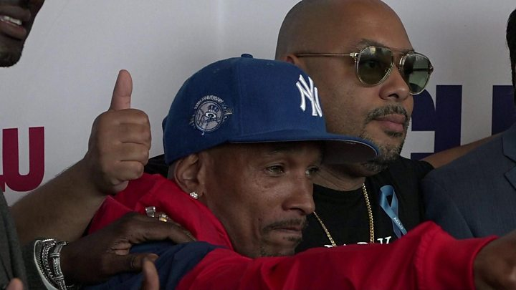



Media captionCentral Park Five: 'They put bounty on our heads'

"Why do you bring this question up now? It's an interesting time to bring it up," he said.

"You have people on both sides of that. They admitted their guilt. If you look at Linda Fairstein and if you look at some of the prosecutors, they think that the city should never have settled that case. So we'll leave it at that."

Ms Fairstein was the top Manhattan sexual crimes prosecutor when the five teenagers were charged with the attack. She went on to become a bestselling crime novelist but was [dropped by her publisher last month](https://www.bbc.co.uk/news/world-us-canada-48563756) amid renewed outcry over the case.

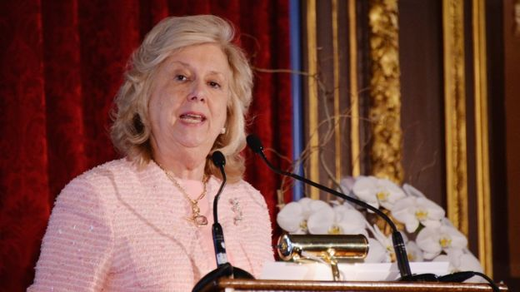*Image copyright Getty Images Image caption Linda Fairstein was the top Manhattan sexual crimes prosecutor when the teenagers were charged She has maintained that the five men were not coerced, and defended the authorities' conduct*.

Raymond Santana, Kevin Richardson, Antron McCray, Yusef Salaam and Korey Wise were aged between 14 and 16 when they were arrested for the brutal rape of a 28-year-old white investment banker, who was left for dead in a bush in Central Park and had no memory of the attack.

The racially charged case shocked the city and provoked fears of gangs of black teenagers going on crime rampages.

The teenagers initially confessed to the crime but later recanted, saying their admissions were the result of police coercion.

They were imprisoned for between five and 13 years – but their convictions were ultimately overturned in 2002 after a serial violent offender named Matias Reyes confessed to the attack, and DNA tests confirmed his guilt.

In 2014, [a $41m (£32m) settlement was reached](https://www.bbc.co.uk/news/world-us-canada-27947989) between the five men and New York City.

<https://www.smithsonianmag.com/history/years-wrongful-imprisonment-ricky-jackson-finally-free-180961434/>

# After 39 Years of Wrongful Imprisonment, Ricky Jackson Is Finally Free

## Locked up for a murder he didn’t commit, he served the longest sentence of any U.S. inmate found to be innocent

By Matthew Shaer; Photographs by Annie Flanagan

Smithsonian Magazine | [Subscribe](https://subscribe.smithsonianmag.com/sub.php?idx=245&inetz=article-text-link-D&ipromo=|perm|sub||text||blue||DFLT)   
January 2017 50412012.8K

**“I feel such a sense of urgency these days. Because I know exactly how much time they took away from me.”**

Ricky Jackson, 59, is sprawled across a leather couch in the basement of his new house in Chesterland, Ohio, some 20 miles east of Cleveland. His Nike-clad feet are propped on the end table. An Apple iPhone rests on his chest. There are framed portraits of Bob Marley, flags commemorating the Cleveland Cavaliers’ 2016 NBA championship and numerous books, including stories by J.G. Ballard and one about ancient Egyptian mythology. A small bar. A neon sign blinks “man cave.”

“I intend to live well,” Jackson continues, pouring himself a glass of pomegranate juice. “But it has nothing to do with whether I’m here in this nice house, or whether I’m homeless. It has to do with attitude. I’ve been given an opportunity, you understand? And I’m not going to waste it by holding grudges.”

Not that anyone would blame him. Beginning at age 18, Jackson spent 39 years in an Ohio prison for a crime he didn’t commit—the longest prison term for an exonerated defendant in American history, and a staggering example of how the criminal justice system can wrong the innocent.

Jackson, who is short and lean, with a creased forehead and pitted cheeks, grew up on Cleveland’s East Side, the first son of a large working-class family. At 18, he enlisted in the Marines, hoping to make a career of it, but within a year was granted an honorable discharge for a balky back. Soon after returning home he and two friends were arrested for killing Harold Franks outside a neighborhood convenience store. Franks was doing business there—he sold money orders—when, according to police, a pair of assailants splashed acid on his face, clubbed him, shot him several times, stole about $425 and fled.

Police never found the murder weapon, and Jackson and his friends, the brothers Wiley and Ronnie Bridgeman, insisted they were elsewhere at the time of the shooting and had never laid eyes on Franks. But detectives had obtained a statement from a local paperboy, 12-year-old Eddie Vernon, who knew the Bridgemans and Jackson. Eddie told police that Jackson fired the handgun, Ronnie Bridgeman doused the victim with acid and his brother drove the getaway car. Though Eddie was a shaky witness—he failed to identify the suspects in a police lineup, and several of his classmates testified he had not been near the crime scene—three separate juries accepted the youngster’s account. In 1975, Jackson and the Bridgemans were convicted of murder and sentenced to die by electric chair.

“The boy I was before prison, with all his dreams, all his intentions, he died the moment I was locked up,” Jackson remembers.

On death row, in a narrow cell with a slot for a window, he was unnerved by the realization that people wanted him to die. Then, in 1977, his death sentence was reduced to life in prison because of a technicality, and the following year the U.S. Supreme Court ruled that Ohio’s capital punishment law was unconstitutional. Jackson joined the regular population at Southern Ohio Correctional Facility.

Prison shaped the adult just as the streets of East Cleveland had shaped the kid. He fought other inmates when he had to, and spent months at a time in solitary confinement. He’s not a religious man, but even in his “darkest moments,” he says, “I had this ember inside me, some little smoldering piece of hope. I’d say, If I give up, what am I really surrendering to? And so you go on.” He studied gardening. He refereed basketball games. He found solace in the prison library, often reading a book a day—biology, nature, history—losing himself in those other worlds. And he wrote letters—to journalists, filmmakers, anyone who might be interested in his case. In 2011, The Scene, a Cleveland magazine, published an article about the frail nature of Jackson’s conviction and the implausibility of the testimony that had condemned him. Among the readers was Eddie Vernon’s pastor, who arranged a meeting between Vernon and lawyers with the Ohio Innocence Project. Vernon rescinded his 1975 testimony, saying police coerced him into fingering Jackson and the Bridgemans. In 2014, prosecutors dismissed charges against the three men.

Ronnie Bridgeman, now Kwame Ajamu, had been paroled in 2003. Wiley had been paroled in 2002 but was reincarcerated three months later following a parole violation. Jackson, who had passed up several chances to shorten his sentence by admitting a role in the Franks killing, was released after spending four decades, his entire adult life, behind bars.

“It was overwhelming, being out after all that time,” Jackson says. “I just did my best to stay grounded. To get the little things done: get a driver’s license, find an apartment.” He bought a used car, started a business with friends refurbishing houses around Cleveland. When settlement money came in from the state—nearly a million dollars—he bought the new house, for himself and his fiancée, whom he met through his niece.

He is still getting used to his “rebirth,” he calls it. He tries to keep busy, traveling to construction sites, speaking at conferences and other events about his time in prison. He’s planning trips to Ireland and Jamaica. In the evenings, he reads, or helps his fiancée’s three kids with their homework. And he stays in touch with the Bridgeman brothers, friends who understand what he’s been through.

Eddie Vernon met with Jackson and the Bridgemans after their exonerations and apologized for implicating them. Jackson forgives him. “He was just this goofy little kid who told a whopper,” Jackson says. Besides, “it wasn’t only [Vernon] that put us there. It was the lawyers, the police, the whole broken system. And there are a lot of innocent men out there who are never going to get justice. In that sense, I feel lucky.”

Read more: <https://www.smithsonianmag.com/history/years-wrongful-imprisonment-ricky-jackson-finally-free-180961434/#RPjFmBskhgSp5Hjx.99>

[List of people scheduled to be executed in the United States - Wikipedia](https://en.wikipedia.org/wiki/List_of_people_scheduled_to_be_executed_in_the_United_States)

## Summary of scheduled executions[[edit](https://en.wikipedia.org/w/index.php?title=List_of_people_scheduled_to_be_executed_in_the_United_States&action=edit&section=1)]

As of May 23, 2023, a total of 43 people are scheduled to be [executed](https://en.wikipedia.org/wiki/Executions) in the United States.[[1]](https://en.wikipedia.org/wiki/List_of_people_scheduled_to_be_executed_in_the_United_States#cite_note-dpic-1) All of these executions are scheduled over four calendar years in six [U.S. states](https://en.wikipedia.org/wiki/U.S._state).[[2]](https://en.wikipedia.org/wiki/List_of_people_scheduled_to_be_executed_in_the_United_States#cite_note-schedule-2)

| **Year** | **Executions** |
| --- | --- |
| [2023](https://en.wikipedia.org/wiki/List_of_people_scheduled_to_be_executed_in_the_United_States#2023) | 9 |
| [2024](https://en.wikipedia.org/wiki/List_of_people_scheduled_to_be_executed_in_the_United_States#2024) | 11 |
| [2025](https://en.wikipedia.org/wiki/List_of_people_scheduled_to_be_executed_in_the_United_States#2025) | 11 |
| [2026](https://en.wikipedia.org/wiki/List_of_people_scheduled_to_be_executed_in_the_United_States#2026) | 12 |
| **Total** | **43** |

| **State** | **Executions** |
| --- | --- |
| [Ohio](https://en.wikipedia.org/wiki/Capital_punishment_in_Ohio) | 33 |
| [Oklahoma](https://en.wikipedia.org/wiki/Capital_punishment_in_Oklahoma) | 6 |
| [Missouri](https://en.wikipedia.org/wiki/Capital_punishment_in_Missouri) | 2 |
| [Alabama](https://en.wikipedia.org/wiki/Capital_punishment_in_Alabama) | 1 |
| [Texas](https://en.wikipedia.org/wiki/Capital_punishment_in_Texas) | 1 |
| **Total** | **43** |

## List of people scheduled to be executed[[edit](https://en.wikipedia.org/w/index.php?title=List_of_people_scheduled_to_be_executed_in_the_United_States&action=edit&section=2)]

### 2023**[**[**edit**](https://en.wikipedia.org/w/index.php?title=List_of_people_scheduled_to_be_executed_in_the_United_States&action=edit&section=3)**]**

*See also:*[*List of people executed in the United States in 2023*](https://en.wikipedia.org/wiki/List_of_people_executed_in_the_United_States_in_2023)

| **No.** | **Date of execution** | **Name** | **Age of person** | | | **Gender** | **Ethnicity** | **State** | **Method** | **Ref.** |
| --- | --- | --- | --- | --- | --- | --- | --- | --- | --- | --- |
| **At execution** | **At offense** | **Age difference** |
| **1** | June 6, 2023 | Michael Andrew Tisius | 42 | 19 | 23 | Male | White | [Missouri](https://en.wikipedia.org/wiki/Capital_punishment_in_Missouri) | [Lethal injection](https://en.wikipedia.org/wiki/Lethal_injection) | Profile: [[1]](https://missourideathrow.com/2008/12/tisius-michael/) |
| **2** | June 2023 | James Edward Barber | 64 | 42 | 22 | [Alabama](https://en.wikipedia.org/wiki/Capital_punishment_in_Alabama) | Profile: [[2]](http://www.doc.state.al.us/deathrow) |
| **3** | July 20, 2023 | Jemaine Monteil Cannon | 51 | 23 | 28 | Black | [Oklahoma](https://en.wikipedia.org/wiki/Capital_punishment_in_Oklahoma) | Profile: [[3]](https://okoffender.doc.ok.gov/) |
| **4** | August 1, 2023 | Johnny A. Johnson | 45 | 24 | 21 | White | Missouri | Profile: [[4]](https://web.mo.gov/doc/offSearchWeb/offenderListAction.do?docId=534534) |
| **5** | September 21, 2023 | Anthony Castillo Sanchez | 44 | 18 | 26 | Oklahoma | Profile: [[5]](https://okoffender.doc.ok.gov/) |
| **6** | October 10, 2023 | Jedidiah Isaac Murphy | 48 | 25 | 23 | [Texas](https://en.wikipedia.org/wiki/Capital_punishment_in_Texas) | Profile: [[6]](https://www.tdcj.texas.gov/death_row/dr_info/murphyjedidiah.html) |
| **7** | November 16, 2023 | [Keith LaMar](https://en.wikipedia.org/wiki/Southern_Ohio_Correctional_Facility) | 54 | 23 | 31 | Black | [Ohio](https://en.wikipedia.org/wiki/Capital_punishment_in_Ohio) | [To be determined](https://en.wikipedia.org/wiki/List_of_methods_of_capital_punishment#Current_methods) | Profile: [[7]](https://appgateway.drc.ohio.gov/OffenderSearch/Search/Details/A317117) |
| **8** | November 30, 2023 | Phillip Dean Hancock | 59 | 37 | 22 | White | Oklahoma | Lethal injection | Profile: [[8]](https://okoffender.doc.ok.gov/) |
| **9** | December 6, 2023 | Elwood Hubert Jones | 71 | 42 | 29 | Black | Ohio | To be determined | Profile: [[9]](https://appgateway.drc.ohio.gov/OffenderSearch/Search/Details/A339441) |

### 2024**[**[**edit**](https://en.wikipedia.org/w/index.php?title=List_of_people_scheduled_to_be_executed_in_the_United_States&action=edit&section=4)**]**

| **No.** | **Date of execution** | **Name** | **Age of person** | | | **Gender** | **Ethnicity** | **State** | **Method** | **Ref.** |
| --- | --- | --- | --- | --- | --- | --- | --- | --- | --- | --- |
| **At execution** | **At offense** | **Age difference** |
| **1** | January 10, 2024 | Scott A. Group | 59 | 32 | 27 | Male | White | [Ohio](https://en.wikipedia.org/wiki/Capital_punishment_in_Ohio) | [To be determined](https://en.wikipedia.org/wiki/List_of_methods_of_capital_punishment#Current_methods) | Profile: [[10]](https://appgateway.drc.ohio.gov/OffenderSearch/Search/Details/A375170) |
| **2** | February 1, 2024 | James Chandler Ryder | 61 | 37 | 24 | [Oklahoma](https://en.wikipedia.org/wiki/Capital_punishment_in_Oklahoma) | [Lethal injection](https://en.wikipedia.org/wiki/Lethal_injection) | Profile: [[11]](https://okoffender.doc.ok.gov/) |
| **3** | February 15, 2024 | Gregory Lott | 62 | 25 | 37 | Black | Ohio | To be determined | Profile: [[12]](https://appgateway.drc.ohio.gov/OffenderSearch/Search/Details/A198547) |
| **4** | March 14, 2024 | John Stojetz | 68 | 40 | 28 | White | Profile: [[13]](https://appgateway.drc.ohio.gov/OffenderSearch/Search/Details/A255365) |
| **5** | April 4, 2024 | Michael Dewayne Smith | 41 | 19 | 22 | Black | Oklahoma | Lethal injection | Profile: [[14]](https://okoffender.doc.ok.gov/) |
| **6** | April 17, 2024 | Archie J. Dixon | 50 | 20 | 30 | White | Ohio | To be determined | Profile: [[15]](https://appgateway.drc.ohio.gov/OffenderSearch/Search/Details/A325702) |
| **7** | June 6, 2024 | Wade Greely Lay | 63 | 43 | 20 | Oklahoma | Lethal injection | Profile: [[16]](https://okoffender.doc.ok.gov/) |
| **8** | June 18, 2024 | Timothy L. Hoffner | 52 | 21 | 31 | Ohio | To be determined | Profile: [[17]](https://appgateway.drc.ohio.gov/OffenderSearch/Search/Details/A315988) |
| **9** | August 13, 2024 | John David Stumpf | 63 | 23 | 40 | Profile: [[18]](https://appgateway.drc.ohio.gov/OffenderSearch/Search/Details/A181258) |
| **10** | October 15, 2024 | Lawrence Alfred Landrum | Profile: [[19]](https://appgateway.drc.ohio.gov/OffenderSearch/Search/Details/A189982) |
| **11** | December 17, 2024 | Warren Keith Henness | 61 | 28 | 33 | Profile: [[20]](https://appgateway.drc.ohio.gov/OffenderSearch/Search/Details/A287375) |

### 2025**[**[**edit**](https://en.wikipedia.org/w/index.php?title=List_of_people_scheduled_to_be_executed_in_the_United_States&action=edit&section=5)**]**

| **No.** | **Date of execution** | **Name** | **Age of person** | | | **Gender** | **Ethnicity** | **State** | **Method** | **Ref.** |
| --- | --- | --- | --- | --- | --- | --- | --- | --- | --- | --- |
| **At execution** | **At offense** | **Age difference** |
| **1** | January 22, 2025 | Sean Carter | 45 | 18 | 27 | Male | Black | [Ohio](https://en.wikipedia.org/wiki/Capital_punishment_in_Ohio) | [To be determined](https://en.wikipedia.org/wiki/List_of_methods_of_capital_punishment#Current_methods) | Profile: [[21]](https://appgateway.drc.ohio.gov/OffenderSearch/Search/Details/A356659) |
| **2** | February 19, 2025 | Stanley Theodore Adams | 58 | 33 | 25 | White | Profile: [[22]](https://appgateway.drc.ohio.gov/OffenderSearch/Search/Details/A420071) |
| **3** | April 16, 2025 | John E. Drummond | 47 | 25 | 22 | Black | Profile: [[23]](https://appgateway.drc.ohio.gov/OffenderSearch/Search/Details/A462868) |
| **4** | May 14, 2025 | James Galen Hanna | 75 | 48 | 27 | White | Profile: [[24]](https://appgateway.drc.ohio.gov/OffenderSearch/Search/Details/A152169) |
| **5** | May 20, 2025 | [James Dean Worley](https://en.wikipedia.org/wiki/Murder_of_Sierah_Joughin#James_Worley) | 66 | 57 | 9 | Profile: [[25]](https://appgateway.drc.ohio.gov/OffenderSearch/Search/Details/A743593) |
| **6** | June 18, 2025 | Percy Hutton | 71 | 32 | 39 | Black | Profile: [[26]](https://appgateway.drc.ohio.gov/OffenderSearch/Search/Details/A195620) |
| **7** | July 30, 2025 | Samuel Moreland | 31 | 40 | Profile: [[27]](https://appgateway.drc.ohio.gov/OffenderSearch/Search/Details/A190490) |
| **8** | August 27, 2025 | Cedric Carter | 52 | 19 | 33 | Profile: [[28]](https://appgateway.drc.ohio.gov/OffenderSearch/Search/Details/A262433) |
| **9** | September 24, 2025 | Douglas Lamont Coley | 50 | 21 | 29 | Profile: [[29]](https://appgateway.drc.ohio.gov/OffenderSearch/Search/Details/A361444) |
| **10** | October 30, 2025 | Timothy L. Coleman | 56 | 26 | 30 | Profile: [[30]](https://appgateway.drc.ohio.gov/OffenderSearch/Search/Details/A328139) |
| **11** | December 10, 2025 | Kareem M. Jackson | 51 | 23 | 28 | Profile: [[31]](https://appgateway.drc.ohio.gov/OffenderSearch/Search/Details/A354156) |

### 2026**[**[**edit**](https://en.wikipedia.org/w/index.php?title=List_of_people_scheduled_to_be_executed_in_the_United_States&action=edit&section=6)**]**

| **No.** | **Date of execution** | **Name** | **Age of person** | | | **Gender** | **Ethnicity** | **State** | **Method** | **Ref.** |
| --- | --- | --- | --- | --- | --- | --- | --- | --- | --- | --- |
| **At execution** | **At offense** | **Age difference** |
| **1** | January 7, 2026 | [Quisi Bryan](https://en.wikipedia.org/wiki/Quisi_Bryan) | 55 | 29 | 26 | Male | Black | [Ohio](https://en.wikipedia.org/wiki/Capital_punishment_in_Ohio) | [To be determined](https://en.wikipedia.org/wiki/List_of_methods_of_capital_punishment#Current_methods) | Profile: [[32]](https://appgateway.drc.ohio.gov/OffenderSearch/Search/Details/A399595) |
| **2** | February 11, 2026 | Antonio Sanchez Franklin | 47 | 18 | 29 | Profile: [[33]](https://appgateway.drc.ohio.gov/OffenderSearch/Search/Details/A363374) |
| **3** | March 12, 2026 | James Earl Trimble | 65 | 44 | 21 | White | Profile: [[34]](https://appgateway.drc.ohio.gov/OffenderSearch/Search/Details/A494014) |
| **4** | April 16, 2026 | Stanley L. Fitzpatrick | 58 | 33 | 25 | Black | Profile: [[35]](https://appgateway.drc.ohio.gov/OffenderSearch/Search/Details/A419722) |
| **5** | May 13, 2026 | Charles Lorraine | 59 | 19 | 40 | White | Profile: [[36]](https://appgateway.drc.ohio.gov/OffenderSearch/Search/Details/A194013) |
| **6** | June 17, 2026 | Gerald Robert Hand | 77 | 52 | 25 | Profile: [[37]](https://appgateway.drc.ohio.gov/OffenderSearch/Search/Details/A449014) |
| **7** | July 15, 2026 | Cleveland Ramon Jackson | 48 | 23 | Black | Profile: [[38]](https://appgateway.drc.ohio.gov/OffenderSearch/Search/Details/A429404) |
| **8** | July 22, 2026 | Danny Lee Hill | 59 | 18 | 41 | Profile: [[39]](https://appgateway.drc.ohio.gov/OffenderSearch/Search/Details/A189528) |
| **9** | August 19, 2026 | James Derrick O'Neal | 72 | 39 | 33 | Profile: [[40]](https://appgateway.drc.ohio.gov/OffenderSearch/Search/Details/A325132) |
| **10** | September 23, 2026 | [George C. Brinkman Jr.](https://en.wikipedia.org/wiki/George_Brinkman_murders) | 54 | 45 | 9 | White | Profile: [[41]](https://appgateway.drc.ohio.gov/OffenderSearch/Search/Details/A764906) |
| **11** | October 21, 2026 | Jerome Henderson | 67 | 26 | 41 | Black | Profile: [[42]](https://appgateway.drc.ohio.gov/OffenderSearch/Search/Details/A186271) |
| **12** | November 18, 2026 | Melvin D. Bonnell Jr. | 69 | 30 | 39 | White | Profile: |

# [Tennessee fires officials after damning death penalty report - BBC News](https://www.bbc.com/news/world-us-canada-64347169)

21 January 2023

Share

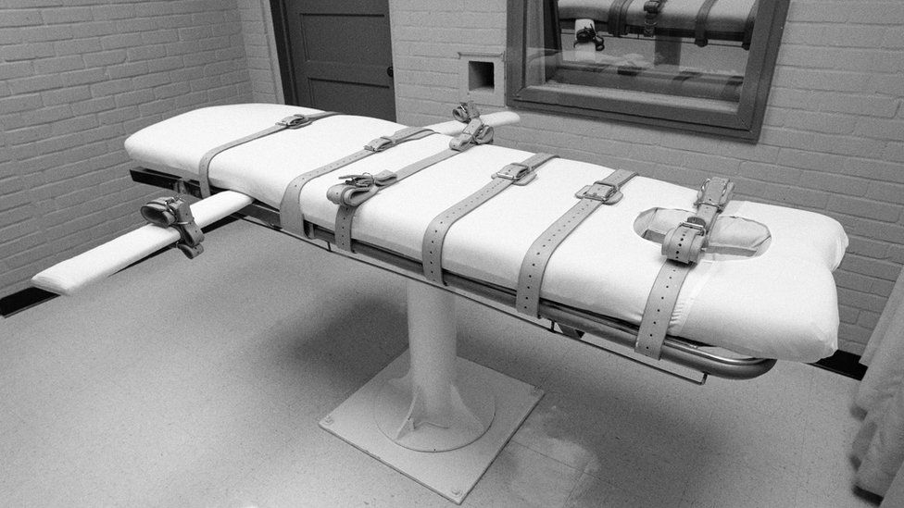IMAGE SOURCE,GETTY IMAGES

Image caption,

The death penalty is facing increased scrutiny in the US after a series of botched executions

**By Madeline Halpert**

BBC News, New York

**Tennessee has fired two top officials after a report revealed numerous errors in the state's lethal injection system.**

The Department of Corrections has fired head lawyer, Debra Inglis, and Inspector General Kelly Young.

The independent report found drugs used in Tennessee's lethal injections were not properly tested for contaminants.

The lethal injection has come under increased scrutiny in recent months after a series of botched executions across several US states.

[**A separate report from the Death Penalty Information Center**](https://www.bbc.com/news/world-us-canada-64003124) found that more than one-third of executions in the US in 2022 were botched or highly problematic.

The report from the non-profit, which takes no position on capital punishment, said executions were visibly problematic because of incompetence, failures to follow protocol or defects in the protocols themselves.

In Tennessee, officials are currently considering changes to the lethal injection protocol and executions are on hold.

Republican Governor Bill Lee paused them in May after calling off the execution of inmate Oscar Smith an hour before he was scheduled to be put to death. He cited an "oversight" in preparations for the lethal injection.

Earlier this month, Governor Lee said the state's Supreme Court would likely wait for the state to finalise changes to its protocol before scheduling future executions,

[**He requested the independent report**](https://app.box.com/s/cxeblwhscz6a8mbngp6cylwbcsz2c7jx/file/1102145253665), which was released in December and revealed several major errors. It showed that in the seven executions carried out since 2018, none of the lethal injections used were tested for contaminants.

The BBC has reached out to the Tennessee Department of Correction for comment.

Elsewhere, Arizona's Democratic Governor Katie Hobbs ordered a review of death penalty protocols on Friday. It will analyse Arizona's execution procedures and training of staff.

The state's Attorney General Kris Mayes has put all executions on hold until the review is completed.

Arizona restarted executions last year after an eight-year pause following the botched 2014 lethal injection of convicted murderer Joseph Wood, whose execution took nearly two hours after officials gave him 15 doses of drugs.

"Recent executions have been embroiled in controversy,'' Ms Hobbs said when announcing the review on Friday. "We just want to make sure the practices are sound and that we don't end up with botched executions like we've seen recently.''

A total of 27 US states still allow the death penalty, including three - California, Oregon and Pennsylvania - which have called for a moratorium on executions.

Media caption,

The five ways the US executes –

Click on link

https://www.bbc.com/news/world-us-canada-64347169

to see the 45 secs video of different execution methods in USA

[South Carolina court halts executions until firing squad is available - BBC News](https://www.bbc.com/news/world-us-canada-57496839)

# South Carolina court halts executions until firing squad is available

Published

17 June 2021

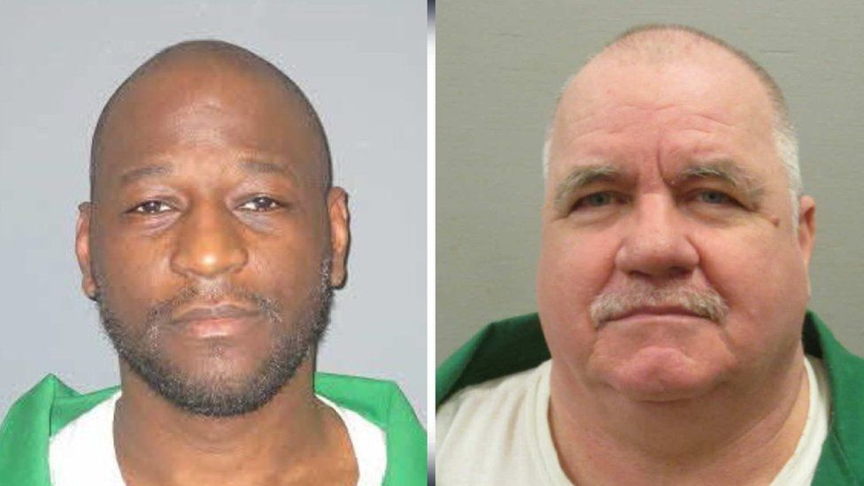IMAGE COPYRIGHTSOUTH CAROLINA DEPARTMENT OF CORRECTIONS

image captionFreddie Owens (L) and Brad Sigmon (R) were due to be executed this month

**A high court in the US state of South Carolina has blocked two executions until the inmates are given the choice of death by electrocution or firing squad.**

A new law requires inmates on death row to decide between the two methods if lethal drugs are not available.

But as prison authorities have not yet formed a firing squad, the executions have been halted by the supreme court.

Inmates Brad Sigmon and Freddie Owens were due to be executed this month.

The convicted murderers were denied lethal injections - their favoured option - because prison authorities did not have the drugs needed.

A shortage of these drugs has led to a 10-year pause in this method of execution in the state.

The new law, which came into effect last month, was designed to close a loophole that allowed inmates to indefinitely postpone their executions if the drugs were not available.

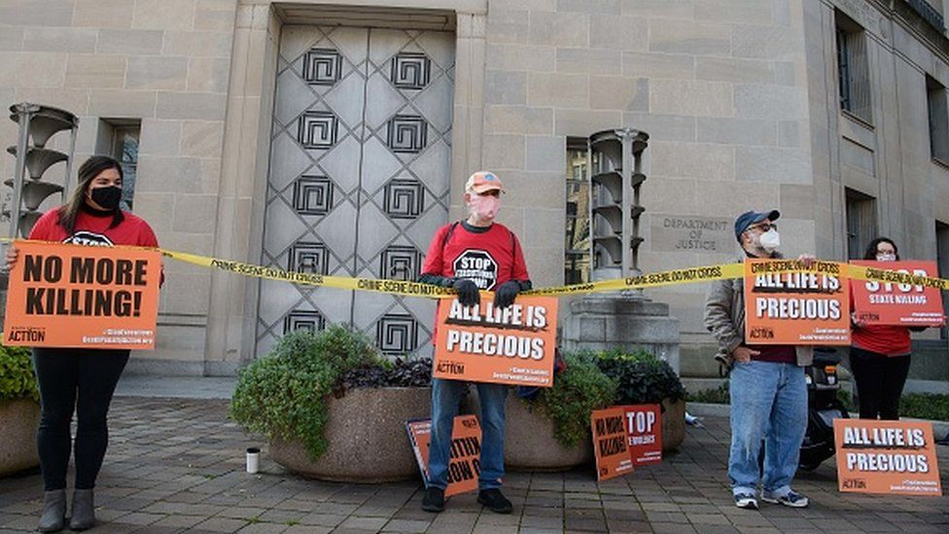IMAGE COPYRIGHTGETTY IMAGES

image caption Lawyers for the inmates argued that electrocution was cruel and unusual

Given the lack of a firing squad, electrocution was the only method of execution available in the state.

But lawyers for Sigmon and Owens challenged the use of the method in court, arguing their clients have the right to die by lethal injection.

They petitioned the South Carolina Supreme Court to stop the planned executions of their clients until their appeals had been heard.

* [**How many countries still have the death penalty?**](https://www.bbc.co.uk/news/world-45835584)
* [**Looking for answers in the life of a killer**](https://www.bbc.co.uk/news/world-us-canada-55587260)
* [**Last meals on death row**](https://www.bbc.co.uk/news/in-pictures-53758533)

On Wednesday, the court ruled in their favour, saying the inmates had not been given the choice "to elect the manner of their execution".

The court said no further execution notices should be issued until "protocols and policies to carry out executions by firing squad" are in place.

In response to the court order, the state's prison authorities said it was "moving ahead with creating policies and procedures for a firing squad".

"We are looking to other states for guidance through this process. We will notify the court when a firing squad becomes an option for executions," the South Carolina Department of Corrections said.

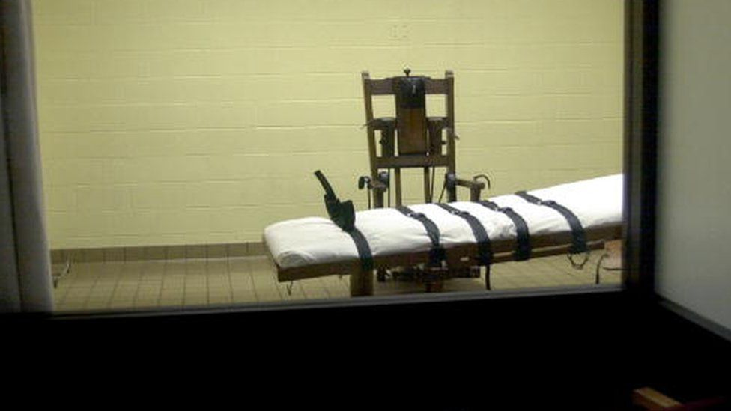IMAGE COPYRIGHTGETTY IMAGES

image captionOnly four US states allow executions by firing squad

South Carolina is one of four states that allow executions by firing squad. Oklahoma, Mississippi and Utah are the others.

Sigmon, 63, was scheduled to be executed on Friday. He has spent nearly two decades on death row after he was convicted in 2002 of killing his ex-girlfriend's parents with a baseball bat.

Owens's execution was planned for 25 June. The 43-year-old has been on and off death row since 1999, when he was convicted of murdering a shop worker during a robbery spree.

[Lee Anderson: New Tory deputy chairman would support return of death penalty - BBC News](https://www.bbc.com/news/uk-politics-64580487)

Lee Anderson: New Tory deputy chairman would support return of death penalty

* Published

9 February 2023

Share

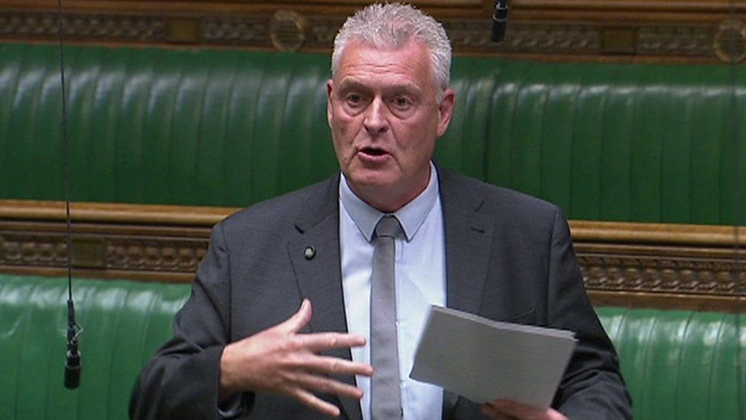IMAGE SOURCE,HOUSE OF COMMONS

**By Becky Morton**

Political reporter

**The new deputy chairman of the Conservative Party, Lee Anderson, has said he would support the return of the death penalty.**

[**In an interview with the Spectator**](https://www.spectator.co.uk/article/lee-anderson-capital-punishment-100-effective/) before he was appointed to the role, he argued "nobody has ever committed a crime after being executed".

The PM said neither he nor the government shared Mr Anderson's stance.

But Labour accused Rishi Sunak of not being strong enough to stand up to what it called Mr Anderson's "nonsense".

In the interview, conducted a few days before he was made deputy chairman on Tuesday but published after his appointment, Mr Anderson was asked whether he would support the return of the death penalty.

In response, he said: "Yes. Nobody has ever committed a crime after being executed."

"100% success rate," he added.

Bottom of Form

[](https://www.thesun.co.uk/)

# Women who send love letters to PRISONERS reveal what they look for in a jailbird pen pal

Women confess to romantically falling for inmates and slam claims they are sick 'groupies'

* [**Sarah Barns**](https://www.thesun.co.uk/author/sbarns/)
* 11:42, 20 Feb 2017
* Updated: 22:40, 22 Feb 2017

**WRITING to a pen pal was something kids did in the era pre-Facebook, WhatsApp and Snapchat.**

But some women are reigniting this bygone hobby by sending rambling love letters – and the occasional racy photograph – to men who are in prison.

[](https://www.thesun.co.uk/living/2907384/women-who-send-love-letters-to-prisoners-reveal-what-they-look-for-in-a-jailbird-pen-pal/)

6

Women have revealed why they send love letters to men in prison (Picture posed by model)Credit: Alamy

Controversial websites such as loveaprisoner.com and writeaprisoner.com feature a list of inmates who are up for finding a pen friend.

Much like a dating profile, the portals feature a photograph alongside a short biography, their hobbies and interests – and details of their incarceration.

Women pick which guy they like they look of before building a rapport – and sometimes a romantic relationship – via the post.

Love a Prisoner claims to have a “75% compatibility rating for those looking for their soul mate” – including inmates on death row.

[](https://www.thesun.co.uk/living/2907384/women-who-send-love-letters-to-prisoners-reveal-what-they-look-for-in-a-jailbird-pen-pal/)

6

Love a Prisoner features profiles of inmates who want a pen friendCredit: lucy.daley@the-sun.co.uk

“Our mission is to give inmates a sense of hopefulness by connecting them to people on the ‘outside world’,” the website states.

“Those from all walks of life have committed to our pen-pal service to communicate with inmates and have formed nurturing and unconditional friendships.

“Inmates are not only thrilled to communicate with pen-pals but have stated that it has been a ‘spiritually and emotionally fulfilling experience’.”

Women who are members of Write a Prisoner have confessed what it is they look for in an inmate.

[](https://www.thesun.co.uk/living/2907384/women-who-send-love-letters-to-prisoners-reveal-what-they-look-for-in-a-jailbird-pen-pal/)

6

Women have revealed what they discuss in the letters - and why sex is off limitsCredit: Alamy

Writing on the site's online forum, a user called ‘Vynte’ said she likes “chatty” prisoners aged 40 and over – and avoids anyone who asks her for cash.

She said: “I want to write to someone who can maintain their end of a conversation. I avoid profiles in which the inmate goes into a spiel about them being wrongfully convicted.

“I also avoid profiles that are ‘seeking donations’ because I don't want pals that expect me to support them financially.

“As far as crimes go, I write to robbers and murderers, but I do not write to sex offenders.”

[](https://www.thesun.co.uk/living/2907384/women-who-send-love-letters-to-prisoners-reveal-what-they-look-for-in-a-jailbird-pen-pal/)

6

Women have built up romantic relationships with men behind barsCredit: Supplied

‘Peanut2’ added: “The age does not matter to me, the mind set and heart is what matters to me.”

Women also gave an insight into what they discuss with their jailbird pen pals.

In a separate thread, a user called ‘XIPO’ said nothing is off limits: “I don't have any taboo topics. In fact, I told them in my first letter that I will totally be honest whether they like it or not.