**Fake News and Conspiracy theories**

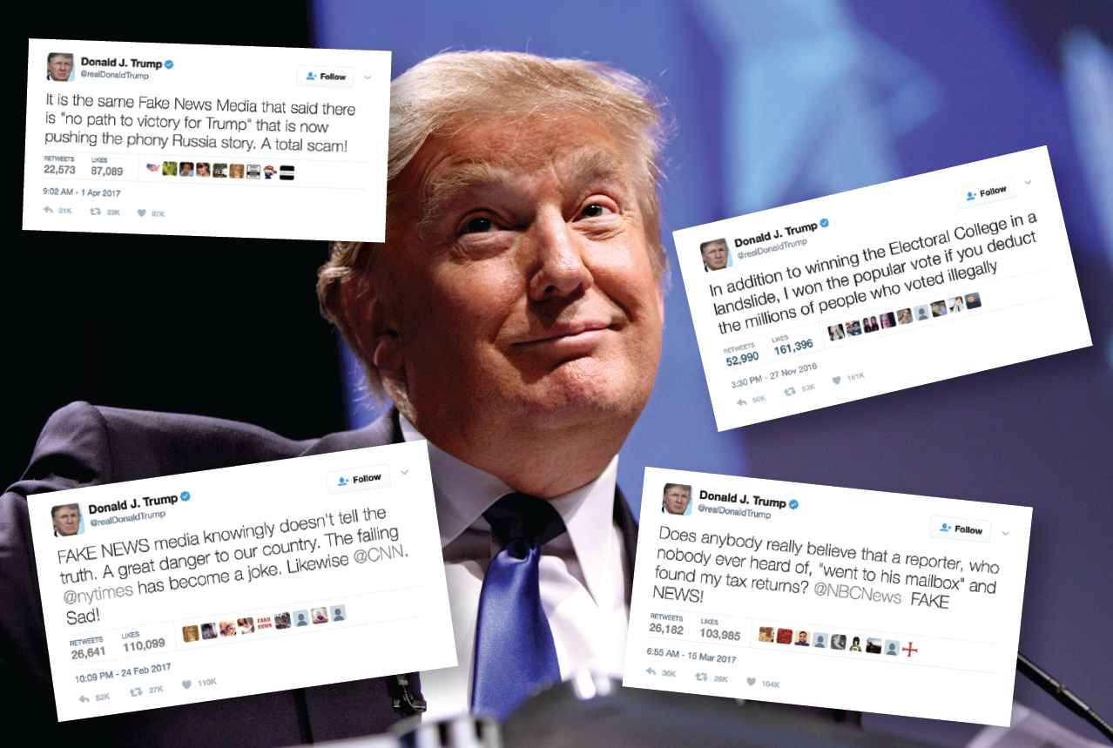

**Table of contents**

# How President Trump took 'fake news' into the mainstream Page 2

Mødt med hovedrysten:Tidligere amerikansk ambassadør påstår, at danskerne ikke har råd til at køre bil Page 3

QAnon: What is it and where did it come from? Page 9

Bill Gates microchip conspiracy theory Page 12

The 15 Most Popular Conspiracy Theories in Recent History Page 16

# Fake news videos Page 30

# Texas (Uvalde) school shooting Page 31

# Climate change / TED talk / What is Fake News video Page 34

# Corona Hoaxes Page 35

# Pizzagate Page 44

See the video, click on link after reading paragraph

[How President Trump took 'fake news' into the mainstream - BBC News](https://www.bbc.com/news/av/world-us-canada-46175024)

# How President Trump took 'fake news' into the mainstream

**How President Trump took 'fake news' into the mainstream**Close

What began as a way to describe misinformation was quickly diverted into a propaganda tool. The BBC's Dave Lee examines how "fake news" went mainstream - and where it might go next.

This story is part of a series by the BBC on disinformation and fake news - a global problem challenging the way we share information and perceive the world around us.

To see more stories and learn more about the series visit [**www.bbc.co.uk/fakenews**](https://www.bbc.co.uk/news/topics/cjxv13v27dyt/fake-news)

Fake News Carla Sands

[Mødt med hovedrysten: Tidligere amerikansk ambassadør påstår, at danskerne ikke har råd til at køre bil | Indland | DR](https://www.dr.dk/nyheder/indland/moedt-med-hovedrysten-tidligere-amerikansk-ambassadoer-paastaar-danskerne-ikke-har)

**Mødt med hovedrysten:**Tidligere amerikansk ambassadør påstår, at danskerne ikke har råd til at køre bil

De verbale smæk står i kø til Carla Sands efter påstand om lidt for fattig dansk middelklasse.

Carla Sands er kandidat for senatet i delstaten Pennsylvania for det republikanske parti. Hun blev udpeget af Donald Trump som USA's ambassadør i Danmark fra 2017 til 2021. (Foto: HANNAH BEIER © Ritzau Scanpix)

LÆS OP

ORDBOG

TEKST

AF

[**Silas Bay Nielsen**](mailto:sibn@dr.dk)

I GÅR KL. 18:24

USA's tidligere ambassadør i Danmark Carla Sands bliver bestormet kommentarer, efter et opslag om Danmark, [hun har skrevet på Twitter](https://twitter.com/CarlaHSands/status/1535091239246340104).

I opslaget har hun vedhæftet et klip fra CNN, der handler om de stigende benzinpriser, som får amerikanere til at ændre deres bilvaner. Til klippet skriver hun:

- Jeg har set det her før. I Danmark har middelklassen ikke råd til at køre bil. De har cykler og tager toget på længere ture. Min ambassadørchauffør kørte på cykel en time i sne for at komme på arbejde. Det er fremtiden, som team Biden vil have for amerikanerne. Er det, hvad du vil have, skriver den tidligere Donald Trump-udpegede ambassadør i opslaget.

Carla Sands' tweet, hvor hun konstaterer, at den danske middelklasse ikke har råd til at køre bil, selv når det sner. (© Fra Twitter)

Opslaget har fået flere danskere til at kommentere opslaget. Blandt andre flere politikere.

Benny Engelbrecht, der tidligere var transportminister i den socialdemokratiske regering, har smidt et billede op som kommentar fra dengang, han var transportminister.

Dertil skriver han, at Carla Sands ikke har grund til bekymring, for danskerne har råd til biler.

Benny Engelbrecht er en af dem, der er gået i kødet på Carla Sands og hendes påstand på Twitter. (© Fra Twitter)

- Som tidligere transportminister kan jeg forsikre dig om, at man vælger cyklen til transport i byen som et valg – og ikke af økonomiske årsager for de fleste danskere, skriver han i en kommentar til opslaget og tilbyder hende en cykeltur med ham, næste gang hun besøger Danmark.

Sundhedsminister Magnus Heunicke (S) har også bemærket Carla Sands' tweet. I [et opslag, skriver han](https://twitter.com/Heunicke/status/1535232051196088320):

- Så er den Trump-udpegede tidligere USA-ambassadør i Danmark i gang med at sprede misinformation om os. Vi er glade for at cykle, hvilket er sundt og godt for miljø og klima, bliver til, at "middelklassen ikke har råds til at køre bil i Danmark". Jeg nægter at tro, at hun ikke ved bedre, skriver Magnus Heunicke.

Sundhedsminister Magnus Heunicke (S) nægter at tror, at Carla Sands ikke ved bedre. (© Fra Twitter)

Det er ikke kun politikere, der har skrevet opslag og kommentarer om eks-ambassadørens tweet.

Flere af dem begynder deres tweet med et: *Middle class Dane here*, hvilket betyder middelklassedansker her. En af dem er brugeren Mikkel Andreas Beck, som blandt andet skriver:

- Jeg har en bil, en motorcykel og fire cykler, fordi jeg elsker at cykle – særligt i København, hvor cykler klart er det bedste transportmiddel på alle årstider.

Flere danskere har delt forskellige billeder af kronprins Frederik, der har sat nogle af sine børn op på en ladcykel.

- Endnu et ikke-sandt udsagn. Eller har kronprinsen heller ikke råd til en bil, skriver en dansk twitterbruger blandt andet.

Flere brugere har tweetet billeder af kronprins Frederik, der kører rundt på cykel med sine børn. (© Fra Twitter)

En anden bruger skriver, at mange danske husstande faktisk har to biler og beder om en forklaring på, hvorfor den ottesporede motorvej ved Køge Bugt så altid er proppet om formiddagen og aftenen.

Danmark har tidligere været vist som skræmmeeksempel fra republikansk side.

I 2018 bragte Fox Business et indslag, hvor værten, Trish Regan, konstaterede, at ingen gad arbejde i Danmark. Samtidig lød det, at ingen færdiggjorde deres uddannelser, fordi de blev betalte for at studere. Og når de blev færdiguddannet, så åbnede de cupcake-cafeer.

Trish Regan fra Fox Business (th.) sammen med Sandra Smith under et af deres shows. (Foto: Chuck Burton © Scanpix)

Hendes bemærkninger om Danmark blev også en historie i amerikansk presse. Under coronaen kom Trish Regan igen i stormvejr. Her beskyldte hun de amerikanske demokrater for at skabe massehysteri og ødelægge regeringen under corona og kaldte virussen for at fupnummer.

Det blev tilsyneladende for meget for Fox, og de to parter droppede samarbejdet.

**LÆS OGSÅ:**[Medier i USA går i rette med Fox-vært efter kritik af Danmark](https://www.dr.dk/nyheder/udland/medier-i-usa-gaar-i-rette-med-fox-vaert-efter-kritik-af-danmark)

Carla Sands var USA’s ambassadør i Danmark fra 2017 til 2021. Hun stiller op for det republikanske parti til senatet i den amerikanske delstat Pennsylvania.

DR har forsøgt at få en kommentar fra Carla Sands. Hun har endnu ikke vendt tilbage.

[QAnon: What is it and where did it come from? (bbc.com)](https://www.bbc.com/news/53498434)

QAnon: What is it and where did it come from?

6 January 2021

By Mike Wendling, BBC News

Getty Images

A protester wearing a shirt with the QAnon slogan 'Trust the plan' talks to police inside the US Capitol building on Wednesday

**Supporters of the QAnon movement were among the crowd that stormed the US Capitol building on Wednesday.**

Several prominent activists were spotted inside the building, and others flew Q-themed banners inside and out.

President Trump - viewed as a hero by the movement - has stopped short of endorsing the conspiracy theory but has described QAnon activists as "people who love our country."

So what is QAnon and who believes in it?

What is it?

At its heart, QAnon is a wide-ranging, completely unfounded theory that says that President Trump is waging a secret war against elite Satan-worshipping paedophiles in government, business and the media.

QAnon believers have speculated that this fight will lead to a day of reckoning where prominent people such as former presidential candidate Hillary Clinton will be arrested and executed.

1:51

Trump on QAnon: 'They do like me'

That's the basic story, but there are so many offshoots, detours and internal debates that the total list of QAnon claims is enormous - and often contradictory. Adherents draw in news events, historical facts and numerology to develop their own far-fetched conclusions.

Where did it all start?

In October 2017, an anonymous user put a series of posts on the message board 4chan. The user signed off as "Q" and claimed to have a level of US security approval known as "Q clearance".

These messages became known as "Q drops" or "breadcrumbs", often written in cryptic language peppered with slogans, pledges and pro-Trump themes.

* [Twitter cracks down on QAnon conspiracy theorists](https://www.bbc.co.uk/news/world-us-canada-53495316)

"Where we go one we go all", often abbreviated as "WWG1WGA!" is one of the most popular QAnon slogans

Nobody actually believes it, right?

Actually, thousands do. The amount of traffic to mainstream social networking sites like Facebook, Twitter, Reddit and YouTube has exploded since 2017, and indications are the numbers have gone up further during the coronavirus pandemic.

The big social media companies subsequently tightened their rules about QAnon content and took down hundreds of Q-supporting accounts and videos.

But social media and opinion polls indicate there are at least hundreds of thousands, if not millions, of people who believe in at least some of the bizarre theories offered up by QAnon.

And its popularity hasn't been diminished by events which would seem to debunk the whole thing. For instance, early Q drops focused on the investigation by special prosecutor Robert Mueller.

QAnon supporters claimed Mr Mueller's inquiry into Russian interference in the 2016 US election was really an elaborate cover story for an investigation into paedophiles. When it concluded with no such bombshell revelation, the attention of the conspiracy theorists drifted elsewhere.

True believers contend deliberate misinformation is sown into Q's messages - in their minds making the conspiracy theory impossible to disprove.

Getty Images

QAnon supporters bring banners and flags to rallies in support of President Trump

What impact has it had?

QAnon supporters drive hashtags and co-ordinate abuse of perceived enemies - the politicians, celebrities and journalists who they believe are covering up for paedophiles.

It's not just threatening messages online. Twitter says it took action against QAnon because of the potential for "offline harm".

Several QAnon believers have been arrested after making threats or taking offline action.

In one notable case in 2018, a heavily armed man blocked a bridge over the Hoover Dam. Matthew Wright later [pleaded guilty to a terrorism charge](https://apnews.com/4a977b1627374e541d5173d4a3d6d987).

* [US conspiracy theory shuts school festival](https://www.bbc.co.uk/news/world-us-canada-48231708)

A Pew Research Center study in September 2020 found that [nearly half of Americans had heard of QAnon](https://www.journalism.org/2020/09/16/most-americans-who-have-heard-of-qanon-conspiracy-theories-say-they-are-bad-for-the-country-and-that-trump-seems-to-support-people-who-promote-them/)- double the number from six months before. Of those who had heard about it, a fifth had a positive view of the movement.

And for many believers, QAnon forms the foundation of their support for President Trump.

Mr Trump has, unwittingly or not, retweeted QAnon supporters, and prior to the election his son [Eric Trump posted a QAnon meme on Instagram](https://www.forbes.com/sites/jackbrewster/2020/06/20/eric-trump-promotes-qanon-conspiracy-on-instagram-while-plugging-tulsa-rally/#269b59553198).

* [How influential is a pro-Trump conspiracy theory?](https://www.bbc.co.uk/programmes/w3csyvn2)

One outspoken QAnon supporter, Marjorie Taylor Greene of Georgia, was elected to the US Congress in November.

*With additional reporting by Jack Goodman and Shayan Sardarizadeh*

[Coronavirus: Bill Gates ‘microchip’ conspiracy theory and other vaccine claims fact-checked (bbc.com)](https://www.bbc.com/news/52847648)

Coronavirus: Bill Gates ‘microchip’ conspiracy theory and other vaccine claims fact-checked

30 May 2020

By Jack Goodman and Flora Carmichael, BBC Reality Check

Share

TOBIAS SCHWARZ

Conspiracy theorists around the world have put Bill Gates at the heart of their stories

**Speculation about a future coronavirus vaccine is ramping up and social-media posts from anti-vaccination campaigners are gaining more traction online.**

We've been debunking a few recent claims.

Why the microchip rumours don't stack up

First up, a conspiracy theory about vaccines that has spanned the globe.

It claims that the coronavirus pandemic is a cover for a plan to implant trackable microchips and that the Microsoft co-founder Bill Gates is behind it.

We've found no evidence to support these claims.

The Bill and Melinda Gates Foundation told the BBC the claim was "false".

The head of the Russian Communist party this week said that so-called "globalists" supported "a covert mass chip implantation which they may in time resort to under the pretext of a mandatory vaccination against coronavirus".

He didn't mention Mr Gates by name but in the US, Roger Stone, a former adviser to Donald Trump, said Bill Gates and others were using the virus for "microchipping people so we can tell 'whether you've been tested'."

A [new YouGov poll of 1,640 people](https://today.yougov.com/topics/politics/articles-reports/2020/05/26/republicans-democrats-misinformation) suggests that 28% of Americans believe that Bill Gates wants to use vaccines to implant microchips in people - with the figure rising to 44% among Republicans.

Rumours took hold in March when Mr Gates said in an interview that eventually "we will have some digital certificates" which would be used to show who'd recovered, been tested and ultimately who received a vaccine. He made no mention of microchips.

That response led to one widely shared article, under the headline: "Bill Gates will use microchip implants to fight coronavirus".

The article makes reference to a study, funded by The Gates Foundation, into a technology that could store someone's vaccine records in a special ink administered at the same time as an injection.

However, the technology is not a microchip and is more like an invisible tattoo. It has not been rolled out yet, would not allow people to be tracked and personal information would not be entered into a database, says Ana Jaklenec, a scientist involved in the study.

The Bill and Melinda Gates Foundation says: "The reference to 'digital certificates' relates to efforts to create an open-source digital platform with the goal of expanding access to safe, home-based testing."

Bill Gates did not say this about a vaccine

The Microsoft billionaire has been the target of [many different false rumours about vaccines](https://www.bbc.co.uk/news/52310194).

A recent post on a UK-based Twitter account said: "Bill Gates admits the vaccine will no doubt kill 700,000 people" and links to a video featuring right-wing conspiracy theorist Alex Jones.

The claim in the tweet, which has had more than 45,000 retweets and likes, is false and misrepresents Gates' words.

In the video, Mr Gates is talking about the efficacy of vaccines in older people and cautions about the risk of side-effects.

He sets out a hypothetical situation about the potential harm of side-effects, saying:"If we have one in 10,000 side-effects, that's way more... 700,000 people who will suffer from that."

He does not "admit" 700,000 will die from a vaccine.

Conspiracy theories about Bill Gates have reached the Italian Parliament, where an independent MP called for Bill Gates to be referred to the International Criminal Court for crimes against humanity.

Pandemic for profit?

There is a strong [anti-vaccination movement in Italy](https://www.bbc.co.uk/news/av/health-48707032/vaccinations-were-a-major-issue-in-the-2018-elections).

One popular Italian video, which has been viewed more than 700,000 times on Facebook, has a caption claiming that the pandemic has been "invented".

The narrator of the clip is Stefano Montanari, an Italian researcher with a degree in pharmacology, who claims the end goal is to get everyone vaccinated.

He argues that the epidemic "will continue to be totally made-up" until there is a vaccine that "will bring money and corruption into the already full pockets of some".

He concludes: "This is a sensational hoax, but a very successful one."

There is no evidence whatsoever to support his theory that the pandemic is a hoax. It is true that whichever pharmaceutical company develops a vaccine could potentially profit from the success, but the idea that this potential profit would be a motive to invent a pandemic is far-fetched.

* [Coronavirus vaccine: When will we have one?](https://www.bbc.co.uk/news/health-51665497)

The meme features an image of Indian Prime Minister Narendra Modi.

Cow-dung vaccine?

A Facebook meme announcing a "wonder drug to battle corona" and a "cow-dung vaccine" has been shared widely on Facebook in India.

Some of the posts, including one shared more than 1,000 times, link to a front-page story from the Ahmedabad Mirror, which reports that a trial of medicine derived from cow's milk, butter, ghee, dung and urine is under way.

The cow is considered sacred in Hinduism and some Hindu groups have claimed that drinking cow urine could boost immunity against the virus - a claim we've looked at [before](https://www.bbc.co.uk/news/av/51979410/coronavirus-more-myths-to-ignore).

However, there is no scientific evidence to support this theory, and the trial described in the Ahmedabad Mirror does not mention testing cow dung as a vaccine or prophylactic treatment.

The article quotes a doctor as saying: "Cow urine is known to have medicinal components that can cure Covid-19." In fact there is no known cure for coronavirus.

We asked Dr Rajni Kant, a biologist and head of research at the Indian Council for Medical Research, about the use of cow urine or dung as a treatment.

He said: "We don't have any significant evidence or study to quote that these have any efficacy against Covid-19. We don't have significant evidence or study to quote anything."

The Rashtriya Kamdhenu Aayog, part of India's Ministry of Agriculture, confirmed there will be trials for a Covid treatment combining cow urine, dung, butter, ghee and milk - but not a vaccine.

**15 of the Most Popular Conspiracy Theories in Recent History**

With the help of social media, these unfounded theories have gained more traction over the years.

**BY**[**FORTESA LATIFI**](https://www.teenvogue.com/contributor/fortesa-latifi)**AND**[**ASHLEIGH CARTER**](https://www.teenvogue.com/contributor/ashleigh-carter)

OCTOBER 3, 2022

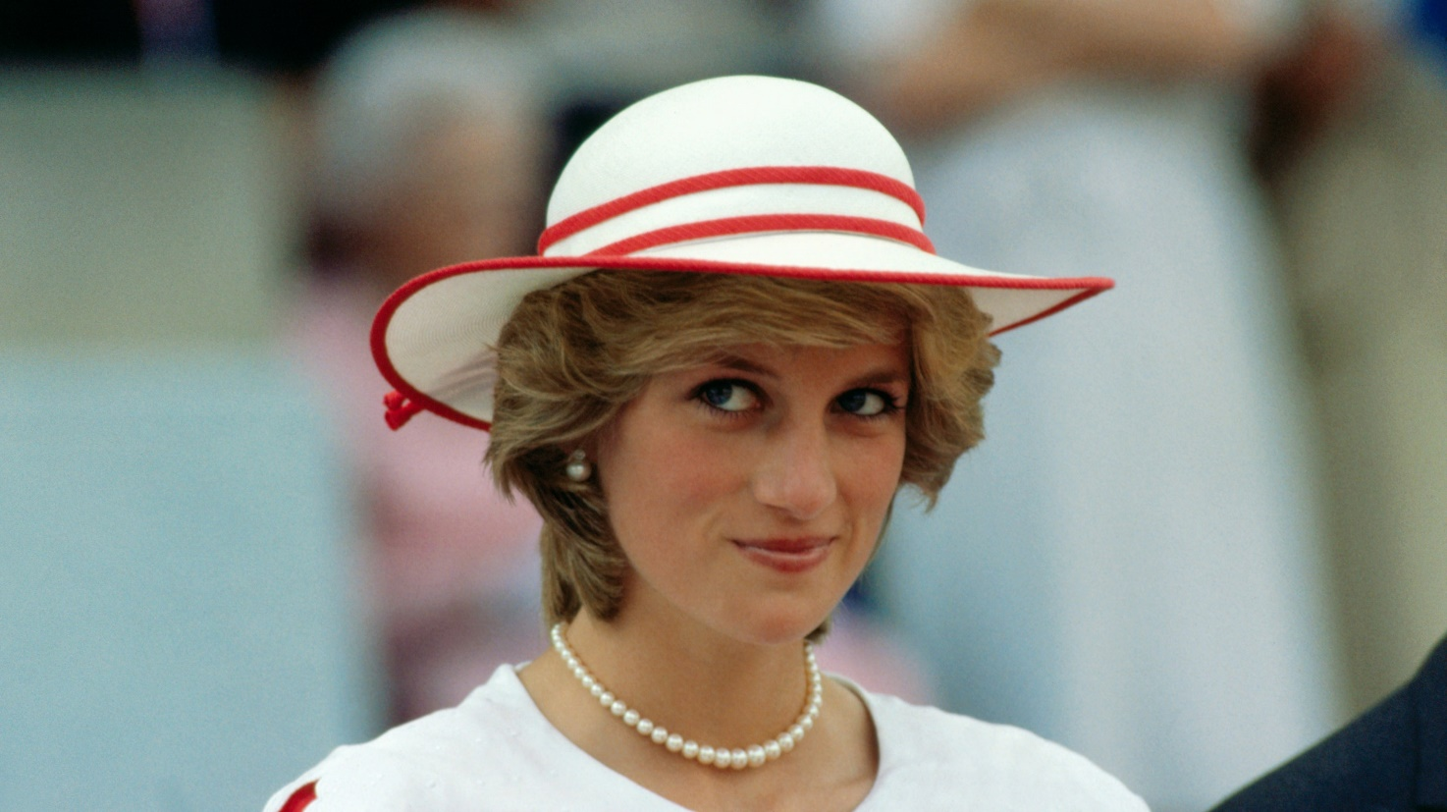

BETTMANN

In the age of [social media](https://www.teenvogue.com/tag/social-media), the [most popular conspiracy theories](https://www.teenvogue.com/story/most-popular-conspiracy-theories-pop-culture-history) can run rampant in an instant; from the [halls of Congress](https://www.nytimes.com/2020/11/03/us/politics/qanon-candidates-marjorie-taylor-greene.html) to theories about some of the world’s biggest celebrities, there are always groups who believe in certain unfounded “truths.” Conspiracy theories are nothing new in the United States, says [Cynthia Miller-Idriss](https://www.cynthiamilleridriss.com/), an American University sociology professor who focuses on extremism and radicalization. But they’ve been able to spread like wildfire over the past decade due to social media, which can easily amplify and circulate misinformation.

After a pandemic emerged in 2020 — killing [more than a million Americans](https://covid19.who.int/) to date — conditions couldn’t be more ripe for conspiracy theories to take hold. Miller-Idriss says that people tend to turn to conspiracy theories when they’ve lost a sense of control and feel afraid and anxious because these theories can offer comfort in the form of a black-and-white answer. “When people feel out of control, they’re attracted to things that offer them an action path,” Miller-Idriss tells *Teen Vogue*. “It’s easier to believe in some nefarious orchestration than to believe that there is an invisible virus in the air that could harm their family.”

According to Miller-Idriss, “inexplicable deaths” — whether it’s death on a mass scale, like the pandemic, or the loss of a famous person like [Princess Diana](https://www.teenvogue.com/tag/princess-diana) — breed conspiracy theories. “When something is so horrifying, it’s easier for people to believe it can’t be true. They can become more vulnerable to conspiracy theories because maybe they can’t psychologically wrap their head around the fact that it is true,” she says. “It’s these episodic, shocking events that create vulnerability."

There's also a long historical record of the U.S. government lying to its citizens, including about [medical experiments](https://www.cdc.gov/tuskegee/timeline.htm), [covert surveillance](https://www.aclu.org/press-releases/aclu-applauds-introduction-of-bipartisan-government-surveillance-reform-act-to-rein-in-warrantless-government-surveillance) and [torture](https://www.aclu.org/blog/lies-and-lying-liars-who-tell-them-cia-edition) programs, and the [existence of weapons of mass destruction](https://www.vox.com/policy-and-politics/2019/3/20/18274228/ari-fleischer-iraq-lies-george-w-bush-wmds) in Iraq. Political conspiracy theories emerging from prior deceptionis a perfectly reasonable response. But sometimes critical thinking and skepticism blossom into something more fanciful and outlandish and a [willingness to believe information](https://www.usatoday.com/story/news/nation/2017/12/23/conspiracy-theory-psychology/815121001/) that matches up with our preexisting political leanings or ideological beliefs.

In recent years, celebrities have become intertwined with some of the biggest conspiracy theories, whether that be as outlandish as their involvement in the Illuminati, or that they’re capitalizing on certain aspects of their personal lives.

In Miller-Idriss's work as the director of American University’s [Polarization and Extremism Research & Innovation Lab](https://www.american.edu/centers/university-excellence/peril.cfm), she has found that one way to combat the biggest conspiracy theories is to reach people [through a process called attitudinal inoculation](https://www.start.umd.edu/publication/vaccinating-against-hate-using-attitudinal-inoculation-confer-resistance-persuasion). With this technique, researchers strive to teach people how propaganda, misinformation, and conspiracy theories function so that when they come across suspicious claims from dubious sources, they’re appropriately skeptical.

Below *Teen Vogue* takes a look at some of the most popular conspiracy theories of the past 50 years.

***Pop Culture Conspiracies***

**1. Taylor Swift is working with the NFL**

In an age where fans and pop culture enthusiasts have begun obsessing over the legitimacy of a celebrity’s personal life, it’s safe to say that Taylor Swift has had to bear the brunt of these conspiracies. The Grammy-winning musician’s dating life is very interconnected to her work, which has birthed some fan theories about who she’s dated, [her sexuality](https://www.theguardian.com/music/2024/jan/08/taylor-swift-nyt-opinion-sexuality), and whether she’s in a “PR relationship.”

Swift’s relationship with NFL star Travis Kelce gained almost constant attention since being linked to him in September 2023. Swift has attended several Kansas City Chiefs games to support Kelce and has been spotted publicly with him. The attention on Swift has [reportedly brought in](https://frontofficesports.com/viewership-records-and-crying-swifties-taylor-swift-and-the-nfls-budding-business-relationship/) more than $330 million for the Chiefs and the NFL, from viewers who watched games, highlights, social media videos, and more. But since Swift’s first appearance at Arrowhead Stadium, many have speculated that the NFL is paying Swift to date Kelce. And after the Chiefs won the AFC Championship game in January 2024, securing their spot in the Super Bowl, right-wing commentators [specula](https://apnews.com/article/super-bowl-taylor-swift-travis-kelce-conspiracy-theories-838ce3087c795cb45468d08ebbb27059)ted that the NFL is “rigged” and that it’s a ploy to get President Joe Biden re-elected. *Huh?*

Taylor Swift and Travis Kelce seem to be mostly unbothered by the conspiracy theories surrounding them, showing each other public affection and gushing about each other in the media. Kansas City Chiefs CEO Clark Hunt also shut down rumors that their relationship is a marketing scheme, saying in an interview that it was “purely organic.”

“When they were just starting off dating, there were a lot of people saying, 'Oh, it's a marketing stunt.' But no, it's very real,” [he told CNBC.](https://www.youtube.com/watch?v=GrXVjdUQ48k) “And as I said, the most important thing is we're happy for the two of them.”

**2. Avril Lavigne died and is being impersonated**

Canadian musician and early-aughts icon Avril Lavigne is the subject of a famous conspiracy theory [that she died in 2003](https://www.teenvogue.com/story/avril-lavigne-called-doppelganger-conspiracy-theory-death-so-weird). As the so-called story goes, Lavigne, who was made famous in 2002 with her hit song “Complicated,” died the following year and a woman named Melissa Vandella has been impersonating her ever since.

The conspiracy theory, which is said to have emerged in 2005 on a Brazillian fan page, claims that Lavigne struggled with her skyrocketing fame after the release of her album, *Let Go*, and used a body double to take on the burden of being famous. At some point in 2003, the “real” Lavigne died, but her legacy and career lived on with Melissa.

The theory cites changes in Lavigne’s appearance, including her facial features and certain birthmarks and moles no longer appearing on the singer’s body.

In 2022, Lavigne seemingly addressed the conspiracy, [making a TikTok](https://www.tiktok.com/@avrillavigne/video/7114106481695264043?lang=en) that poked fun at the constant comments asking if she’s the “real” Avril Lavigne.

**3. Princess Diana’s death was no accident**

When Princess Diana – a beautiful, young, royal outsider known as [“the people’s princess”](https://www.cnn.com/2020/08/31/world/princess-diana-death-the-windsors-series/index.html) – was killed in a car crash in Paris in 1997, one year after her divorce from Prince Charles, conspiracies immediately abounded. The specifics vary, but the crux of most Diana-related theories is this: The car accident that killed her was not an accident. At the time of her death, she was dating Dodi Fayed, an Egyptian film producer who died in the limo alongside her, who was supposedly planning to [propose to Diana](https://www.washingtonpost.com/news/retropolis/wp/2017/08/30/dianas-last-day-dodis-yacht-a-ritz-suite-a-diamond-ring-and-relentless-photographers/) the night of the accident. In a court [witness statement](https://www.irishtimes.com/news/al-fayed-accuses-royals-over-death-of-diana-1.968945), Dodi’s father, Mohamed al-Fayed, said they were killed because the monarchy couldn’t stand the thought of Diana and Prince Charles’s sons — heirs to the British throne — having a [stepfather who was Egyptian and Muslim](https://www.ibtimes.com/why-princes-william-harry-are-not-touch-princess-dianas-ex-boyfriends-family-2809641). Dodi’s father also claimed [Diana was pregnant at the time of the crash](https://www.marieclaire.com.au/princess-diana-pregnant-night-she-died), though the coroner who examined Diana [said she was not](https://www.theguardian.com/world/2004/jan/07/monarchy.uk).

ADVERTISEMENT

Another theory is that the limo driver, [Henri Paul, who was drunk at the time of the accident](https://www.nytimes.com/1997/09/21/world/to-those-who-knew-diana-s-driver-his-actions-are-an-unsettling-puzzle.html#:~:text=Henri%20Paul%2C%20the%20man%20who,antidepressant%20drugs%20before%20the%20accident.), intentionally crashed the car. Because Paul was the head of security at the Ritz Hotel in Paris, where the couple had departed from just prior to the crash, conspiracy theorists believe he might have been on the [payroll of a national intelligence service group](https://www.independent.co.uk/news/uk/home-news/princess-diana-death-conspiracy-theories-b1746545.html) that wanted Diana dead. Other theorists believe that Diana’s medical care after the crash was [deliberately sabotaged](https://www.theguardian.com/uk/2007/nov/14/monarchy.davidbatty); for conspiracy theorists in the U.S., this idea arose from the [differences between French and American approaches to emergency care](https://abcnews.go.com/Health/HealthCare/story?id=8437560). In France, protocol dictates that emergency medical personnel attempt to stabilize a patient before transferring to the hospital; in the U.S., getting to the hospital is the first priority. Because Diana was treated at the scene and not immediately rushed to the nearest hospital, some think this is proof she was [purposefully killed](https://www.theguardian.com/uk/2007/nov/14/monarchy.davidbatty).

**4. Beyoncé & Jay-Z are Illuminati leaders**

“Y’all haters corny with that Illuminati mess…” pretty much sums up Beyoncé’s feelings on this theory. Beyoncé and Jay-Z are said to be prominent leaders of the secret cabal of elites who control the world. The Illuminati gets thrown around a lot as a top conspiracy, but there is some truth to the group that stems back more than 300 years.

The Bavarian Illuminati was an enlightenment group that [was founded](https://www.vox.com/2015/5/19/8624675/what-is-illuminati-meaning-conspiracy-beyonce) in 1776 in Germany. The group started with just a handful of members and is believed to have grown to a couple hundred, with ideas of grandeur and influence over political decisions. The secret society was known for using symbols and codenames to avoid identification.

Whether the Illuminati was successful at having any influence within society remains to be seen, but conspiracy theorists strongly believe that the group persevered and now runs the world. (Cue, “Who Run The World?”) Jay-Z was first roped into the conspiracy theory after his rise to fame and fortune in the hip-hop community. The rapper famously makes a triangle shape with his hands as his symbol. Illuminati believers think that the triangle represents the secret group. Beyoncé has thrown the triangle as well, which led people to suspect she was also in the group. Conspiracy theories claim that the couple gives “clues” to their allegiance in music videos and songs. But given that Beyoncé directly addressed it in her song “Formation,” it’s safe to say it’s likely not true.

***Historical Conspiracy Theories***

**5. Myths about the Holocaust**

Between 1941 and 1945, six million Jews were killed across Europe in a horrific genocide led by Nazi dictator Adolf Hitler. Despite the fact that the Holocaust is [one of the best-documented events in history](https://encyclopedia.ushmm.org/content/en/article/holocaust-denial-key-dates), there are swaths of the population that [don’t believe it happened](https://www.teenvogue.com/story/holocaust-distortion-what-is) — or they believe the death toll has been enormously inflated. One 2014 [survey](https://www.theatlantic.com/international/archive/2014/05/the-world-is-full-of-holocaust-deniers/370870/), coordinated by the Anti-Defamation League, of more than 53,000 people across 100 countries found that only 30% of respondents thought historical accounts of the Holocaust were accurate. Respondents under the age of 65 were more likely to say they didn’t believe the Holocaust happened as history books say it did.

Poor education on the subject may be one explanation for this, but some conspiracy theorists [push the anti-Semitic notion](https://www.insider.com/qanon-conspiracy-theory-anti-semitism-jewish-racist-believe-save-children-2020-10) that the [Holocaust was invented or exaggerated to garner sympathy and monetary gains for Jewish people](https://www.museumoftolerance.com/education/teacher-resources/holocaust-resources/what-is-holocaust-denial.html) while serving and advancing Jewish interests. Deborah E. Lipstadt, a historian and professor who has written [books on Holocaust denial](https://bookshop.org/books/history-on-trial-my-day-in-court-with-a-holocaust-denier/9780060593773), separates Holocaust deniers into two groups: There are the hard-core deniers who say the Holocaust didn’t happen at all; then, [Lipstadt says](https://www.ushmm.org/antisemitism/holocaust-denial-and-distortion/explaining-holocaust-denial), there are the less-fervent deniers who may admit the Holocaust happened but question the official death toll or that gas chambers were used for mass murder.

Among the many poignant points Lipstadt raises about Holocaust denial [is this question](https://www.ushmm.org/antisemitism/holocaust-denial-and-distortion/explaining-holocaust-denial): “For the deniers to be right, who has to be wrong? Well, certainly all the survivors… the bystanders… but most of all you have the perpetrators. They never said it didn’t happen.”

**6. Aliens built the Egyptian pyramids**

This long-standing theory has prevailed for years and is one that many have likely seen on social media and beyond. The famous conspiracy theory [alleges](https://www.vice.com/en/article/g5bnpm/why-do-so-many-people-still-think-aliens-built-the-pyramids) that the ancient pyramids in Egypt, particularly the Great Pyramid of Giza, were not built by ancient Egyptians, but were instead created by extraterrestrial lifeforms.

Experts believe that people have gravitated to this idea because some find it hard to believe that an ancient civilization had the means to build such grand structures that have endured thousands of years later. Historians [believe](https://aeraweb.org/projects/how-old-are-the-pyramids/) the pyramids took around 85 years to build and were constructed sometime between 2589 and 2504 BC — making them more than 4,000 years old.

Prominent figures including Elon Musk and Joe Rogan have in recent years pedaled this conspiracy theory. After Musk tweeted in 2020 that “Aliens built the pyramid obv,” Egyptian officials responded, offering to [show him the evidence](https://www.bbc.com/news/world-africa-53627888) against that theory — including the tombs found underneath the pyramids. While some may write off the conspiracy as being just that, some believe it’s rooted in racism. Grand structures that were built in ancient Greece and Rome seem to be immune to similar conspiracy theories, and experts believe it “perpetuates a very Eurocentric view of other cultures” including Egypt, the Mayans, and the Incans.

**7. The flat Earth theory**

The 2017 Flat Earth International Conference featured speakers such as Mark Sargent, who runs the Flat Earth Clues YouTube series and has enjoyed a leading role in [Netflix’s *Behind the Curve*](https://www.syfy.com/syfywire/netflix-flat-earth-documentary-behind-the-curve-conspiracy-theorists), a documentary about Flat Earthers. Sargent claims that the world is [a flat soundstage](https://www.itv.com/thismorning/articles/mark-sargent-the-man-who-says-the-earth-is-flat) under a dome, sort of like the *Truman Show.* Although there’s not extensive polling on how many people think the Earth is flat, there’s evidence that [younger people](https://blogs.scientificamerican.com/observations/do-people-really-think-earth-might-be-flat/) are more likely to believe this is the case.

The core of the movement is spelled out in the name The Earth is flat, not a globe. The actual layout of the Earth varies among Flat Earthers, but the majority seem to believe the planet is a [flat disc with an ice wall around it](https://www.livescience.com/24310-flat-earth-belief.html). Although it can be easy to laugh off the Flat Earth theory — which [theorists themselves accidentally debunked](https://www.newsweek.com/behind-curve-netflix-ending-light-experiment-mark-sargent-documentary-movie-1343362) in *Behind the Curve —* this kind of belief can be a harbinger of extreme science skepticism about issues with real-world implications, like [vaccines](https://www.publichealth.org/public-awareness/understanding-vaccines/vaccine-myths-debunked/).

***Government Conspiracy Theories***

**8. The CIA had a hand in JFK's assassination**

Lee Harvey Oswald was arrested on November 22, 1963, for assassinating President John F. Kennedy Jr. that same day in Dallas, Texas. Two days later, while being transported to a local jail, Oswald was shot and killed by Jack Ruby, a Texas nightclub owner. This shocking set of events was ripe for conspiracies from the start: Not only was a handsome, [popular](https://news.gallup.com/poll/165902/americans-rate-jfk-top-modern-president.aspx) president fatally shot in broad daylight, but the accused assassin was killed days later, inviting speculation about a cover-up. As early as the late 1960s, [more than 50% of Americans didn’t believe](https://fivethirtyeight.com/features/the-one-thing-in-politics-most-americans-believe-in-jfk-conspiracies/) Oswald had acted alone. And as of 2017, FiveThirtyEight reports, [61% of Americans](https://fivethirtyeight.com/features/the-one-thing-in-politics-most-americans-believe-in-jfk-conspiracies/) believed the assassination involved a conspiracy of some sort.

ADVERTISEMENT

There are a few main JFK conspiracy theories. One popular theory is that the CIA killed JFK in retaliation for the failed [Bay of Pigs](https://www.history.com/topics/cold-war/bay-of-pigs-invasion) invasion to overthrow Cuban leader Fidel Castro. According to biographer Philip Shenon, Bobby Kennedy, JFK's brother and the attorney general, [initially thought a group of rogue CIA agents were involved](https://www.nbcnews.com/news/other/inside-job-cia-suspect-some-jfks-killing-f2D11627219) in JFK's death, though he later reconsidered. Another theory is that Oswald wasn’t the lone gunman; people can hardly be faulted for believing this when a [House of Representatives Select Committee on Assassinations found](https://www.washingtonpost.com/news/retropolis/wp/2017/10/24/jfk-assassination-conspiracy-theories-the-grassy-knoll-umbrella-man-lbj-and-ted-cruzs-dad/) that there was “probably” a conspiracy involving a second shooter. In 1982, another committee called those findings into question, but the theory had already taken root. A third theory: The assassination was actually a mob hit meant to punish Bobby Kennedy for cracking down on the mafia. Oh, and did you hear the one about [Ted Cruz’s father](https://www.vox.com/2016/5/3/11580740/ted-cruz-lee-harvey-oswald-donald-trump)? We’re going to skip it here, but if you feel like a laugh, look into it.

**9. The moon landing was faked**

In July 1969, astronauts Neil Armstrong and Buzz Aldrin became the first humans to land on the surface of the moon — or did they? Just kidding. They absolutely did. But [by the 1970s, 30% of Americans believed the moon landing had been faked](https://www.voanews.com/usa/millions-still-believe-1969-moon-landing-was-hoax). Alternative histories soon materialized. In the case of the “fake moon landing,” William Kaysing apparently started writing the book *We Never Went to the Moon: America’s Thirty Billion Dollar Swindle* as [satire, but he ended up fully believing](https://gen.medium.com/the-moon-landing-hoax-theory-started-as-a-joke-5a8e66e15d56) the conspiracy. The primary idea in his book was that the footage of astronauts taking their first steps on the moon’s surface — which hundreds of millions of people watched live on TV — was [actually shot at Nevada’s Area 51](https://www.rollingstone.com/culture/culture-features/moon-landing-conspiracy-theories-explained-861205/) (another hotbed for conspiracy theorists that we’ll get to later).

As recently as 2019, a [small survey showed that 10% of Americans](https://www.satelliteinternet.com/resources/moon-landing-real-survey/) still believed that the moon landing was a hoax. (In 2018, after [NBA star Steph Curry said he didn’t believe in the moon landing](https://www.nytimes.com/2018/12/10/sports/stephen-curry-moon-landing.html), NASA offered him a lunar lab tour.)

**10. 9/11 was an inside job**

In a series of coordinated terror attacks, nearly 3,000 people lost their lives during the events of September 11, 2001, with thousands more [injured](https://www.usatoday.com/story/news/2015/09/09/911-death-and-injury-total-still-rising/71943340/) and over [2,000 first responders](https://www.cancercenter.com/community/blog/2020/09/9-11-cancer) eventually losing their lives due to illnesses related to their time working at [Ground Zero](https://www.911memorial.org/). On that fall day in 2001, Americans watched, stunned, as two planes hit the Twin Towers in New York City, while a third struck the Pentagon in Washington, DC, and a fourth crashed into a field outside of Shanksville, Pennsylvania. September 11 took its place in history as the date of the most deadly foreign attack on American soil, usurping [Pearl Harbor](https://www.history.com/topics/world-war-ii/pearl-harbor).

Maybe it’s because of the scale of loss — that nearly 3,000 people could be killed within a few hours on a sunny September morning — or because of the [lies that have been told to the American people](https://www.nbcnews.com/id/wbna7634313) to sell them on the [endless wars](https://www.chicagotribune.com/nation-world/ct-nw-trump-sept-11-afghanistan-20190911-6wxuype32rcynpeytcjhiv2vvi-story.html) that followed the attacks, but the subject of 9/11 has always been a playground for government conspiracy theories. One of the most prevalent theories is that the administration of President George W. Bush [“did” 9/11](https://www.jstor.org/stable/43487848), or at least knew about it and l[et it happen](https://www.jstor.org/stable/43487848) because the administration wanted to go to war in Afghanistan and Iraq for oil. Many 9/11 theories branch out of the core conspiracy that 9/11 was an inside job. The “proof”? Supposedly, the Twin Towers could only have [collapsed the way they did](https://www.snopes.com/fact-check/journal-endorses-911-conspiracy-theory/) as a result of controlled demolition (this is false). Another favorite among conspiracy theorists: The [Pentagon was not hit by a plane](https://apnews.com/article/archive-fact-checking-7351850041) but by a missile.

ADVERTISEMENT

A number of prominent figures on the right, including [Congresswoman Marjorie Taylor Greene](https://www.forbes.com/sites/andrewsolender/2020/08/13/trump-backed-candidate-marjorie-taylor-greene-promotes-911-conspiracy-theory/?sh=68fbce12f0c3) (R-GA), have peddled conspiracy theories about 9/11. According to [Slate](http://www.slate.com/articles/news_and_politics/trutherism/2011/09/where_did_911_conspiracies_come_from.html), InfoWars radio host Alex Jones is “one of the earliest and most influential 9/11 conspiracy theorists” and has helped these ideas gain ground. Just a tip: If you find yourself in a crowd with Greene and Jones, it may be time to rethink a few things.

**11. Mass shootings like Sandy Hook were “false flags”**

After 20 first-graders and six school staffers were killed at Sandy Hook Elementary School in Connecticut on December 14, 2012, Alex Jones used his formidable platform to claim the attack hadn’t actually happened. The [mass shooting](https://www.teenvogue.com/story/conspiracy-theories-mass-shootings), according to Jones, was “completely fake” and the slain children were hired “actors.” The families of those killed during the Sandy Hook shooting [sued Jones for defamation](https://www.teenvogue.com/story/sandy-hook-parents-suing-alex-jones-defamation) and won. Sandy Hook [conspiracies spread far and wide](https://nymag.com/intelligencer/2016/09/the-sandy-hook-hoax.html), with some grieving parents [releasing birth certificates](https://www.nbcnews.com/news/us-news/sandy-hook-father-receive-450-000-conspiracy-theorist-jury-says-n1068026) to prove their children existed, and having to deny requests to exhume their children’s bodies.

Mass shootings continue to bring out the worst in conspiracy theorists. After the Parkland, Florida, shooting at Marjory Stoneman Douglas High School left 17 dead, [survivors were called “crisis actors."](https://www.nbcnews.com/news/us-news/how-internet-s-conspiracy-theorists-turned-parkland-students-crisis-actors-n849921) When a gunman killed 58 people in Las Vegas, [theories ran wild](https://www.usatoday.com/story/news/nation/2018/08/03/sheriff-las-vegas-investigation-mass-shooting/898643002/) that he hadn’t acted alone. And no matter where the shooting takes place or how many people are affected, it seems there are always those who are ready to call it a [“false flag” attack](https://www.politifact.com/article/2019/aug/08/why-do-some-people-think-mass-shootings-are-staged/), designed by the “deep state” to push gun control laws. But if that were true, don’t you think we would have, you know, passed substantial gun control by now?

**12. Top Democrats are behind a child sex ring**

In October 2016 (what we used to think of as the most cursed year before we entered the hellscape of 2020), the emails of Hillary Clinton’s campaign chairman, John Podesta, were leaked online. In the emails, Podesta writes about possibly holding a fundraiser at the DC pizzeria Comet Ping Pong, and mentions ordering cheese pizza. These seemingly innocuous details became fuel for the wild conspiracy that Comet Ping Pong was the headquarters of a child sex-trafficking ring run by Democratic leaders, including Clinton and Podesta. Cheese pizza, theorists claimed, actually meant child pornography. As in so many conspiracy communities, the emails became a [cipher only insiders could decode](https://www.washingtonpost.com/dc-md-va/2021/02/16/pizzagate-qanon-capitol-attack/).

A few weeks after Podesta’s emails were leaked and “Pizzagate” started gaining traction online, a 28-year-old man walked into the northwest Washington pizzeria with an AR-15 rifle. After his [search of the premises](https://www.starnewsonline.com/news/20161205/dc-pizza-place-shooter-former-cfcc-student-local-actor) yielded no dungeon holding child sex slaves, he fired his gun at a locked door before surrendering to police.

Although the would-be gunman later told a judge his actions were “[foolish and reckless](https://www.washingtonpost.com/local/public-safety/pizzagate-gunman-sentenced-to-four-years-in-prison-as-prosecutors-urged-judge-to-deter-vigilante-justice/2017/06/22/a10db598-550b-11e7-ba90-f5875b7d1876_story.html),” Pizzagate conspiracies continued to proliferate online, becoming the seed for the equally fantastical [QAnon](https://www.teenvogue.com/story/qanon-conspiracy-theories-social-media-teens) conspiracy. In October 2017, an anonymous poster called “Q” began posting on the messaging board 4chan, claiming to be an intelligence officer in the U.S. government. Q expanded the foundations of Pizzagate: Not only are politicians and Hollywood elites really satanic pedophiles, they also [harvest the blood of children to stay young](https://www.wired.com/story/opinion-the-dark-virality-of-a-hollywood-blood-harvesting-conspiracy/). The only person who could stop them was Donald Trump. (After the election of President Joe Biden, some in the Q universe continue to insist that Biden is an illegitimate president and Trump is ruling [from the shadows](https://www.chicagotribune.com/nation-world/ct-nw-qanon-biden-inauguration-20210121-ekw3zi6krjeirjkzqpgk7ceorm-story.html), from which he will one day emerge to take power after the arrests of everyone from Hillary Clinton to Tom Hanks to the Pope.)

ADVERTISEMENT

There’s so much to say about QAnon, including its [promoters in Congress](https://www.rollcall.com/2020/11/05/qanon-goes-to-washington-two-supporters-win-seats-in-congress/) (hi again, [Marjorie Taylor Greene](https://www.washingtonpost.com/politics/greene-qanon-house-trump-republicans/2021/01/30/321b4258-623c-11eb-ac8f-4ae05557196e_story.html)!), its [popularity among suburban mothers](https://www.elle.com/culture/a34485099/qanon-conspiracy-suburban-women/), its [role in the deadly January 6 insurrection](https://abcnews.go.com/US/qanon-emerges-recurring-theme-criminal-cases-tied-us/story?id=75347445), and its [ties to the wellness industry](https://podcasts.apple.com/us/podcast/the-wellness-to-qanon-pipeline/id1535408667?i=1000521333353), but we’ll leave you with this: Even Alex Jones appears to have [given up on Q](https://www.independent.co.uk/news/world/americas/us-politics/alex-jones-trump-qanon-capitol-b1799038.html).

**13. COVID-19 as population control**

Conspiracies about the novel coronavirus are a dime a dozen: The [vaccine implants a microchip](https://www.bbc.com/news/52847648) used to track people; the [fatality rate has been wildly inflated](https://www.usatoday.com/story/news/factcheck/2021/02/16/fact-check-cdc-not-inflating-covid-19-deaths/6764078002/); oh, and [Bill Gates is not only responsible for the virus](https://www.reuters.com/article/uk-factcheck-gates/fact-check-bill-gates-is-not-responsible-for-covid-19-idUSKBN2613CK) but also the head of a plot to use the [virus as population control](https://www.reuters.com/article/uk-factcheck-bill-gates-fake-3-billion-q/fact-check-no-evidence-bill-gates-said-at-least-3-billion-people-need-to-die-idUSKBN29Y20D). Are you tired yet? I am.

These theories have been debunked repeatedly, yet they persist. That might have something to do with [then-president Donald Trump](https://www.teenvogue.com/story/trump-covid-positive-conspiracy-theories) saying the virus was no more deadly than the flu and would one day “disappear, like a miracle” without the need for a vaccine. Or it could be related to some Republican lawmakers who [floated the idea](https://www.theguardian.com/us-news/2020/apr/11/republican-tom-cotton-coronavirus-china) that COVID could be a Chinese “bioweapon.” Or it could just be that, in a time of [historic political polarization](https://www.pewresearch.org/fact-tank/2020/11/13/america-is-exceptional-in-the-nature-of-its-political-divide/), this country was uniquely ill-suited to deal with a catastrophic pandemic that has killed hundreds of thousands of Americans. Take your pick (and get your vaccine, if you’re able).

**14. Area 51 is home to lots of aliens (and government secrets)**

This is perhaps the largest alien conspiracy theory in the United States and has spawned more than a few movie plots and memoirs. Located in The High Desert, it has long been the scene of many [UFO](https://www.teenvogue.com/story/house-ufo-hearing-military-testimony) stories. And while we do know officially — as [confirmed by The Pentagon](https://www.washingtonpost.com/news/retropolis/wp/2017/12/18/the-government-admits-it-studies-ufos-so-about-those-area-51-conspiracy-theories/) in 2017 — that the government does have an interest in collecting and analyzing anything that could be a threat to our aerospace, the exact work being done at Area 51 is still a complete mystery.

A whole vault of interesting conspiracy theories has emerged as the years go on. The most popular school of thought from conspiracy groups is that there are actual alien lifeforms from an accidental crash landing on Earth hidden in the hills of the desert being subjected to testing and experimentation. This claim was led by a farmer named William “Mac” Brazel, who found strange scraps of metal and other debris on his property in Roswell, New Mexico in 1947. After reporting the incident, the remains were collected by government-sent armored vehicles. Imaginations were officially running wild. Other popular thoughts — straying from alien conspiracy theories — are that the area is used for scientists studying time travel, teleportation, and/or experimenting with ways to turn the weather into a weapon of mass destruction.

It’s likely there is something secret and important happening here, but it’s more likely we’ll see a new aircraft with incredible speed potential or camouflage capabilities before we see any time traveling happening.

**15. There’s a hidden chamber filled with government secrets behind Mount Rushmore**

When it comes to American conspiracies, this one is straight from a scene in *National Treasure*. And while this conspiracy was a part of the movie’s plot around a particularly obstacle-laden hunt for gold, the theory that *something* was hiding within Mount Rushmore came about far before it was hinted at on the silver screen. It’s a fact that there’s a [small room](https://www.history.com/news/mount-rushmores-secret-chamber) inside the monument, situated behind Abraham Lincoln’s head. The monument’s sculptor, Gutzon Borglum, created an 18-foot door that leads into a 74-foot-long and 35-foot-tall room. The main intention was to house important American documents — like the Declaration of Independence and the Constitution — and serve as a shrine of sorts. Consider it an attempted artist’s statement.

What was envisioned as a massive, 800-foot staircase leading from the front of the monument into what was meant to be the gilded Hall of Records is now a much emptier version of Borglum’s dream. In fact, it serves as a memorial to the sculptor himself. After the budget for the monument was cut in 1939 (a year after ground was broken), progress on the chamber stopped. Borglum passed away seven months later, leaving a mysterious hole that has since become a topic of conversation for those intrigued by historical conspiracy theories.

In 1998, generations of Borglum’s family gathered to pay respects to the artist. The group placed a set of 16 porcelain panels in the room, each inscribed with words from the very documents he had hoped to house in the space. The items were laid to rest underground in a teakwood box and the burial site was topped with a granite capstone embellished with a quote from Borglum. As you can imagine, where there is a room with no easy entry and a storied past, there is doubt. Some believe that this is one of many government conspiracy theories, and that the visitor-prohibited space is used to hide secret files.

**Want more from** ***Teen Vogue*? Check this out:** **[QAnon Conspiracy Theories Are Driving Families Apart](https://www.teenvogue.com/story/qanon-conspiracy-theories-social-media-teens)**

**12 conspiracy theories**

[12 Of The Most Popular Conspiracy Theories In American History - WorldAtlas](https://www.worldatlas.com/articles/12-of-the-most-popular-conspiracy-theories-in-american-history.html)

**10 conspiracy theories**

[Top 10 Most Famous Conspiracy Theories (listland.com)](https://www.listland.com/top-10-most-famous-conspiracy-theories/)

[Fake News - BBC News](https://www.bbc.com/news/topics/cjxv13v27dyt) ……Lots more examples…

[[How do I spot fake news? – BBC What’s New - YouTube](https://www.youtube.com/watch?v=0vjar1iqK-c) (2½ minute video)](https://www.bbc.com/news/world-europe-61441192)

[Fake News Generator: Who starts viral misinformation? - BBC News - YouTube](https://www.youtube.com/watch?v=UAy6PI5UtSU) (2½ minute video)

Area 51

[Bing Videoer](https://www.bing.com/videos/riverview/relatedvideo?&q=area+51&qpvt=area+51&mid=67B48C9D693BF7E82FF167B48C9D693BF7E82FF1&&FORM=VRDGAR)

[Texas shooting: How false rumours spread that gunman was trans - BBC News](https://www.bbc.com/news/61607042)

# Texas shooting: How false rumours spread that gunman was trans

**By Shayan Sardarizadeh & Kayleen Devlin**  
BBC Monitoring

Published

28 May 2022

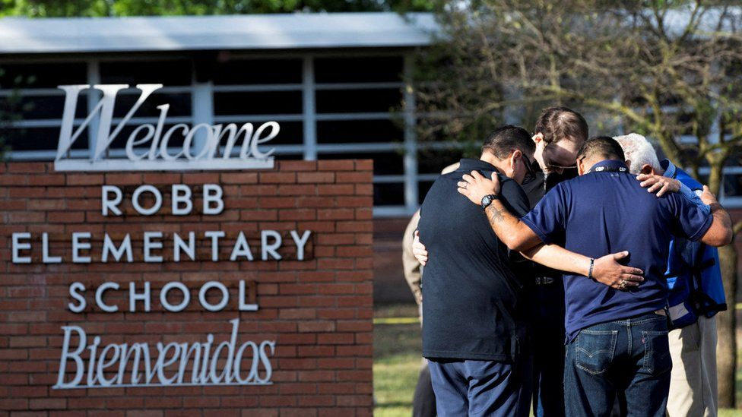IMAGE SOURCE,REUTERS

**Minutes after Tuesday's tragic shooting at the Robb Elementary School in Uvalde, Texas, false rumours began spreading about the identity of the gunman.**

Images of three separate trans women were shared online purporting to be of the gunman, and leading to a barrage of abuse.

The inaccurate claims were also amplified by US politicians and political influencers, some of whom also more broadly linked transgenderism to violence.

## Rumours begin

Almost immediately after the shooting, pictures of the gunman, Salvador Ramos, 18, appeared online.

Ramos didn't have a huge social media footprint - but one photo in particular was widely circulated. Taken from his Instagram and TikTok accounts, it showed him looking into a mirror wearing a dark grey hoodie.

The rumour that he was trans appears to have started on the fringe message board 4chan, and in particular the /pol/ or "Politically Incorrect" board, which has for years been associated with the far-right and mass shootings. A controversial hub of internet subculture, 4chan has been the birthplace of many harassment and trolling campaigns.

Users posted an image of a trans woman who slightly resembled Ramos, along with a link to her Reddit profile, and baselessly claimed she was the gunman.



* LISTEN: [**What is 4chan?**](https://www.bbc.co.uk/programmes/p05402xs)
* [**Buffalo shooting: How far-right killers are radicalised online**](https://www.bbc.co.uk/news/blogs-trending-61460468)

It didn't take long for the claim to migrate to other, larger social platforms, and it began to be repeated by far-right and right-wing activists and politicians.

Conservative activist Candace Owens claimed there were photos of the gunman "cross-dressing", and claimed this was evidence that "there were plenty of signs that he was mentally disturbed".

Republican congressman Paul Gosar, of Arizona, repeated the trans claim in a tweet that he later deleted. Mr Gosar also called the gunman, who was born in the United States, an "illegal alien", although Texas governor Greg Abbott, also a Republican, stated that Ramos was a US citizen.

We contacted Ms Owens, and Mr Gosar's spokesperson, for comment.

IMAGE SOURCE,TWITTER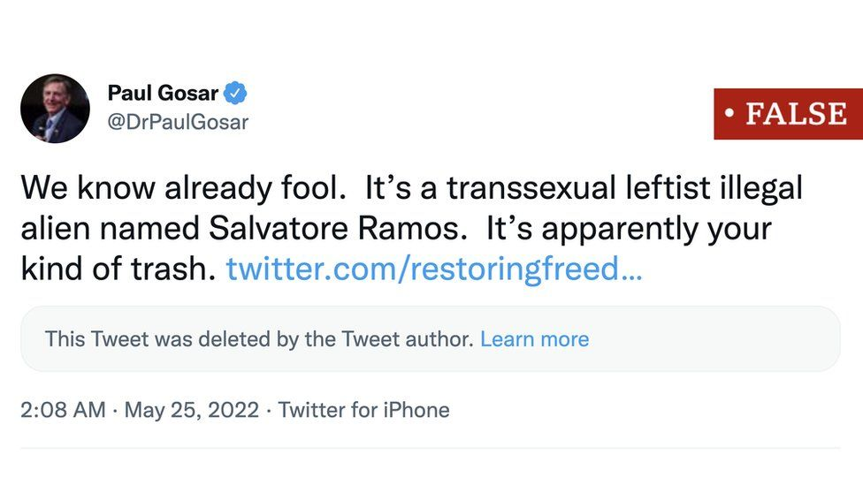

Image caption,

Republican congressman Paul Gosar repeated the false claims in a now deleted tweet

Another congressman, Pete Sessions, claimed in an interview on the Today Programme on Thursday that Ramos "wore dresses".

Sam, the transgender woman targeted by the 4chan campaign, posted on Reddit saying that she didn't live in Texas and was alive after the shooting, even though Ramos was shot dead.

But Sam - not her real name - wasn't the only trans person targeted by false stories. Images of Sabrina, another trans woman, appeared in photo collages alongside the actual photo of the gunman, with similar false claims.

She posted an image of herself holding her phone with the time and date visible to prove she was alive after the shooting. And another trans person's image which also appeared on 4chan later popped up in far-right spaces, including conspiracy theorist Alex Jones's Infowars website.

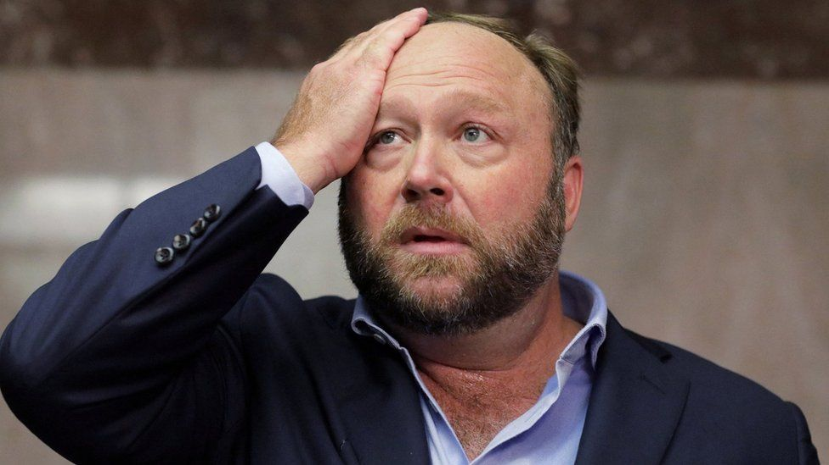IMAGE SOURCE,REUTERS

Image caption,

False rumours were repeated by Alex Jones of Infowars

## Common pattern

This is not the first time that trans and other LGBT individuals have been the targets of misinformation, says Mallory Moore, a researcher with the Trans Safety Network, a UK-based organisation.

She says the organisation advised Sabrina on how to put social media safeguards in place following the attack and online abuse - something she described as "pre-emptive".

"As things tend to spiral, people will pick through someone's social media and dump it online," she says. "Getting ahead of that is a sensible precaution."

As often happens after mass shootings, a number of other false rumours spread in the wake of the attack.

BBC News observed at least a dozen fake accounts claiming to belong to the gunman in the aftermath, most of which were attempts to copy his removed, genuine account on Instagram. Most have been removed.

[How high-profile scientists felt tricked by group denying climate change - BBC News](https://www.bbc.com/news/blogs-trending-61166339)

Long article on the Creative Society

Ted talk [Fake News. It's Your Fault. | Christina Nicholson | TEDxBocaRaton - YouTube](https://www.youtube.com/watch?v=tRPDwSSjdOM)

[What Is Fake News? - YouTube](https://www.youtube.com/watch?v=V4o0B6IDo50) (3½ minute video)

Examples of fake news

[4. Fake News Examples - Fake News: Separating Truth From Fiction - LibGuides at Valencia College](https://libguides.valenciacollege.edu/c.php?g=612299&p=4251645)

[What is fake news, what are the worst examples and why does it matter? | ITV News](https://www.itv.com/news/2019-02-18/fake-news-examples-pope-trump-pizzagate-clinton)

Use of fake news to influence

[True or false? How much is fake news influencing our lives? - Issue 12 - University of Derby](https://www.derby.ac.uk/magazine/issue-12/influence-of-fake-news/)

[These are some of the coronavirus hoaxes and fake news stories being shared - and what you can do to stop their spread | ITV News](https://www.itv.com/news/2020-03-23/these-are-some-of-the-fake-news-and-hoaxes-being-shared-about-coronavirus-and-what-you-can-do-to-stop-their-spread)

# These are some of the coronavirus hoaxes and fake news stories being shared - and what you can do to stop their spread

* [CORONAVIRUS](https://www.itv.com/news/topic/coronavirus)
* [CORONAVIRUS EXPLAINERS](https://www.itv.com/news/topic/coronavirus-explainer)
* Monday 23 March 2020, 1:35pm

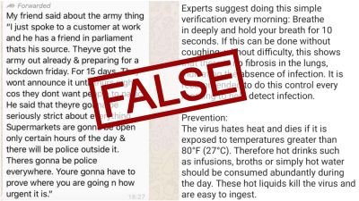

The spread of false information during the [**coronavirus outbreak**](https://www.itv.com/news/topic/coronavirus) has been rapid with well-meaning friends and family sharing messages on messaging platforms including WhatsApp warning of everything from the army closing London to beating the virus by drinking hot drinks.

This is not just annoying spam; it can be dangerous. Here, we debunk some of the most circulated Covid-19 messages that have spread at speed.We will update this article when there are new false stories being circulated.

* **'If you can hold your breath for 10 seconds, then you don't have the virus'**

**The claim:** This long message began circulating early on in the crisis and the claims have been shared more than 30,000 times on Facebook in over a dozen countries, including India, Nigeria and the USA.The message contained several pieces of false information including fake advice on how to detect whether you have the virus, telling people to "breathe in deeply and hold your breath for 10 seconds."

It goes onto say: "If this can be done without coughing, without difficulty this shows that there is no fibrosis in the lungs, indicating the absence of infection. It is recommended to do this control every morning to help detect infection."

The message was usually forwarded from a friend citing a seemingly reliable source ie "Jenny who works with Royal College of Surgeons who received it from the member of Stanford hospital board".

* [**WhatsApp to limit message forwarding to stop spread of disinformation**](https://www.itv.com/news/2020-04-07/whatsapp-to-limit-message-forwarding-to-stop-spread-of-disinformation)

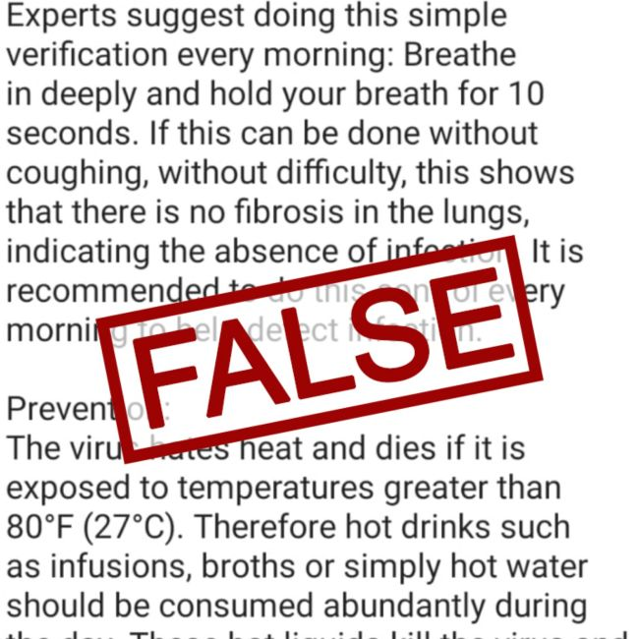Credit: ITV News

**The truth:** Dr Sarah Jarvis, GP and clinical director of patientaccess.com debunks this: "Fibrosis is not a feature of coronavirus and you cannot tell... if you've got COPD (chronic obstructive pulmonary disease) you won't be able to hold your breath for 10 seconds anyway.

"And some people who have coronavirus the only symptom they've got is a fever and not a cough."

* [**Sharing fake news on coronavirus should be an offence, Tory MP warns**](https://www.itv.com/news/2020-03-30/sharing-fake-news-on-coronavirus-should-be-an-offence-tory-mp)

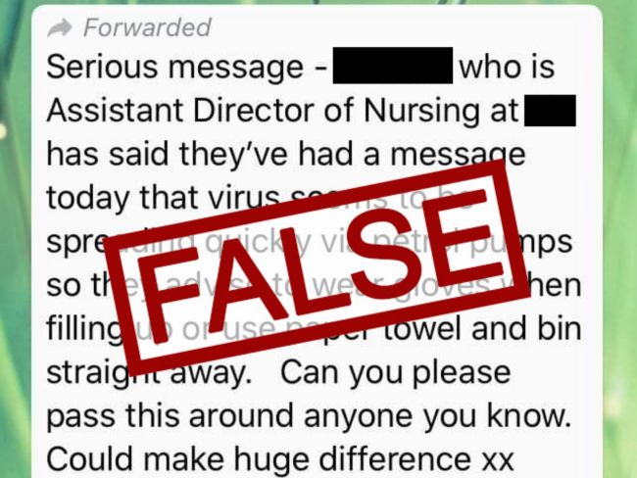Credit: ITV News

* [**A fake news WhatsApp voicenote**](https://www.itv.com/news/central/2020-04-08/whatsapp-audio-recording-is-slammed-as-fake-news-by-public-health-england)

**The claim:** The message, which is voiced to make it look like it's been leaked by someone working with the ambulance service, states that on Thursday (9 April) the UK will hit its peak and face 900 deaths per day from coronavirus. The hoax message states that one third of the 900 deaths will be babies, children and teenagers with no underlying health issues.It also says that when this happens the NHS will become overwhelmed and unable to respond.

**The truth:** Public Health England have now told us that this recording is fake news and they are urging people to ignore it.

The body says: “We are aware of a voice message circulating about the ambulance response to coronavirus, as well as restrictions on movement and predicted case numbers, which claims to have come from PHE.

"This is fake news, and we would urge people to ignore the message and not share it further.

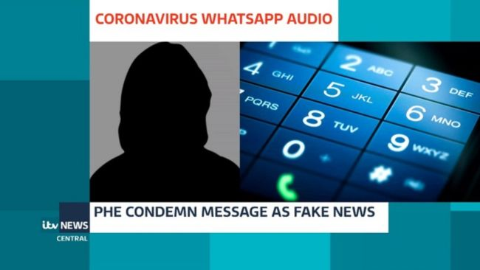Public Health England have assured us that the recording is fake.Credit: ITV News Central

* **The virus spreads through petrol pumps**

**The claim:** This hoax social media message appeared over the weekend of 21/22 March and was shared on WhatsApp. The message claimed the virus was "spreading quickly via petrol pumps". It went on to say people should "wear gloves when filling up or use paper towel and bin straight away."

**The truth:** "A petrol pump is a hard surface," Dr Jarvis says.

"The handle of petrol pump is a hard surface. The best evidence we have, and we don't know, is that on average we think the virus can survive on a hard surface for up to three days, on metal or glass, possibly on plastic. Perhaps one day on cardboard.

"What that means if you touch a petrol pump that a lot of other people have touched before, in exactly the same way that if you've touched a ATM or if you touch a lift button or if you touch supermarket trolley. Yes, it can spread. But because it is a hard surface, you're not going to get it through the fumes."

Public Health England reiterated that on Monday with a statement that read: "Petrol pumps are no worse than other surfaces, although we do recommend people use gloves and wash their hands after using them."

* **5G causes the coronavirus**

**The claim:** Even celebrities have been promoting this conspiracy theory linking [**5G technology with coronavirus**](https://www.itv.com/news/central/2020-04-04/mobile-networks-criticise-theories-linking-coronavirus-to-5g).

Videos purportedly showing masts on fire were posted on social media after theories about the link between the mobile technology and Covid-19 circulated online.

Cheers actor Woody Harrelson and former Dancing on Ice judge Jason Gardiner are among stars who have shared theories.

**The truth:** Scientists have completely rejected the claims.Condemning the theories as "the worst kind of fake news".

At a Downing Street press conference, national medical director of NHS England Professor Steve Powis said: "I'm absolutely outraged, absolutely disgusted, that people would be taking action against the very infrastructure that we need to respond to this health emergency.

"It is absolute and utter rubbish."

Cabinet Secretary Michael Gove added: "That's just nonsense, dangerous nonsense as well."

Dr Michael Head, senior research fellow in global health at the University of Southampton, said: "Conspiracy theorists are a public health danger who once read a Facebook page.

"Here, we also see similar groups of people keen to show their ignorance on a topic where they have no helpful expertise, nor any inclination to post useful public health messages.

"The celebrities fanning the flames of these conspiracy theorists should be ashamed."

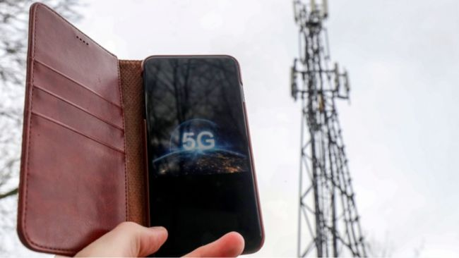5G is not linked to the coronavirus in any way.Credit: PA

* **Beat the virus with hot water**

**The claim:** Another part of the message that encouraged us all to hold our breath for 10 seconds also claimed the virus "hates heat and dies if it is exposed of temperatures greater than 27C." It told us to "abundantly" consume hot drinks "such as infusions, broths or simply hot water" during the day.

"These hot liquids kill the virus and are easy to ingest," the viral message stated.

**The truth:** "Technically, the virus is destroyed by 60C but the virus, don't forget, lives in an awful lot of places where hot drinks don't get to, like the back of your nose," Dr Jarvis explains. "You also run the risk of scolding yourself."

**How you can check whether a message you receive is true and how to not spread fake news about coronavirus**

* Are there spelling errors and strange punctuation? Lots of capital letters are also a giveaway as is a strange URL. Information from reputable sources will be written in clear, grammatically correct English.
* Read beyond the headline. Does it sound unbelievable, it probably is.
* Where did the article come from? If it popped up in your social media feed proceed with caution. If the information was shared by a friend do not assume it is accurate. Vet the information and double check it against official advice before forwarding it to one of your contacts.
* Is the information on credible news sites, or the government or NHS websites? If not, it is unlikely to be true.
* Check the image. Many false news stories will contain a retouched picture or edited video clip.
* Play detective and look at fact-checking websites. Poynter.org has a [**Coronavirus facts database**](https://www.poynter.org/ifcn-covid-19-misinformation/) that has collated many of the most misleading messages.
* The Government's [**SHARE checklist**](https://kbiyx86als2gtl9f1owsrxmd-wpengine.netdna-ssl.com/wp-content/themes/Faded_WP_May_12_2019/faded/theme-assets/images/share-list-image.png) is a handy tool to take a look at if you're unsure about the validity of any claims you have been sent or have seen on social media.

**What are WhatsApp doing to stop the spread of fake news and misinformation about coronavirus?**

WhatsApp are attempting to tackle the issue and have launched a website to help combat misinformation surrounding the ongoing coronavirus pandemic.

The Facebook-owned company have partnered with the World Health Organisation and UNICEF for [**WhatsApp Coronavirus Information Hub**](https://www.whatsapp.com/security/?lang=en) which provide reliable information to users and provides links to reliable sources.

In a statement, a spokesperson for the company said they were "supporting the work of fact checkers around the world to help debunk myths."

They have introduced a number of measures, including reducing the amount of times a message can be forwarded.

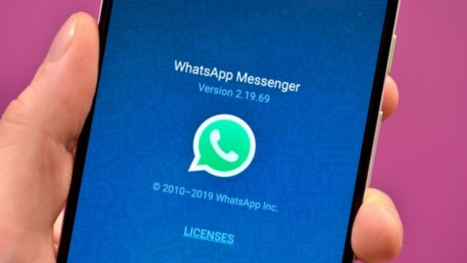WhatsApp are working on ways to tackle false information spread by users.Credit: PA

"We are currently working with health ministries all over the world, and NGOs including the World Health Organization, to launch official Coronavirus Information Helplines to allow people to ask questions about the virus, and to receive official, trusted health advice," the statement said.

"We are supporting the work of fact checkers around the world to help debunk myths about Coronavirus across all social platforms.

"And we have introduced a series of product changes to address the spread of such messages on our platform, such as reducing the number of people you can forward a message to just five chats at once and introducing the 'forwarded' and 'highly forwarded' labels to highlight when you should stop and think about whether you should share something that has been shared multiple times."

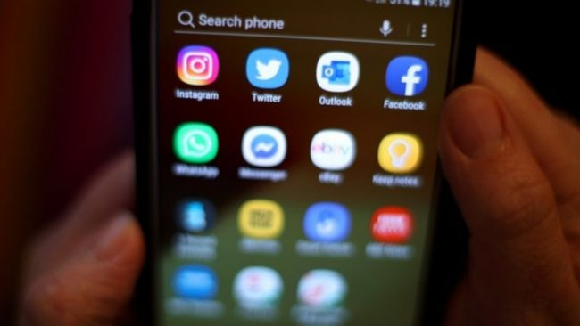A Tory MP has called on knowingly sharing false information to be an offence.Credit: PA

* **What is the Government doing to tackle coronavirus-related misinformation?**

The Government is starting to make efforts to crack down on dangerously misleading information relating to the coronavirus pandemic.

On Monday, the Government announced that a specialist Rapid Response Unit was "working at pace to combat false and misleading narratives about coronavirus".

The Department of Digital, Culture, Media and Sport said the unit was tackling up to 70 incidents a week, many "containing multiple misleading claims".

The [‘Don’t Feed the Beast’](https://sharechecklist.gov.uk/) public information campaign, that first ran in 2019, is being relaunched next week in a bid to encourage people to scrutinise what they read online, the Department announced.

Culture Secretary Oliver Dowden said it was "vital" misinformation did not undermine "expert medical advice".

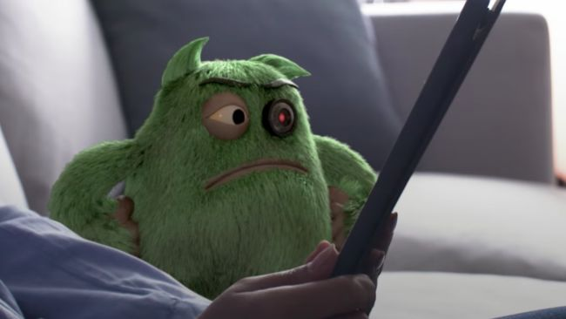The Government are relaunching its 'Don't Feed the Beast Campaign' to help tackle disinformation.Credit: Facebook/UK Government

"We’re working with social media companies, and I’ll be pressing them this week for further action to stem the spread of falsehoods and rumours which could cost lives," Mr Dowden said,

Over the weekend, the Government endorsed an online service that helps users identify trustworthy websites and flags any that are hosting harmful misinformation.

The app's makers NewsGuard say they have identified more than 140 websites publishing fake news on the Covid-19 pandemic, many of them getting more engagement over a 24-hour period than some NHS websites receive in a month.

Last week, former chairman of the Digital, Culture, Media And Sport (DCMS) Select Committee Damian Collins even [**called for it to be an offence to knowingly share fake news**](https://www.itv.com/news/2020-03-30/sharing-fake-news-on-coronavirus-should-be-an-offence-tory-mp)**.**

The Tory MP has partnered with [Infotagion](https://infotagion.com/), a free-to-access website, which allows people to post screenshots of coronavirus-related information they have received online.

[Pizzagate conspiracy theory - Wikipedia](https://en.wikipedia.org/wiki/Pizzagate_conspiracy_theory)

[What is Pizzagate? 10 Facts About the Conspiracy Theory (esquire.com)](https://www.esquire.com/news-politics/news/a51268/what-is-pizzagate/) this is good

# Years After Being Debunked, Interest in Pizzagate Is Rising—Again

Here are ten key things to know about the bizarre conspiracy theory.

 By [Michael Sebastian](https://www.esquire.com/author/13750/michael-sebastian/) and [Gabrielle Bruney](https://www.esquire.com/author/208564/gabrielle-bruney/)

Jul 24, 2020

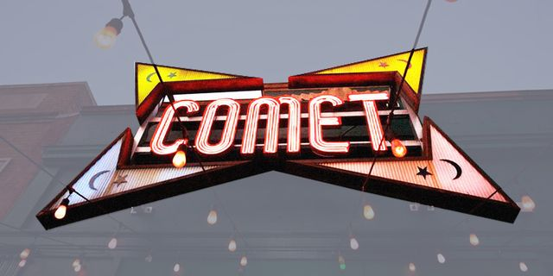

In June, Justin Bieber went live on his Instagram account. Among the countless questions and comments directed at the pop star was one from a social media user who asked Bieber to [touch his hat](https://www.bbc.com/news/technology-53528400)if he were a survivor of child sex trafficking. Bieber did subsequently adjust his beanie, but it's entirely likely that he'd never even noticed the request. However, for followers of the Pizzagate conspiracy, it offered proof of their belief in a powerful cabal of pedophiles who not only traffic kids for sex, but also physically abuse and even murder and cannibalize them in horrifying Satanic rituals.

 related story

](https://www.esquire.com/news-politics/a22646546/q-anon-trump-conspiracy-theory-explained/)](https://www.esquire.com/news-politics/a22646546/q-anon-trump-conspiracy-theory-explained/)

[Meet QAnon: The Grandaddy of Conspiracy Theories](https://www.esquire.com/news-politics/a22646546/q-anon-trump-conspiracy-theory-explained/)

The fact that no evidence supports this thoroughly debunked theory hasn't stopped Pizzagate, which first went viral in 2016 before making a resurgence in recent months, from spreading. Here's what you should know.

### **What the hell is Pizzagate?**

It all started in early November 2016, when Clinton campaign manager John Podesta's email was hacked and the messages were published by Wikileaks. One of the emails, [according to The New York Times](http://www.nytimes.com/2016/11/21/technology/fact-check-this-pizzeria-is-not-a-child-trafficking-site.html), was between Podesta and James Alefantis, the owner of D.C. pizzeria Comet Ping Pong. The message discussed Alefantis hosting a possible fundraiser for Clinton.

Users of the website 4Chan began speculating about the links between Comet Ping Pong and the Democratic Party, [according to the BBC](http://www.bbc.com/news/blogs-trending-38156985), with one particularly vile connection burbling to the surface: the pizzeria is the headquarters of a child trafficking ring led by Clinton and Podesta.

### **Seriously?**

Yes. The conspiracy theory that prominent members of the Democratic Party are somehow involved in a global child-trafficking ring took root on far-right conservative websites. [According to the BBC](http://www.bbc.com/news/blogs-trending-38156985), the conspiracy theory linking this very false theory to Comet kicked around 4Chan until someone posted a long document with "evidence" to a now-banned alt-right section of Reddit several days before the U.S. election. The alt right is a fringe group of far-right extremists—comprised, mostly, of white supremacists and old-fashioned racists—who share their views and various forms of propaganda online.

### **Also, the nation of Turkey is involved in the spread of Pizzagate.**

Around mid-November, [the BBC explained](http://www.bbc.com/news/blogs-trending-38156985), a pro-government media outlet in Turkey started tweeting the conspiracy theory using the hashtag #pizzagate. The reason, [according to The Daily Dot](http://www.dailydot.com/layer8/pizzagate-alt-right-turkey-trolls-child-abuse/), is that supporters of Turkish President Recep Tayyip Erdogan were trying to accuse opponents of hypocrisy. An actual child-abuse scandal had rocked a foundation connected to the Turkish government, and Erdogan's supporters were asking why people weren't also outraged over Pizzagate. In other words, it was meant as a distraction.

## **How does this involve Comet Ping Pong?**

The 120-seat restaurant opened in D.C. in 2006 years ago and, [according to The New York Times](http://www.nytimes.com/2016/11/21/technology/fact-check-this-pizzeria-is-not-a-child-trafficking-site.html), is considered a kid-friendly place, with ping-pong tables and craft rooms. It's also played host to concerts by local musicians, including the band Fugazi.

This content is imported from Instagram. You may be able to find the same content in another format, or you may be able to find more information, at their web site.

[VIEW ON INSTAGRAM](https://www.instagram.com/p/BMqDJu1ArVt/?taken-at=85083&hl=en)

Comet Ping Pong's owner, James Alefantis, is an artist and D.C.-native who was a Clinton supporter but had never met her, according to the Times. Alefantis has prominent friends in the Democratic party. Tony Podesta, brother of John Podesta, frequents the restaurant.

Alefantis was also in a relationship with David Brock, the founder of the website Media Matters for America. The Times described Brock as "a provocative former right-wing journalist who became an outspoken advocate for Mrs. Clinton."

## **The restaurant's staff and customers have come under frequent assault online because of this nonsense.**

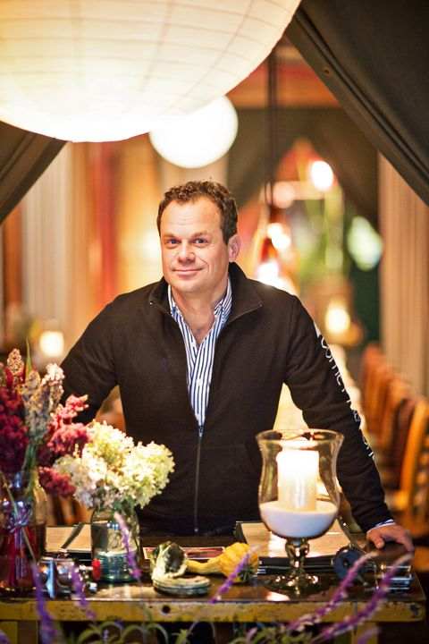

James Alefantis.

THE WASHINGTON POSTGETTY IMAGES

As fake news stories on far-right conservative blogs began to pile up and spread online, the Facebook page and Instagram feed of Comet Ping Pong began filling up with comments to the tune of "we're on to you." It quickly spiraled out of control, with threatening messages pouring through. "I will kill you personally," one message read, [according to the Times](http://www.nytimes.com/2016/11/21/technology/fact-check-this-pizzeria-is-not-a-child-trafficking-site.html).

Alefantis and his staff of 40 people received threatening phone calls and text messages. Photos of customers' children posted online were taken and used in articles as evidence of the child-abuse ring. Many of those customers, the Times noted, hired lawyers to have the pictures removed.

As the threats mounted—including one person who showed up at the restaurant to investigate for himself—Alefantis contacted local police as well as the FBI. He also got in touch with Twitter, Facebook and Reddit in an effort to remove the posts and stories about the conspiracy theory.

None of it worked. The social media posts, texts and phone calls continued to mount.

## **The situation finally boiled over into real violence.**

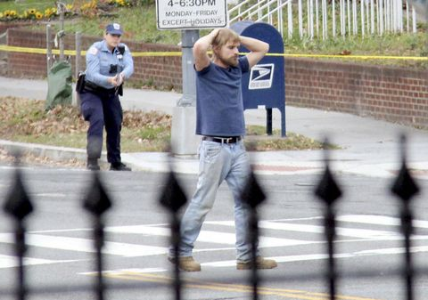

Edgar Maddison Welch in the moments before police arrested him outside Comet Ping Pong pizzeria in Washington, D.C., on Dec. 4.

AP

On the afternoon of Sunday, December 4 2016, 28-year-old Edgar Maddison Welch, of Salisbury, North Carolina, walked through the front door of Comet Ping Pong and pointed an assault rifle in the direction of an employee, according to the Associated Press. The employee fled and called police, but Welch fired his gun, possibly striking the walls, door, and a computer. No one was hurt.

Police surrounded the pizzeria, [according to The Washington Post](https://www.washingtonpost.com/news/local/wp/2016/12/04/d-c-police-respond-to-report-of-a-man-with-a-gun-at-comet-ping-pong-restaurant/?utm_term=.6baea43f6774), which said Welch emerged about 45 minutes later, his hands in the air, to surrender to authorities. He told police he'd gone to the restaurant to "self-investigate" reports of the child-trafficking ring.

](https://join.esquire.com/pubs/HR/ESQ/ESQ1_Plans.jsp?cds_page_id=253005&cds_mag_code=ESQ&cds_tracking_code=esq_edit_article_lifestyle)

Esquire Select

esquire.com

[JOIN NOW](https://join.esquire.com/pubs/HR/ESQ/ESQ1_Plans.jsp?cds_page_id=253005&cds_mag_code=ESQ&cds_tracking_code=esq_edit_article_lifestyle)

He was carrying a Colt AR-15 rifle, a Colt .38 handgun, a shotgun and a folding knife. Police charged him with assault with a dangerous weapon, other weapons offenses and destruction of property.

Earlier, Welch allegedly drove his Buick LeSabre into a teenage pedestrian in North Carolina, [according to Slate](http://www.slate.com/blogs/the_slatest/2016/12/04/pizzagate_gunman_edgar_maddison_welch_ran_over_a_teenager_with_his_car.html). The 13-year-old "suffered head, torso, and leg injuries, [WBTV reported](http://www.wbtv.com/story/33467722/13-year-old-struck-by-vehicle-in-salisbury-airlifted-to-hospital). Welch stayed at the scene until police arrived, WBTV added, although a witness said it appeared Welch didn't try to avoid striking the pedestrian.

In a statement after the incident at Comet, Alefantis called out the dangers of fake news. "What happened today demonstrates that promoting false and reckless conspiracy theories comes with consequences," he said. "I hope that those involved in fanning these flames will take a moment to contemplate what happened here today, and stop promoting these falsehoods right away."

## **Welch wasn't the only would-be vigilante to target Comet Pizza.**

This content is imported from Twitter. You may be able to find the same content in another format, or you may be able to find more information, at their web site.

The Pizzagate gunman surrendered when he discovered Pizzagate was a lie. <https://t.co/S4mTbFgS1M> [pic.twitter.com/chdJCuaN5c](https://t.co/chdJCuaN5c)

— Matt Pearce 🦅 (@mattdpearce) [December 5, 2016](https://twitter.com/mattdpearce/status/805901830576214016?ref_src=twsrc%5Etfw)

Welch, who told [*The Times*](https://www.nytimes.com/2016/12/07/us/edgar-welch-comet-pizza-fake-news.html) that he believed that Hillary Clinton had personally murdered children, isn't the only person to target the pizzeria in person. In 2019, [Ryan Jaselskis](https://www.washingtonpost.com/local/public-safety/man-who-set-fire-at-comet-ping-pong-pizza-shop-sentenced-to-four-years-in-prison/2020/04/23/2e107676-8496-11ea-a3eb-e9fc93160703_story.html) walked into the restaurant and set a curtain on fire. Employees and a customer were able to put out the flames before the fire spread. Jaselskis, who had a history of mental illness, was sentenced to spend four years in prison in April.

## **The shooting didn't stop someone close to Trump from inflaming the situation.**

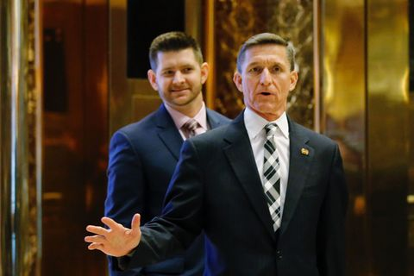

Michael Flynn and his son, Michael Flynn Jr., arriving at Trump Tower in November.

GETTY IMAGES

Shortly after the incident at Comet Ping Pong, Michael Flynn, Jr., the son of Trump's former national security advisor Ret. Lt. Gen. Michael Flynn, tweeted his support of the conspiracy theory:

The story Michael Jr. shared on Twitter suggests Welch's actions were meant as a "false flag" and will now be leveraged to push for censorship of independent media, [according to Politico](http://www.politico.com/story/2016/12/incoming-national-security-advisers-son-spreads-fake-news-about-dc-pizza-shop-232181).

Michael Jr. isn't just Flynn's son, he was his chief of staff and, [according to The Washington Post](https://www.washingtonpost.com/news/the-fix/wp/2016/12/05/did-michael-flynn-really-tweet-something-about-pizzagate-not-exactly/?utm_term=.d72d7fa70814), his closest adviser. But he might be taking after his dad in spreading baseless rumors. The elder Flynn, who led chants of "lock her up" at the Republican National Convention, tweeted a link to a fake news story claiming police in New York had found a link between Clinton, her staff and the child-sex ring.

## **So why didn't Pizzagate go away?**

Many aspects of Pizzagate were eventually folded into the broader [QAnon conspiracy theory](https://www.esquire.com/news-politics/a22646546/q-anon-trump-conspiracy-theory-explained/), which posits that Donald Trump is secretly engineering the downfall of the deep state and its cabal of elite pedophiles. Obviously, non of that is at all true.

But Pizzagate came [roaring back in 2020](https://www.nytimes.com/2020/06/27/technology/pizzagate-justin-bieber-qanon-tiktok.html), when the theory, once associated primarily with older Trump supporters, found a new, younger audience on platforms like TikTok. And while the theory has spread, it's become less overtly political, morphing to falsely accuse celebrities like Ellen DeGeneres and Chrissy Teigen, and brands like Wayfair.

## **Wait, what does Wayfair have to do with this?**

In July, a Reddit user sparked a [viral conspiracy theory](https://www.newsweek.com/wayfair-child-trafficking-conspiracy-theory-cabinets-scandal-1517013) with a post about, of all things, cabinets being sold by the online furniture retailer Wayfair. The cabinets, which all cost more than $10,000, had been given female names as their product titles on the website. Soon, the theory that Wayfair was trafficking children disguised as furniture was spreading around the internet. Wayfair refuted it by [explaining](https://www.reuters.com/article/uk-factcheck-wayfair-human-trafficking/fact-check-no-evidence-linking-wayfair-to-human-trafficking-operation-idUSKCN24E2M2) that the items earned their high prices because they are industrial-grade cabinets, and that an algorithm had named the products. Still, that didn't stop believers from doing their signature deranged deep dive into attempting to connect the company to child abuse.

This content is imported from Twitter. You may be able to find the same content in another format, or you may be able to find more information, at their web site.

The Left and Mainstream media keep saying [#WayFair](https://twitter.com/hashtag/WayFair?src=hash&ref_src=twsrc%5Etfw) is fake.  
Tell me more 🤡🤡🤡🤡🤡[#PizzaGate2](https://twitter.com/hashtag/PizzaGate2?src=hash&ref_src=twsrc%5Etfw) [pic.twitter.com/EfMT2yD2AE](https://t.co/EfMT2yD2AE)

— 𝙑𝙚𝙧𝙪𝙢 𝘽𝙚𝙡𝙡𝙖𝙩𝙤𝙧 (@VerumBellator1) [July 18, 2020](https://twitter.com/VerumBellator1/status/1284558775718830080?ref_src=twsrc%5Etfw)

And because Ellen DeGeneres has a partnership with Wayfair, Pizzagaters decided that she's somehow [in on the kid smuggling](https://www.facebook.com/1509165282598813/posts/1548155575366450). Chrissy Teigen [attracted the conspiracists' attention](https://www.independent.co.uk/arts-entertainment/tv/news/chrissy-teigen-jeffrey-epstein-conspiracy-twitter-trolling-ghislaine-maxwell-a9619581.html) after some of her old tweets surfaced, while Jimmy Fallon and Jimmy Kimmel, who took breaks from their late night shows this summer, were [interpreted by the Pizzagate-addled](https://www.reuters.com/article/uk-factcheck-celebrities-taking-breaks-s/fact-checkclaims-of-celebritiesending-ortaking-breaks-from-their-showsrooted-in-conspiracy-theories-idUSKCN24M208) as attempting to dodge their involvement in the conspiracy.

## **So people really take this idea seriously?**

New York Times reporter [Sheera Frankel said in an interview](https://www.esquire.com/author/208564/gabrielle-bruney/) that pandemic lockdown-induced boredom may be helping to fuel some of the interest in Pizzagate on TikTok. Teens she spoke to said that they'd shared conspiracy videos just because it seemed like fun.

But some, like Welch, take Pizzagate dangerously seriously. At one Trump rally, a woman [tearfully](https://www.vanityfair.com/news/2020/06/inside-the-cult-of-trump-his-rallies-are-church-and-he-is-the-gospel) told [writer Jeff Sharlet](https://www.esquire.com/entertainment/a28891742/jeff-sharlet-the-family-interview-netflix/) that the Clintons literally eat children—there are plenty of true believers. And in 2019, the [FBI identified extreme conspiracy theorists](https://news.yahoo.com/fbi-documents-conspiracy-theories-terrorism-160000507.html) as a domestic terrorist threat.

Luckily, some platforms are moving to squash the spread of this viral mythology. Reddit banned its [Pizzagate](https://www.washingtonpost.com/news/the-intersect/wp/2016/11/23/fearing-yet-another-witch-hunt-reddit-bans-pizzagate/) subreddit in 2016 and [a QAnon group](https://www.nbcnews.com/tech/tech-news/reddit-bans-qanon-subreddits-after-months-violent-threats-n909061) in 2018. And in July, Twitter purged [thousands of QAnon associated accounts](https://www.cnn.com/2020/07/21/tech/twitter-qanon-crackdown/index.html), and implemented measures to prevent the amplification of QAnon content. TikTok followed by blocking QAnon hashtags.

It's unclear just how effective this will be in stopping the spread, as conspiracists tend to hop ship for rival platforms in the wake of crackdowns. But hopefully, vigorous moderation can help confine Pizzagate to the margins of the web.

The Associated Press contributed to this report.

[Liz Crokin: The Hillary Clinton Sex Tape Will Finally Prove That Pizzagate Is Real | Right Wing Watch](https://www.rightwingwatch.org/post/liz-crokin-the-hillary-clinton-sex-tape-will-finally-prove-that-pizzagate-is-real/) crazy video!! Good