**Abortion**

**Page 1 films**

* New US laws
* **Pro-life “It’s a baby!”**
* Donald Trump pro-life
* **Hypocrisy (Pro-life Senator asks mistress to have abortion )**

**Page 2 Alabama**

Page 3 Ohio

Page 8 Texas

Page 10 Arizona judge approves return to 19th century near-total ban

**Page 12 Texas teen attacks new law in high school graduation speech**

**Page 14 Teens Who Survived An Attempted Abortion**

# Page 17 Men Aren’t Quite Sure How to Be Abortion-Rights Activists

New US laws and their consequences explained

<https://www.youtube.com/watch?v=FHlI6Vjc0tI>

Pro-life “It’s a baby!”

<https://www.youtube.com/watch?v=2y7bnauItow>

Donald Trump pro-life

<https://www.youtube.com/watch?v=07rqR52dvCE>

[GOP-controlled states continue to pass abortion restrictions - YouTube](https://www.youtube.com/watch?v=rJRmWGj6CS0)

May 2023 (the latest developments)

Hypocrisy (Pro-life Senator asks mistress to have abortion )

https://www.youtube.com/watch?v=R-KvVPvx0yw

**Alabama abortion laws**

<https://www.bbc.com/news/av/world-us-canada-48283473/alabama-passes-bill-banning-abortion>

# Alabama passes bill banning abortion

Alabama has become the latest US state to move to restrict abortions by passing a bill to outlaw the procedure in almost all cases.

The law includes a ban on abortion in cases of rape or incest.

Supporters say they expect the law to be blocked in court, but hope that the appeals process will bring it before the Supreme Court.

The bill has been signed by Alabama's Republican governor, Kay Ivey.

For more on Alabama <https://www.bbc.com/news/world-us-canada-48275795>

[The looming battle over abortion in the US - BBC News](https://www.bbc.com/news/world-us-canada-57208053)

The looming battle over abortion in the US

By Pratiksha Ghildial  
BBC News, Ohio

Published

28 May 2021

* [**US abortion debate**](https://www.bbc.com/news/topics/cvj0q32px61t)

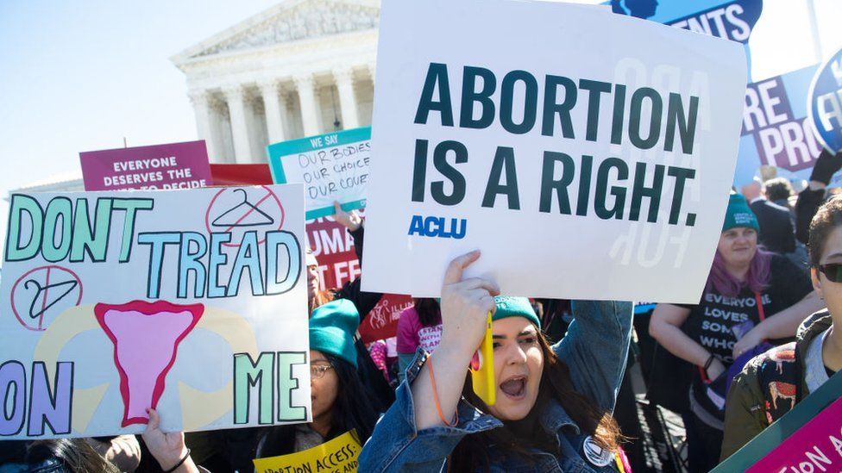IMAGE COPYRIGHTAFP VIA GETTY IMAGES

**Pro-choice activists say that state lawmakers across the country are trying to restrict abortion at a pace not seen in decades. So what will this mean for a decades-long fight over the issue in America?**

On a Friday night, Julie gets ready to go out with her partner while her two boys curl up on the sofa to watch a Disney movie with their babysitter.

It is a typical happy family scene, one that Julie probably never envisaged when, aged just 19, she was raped and took the decision to have an abortion.

"I come from a small town in Ohio. All German Catholics, very conservative. So when I found out I was pregnant I panicked. I didn't know what to do. I knew that I could not have this baby," she says.

She had been fervently anti-abortion then, but when she got pregnant against her will, her views on the subject changed completely.

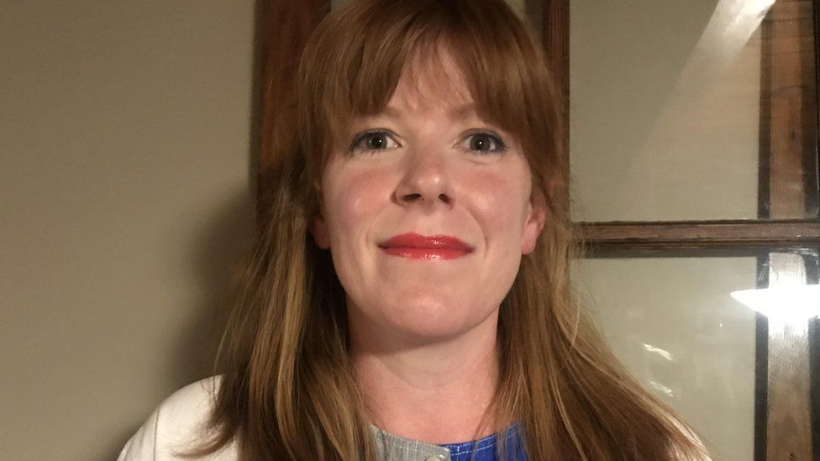

image captionJulie says she's concerned by the current proposed legislation in the US

And, several years later, after an unplanned pregnancy during an emotionally distressing time following her mother's death, she took the decision to have another abortion.

"My abortions, I have no regrets whatsoever for them," she says.

"In fact, it's changed my life. After my first abortion, I had my first examination as a grown woman. I got on birth control. I made yearly appointments for my pap smear and checks. I feel that girls and young women from small, religious communities have a fear or think that they don't need that."

Julie says the current spate of anti-abortion legislation introduced across the country worries her.

"I think it's important for all of us to take a stand and fight for our reproductive rights because, like me, you never know when you are going to be in that position and what you are going to do."

* [**What is Roe v Wade ruling on abortion?**](https://www.bbc.co.uk/news/world-us-canada-54513499)

According to a report by two prominent pro-choice groups, [**Planned Parenthood and the Guttmacher Institute, more than 500 such restrictions have been introduced so far in 2021**](https://www.guttmacher.org/article/2021/04/2021-track-become-most-devastating-antiabortion-state-legislative-session-decades) - significantly more than a comparative period in any other year since the 1970s, when abortion was legalised across the country.

These restrictions run the gamut from a near total ban in states like Arkansas and Oklahoma - where new laws would bar access to the procedure except under very limited circumstances - to states like Idaho and Texas that limit abortion after six weeks of pregnancy, before many women might know they are pregnant.

Furthermore, state legislators in Arizona and Ohio have passed laws that will prohibit doctors from performing abortions based on a foetal diagnosis of Down Syndrome.

Some of these laws allow exceptions in cases of medical emergencies, rape and incest.

Republican lawmakers across the country pushing for more abortion restrictions are emboldened by a conservative-leaning Supreme Court shaped by former President Donald Trump's appointments, the most recent being Justice Amy Coney Barrett last year.

* [**Who is the new US Supreme Court judge?**](https://www.bbc.co.uk/news/election-us-2020-54303848)
* [**What is the US Supreme Court?**](https://www.bbc.co.uk/news/world-us-canada-38707720)

And for the first time since she joined the top court, it will take up a case challenging a Mississippi law that bans most abortions after 15 weeks of pregnancy. If this law is allowed to come into effect, it could pave the way for more such bans in other states.

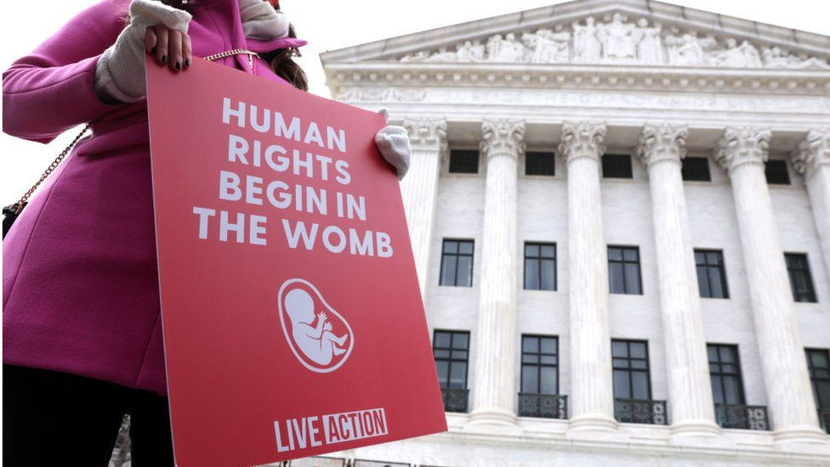IMAGE COPYRIGHTGETTY IMAGES

Experts say this slew of legislation at the state level is all part of a strategy by anti-abortion groups to get the Supreme Court to overturn the landmark ruling from 1973, Roe v Wade, that legalised abortion nationwide in the United States.

It protects a woman's right to an abortion only until viability - the point at which a foetus is able to live outside the womb, generally by the start of the third trimester, 28 weeks into a pregnancy.

Allie Frazier, 27, from the anti-abortion group Ohio Right to Life says no life should be disposable. "We don't get to choose who lives or dies based on what is most convenient for us.''

So what about people who end up with unwanted pregnancies?

"Abortion ends a distinct human life. Women deserve better than abortion," she says.

Abortion is arguably the most divisive issue in US politics and it has long been highly charged.

Democrats, who largely support abortion rights, are currently in power in Washington. President Joe Biden has said he will protect a woman's right to choose.

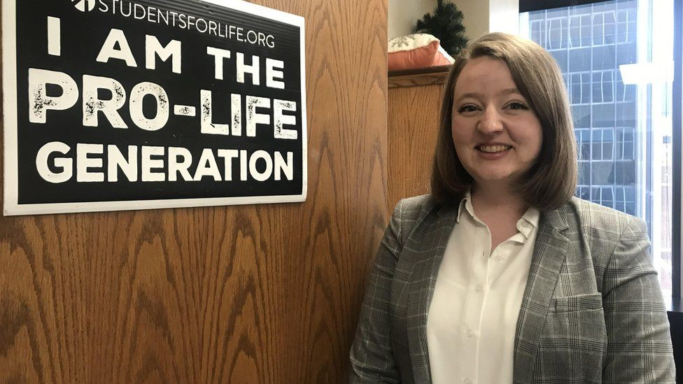

image captionAllie Frazier

However, in recent years conservative anti-abortion groups have put their weight behind bringing in more restrictive abortion legislation in Republican-governed states.

Cathi Herrod, from the group Center for Arizona Policy, which backed the recent state legislation prohibiting abortion on the basis of genetic anomalies like Down Syndrome, says she hopes that abortion in the United States would not only be illegal but unthinkable.

"This directly reflects the will of the people as they have elected legislators who want to regulate abortion and want to look out for the lives of pre-born children as well as the lives of their mothers," she says.

Surveys tend to reveal a complex picture of where Americans stand on the issue.

[**A 2019 poll by NPR/PBS/Marist indicates that a majority of them do want abortion to remain legal**](https://www.npr.org/2019/06/07/730183531/poll-majority-want-to-keep-abortion-legal-but-they-also-want-restrictions) but also want restrictions on abortion rights. A Gallup poll [**last year suggests that most Americans want abortion to be legal only under certain circumstances**](https://news.gallup.com/poll/1576/abortion.aspx).

And a more recent Pew research survey showed that 59% of Americans want it to be legal under all or most cases.

Maleeha, an immigrant from Pakistan who now lives in Texas, says she was stunned at the number of hoops she had to jump through to get an abortion seven years ago.

She ended up having to travel to Colorado to get one because it was such a challenge in her home state. A relative paid for her flight and hotel as she was then a college student who would have struggled to afford it.

"You hear a lot about freedom in the US and how people are so open-minded and things are so much easier," she says.

"In Pakistan, sure, people don't like to talk about it - but it wouldn't garner the same kind of reaction or horror that it evokes here."

Campaigners like Planned Parenthood say 29 states out of 50 have a majority of anti-abortion lawmakers in their legislatures and are actively enforcing ways to limit access to the procedure. They argue a decision on whether to keep a pregnancy is often based on personal circumstances - and that politicians should stay out of it.

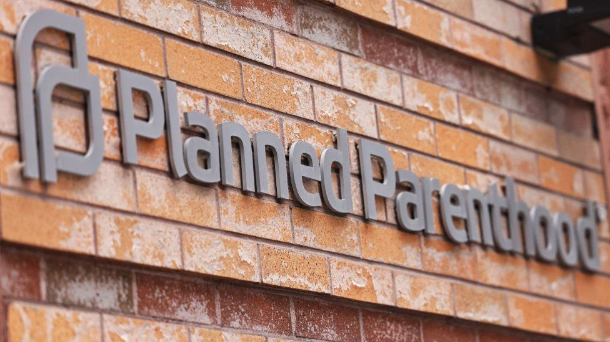IMAGE COPYRIGHTGETTY IMAGES

Elizabeth Nash, from the Guttmacher Institute, which has been documenting the state-level restrictions across the country, says: "The amount of legislation that we are seeing has been building for a few years and comes from the fact that policymakers are extremely conservative. We also now have a judiciary that is very conservative because of all the Trump appointments."

Many of these restrictions are set to come into effect later this year but will most likely face legal challenges.

Experts believe that several will be struck down by the lower courts but that some of these legal challenges will end up before the nine members of the Supreme Court. Pro-choice groups fear that the existing law could be significantly reshaped by the top court, if not completely overturned.

# Abortion: Texas governor signs restrictive new law

Published

19 May 2021

Share

Related Topics

* [**US abortion debate**](https://www.bbc.com/news/topics/cvj0q32px61t)

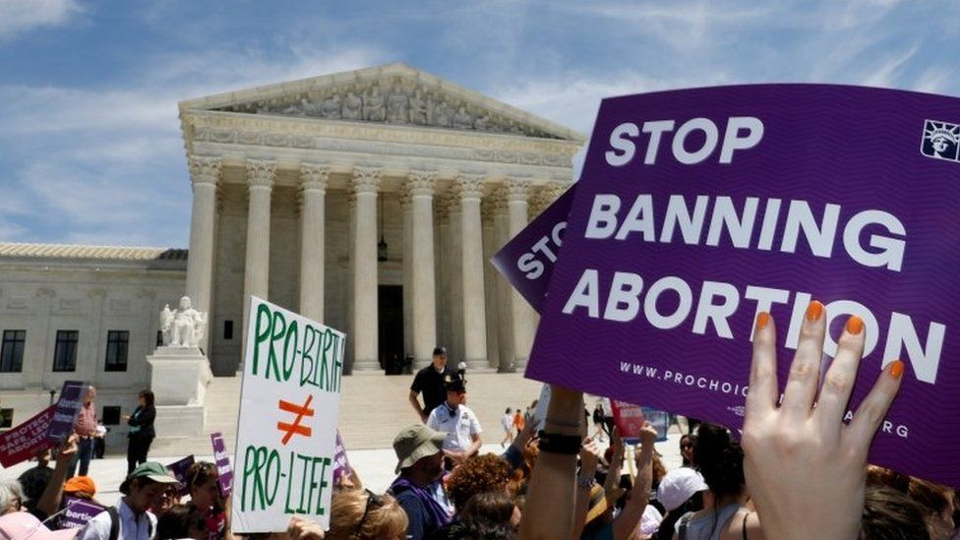IMAGE COPYRIGHTREUTERS

image captionAbortion is one of the most divisive issues in the US

**The governor of Texas has signed a law banning abortion from as early as six weeks - before most women know they are pregnant.**

Governor Greg Abbott signed the legislation at a ceremony on Wednesday.

It bans abortions after the detection of what anti-abortion campaigners call a foetal heartbeat, something medical authorities say is misleading.

The law is also unique in giving any individual the right to sue doctors who perform the procedure past this point.

Doctors and women's rights groups have heavily criticised the law, which will take effect in September if it is not stopped by a court.

Texas is the latest and largest US state to pass abortion restrictions.

It comes just days after [**the US Supreme Court agreed to hear a case**](https://www.bbc.co.uk/news/world-us-canada-57148278) which could upend the nationwide legal right to abortion, laid out in the landmark 1973 Roe v Wade ruling. A ruling could give individual states greater powers to restrict abortions.

## **What does the Texas abortion law say?**

"Our creator endowed us with the right to life, and yet millions of children lose their right to life every year because of abortion," Governor Abbott said at the ceremony, which was broadcast live on Facebook. "In Texas we work to save those lives."

The BBC is not responsible for the content of external sites.[**View original tweet on Twitter**](https://twitter.com/GregAbbott_TX/status/1395037572158603265)

1px transparent line

Unlike in other states, the Texas law does not let state officials enforce the ban. Anyone inside or outside the state instead now has the power to sue abortion providers - or anyone who could have helped a person to get the procedure - after the limit. They can seek up to $10,000 (£7,061) in damages per defendant.

[**The Texas Tribune reports**](https://www.texastribune.org/2021/05/18/texas-heartbeat-bill-abortions-law/) that supporters of the bill hope this novel provision will trip up legal challenges to the legislation, as without state officials enforcing the ban, there will be nobody for pro-women's rights groups to sue.

It also allows abortions in the case of a medical emergency, but not for pregnancies resulting from rape or incest.

Close to a dozen states in the US have passed similar laws based on the "foetal heartbeat" provision. But the American College of Obstetricians and Gynaecologists says the name is misleading, and that what is being detected is "a portion of the foetal tissue that will become the heart as the embryo develops".

* [**What's going on with US abortion rights?**](https://www.bbc.co.uk/news/world-us-canada-47940659)
* [**What is Roe v Wade ruling on abortion?**](https://www.bbc.co.uk/news/world-us-canada-54513499)
* [**Why Utah is making men pay women's pregnancy costs**](https://www.bbc.co.uk/news/world-us-canada-56654289)

In a statement on Wednesday, Planned Parenthood Action Fund President Alexis McGill Johnson said it was "appalling that in defiance of public opinion and public health, state politicians remain committed to controlling our bodies."

"Access to abortion has never been more at risk — and we're going to fight back like hell," [**she tweeted**](https://twitter.com/alexismcgill/status/1395038331344457728).

And an open letter signed by 200 doctors earlier this month said they were "deeply concerned" by the bill, and how it empowers individuals to sue healthcare providers.

"These bills create a chilling effect that might prevent physicians from providing information on all pregnancy options to patients out of fear of being sued," [**it read**](https://documentcloud.adobe.com/link/review?uri=urn%3Aaaid%3Ascds%3AUS%3Ab41d1c79-bb99-4917-ab3e-f6dc665650a2#pageNum=1). "The Texas legislature has no right to cause this type of grievous harm to Texas physicians or the people we serve."

[US abortion rights: Arizona judge approves return to 19th century near-total ban - BBC News](https://www.bbc.com/news/world-us-canada-63019248)

US abortion rights: Arizona judge approves return to 19th century near-total ban

* Published

24 September 2022

Share

**Related Topics**

* [**US abortion debate**](https://www.bbc.com/news/topics/cvj0q32px61t)

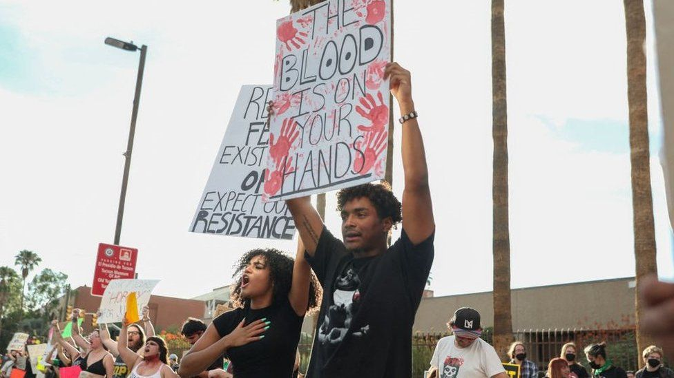IMAGE SOURCE,GETTY IMAGES

Image caption,

Abortion rights protestors in Tucson, Arizona in July.

**By Elsa Maishman**

BBC News

**A near-total ban on abortion dating from 1864 must be enforced in Arizona, a judge has ruled.**

The judge lifted an injunction which barred enforcement of a law allowing abortion only to save the mother's life.

This year the US Supreme Court overturned Roe v Wade, which determined there was a constitutional right to abortion.

Since then US states have been deciding if or when to allow the procedure.

Arizona's law predates the state's founding and includes a two- to five-year prison sentence for anyone who helps someone get an abortion.

It was blocked in 1973, after the Supreme Court's historic Roe v Wade ruling.

Judge Kellie Johnson of Pima County Superior Court lifted this injunction on Friday.

The decision was condemned by the White House as "catastrophic, dangerous and unacceptable", with a spokesperson highlighting the lack of exemptions for survivors of rape and incest, or women with medical conditions.

The president of Planned Parenthood Arizona, Brittany Fonteno, said she could not overstate how "cruel" it was.

"No archaic law should dictate our reproductive freedom," she said.

Roe v Wade [**was overturned in June.**](https://www.bbc.co.uk/news/world-us-canada-61928898) This did not automatically make abortion illegal, but it gave individual states the power to impose their own bans.

* [**What is Roe v Wade ruling on abortion?**](https://www.bbc.co.uk/news/world-us-canada-54513499)

Complicating the situation, Arizona, like several other Republican-led states, passed legislation banning abortion after 15 weeks earlier this year so it could be brought into effect after Roe v Wade was overturned.

It is now unclear whether the 15-week ban or the near-total ban will take precedence.

Governor of Arizona Doug Ducey said it would be the 15-week ban, but his fellow Republican Attorney General Mark Brnovich said it should be the older ban.

Abortion has been difficult to obtain in Arizona in recent months as doctors and abortion clinics have faced confusion over which law will take effect.

[Abortion: Texas teen attacks new law in high school graduation speech - BBC News](https://www.bbc.com/news/newsbeat-57343832)

See the speech here…

[Valedictorian Goes Off Script To Blast Texas Abortion Law - YouTube](https://www.youtube.com/watch?v=225YADqsZhY)

# 3 June 2021

# Abortion: Texas teen attacks new law in high school graduation speech

Published

1 hour ago

Share

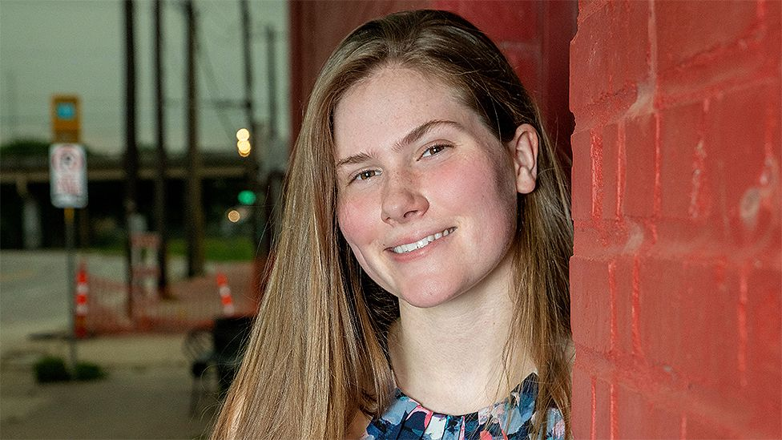IMAGE COPYRIGHTPAXTON SMITH

image captionPaxton Smith changed the speech approved by her school to talk about abortion rights

**When Paxton Smith got up to deliver her high school graduation speech, it was supposed to be about TV and the media.**

But the teenager ditched the script that had been approved by her school, and spoke about abortions instead.

In her home state of Texas, a law banning abortion from as early as six weeks [**has recently been signed**](https://www.bbc.co.uk/news/world-us-canada-57177224).

"I cannot give up this platform to promote complacency and peace when there is a war on my body," Paxton said in the speech that's since gone viral.

The law bans abortions after the detection of what anti-abortion campaigners call a foetal heartbeat, something medical authorities like the American College of Obstetricians and Gynaecologists say is misleading. Many women would not know they are pregnant that early on.

The law does allow abortions in the case of a medical emergency, but not for pregnancies resulting from rape or incest.

When signing the bill, Texas governor Greg Abbott said "millions of children lose their right to life every year because of abortion" and "in Texas we work to save those lives".

## **'We cannot stay silent'**

Doctors and women's rights groups have heavily criticised the change, which will take effect in September if it's not stopped by a court.

"In light of recent events, it feels wrong to talk about anything but what is currently affecting me and millions of other women," Paxton said to fellow students at Lake Highlands High School.

Figure captionWarning: Third party content may contain adverts

"I have dreams, hopes and ambitions," Paxton said.

"Every girl here does. We have spent our whole lives working towards our futures, and without our consent or input, our control over our futures has been stripped away from us."

"I am terrified that if my contraceptives fail me, that if I'm raped, then my hopes and aspirations, efforts and dreams for myself will no longer matter," she added.

* [**What's going on with US abortion rights?**](https://www.bbc.co.uk/news/world-us-canada-47940659)
* [**The looming battle over abortion in the US**](https://www.bbc.co.uk/news/world-us-canada-57208053)

She said it was "gut-wrenching" and "dehumanising" to have the autonomy over her body taken away and that this was a "problem that can't wait".

"I cannot give up this platform to promote complacency and peace, when there is a war on my body and a war on my rights.

"A war on the rights of your mothers, a war on the rights of your sisters, a war on the rights of your daughters.

"We cannot stay silent," she concluded.

## **'This took guts'**

The speech has been viewed millions of times across YouTube, Twitter and TikTok, being praised by many.

Hillary Clinton, the 2016 presidential candidate, [**tweeted**](https://twitter.com/HillaryClinton/status/1400127800288419840): "This took guts. Thank you for not staying silent, Paxton."

And local Democratic politician Beto O'Rourke thanked Paxton for "inspiring Texas with your refusal to accept injustice as the price of participation in civic life".

The Richardson Independent School District, that Lake Highlands School is a part of, has reportedly said it will review student speech protocols before future graduation ceremonies.

"The content of each student speaker's message is the private, voluntary expression of the individual student and does not reflect the endorsement, sponsorship, position or expression of the district or its employees," it said [**in a statement to CBS**](https://dfw.cbslocal.com/2021/06/02/dallas-high-school-valedictorian-paxton-smith-scraps-speech-abortion-rights/).

[**http://www.teenbreaks.com/abortion/abortionsurvivors.cfm**](http://www.teenbreaks.com/abortion/abortionsurvivors.cfm)

**TeenBreaks is a Resource For Abortion and Pregnancy**

* [Home](http://www.teenbreaks.com/)
* [Pregnancy](http://www.teenbreaks.com/pregnancy/pregnancyhome.cfm)
* [Abortion](http://www.teenbreaks.com/abortion/abortionhome.cfm)
* [Relationships](http://www.teenbreaks.com/relationships/relationships-home.cfm)
* [Abuse Issues](http://www.teenbreaks.com/sexualabuse/sexual-abuse.cfm)
* [Contact Us](http://www.teenbreaks.com/contact.cfm)

**Abortion Survivors**

**Teens Who Survived An Attempted Abortion**

**1.** Attempted abortion survivors. These are people who survived an actual abortion attempt. In other words, the abortion failed to kill them.

**2.** Twin abortion survivors. These are people whose twin was aborted but they themselves survived.

**3.** Sibling abortion survivors. These are people born into families where a brother or sister was aborted.

Put yourself in their places. What is it like to know that your own parent attempted to kill you before you were born? Or, why was your brother or sister aborted and you were not? These are the terrible issues which abortion survivors have faced and dealt with. There are many abortion survivors. Here is a sampling of their stories:

**Gianna Jessen**

My name is Gianna Jessen... I was aborted, and I did not die. My biological mother was 7 months pregnant when she went to Planned Parenthood in southern California, and they advised her to have a late-term saline abortion.

A saline abortion is a solution of salt saline that is injected into the mother's womb. The baby then gulps the solution. It burns the baby inside and out, and then the mother is to deliver a dead baby within 24 hours.

This happened to me! I remained in the solution for approximately 18 hours and was delivered ALIVE... in a California abortion clinic. There were young women in the room who had already been given their injections and were waiting to deliver dead babies. When they saw me the abortionist was not yet on duty and had me transferred to the hospital.

**I was aborted and I did not die!**

I should be blind, burned... I should be dead! And yet, I live! Due to a lack of oxygen supply during the abortion I live with cerebral palsy.

When I was diagnosed with this, all I could do was lie there. They said that was all I would ever do! Through prayer and hard work by my foster mother, I was walking at age 3 ½ with the help of a walker and leg braces. At that time I was also adopted into a wonderful family. Today I am left only with a slight limp. I no longer have need of a walker or leg braces.

...Death did not prevail over me... and I am so thankful!

**Ashley**

My mother had an abortion before she had me. Not too long after, she found out she was pregnant again. She decided that time to go for adoption instead of abortion. However, at the last minute she changed her mind, so I live with her now.

She never married, and for twelve years I grew up an only child and was spoiled. Then my father came for a visit, and later my mother announced she was yet again pregnant. I didn't know what to think. I had grown up all by myself, and now there was someone else to share my attention with. I feel left out, like this new baby has taken over.

If my mother had never gotten that abortion, I would not be going through some of the depression I am now because I would have grown up with a sibling all my life and would, without a doubt, be better off, for I would probably not be such a loner and so used to getting all the attention.

## Sarah Smith

## "My Mother's Choice Was My Death Sentence".

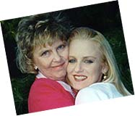My mother's choice was my death sentence. My mother, Betty, had an abortion... A few weeks after that she was sitting at home reading when the book on her stomach began to bounce up and down. That's when she knew she was still pregnant... with ME!

"I'm so sorry, Betty," the doctor told her when she went back to him, "You were carrying twins."

Although a second abortion was suggested, my mother refused and instead brought me to term. I was born with bilateral congenital dislocated hips, a condition for which I've had dozens of operations. It hasn't stopped me from pursuing my medical studies, though, or from speaking out whenever I can for the right to life.

I have forgiven my parents for trying to abort me, and I forgive the abortionist who killed my twin brother and who almost killed me. I often think of my brother, Andrew James, whom nobody can replace.

I believe that the way of truth, love, and God's grace is the only way to deal with the abortion tragedy. I would like to call all people to stand with me to defend the right to life of all persons. There are many alternatives to abortion. Nobody needs to sacrifice her child, no matter what anyone says.

I believe that the way of truth, love, and God's grace is the only way to deal with the abortion tragedy. I would like to call all people to stand with me to defend the right to life of all persons. There are many alternatives to abortion. Nobody needs to sacrifice her child, no matter what anyone says.

**Alex**

when I was 3 years old I saw my mom on TV. She was speaking to a man about how she killed her baby and regretted it. As she told her story and how she became a pro-life speaker, I watched and listened. My grandma didn't think I was old enough to understand.

When my mom picked me up that night, I asked her why she killed my brother or sister and why she didn't kill me. My mom said she was in shock that her 3-year-old would ask these questions. She answered them the best she could for me, and as I got older, I learned more.

Now my mom and I are pro-life speakers. She has been one for almost 15 years, and I just started last year. My mom was 18 when she had the abortion, and I'm now 17.

***"I thank God I'm alive."***

I thank God I'm alive. I'm still sad to know I have an older brother or sister who was denied the chance to LIVE - something we all take for granted. I hope someday we will meet. That's why I do what I do.

<https://www.theatlantic.com/family/archive/2019/06/men-abortion-debate/591259/>

# Men Aren’t Quite Sure How to Be Abortion-Rights Activists

Does a movement that proclaims a deep belief in women’s autonomy have a place for male voices?

[**Ashley Fetters**](https://www.theatlantic.com/author/ashley-fetters/)

Jun 10, 2019

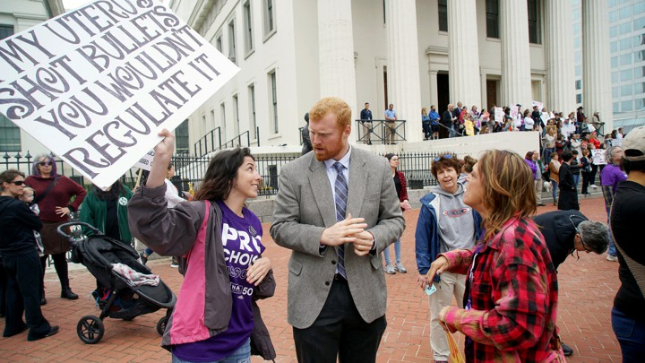Lawrence Bryant / Reuters

On a Wednesday night in late May, 44-year-old Matt Garbett of Atlanta attended a meeting held by NARAL Pro-Choice America, a prominent abortion-rights group, at the urging of a female friend who is active in the local chapter. A few weeks earlier, both Georgia and Alabama had taken measures to restrict access to abortion.

Garbett had always believed that Americans should have the right to get an abortion, and he’d always voted that way—and until that night, he said, he’d thought that was enough. But what Garbett saw at that meeting startled him. In a “completely packed” room, full of what he estimated to be 80 people, only three were men. Garbett didn’t feel out of place, however; instead, he was “absolutely embraced and welcome,” he told me. “I was, oddly, *overly* thanked [for being there]. The next day, Garbett [voiced his bewilderment](https://twitter.com/mwgarbett/status/1131676550259269632) in a thread on Twitter. “Last night I attended my first @NARALGA meeting,” he began. “My biggest takeaway: Men... we are not showing up.”

For decades, abortion has been slotted into the category of “women’s issues,” next to other pregnancy-adjacent topics such as contraception access and paid parental leave. Additionally, some abortion rights advocates haven’t wanted men to be particularly involved: A movement focused on women’s autonomy will necessarily prioritize women’s voices. But most pregnancies require a man’s active participation—so it stands to reason that men have a place in the abortion conversation. As the future of abortion becomes more uncertain, some abortion-rights advocates and groups are actively calling for men to join their fight. Where people disagree is over just what men’s place is in the broader debate—and how large it should be.

In the anti-abortion movement, men feature prominently. Some anti-abortion groups, such as the Family Research Council, the Life Issues Institute, and the Charlotte Lozier Institute, have male presidents; the National Right to Life Committee, which bills itself as the oldest and largest anti-abortion organization, grew out of the all-male United States Conference of Catholic Bishops in the late 1960s. Every year, men are robustly represented at the March for Life, both in men-only groups and in mixed-gender coalitions.

But in the abortion-rights movement, men are far less visible. Part of that may be because of men’s complicated role in abortion rights historically. As Alesha Doan, a public-affairs professor at the University of Kansas and a co-author of *Abortion Regret: The New Attack on Reproductive Freedom and Opposition*, pointed out in an interview, abortion was largely available throughout the 19th century in the United States. “It was men, male physicians, who spearheaded the several-decade campaign to pass laws that essentially criminalized abortion,” she said, starting in the mid-19th century. By 1910, [nearly every state had anti-abortion laws](https://books.google.com/books?id=tJnZWitvR6oC&pg=PA51&lpg=PA51&dq=alesha+doan+abortion+1910&source=bl&ots=GCtSpITI6j&sig=ACfU3U0CHMbFGuBXVBOBGudW2nhNdSNyyw&hl=en&sa=X&ved=2ahUKEwiJ5I6fxdXiAhUMd98KHSwqCxIQ6AEwBXoECAkQAQ#v=onepage&q=alesha%20doan%20abortion%201910&f=false), but illegal abortion occurred “at a fairly high rate,” Doan said. By the 1950s, physicians—still overwhelmingly male—began to push to decriminalizeabortion, so that doctors could safely practice it. Their efforts resulted in a patchwork of laws at different levels of government that regulated who could get abortions and when, made in cooperation with politicians (also overwhelmingly male).

Doan noted that in the years before the Supreme Court’s *Roe v. Wade* decision, there certainly were women opposing abortion—but legislators and doctors, both predominantly male professions at the time, were still the ones making the laws and enforcing them. “Again, you had men as the gatekeepers, able to decide who got to have an abortion and whose reasoning was compelling and whose was not,” she told me. When a large part of the feminist movement joined the fight to preserve abortion rights, Doan said, is when abortion began to be popularly framed as an issue of women’s autonomy versus the (largely male) forces that sought to undermine it.

According to Doan, men figure more visibly on the anti-abortion side of the debate because it is typically aligned with conservative and “traditional” values, especially concerning families and households. These ideals emphasize the father’s role as head of the family, so for men who believe in them, the anti-abortion cause “very much has to do with reclaiming masculinity, restoring men to their role as protectors and providers,” she said. “Anti-abortion activists [tend to] see abortion as one of the key factors that allows men to be unmanly, to run away from their role of being responsible for the family … It’s, *We’re here to protect the unborn, and to protect women from the alleged harms or coercion of abortion.*”

Marjorie Dannenfelser, the president of the Susan B. Anthony List, an organization that supports anti-abortion female politicians, emphasized to me that women do have different and often much more personal perspectives on pregnancy from men. This is one reason she believes it’s important for groups like the Susan B. Anthony List to have female leadership. “Women are uniquely situated to talk about this issue, because we *have* babies,” she said. Still,she also sees men as important allies. “You don’t have to earn your right to speak out on a great human-rights battle,” she told me. The entire abortion debate “comes down to one fundamental question about whether this is another human or not,” she said, “and if it *is* another human, then we have a serious, serious problem on our hands, and everyone should speak to it.” If an abortion were truly just a simple medical procedure that only women and people with uteruses could need, like a hysterectomy, “sure, men could be supportive. There wouldn’t be this huge controversy over who gets to talk and who doesn’t,” she added. (A representative for the National Right to Life Committee offered a similar sentiment: “We welcome men into the conversation because we see this as a human-rights issue.”)

Dannenfelser also said she finds the idea that abortion is an issue men should weigh in on only with their votes or donations “insulting.” “*We want your money, we want your emotional support. But especially your money, and then just shut up and go away.* I think a lot of women have been on the other side of that attitude,” she said, “and I reject it wherever I see it.” Ultimately, men and women can serve the anti-abortion cause in “complementary” ways, Dannenfelser told me. “More support is better, from both [men and women].”

Abortion-rights activists, meanwhile, have recently been calling for a level of male involvement similar to that of the anti-abortion movement—and expressing dismay at the lack of male voices speaking out about how abortion has affected their lives. Last month, *Jezebel* published an essay titled “[How Do We Make Cis Men Give a Shit About Abortion?](https://theslot.jezebel.com/how-do-we-make-cis-men-give-a-shit-about-abortion-1834928975)” The *New York Times* opinion section ran [a column](https://www.nytimes.com/2019/06/02/opinion/abortion-laws-men.html) urging men to think about their own precarious legal situation in an unwanted pregnancy should abortion become illegal.Alison McQuade, a social-media consultant based in Washington, D.C., [tweeted in May](https://twitter.com/akmcquade/status/1128823549362417664), “Men are so eager to join in the ‘WE are pregnant!’ and ‘WE are having a baby!’ party, but suddenly become deafeningly silent when it’s ‘WE had an abortion.’” In an essay for *The Bitter Southerner* titled [“Southern Men: Where Y’all At?,”](https://bittersoutherner.com/southern-men-where-yall-at-abortion-bans) the Atlanta-based writer Gray Chapman called for men to join the battle to preserve abortion rights in Georgia, because abortion, or the lack of access to it, could have significant repercussions in their lives too:

One in four American women will have an abortion by age 45, which means most of y’all know and love more than a few women whose lives today are possible *only* thanks to the freedom they had to make choices about their own reproductive futures. It’s likely, too, that a woman’s abortion has helped make possible your own lives and livelihoods as you know them today.

Many men, Chapman went on, “say they’re hesitant or just plain scared to speak up about this stuff. They feel it’s not their place to say anything, or worse, that they’ll say the wrong thing. That’s understandable, albeit sort of a cop-out.”

Indeed, when Matt Garbett concluded his Twitter thread about the lack of men’s participation in support of abortion rights, men responded to his call with concerns about whether he would be welcome in such a heavily female environment. “Admittedly,” [one tweeted](http://twitter.com/unRonic/status/1131677928935366662), “I don’t know where I would be the most useful nor do [I] want my presence at events to be [a] problem for others,” he wrote. So rather than attend rallies or participate in organized efforts, he wrote, he simply donates money to the cause.

Amelia Bonow—a co-founder of [Shout Your Abortion](https://shoutyourabortion.com/), which encourages people to talk about their pregnancy termination with the goal of normalizing and humanizing the practice—has been thinking about men’s role in the abortion conversation a lot lately. After nearly four years of facilitating ways for people who have had abortions to share their stories publicly, Shout Your Abortion “has shifted,” she told me. This summer, the organization will release a video series in which men speak candidly about their personal experiences with and thoughts about abortion, part of a deliberate attempt by the organization to include more men’s voices.

Bonow acknowledged that the construct of abortion as an expression of a woman’s right to bodily autonomy can make it seem like a topic only women are fit to address. The aesthetic of Planned Parenthood’s marketing, for example—with its heavy use of the color pink—seems to telegraph that. And it hasn’t helped, Bonow added, that some supporters of abortion rights have [all but](https://twitter.com/cmclymer/status/851404825380237317) [insisted](https://twitter.com/sadydoyle/status/856612944938926082) that the abortion-rights movement be a no-men zone.

“I’ve seen all these signs that are like, you know, *No uterus, no opinion*,” she said. “I think that’s a reductive, gendered framing that makes it seem like we’re the only ones allowed to talk about it. I think that approach has spooked some men out of the conversation who we really need to be a part of it.” Every day on social media, she said, she sees progressive men in media and politics weigh in on “every progressive issue” except abortion, even though abortion is tied up in some of those issues, too. “Anyone who cares about economic justice, racial justice, human rights,” she said, “abortion access is your issue.”

Doan, the University of Kansas professor, compares the fight to preserve abortion rights to the fight against racism, or the fight for LGBTQ rights—in which the importance of support from outside the marginalized groups in question, or “allyship,” is routinely highlighted. “I think [abortion] has been defined as exclusively a women’s-rights issue that therefore has to only be dealt with by women,” Doan said. “It’s a faulty way of thinking, much the same way as when we talk about racism and then ask people and communities of color to solve the problem themselves.”

Now is a pivotal moment in the abortion debate, given Georgia’s and Alabama’s recent bills, and an emerging emphasis on abortion as [a key issue in the 2020 presidential election](https://www.theatlantic.com/politics/archive/2019/06/2020-democrats-abortion/590701/). And because political activism is often a strength-in-numbers endeavor, if abortion-rights groups that are majority-women can appeal to more men—half of the population—they could massively boost their influence.